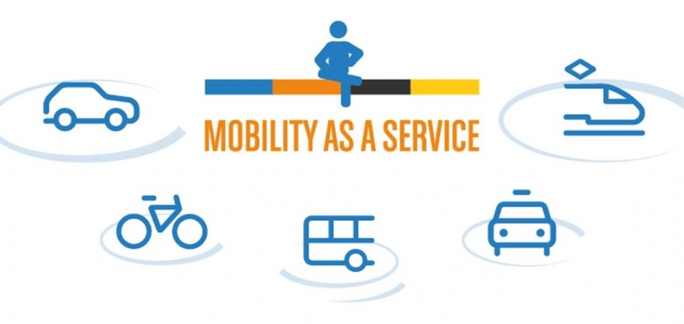**Mobility-as-a-Service (MaaS)** adalah solusi pengganti transportasi manual atau pribadi menjadi sebuah layanan. Memudahkan layanan transportasi public dan pribadi melalui saluran yang dapat membuat dan mengatur perjalanan kita, pengguna pun dapat membayar cukup dengan satu akun. Pengguna dapat membayar tiap perjalanan atau berlangganan dalam sebelum sesuai jarak tertentu yang dibatasi. Konsep MaaS sendiri itu menawarkan solusi terhadap traveler dan pengguna kendaraan sesuai kebutuhannya. MaaS itu tidak hanya untuk pengguna kendaraan pribadi, sasarannya pun bisa diterapkan untuk pengantaran barang, juga bisa perpindahan tempat tinggal.

Contoh produk:

Uber, Grab (GrabHitch), Go-Jek, Temanjalan, Nebengers, etc

Digital innovations in urban mobility has become more widespread providing companies like Uber to become multi-billion dollar global enterprises.

Digital disruptions are now reaching the metro, rail, road, air and automotive industries across the globe.

Digital Transportation applications aim to integrate all modes of urban transport to provide the vision of a seamless end to end journey experience. Technology has a major role to play as the transport sector now stands on the brink of great change, where digital innovation will go further to bring economic and societal improvements.

This shift is fueled by a myriad of innovative new mobility service providers such as ride-sharing and e-hailing services, bike-sharing programs, and car-sharing services as well as on-demand "pop-up" bus services. On the other hand, the trend is motivated by the anticipation of self-driving cars, which put in question the economic benefit of owning a personal car over using on-demand car services, which are widely expected to become significantly more affordable when cars can drive autonomously.

This shift is further enabled by improvements in the integration of multiple modes of transport into seamless trip chains, with bookings and payments managed collectively for all legs of the trip.[1] In London, commuters use the Oyster card, a contactless payment bank card, to pay for their travel. Between the multiple modes, trips, and payments, data is gathered and used to help people’s journeys become more efficient.[2] In the government space, the same data allows for informed decision-making when considering improvements in regional transit systems. Public transport scheduling and the spending of consumer dollars can be justified by obtaining and analyzing data based around modern urban mobility trends.[3]

Travel planning typically begins in a trip planner. For example, a trip planner can show that the user can get from one destination to another by using a train/bus combination. The user can then choose their preferred trip based on cost, time, and convenience. At that point, any necessary bookings (e.g. calling a taxi, reserving[4] a seat on a long-distance train) would be performed as a unit. It is expected that this service should allow roaming, that is, the same end-user app should work in different cities, without the user needing to become familiar with a new app or to sign up to new services.

Short Term Impact: MaaS may cause a decline in car ownership, which would reduce overall emissions. By nature, MaaS could also significantly increase the efficiency and utilization of transit providers that contribute to the overall transit network in a region. The predictions were validated by the Ubigo trial in Gothenburg during which many private cars were deregistered for the duration of the trial and utilization of existing transit services increased the efficiency of the overall network. Ultimately, a more efficient network coupled with new technology such as autonomous vehicles will significantly reduce the cost of public transit.

**Benefits to MaaS**

MaaS has many benefits that can improve ridership habits, transit network efficiency, and societies that adopt MaaS as a viable means of transportation. MaaS would decrease costs to the user, improve utilization of MaaS transit providers, reduce city congestion as more users adopt MaaS as a main source of transit, and reduce emissions as more users rely on public transit components or electric, autonomous vehicles in a MaaS network.

**History**

The concept first arose in Sweden. A well-executed trial was conducted in Gothenburg (Goteborg) under the monthly subscription model.[6] The service was well received, however, it was discontinued due to lack of support at the government level for third party on-selling of public transport tickets.

The idea then gained widespread publicity through the efforts of Sampo Hietanen, CEO of ITS Finland, and Sonja Heikkila, then a Masters student at Aalto University,[7] and the support of the Finnish Ministry of Transport and Communication.[8]

MaaS became a popular topic at the ITS Congress 2015 in Bordeaux, and subsequently, the Mobility as a Service Alliance was formed.[9]

The EU-funded "Mobinet" project[10] has laid some of the groundwork for MaaS, e.g. pan-European identity management of travellers, and payments, and links to trip planners.

In 1996 the concept of an "intelligent information assistant" integrating different travel and tourism services has been introduced at the ENTER conference.

**MaaS Payment Methods**

The concept assumes use through mobile app, although the concept can also be used for any type of payment (transit card, ticket, etc.).

The concept is then broken down further into 2 payment models:

The Monthly subscription model assumes that enough users consume public transit services on a monthly basis to offer bundled transit service. Users pay a monthly fee and receive bundled transit services such as unlimited travel on urban public transport in addition to a fixed number of taxi kilometers. The monthly subscription model incorporates a well-funded commercially operated "MaaS Operator" which will purchase transport services in bulk and provide guarantees to users. In Hanover, Germany, the MaaS operator can purchase bulk transit services and act as the middleman through the product, Hannovermobil.[12] it is not necessary that the operator include all forms of transport, but just enough to be able to provide reasonable guarantees. A monthly subscription will also provide enough funding for the MaaS operator to purchase significant enough transit services that it can use market power to achieve competitive prices. In particular, a MaaS operator may improve the problems of low utilization - e.g. in Helsinki, taxi drivers spend 75% of their working time waiting for a customer, and 50% of kilometers driven without generating revenue. A MaaS operator can solve this problem by guaranteeing a base salary to taxi drivers through existing employers.

The Pay-as-you-go model operates well in environments with a high number of “one-off” riders (tourists, transit networks in areas with high car adoption, etc.). Each leg of the booked trip (each train trip, taxi trip etc.) is priced separately and is set by the transport service provider. In this model, mobile applications would operate as search engines, seeking to draw all transport service providers into a single application, enabling users to avoid having to interact with multiple gateways in an attempt to assemble the most optimal trip. Many cities have cards which pay for intermodal public transport, including Vienna[13] and Stuttgart[14] but none yet include taxis/on-demand buses in the service.

Both models have similar requirements, such as trip planners to construct optimal trip chains, and technical and business relationships with transport service providers, (i.e. a taxi booking/payment API and e-ticketing, QR codes on urban buses and metros, etc.).

**Impact of Autonomous Vehicles on MaaS**

As the development of the autonomous car accelerates, the company Uber has announced that it plans to transition its app to a fully autonomous service and aims to be cheaper than car ownership.[15] Many automobile manufacturers and technology companies have announced plans or are rumored to develop autonomous vehicles, including Tesla, General Motors, Google, Apple, and Local Motors.

Autonomous vehicles would allow the public to use roads in low cost-per-mile, self-navigating vehicles to a preferred destination at a significantly lower cost than current taxi and ridesharing prices. The vehicles would have a large impact on the quality of life in urban areas and form a critical part of the future of transportation, while benefiting the traveler, the environment, and even other sectors such as healthcare.[16]

In January 2016, the President of the United States, Barack Obama, secured funding to be used over the next ten years to support the development of autonomous vehicles.[17]

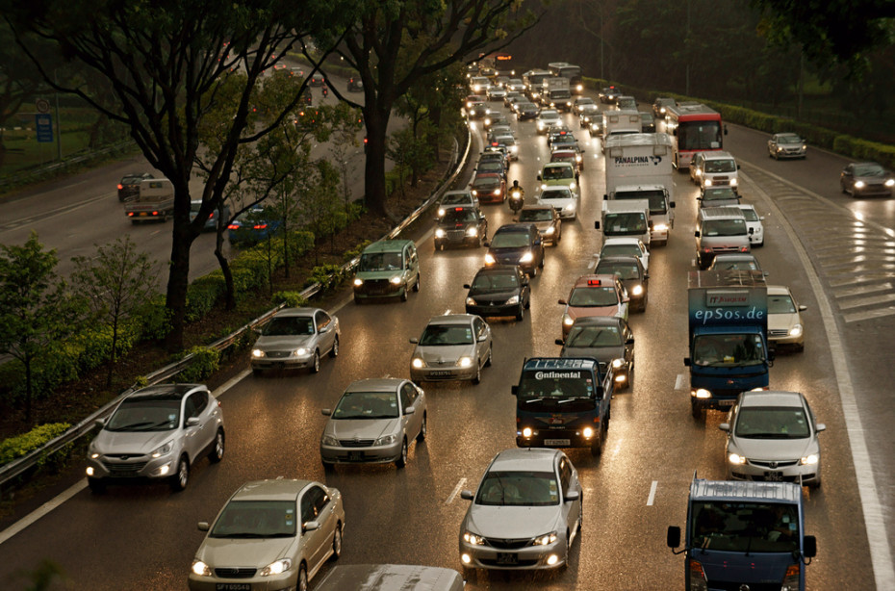

It’s the future. You have just bought your first fully autonomous car and let it drive you to work this morning. It was a little scary at first, but you forgot about the lack of a driver quickly, and now you are at your office.

What is the car doing right now? Right, it is sitting in the parking lot, doing nothing other than perhaps charging. What a waste! So you decide to let your car act as a cab when you are not using it. You don’t want to run a cab business, you just want to reduce the cost of car ownership, so your outsource the job to a cab service. Only, you’re not the only one thinking like this. Everyone’s got their car moonlighting as a cab. There is an over-supply, and no one’s making much money.

In fact, there are so many cheap cabs, you sell your car and just use autonomous cabs to get around instead. It’s much cheaper than owning your own.

Alternative cab services like Uber and Lyft are already preparing us for this future, and the amount of money they’ve raised leaves no doubt that they are able to convince a lot of people that mobility-as-a-service is a growing market.

Americans spend about $300 billion every year on gas alone, and this is only a fraction of the total cost of car ownership. Hence, the money to fuel this new market is certainly there and it is big. And trends like this can become self-fulfilling prophecies: Once a lot of people believe a market transformation like this is going to happen, and it is feasible from a technical and financial perspective, then it will happen. And the more people believe it and the more money is behind it, the faster the transformation will take place.

This phenomenon where a service replaces a product is nothing new. GE, Xerox, and more recently Amazon Web Services are all good examples of this. GE started selling “Power by the Hour”, where it leased jet engines to airlines rather than selling them. Xerox started selling print services instead of printers. And now there are signs that the same conversion from products to services is happening in the consumer market as well.

And let’s face it, who wants to own a car? Their insurance costs a lot of money, require space for parking which can come at a premium, especially in urban areas, require maintenance, washing, cleaning, and after a certain point require a lot of repairs. Apart from the aesthetic pleasure, owning a car is mostly a pain. The only reason most of us still want one is we want the flexibility to get around reliably and cheaply. But those things are mostly qualities of the usage of the car, not the car itself, which means that they can be designed into a service offering as well.

## Ramifications

Disruptive changes like this open the door for new entrants to the market. Market participants know this as the risk of substitution. Established players need to be aware that their current competitors may not be their most dangerous competitors of tomorrow. As for mobility-as-a-service, the biggest existing industry at risk of substitution is the car industry.

Instead of marketing and selling to consumers, car manufacturers will need to sell to service providers. Providers may compete on the types of vehicles they use and hence a consumer’s image of a certain brand of car may still matter. But nonetheless, the competition car makers will fight will be different, and new entrants who may be faster to understand and adapt to the new requirements may be able to out-do established players.

It is also conceivable that car manufacturer themselves will stop selling cars and provide services based on them instead. This would very closely resemble GE’s Power by the Hour and would bring along the same benefits for car makers as it did for GE.

While almost all car makers seem to be preparing for the self-driving future, with new autonomous technology being announced on an almost monthly basis by now, it is unclear how many of them have taken note of the larger trend of mobility-as-a-service. Daimler is a positive example. Their recent acquisition of both a car sharing service (Car2Go) as well as a trip planning smartphone app (RideScout), is indicative of an understanding of what the components to a successful mobility-as-a-service strategy of the mobility market of the future will be.

On the aggressor side, i.e., the possible source for substitution, service companies like Uber and Lyft, Bridj, and RidePal seem best prepared to occupy lucrative market positions in this future market. What all of these companies have in common is an enabler for disruption that we have seen unleash its power in many other industries before: software. As Marc Andreessen says, “software eats the world”, and the mobility market and the car industry are not going to be an exception to that.

Alternative cab services gather a lot of real-time information about their customers, and this kind of data will allow new mobility-as-a-service providers to better target riders, optimize their fleets of vehicles in real-time, allow for new forms of ride-sharing that will ease congestion, and lower the cost of transportation for riders. It will also provide urban planning departments with unprecedented data to base their decisions on.

## Opportunity

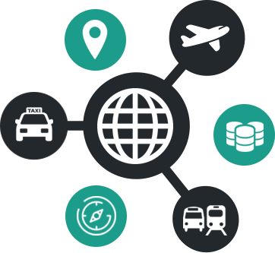The resulting opportunity for urban transit optimization should not be underestimated. Different types of car-pooling, including dynamic, real-time versions, have been tried many times, but there hasn’t yet been a huge success for it. One of the most commonly stated obstacles is the flexibility and reliability of using such a service instead of driving one’s own car.

Yet, public transit is a form of ride-sharing, and if we measure success in terms of people moved per day, it is hugely successful. Why is that? Perhaps because the business model is different: Trains and buses will run, even if you are the only rider one on them, or even when they are empty. There are other factors as well, such as the anonymity and unstated understanding that riders don’t need to talk to each other, even when sharing a tight space.

Seeing ride-sharing from the perspective of public transit, and envisioning the new means of scheduling vehicles on-demand and plotting their routes based on the specific needs of the riders assigned to it, hence doesn’t seem so far fetched, and companies like [Bridj](http://bridj.com/) are already going in this direction. Just like in public transit, reliability can be accomplished with more money. For instance, if there is no carpool available for your requested ride, a personal vehicle may come and pick you up. With this kind of guarantee, travelers can be enticed to participate in a service.

Overall, mobility-as-a-service will be a good thing for most travelers as well as the planet. Services are a lot easier to optimize than several million peoples’ individual behaviors, and since cost and environmental impact are actually correlated in transportation, service providers will have the financial incentive to do this optimization in a way that will mostly benefit the environment.

Christian Fritz leads the Representation and Planning (RAP) area at[*PARC*](http://www.parc.com/), which is tasked with building, maturing, and deploying innovative software that addresses previously unmet market needs. His current focus is on applications in digital manufacturing and urban transportation.

Reference:

<http://www.startify7.eu/thessaloniki/about_the_topic>

<https://en.wikipedia.org/wiki/Mobility_as_a_service_(transport)>

<http://www.nebengers.com/>

<https://temanjalan.com/>

<https://www.grab.com/id/blog/driver/hitch/ajak-sesama-pengemudioktober2016/>