Test 2 (STARLIGHT 10)

LISTENING (ЕГЭ 2020 Веселова Вариант 3)

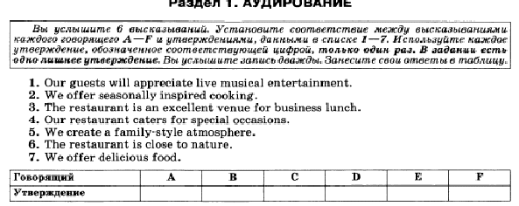

VOCABULARY+GRAMMAR

1. *Complete the sentences with the words in the list in the correct form. There are some ODD words.*

**A first course recipe prescription treat supplement flavour fry recover lose artificial miss guilty**

1. We were surprised to be offered cheese and biscuits as a …- we are more used to eating it at the end of the meal.
2. I found a really good … on the Net for the pumpkin pie.
3. Women like to be **…**  like ladies now and then, Josh.
4. This herb has a wonderful … that goes well with salads.
5. She …the onions in oil until they were a lovely golden colour.
6. With any illness, it’s important to … at your own pace.
7. Never … heart even if you have already been told: we cannot help anymore.
8. We cannot afford to … the target, otherwise millions will suffer.
9. The doctor wrote me a … and some cough medicine.
10. Jane felt … after the offensive comments she made about Anna.
11. *Find the words with similar meaning. Write them in pairs.*

**lifespan advantage bad-tempered benefit energetic get rid of burn longevity sullen vibrant**

**serious very angry unsociable withdrawn enraged severe**

1. *Change the sentences into the reported speech. Use the verbs*

***forbid, allow, order, suggest, remind, beg, promise, threaten, apologize, invite, warn.***

1. “Why don’t we go to the cinema?” he asked me.

2.”Don’t go too near the fire-you’ll burn yourself!”

3. “Please, please help me!” he said to me.

4.”You can go to the party” he said to me.

5. “I’m sorry I damaged your car” she said.

6. “Don’t forget to call Steve “ she said to me.

7.”Give me my diary back or I’ll tell mum” she told her brother.

8. “You cannot eat in the classroom” he said to me.

9.”I’ll bring you the money I owe you tomorrow” he said.

10. “Would you like to come to my party on Saturday?” she said.

*d) Complete the sentences with the verbs* ***rise, raise, arise****. Use their correct form.*

1. I´m afraid the baby´s temperature is _________. We should take him to hospital.

1. The argument _________ over a disagreement about the children´s education
2. In economy, it´s a rule that production costs _________ in line with inflation.
3. The motorbikes _________ enormous clouds of dust as they went by.
4. _________ your hand if you want to ask any questions.

e)

