Контрольная работа по тексту администрации за 1 полугодие

8 класс (углубленное изучение)

**Listening**

1. Listen to the synopsis of the popular film *Confessions of a Shopaholic and complete the following* statements.

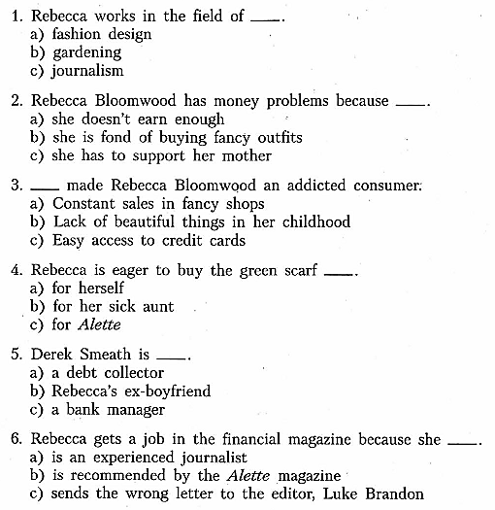

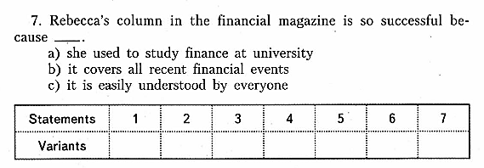

**Reading**

1. Match the parts of the texts with their titles. There is one title you don`t have to use.





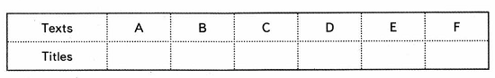

**Use of English**

1. Fill in the gaps transforming the capitalized words.
2. What a horrible _____place! MESS
3. I`ve ____seen her so unhappy. RARE
4. To my ____ I didn`t have to wait long. RELIEVE
5. A ____ of danger of smoking is on every pack of sigarettes . WARN
6. Have you ever tasted cheese-_______ crisps? FLAVOUR
7. Mary was very _____ to help but she had to agree. RELUCTANCE
8. The nurses in the hospital wore _____white caps. STARCH
9. Sam gave us a ______ look and left the room. DIGNITY
10. Read the text and fill in the gaps with the proper grammatical form of the capitalized words.

Advantages and Disadvantages of Shopping online.

Finding a product online is much____1) EASY than looking for it in the local store. You can search any product_____2) EASY by using the search engine feature of an online shopping website. But in store you have to look for it until you will find it. This is how you can save some valuable time. Many people hate searching a product in the corners of the shop and stand in the line for paying the price. Shopping from the local store becomes ____3) MUCH time consuming and expensive if you _____4) HAVE NOT your own car. You can solve all the above problems just by shopping online. If you _____5) FIND NOT a product then you can switch to a new shopping website without wasting your time. On the other hand if you do not find any product in the store you sometimes are forced to buy a _____6)BAD thing from the local store. If you _____7) LIKE NOT the price of the product from an online shop, you ______8) SWITCH to another online store to look for the _____9) CHEAP prices.