=

Merit Advancement Application
Level and Band Advancement

Personal Details
Name: | Ole Nielsen |  | Phone: | x9048
Division/Branch |  | Geospatial and Earth Monitoring Division (GEMD)
Section/Work Area/Project |  | Risk Assessment Methods Project (RAMP)

Nominated Manager Details
Name: | Matt Hayne |  | Phone: | x9536
Section/Work Area/Project |  | Risk Assessment Methods Project (RAMP)

Application Details
I am currently at: | Band | 3 | Level | 5 | Pay Point | 4 | Salary | $77,015
I am applying for advancement to: | Band | 3 | Level | 6 | Pay Point | 1 | Salary | $83,300

The Certified Agreement has this to say about Level and Band advancement:
- Employees must have an Individual Work Plan in place and had a formal performance assessment before they are considered for merit advancement
- Employees must indicate which, if any, of the 19 performance indicators in the six criteria do not apply to their current role and responsibilities and which should be weighted more heavily as a result (agreed at the time of the Individual Work Plan)
- Employees must demonstrate sustained high performance at their Level which means that their current performance against work responsibilities and work complexity are commensurate with the description of work at the higher Level and their overall contribution is as assessed as High Performance
- The employee’s performance is assessed as at least Effective against each of the performance categories at the standard expected at the higher Level.

Role and Main Responsibilities for the sustained period of 12 months as described in your Individual Work Plan
- Lead the GA inundation modelling project (development of software for computational fluid mechanics and applications in risk modelling and impact forecasting).

- Contribute to inundation and impact forecasting for the Australian Tsunami Warning System (ATWS).

- Liaise with other agencies in order to foster a collaborative approach to hazard and risk modelling and present work publicly.

- Provide strategic assistance to IT and GA staff in building and using corporate Beowulf cluster for high performance computing.

- Provide software support and advice for RAMP staff.

Referees (in addition to nominated manager)
Name | Relationship | Written report provided (Y/N) | Phone
Dr Stephen Roberts (external) | Collaborator at the ANU | Y | (02) 6125 4445
Lesley Wyborn | Corporate sponsor | Y | x9489
Spiro Spilliopoulus | Colleague | Y | x9494
Adrian Hitchman | Colleague | Y | x9800
David Robinson | Colleague (currently ANU) | Y | (02) 6125 5162
Trevor Dhu | RAMP Project Manager |  | x9076
Duncan Gray | Under my supervision |  | x9077
Jane Sexton | Under my supervision |  | x9841

Notes about Referees:
- Referees must be familiar with your work.
- If you have people management responsibilities, include as a referee the name of at least one of the people you manage.
- As part of the assessment process the panel may contact nominated referees and/or, at its discretion, others who are familiar with your work.
- Provide your referees with a copy of your application.
- Your application must include a report from your nominated manager unless otherwise arranged with HR.
Applicant's Signature: |  | Date: | / /

Current Role and Main Responsibilities
Indicate if any of the performance indicators, listed under the six performance categories do not apply to your current role and responsibilities and any, which you feel, should be weighted more heavily, given your current role and responsibilities.
Your nominated manager needs to verify this (see below).

CRITERIA AND PERFORMANCE INDICATORS | Applies in current role | Needs to be weighted more heavily in current role
- Achievement of Results/Outputs
Contribution to team achievements | Yes
Record of achievement of results/ outputs of value to GA project/ work area/clients | Yes | Yes
- Leadership
Strategic perspective and contribution | Yes
Leadership in specialist area | Yes | Yes
Leadership of people | Yes
- Management
Managing self | Yes
Managing others | Yes
Managing project/work area/activity | Yes | Yes
Communication, liaison, negotiation and influencing skills | Yes
- Client interaction
Identifying client needs | Yes
Meeting client needs | Yes
Developing new ventures/projects/products | Yes
- Corporate contribution
Corporate awareness | Yes
Involvement GA/ITR/APS/ professional arena activities | Yes
Sharing expertise | Yes | Yes
Corporate information management | Yes | Yes
- Learning and development
Development of professional/technical skills, knowledge, expertise | Yes
Development of self in line with GA key work values (Leadership, Management, Client Interaction, Corporate Contributions) | Yes
Development of others | Yes

Nominated Manager’s Signature: |  | Date: | / /

CLAIMS FOR LEVEL/BAND ADVANCEMENT

PART 1 – SUMMARY OF CLAIMS
My work in GA since my commencement in March 2003 has had the following impacts:

A new modelling capability that has enabled GA to simulate effects of tsunami or storm surge disasters on the built environment and to present the results in forms that are easily interpreted.
My achievements in this area have
- Provided GA with a state-of-the-art hydrodynamic modelling tool that has raised the bar for what is technically and conceptually possible.
- Formed an integral part of a recent successful cabinet submission for the Australian Tsunami Warning System and presentation to the PMSEIC where it was recognised that computational modelling plays an essential role in delivering warnings, education and risk assessments of natural disasters.
- Been the direct cause for state and territory governments to fund positions at GA for collaborative projects. This is significant, as it has traditionally been difficult for GA to get the state governments involved.
- Been awarded the "EMA Safer Communities Award 2005" and is the main reason Emergency Management Australia is now recognising the benefits of entering a formal collaboration with scientists at GA.
- Caused the re-insurance industry to consult with GA and has allowed GA access to valuable insurance data that was previously intractable.
- Attracted international interest, e.g. from the Sri Lankan government.
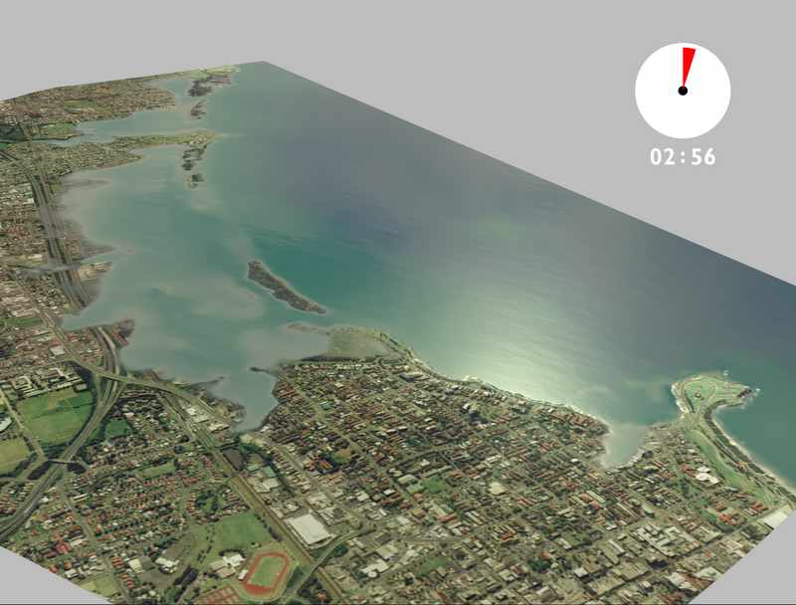
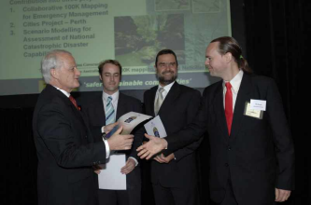
A corporate high performance computational facility that has given GA the means and the culture to undertake large scale computational modelling – something GA is relying on increasingly. Results include
- a geomagnetic map of unprecedented high resolution
- outputs from tsunami and earthquake hazard and risk modelling; and
- the formation of the High Performance Computing User Group in GA.

Innovative capabilities in information management and a cultural change within the organisation in regard to software are having widespread impacts within GA:
- Automatic revision control of software projects is saving GA tens of thousands of dollars every year.
- The focus on standards, rigorous testing, use of open source software and proven methodologies is helping GA be more effective in terms of time, quality and productivity.
- Tools are now available for processing large datasets that were inaccessible to Excel or ESRI products due to size constraints.
- More than 70 scientists within GA have joined the Programmers‘ User Group, chaired by me, in order to pursue excellence in software development and better information management practices.

PART 2 – YOUR PERFORMANCE AT THE NEXT LEVEL

Achievement of Outputs/Results
Application of skills, knowledge, expertise; Contribution to team achievements; Record of achievement of results/outputs of value to GA project/work area.
Hydrodynamic inundation modelling tool (ANUGA):
The inundation modelling project is a highly complex activity which revolves around a sophisticated software package designed and written from scratch by me and my team at GA with research input from the ANU (hence the name). In spite of limited knowledge of fluid mechanics, I was able to liaise with the key researchers in transferring the science into GA and turning the theories into a production grade tool now the centrepiece for hydrodynamic inundation modelling within GA. Tangible results from this activity are:
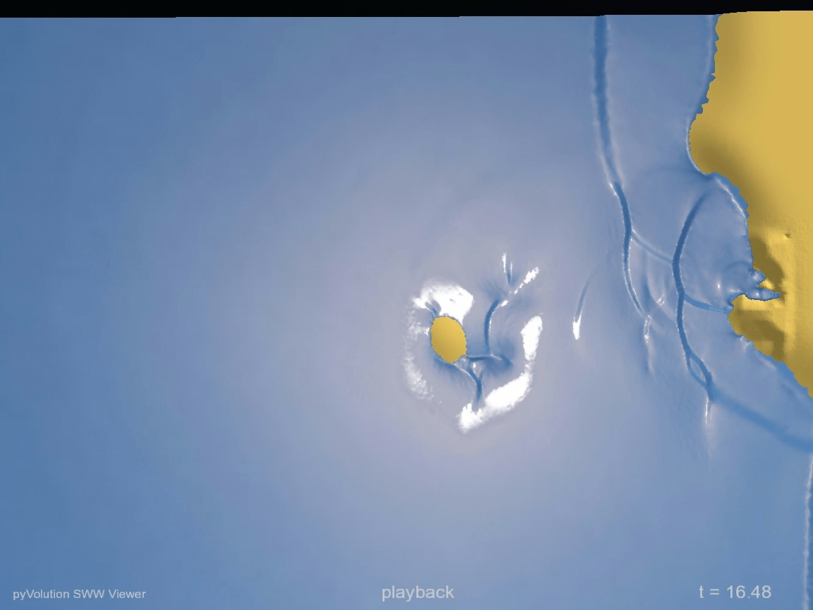
- The code executes 200 to 300 times faster than the first ANU prototype and can accommodate problems more than 10 times the size. This is due to my experience in high performance computing and optimisation.
- The innovative interface is so easy to use that a meaningful model can be built using only a screen full of powerful high level commands. New users of the code praise the ease with which they can interact with the model. This is due to my skills in software engineering,
- The model output is interpreted and visualised in a manner that makes it easy for GA to communicate the science to stakeholders. Impacts include new funding for two positions and considerable kudos for GA. This is due to my modular design and my successful liaisons with visualisation specialists.

Leadership
Strategic perspective and contribution; Leadership in specialist area; Leadership of People.
I have been responsible for leading the design and development of ANUGA since its conception in 2003 and took responsibility for the entire activity in November 2004. The activity, originally labelled Storm Surge Modelling, lacked involvement from external experts and stakeholders who had not been involved and who suspected that GA was encroaching on their mandates. Having identified this problem, I renamed the activity Inundation Modelling and broadened its focus. The significance of this was:
- The new name reflects accurately that ANUGA is capable of modelling flows onto dry land and among structures generated by a range of phenomena including storm surge and tsunami (a concept I put forward in a graduate proposal submitted prior to the 2004 tsunami).
- The broader scope signified a strategic shift in focus and allowed collaborators at organisations such as CSIRO or BoM to liase with GA in Storm Surge modelling activities using and respecting capabilities in all groups involved. A direct consequence of this is a project with Dr. Kathy McInnes of CSIRO atmospheric research who is the leading Australian scientist in storm surge modelling.
- We were able to respond with agility to the demands for a tsunami scenario by the Catastrophic Disasters Working Group following the December 2004 tsunami through a collaborative approach with my staff and collaborators. This work was given an award as outlined in the summary.

I have shown strong leadership across the organisation in information management, software practices and parallel computing. Examples are that I:
- Formed two GA user groups. The High Performance Computing User Group and the Programmers’ User Group which gives over 10% of the organisation a forum to discuss common issues with information and software management .
- Initiated a new collaboration with AGIMO to help GA resolve issues with software IP so that GA can disseminate the software products we produce. This collaboration will help GA to achieve organisational outcomes identified in the strategic plans and facilitate a whole of government approach to IM standards.
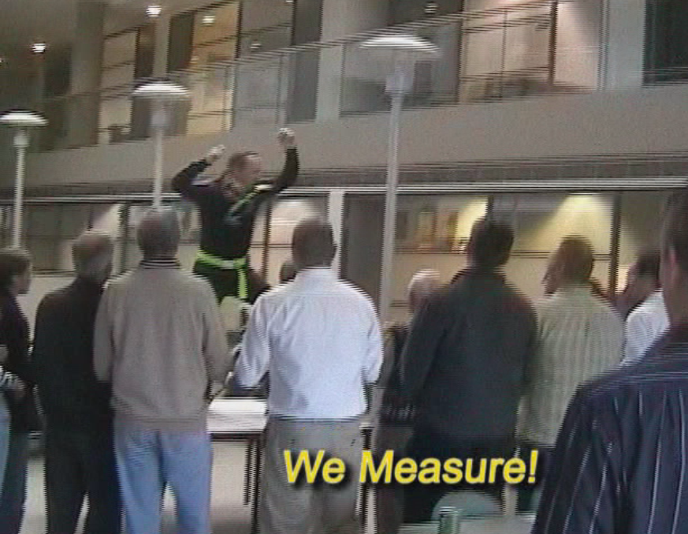
- Influenced CIMA, IT and the EB to develop new important enterprises including a corporate revision control system that allows significant efficiency gains for GA and a corporate super computing facility.
- Increased awareness within GA of a range of emerging important technologies such as information retrieval and interoperable systems.

Management
Managing self; Managing others; Management of project/work area/activity; Communication, liaison, negotiation and influencing skills.
The creation of the inundation modelling activity has required a broad range of management skills:
- Brought together staff, stakeholders and collaborators with different skills and agendas together to achieve results by fostering a climate of enthusiasm, empowerment and trust.
- Introduced an innovative tool for managing, prioritising and tracking software issues that has greatly enhanced the effectiveness of the team and our collaborators.
- Recruited, managed and supervised one level four software engineer (since 2003), a level five modeller and an additional level four software engineer (since 2005).
- Scoped, negotiated, and supervised 10 contracts for science transfer, modelling, parallelisation, visualisation and technical writing since 2004. All were completed and accrued on time.
- Managed upwards to achieve improved IM and IT practices as well as additional resources.
- Managed the balance between my own hands-on development of the model and leveraging input from various stakeholders under tight time frames.

Client Interaction
Identifying client needs; Meeting client needs; Developing new ventures/projects/products.
The inundation modelling activity is a high profile project involving clients and stakeholders nationally and internationally. Clients include Federal Government, Emergency Management Australia, State and Territory Governments, academia and international organisations.
The activity has had impacts on all of the above and my role is and has been to ensure that the continued development is driven by the needs of our clients. I accomplished this by listening to clients in meetings and by ensuring that the project is as agile as possible. An example is the swift response to the demands following the 2004 tsunami where we delivered scenarios for the Catastrophic Disasters Working Group in a very short time.
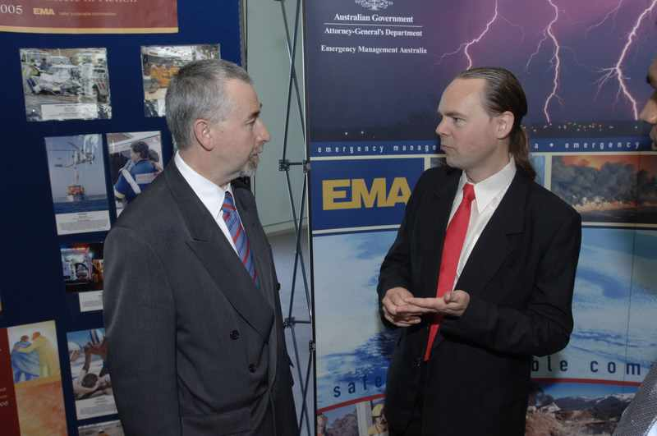
In addition I have initiated new stakeholder opportunities with the Centre of Excellence for Autonomous Systems, CSIRO atmospheric research, parts of BOM and the ANU.

Corporate Contribution
Corporate awareness; Involvement in GA/ITR/APS/professional arena activities; Sharing expertise; Corporate information management.
- Represented the organisation and Australia by presenting to the UN in Bangkok in June 2005.
- I have given GA a computational facility and I am building capacity in staff to use it effectively.
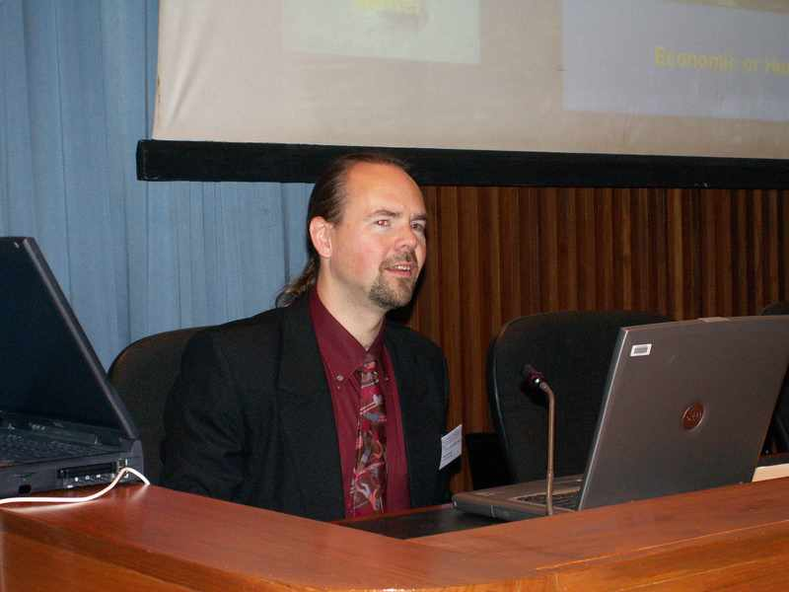
- From the moment I started in the organisation I have focused on improving the corporate information management strategy. This is now being recognised as a strategic priority.
- I have represented GA at open days and through numerous seminars.

Learning and Development
Development of professional/technical skills, knowledge, expertise; Development of self in line with GA key work values (Leadership, Management, Client Interaction, Corporate Contributions); Development of others.
Important developments include
- Completing Geoplus 2005 has honed my corporate awareness and management/leadership skills.
- Ongoing self study in computational fluid mechanics was necessary to develop ANUGA.
- I have learned to touch type using the revolutionary Dvorak keyboard layout reducing the risk of RSI.
- Coached staff across the organisation in mathematical modelling, software engineering and high performance computing.

Applicant's Signature: |  | Date: | / /

