Proposed meeting to review of the two current non-ongoing positions in the “inundation modelling activity” within RAMP.

Requested attendees: John Schneider, Matt Hayne, Trevor Dhu, Bob Cechet & Ole Nielsen

The December 2004 “Boxing Day” tsunami disaster highlighted the need for Australia to understand and manage the risk posed by tsunamis to the vulnerable coastal zone. New initiatives within GA have followed in the aftermath of this event. Most notable is the Australian Tsunami Warning System (ATWS) which currently has attracted funding until 2009, and is likely to be continuing. Other initiatives with regard to tsunami inundation modelling have had significant bearing on GA as well. The WA Fire and Emergency Services Authority (FESA) has taken the lead and struck a partnership with GA to conduct tsunami risk assessments and detailed inundation modelling for priority areas in their state. The NSW Department of Natural Resources is likely to follow suit as are other states such as Tasmania and Queensland. There is a growing need for authorities responsible for planning or the safety of the public to “locally” understand and manage the risk posed by tsunamis or other phenomenon to the coastal environment and infrastructure.

An integral component of GA’s capability is the Inundation Modelling Activity (IMA) within the Risk Assessment Modelling Program (RAMP). As this activity has emerged from its development stage, and has seen successful validation in both storm surge and tsunami inundation scenarios, it has succeeded in attracting funding from both the ATWS and FESA to resource two non-ongoing positions that are critical for producing tsunami impact scenarios, risk models, manage liaisons with stakeholders and advancing the research underpinning the program. One is a Level 5 computational modeller position currently filled by Dr Jane Sexton, the other a Level 4 computational modeller/software engineer position currently filled by Nick Bartzis.

Both these positions are currently non-ongoing and funded to the end of the 06/07 FY. Currently, forward planning has IMA within RAMP reducing from four to two staff in the 07/08 FY. Under this scenario the IMA will not be able to meet the current demands from FESA, ATWS and RAMP let alone support the proposed cyclone impact initiative with the Bureau of Meteorology (storm surge inundation scenario modelling) and/or expand in new directions such as the modelling of riverine flooding in both inland and estuarine regions. Moreover, a solid capability in fluid mechanics is likely to become essential in other areas such as modelling of ground water flow, sediment transport and climate change considerations involving the above natural and extreme environmental processes.

The imminent “open source” release of the inundation modelling code has stimulated significant interest within the modelling community. IMA is being approached to collaborate with University research groups and the CSIRO in undertaking joint research into the above scientific areas which have previously been short-listed in forward planning for future involvement. IMA sees this type collaboration as mutually beneficial and an ideal vehicle for developing GA intellectual property in new areas of research. However, the current employment structure with IMA restricts me (as leader of the activity) from exploring the opportunities for medium-term multi-year collaborative efforts.

I therefore propose that GA considers the future of these two non-ongoing positions in recognition of the importance of the inundation modelling activity, the likelihood of continual growth and diversification, the need to establish and/or maintain links with other Federal government departments and institutions (Bureau of Meteorology, CSIRO, Emergency Management Australia), and the need for continuing GA IP development with regard to applications through collaborative efforts.

Best Regards
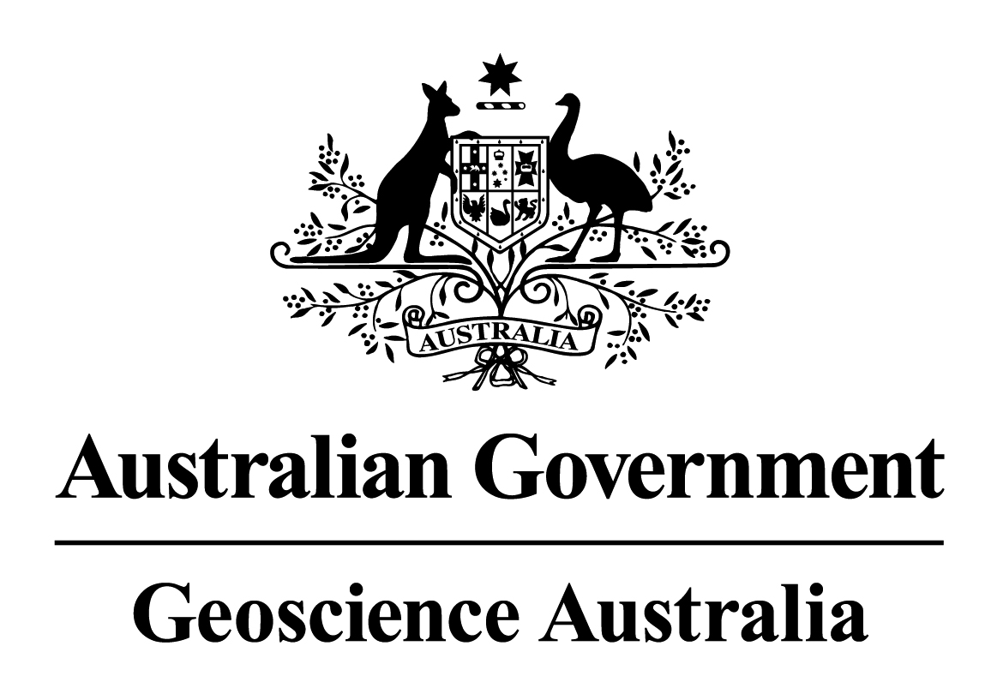
Ole Nielsen, RAMP, x9048

