**PROPOSED FEATURES - HCM APEX**

**HUMAN RESOURCE:**

1. 360 degrees Feedback
2. Benefits Management
3. Employee Database
4. On boarding
5. Performance Management
6. Self Service Portal
7. Time off Management
8. Applicant Tracking
9. Compensation Management
10. Employee Profile
11. Payroll Management
12. Recruitment Management
13. Time and Attendance Management
14. Employee Training
15. Employee Infractions
16. HR forms
17. Medicals
18. Document Management
19. Asset Management
20. Projects
21. Staff Loans
22. Travels Management
23. Expense Management

**COMPENSATION:**

1. Compensation calculation
2. Compensation Statement
3. Incentive Programs
4. Salary Planning
5. Compensation Assessment
6. Compensation Plan Modelling
7. Employee Reward Programs
8. Organisational Charting

**PAYROLL:**

1. 401(K) Tracking
2. Multi-Country
3. Self –Service Portal
4. Vacation/Leave Tracking
5. Wage Garnishment
6. Application of Benefits Management
7. Direct Deposit
8. Multi – State
9. Payroll Reporting
10. Tax Compliance
11. W-2/1099 Preparation

**DYNAMIC (AI DRIVEN) HOME PAGE:**

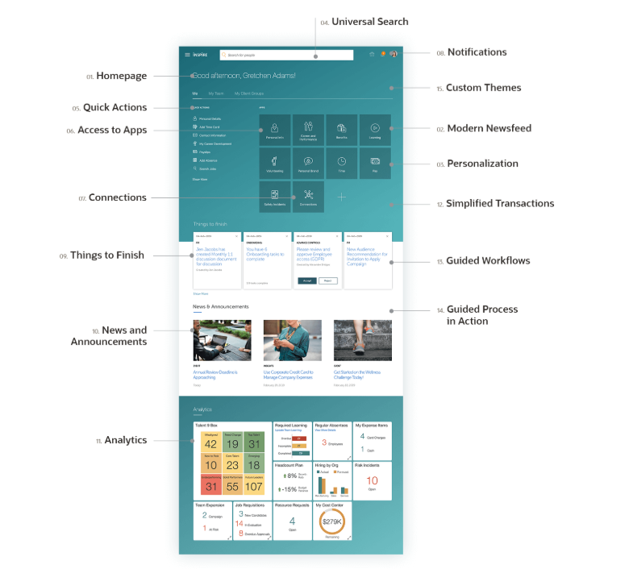

**ANALYTICS:**

