**HOW TO ACCESS THE COMPANY SECRETARY APP**

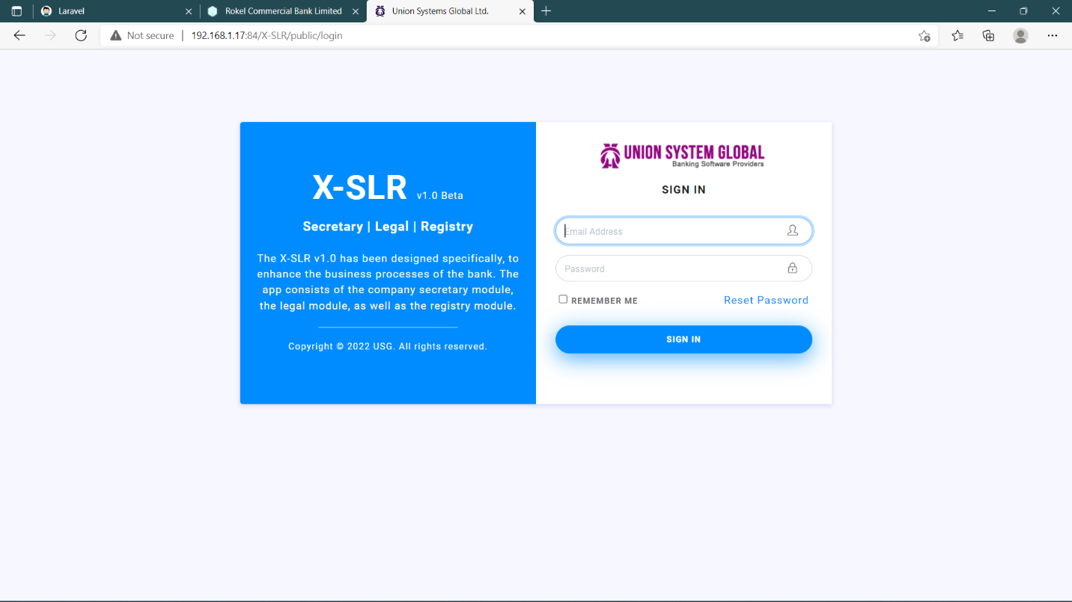

**MAIN LOGIN PAGE**

The main login page can be used to access all the three separate apps

1. Company secretary
2. Legal
3. Registry

URL to access website: 192.168.1.17:84/X-SLR/public/login

**SUPER ADMIN**

The super admin has the right to access all the 3 separate apps

Credentials

**Email:** suser@usg.com

**Password:** secret123

**AFTER LOGIN SCREEN**



