**HR SYSTEM**

**USER ACCESS**

The hr system has two access levels

* ADMIN
* NORMAL USER

**NORMAL USER STRUCTURE**

* **MODULES (MODULES FOR THE NORMAL USER)**
* Profile
* Leave
* Projects
* Document management
* Imprest
* Expenses
* Discussions
* Personal information
* User reports
* Time management
* Company
* Training
* Performance
* Finance
* **THE PROFILE MODULE**

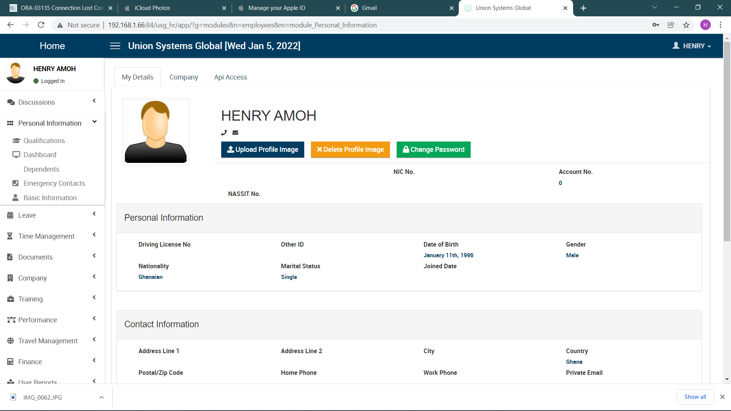

The profile module contains three tabs My details, Company, Api Access:

**My details** – This tab contains all information about the user.

**Company** – This tab contains information about the structure of the company

**Api Access** –?????????????????????????????????????????

* **THE LEAVE MODULE**

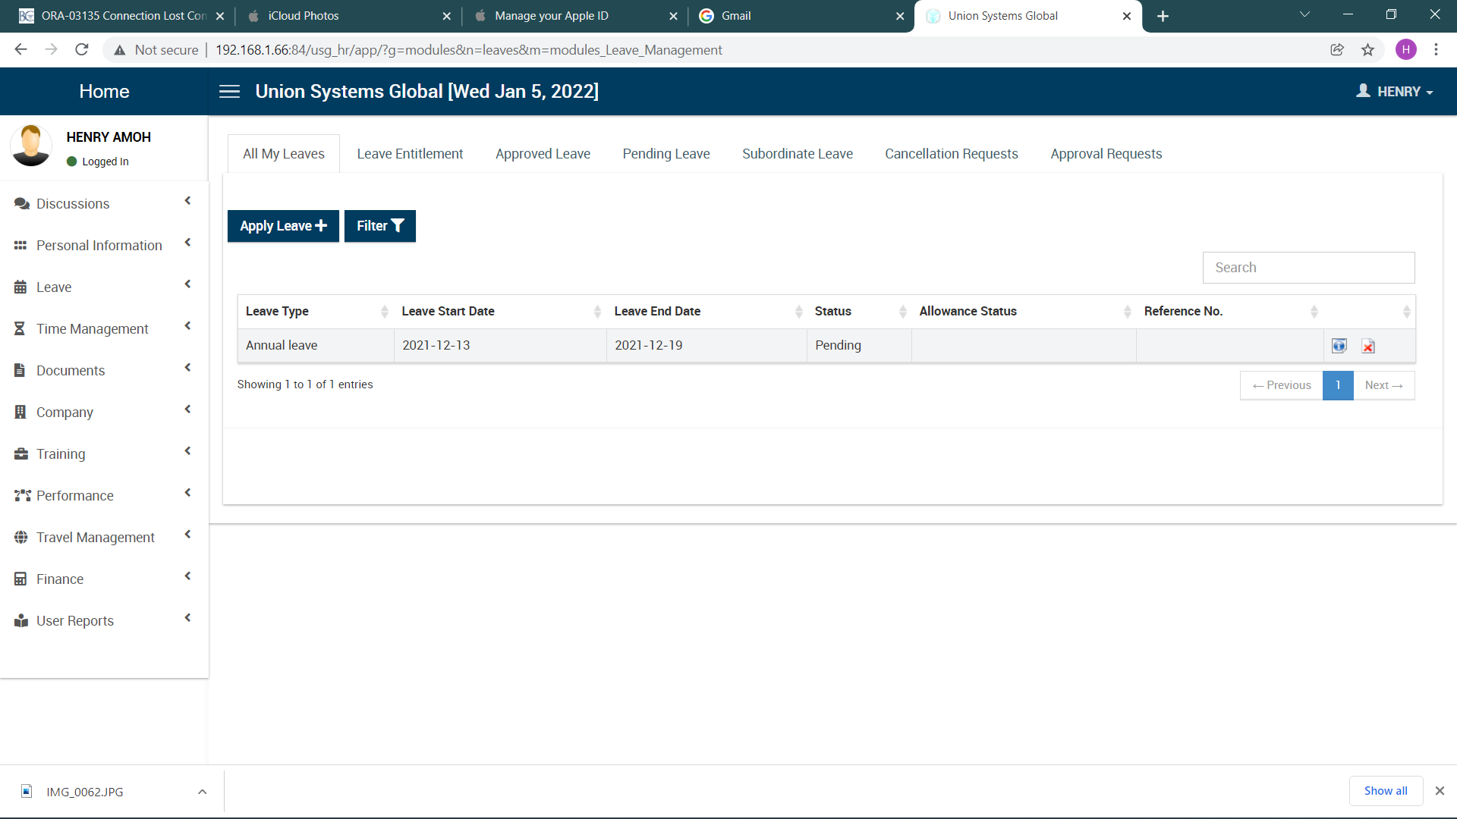

The leave module, allows the user to apply for leave, this module has seven tabs

**All My Leaves** – this tab allows users to apply for leave, it also has a grid to display all the leaves of a user, the user can cancel a leave that is pending from this tab

**Leave Entitlement** – this tab allows users to view the various types of leaves available to them and what each leave type entails

**Approved Leave** – this tab displays all approved leaves of the user

**Pending Leave** – this tab displays all pending leaves of the user

**Subordinate Leave** – A user can see all the leaves applied by their subordinate and approve or reject them

**Cancellation Request** –???????????????????????????????????

**Approval Request** –????????????????????????

* **PROJECT MODULE**

This module allows users to create projects, users can edit and delete projects created, the project module can also be located under the **TIME MANAGEMENT MODULE**

* **DOCUMENT MANAGEMENT MODULE**

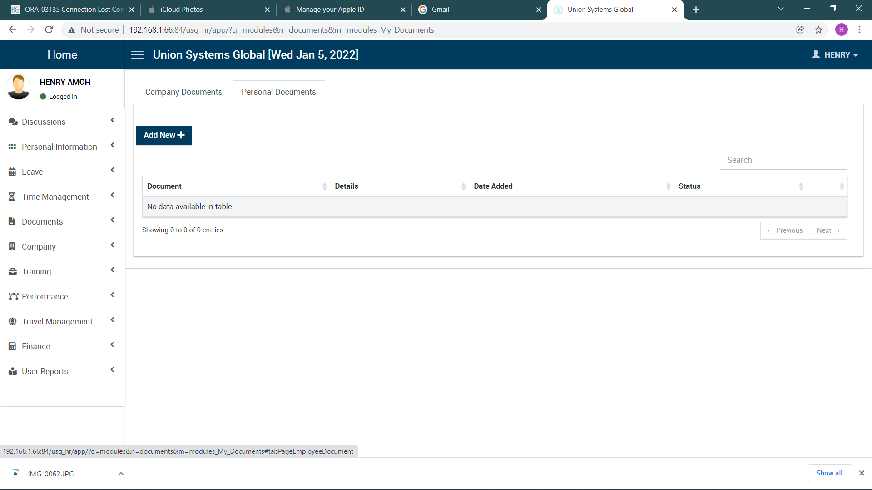The document management module contains two tabs, the company document tab and the personal document tab.

**The company document tab** – Allows users to view company documents that have been shared with them by the adminstrator

**The Personal Document Tab** – Allows users to add personal documents for storage, the system also notifies users when the document becomes invalid.

* **IMPREST MODULE**

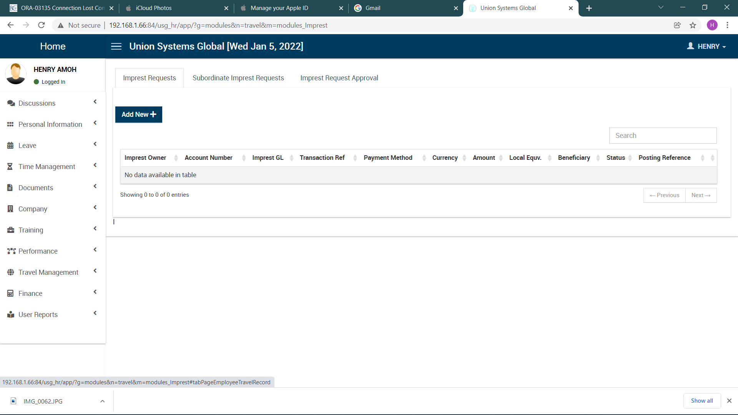The imprest module is made up three tabs, the imprest requests tab, subordinate imprest requests tab and the imprest request approval

**Imprest Requests** – the imprest request tab handles imprest requests from users, an imprest can be requested by clicking on the **ADD NEW BUTTON**, it has a table that displays all imprest that has been requested by the user, the imprest can be edited and deleted by the user

**Subordinate Imprest Request** – allow users to see all imprest that has been requested by the users’ subordinates

**Imprest Request Approval** –?????????????????????????????

* **EXPENSES**

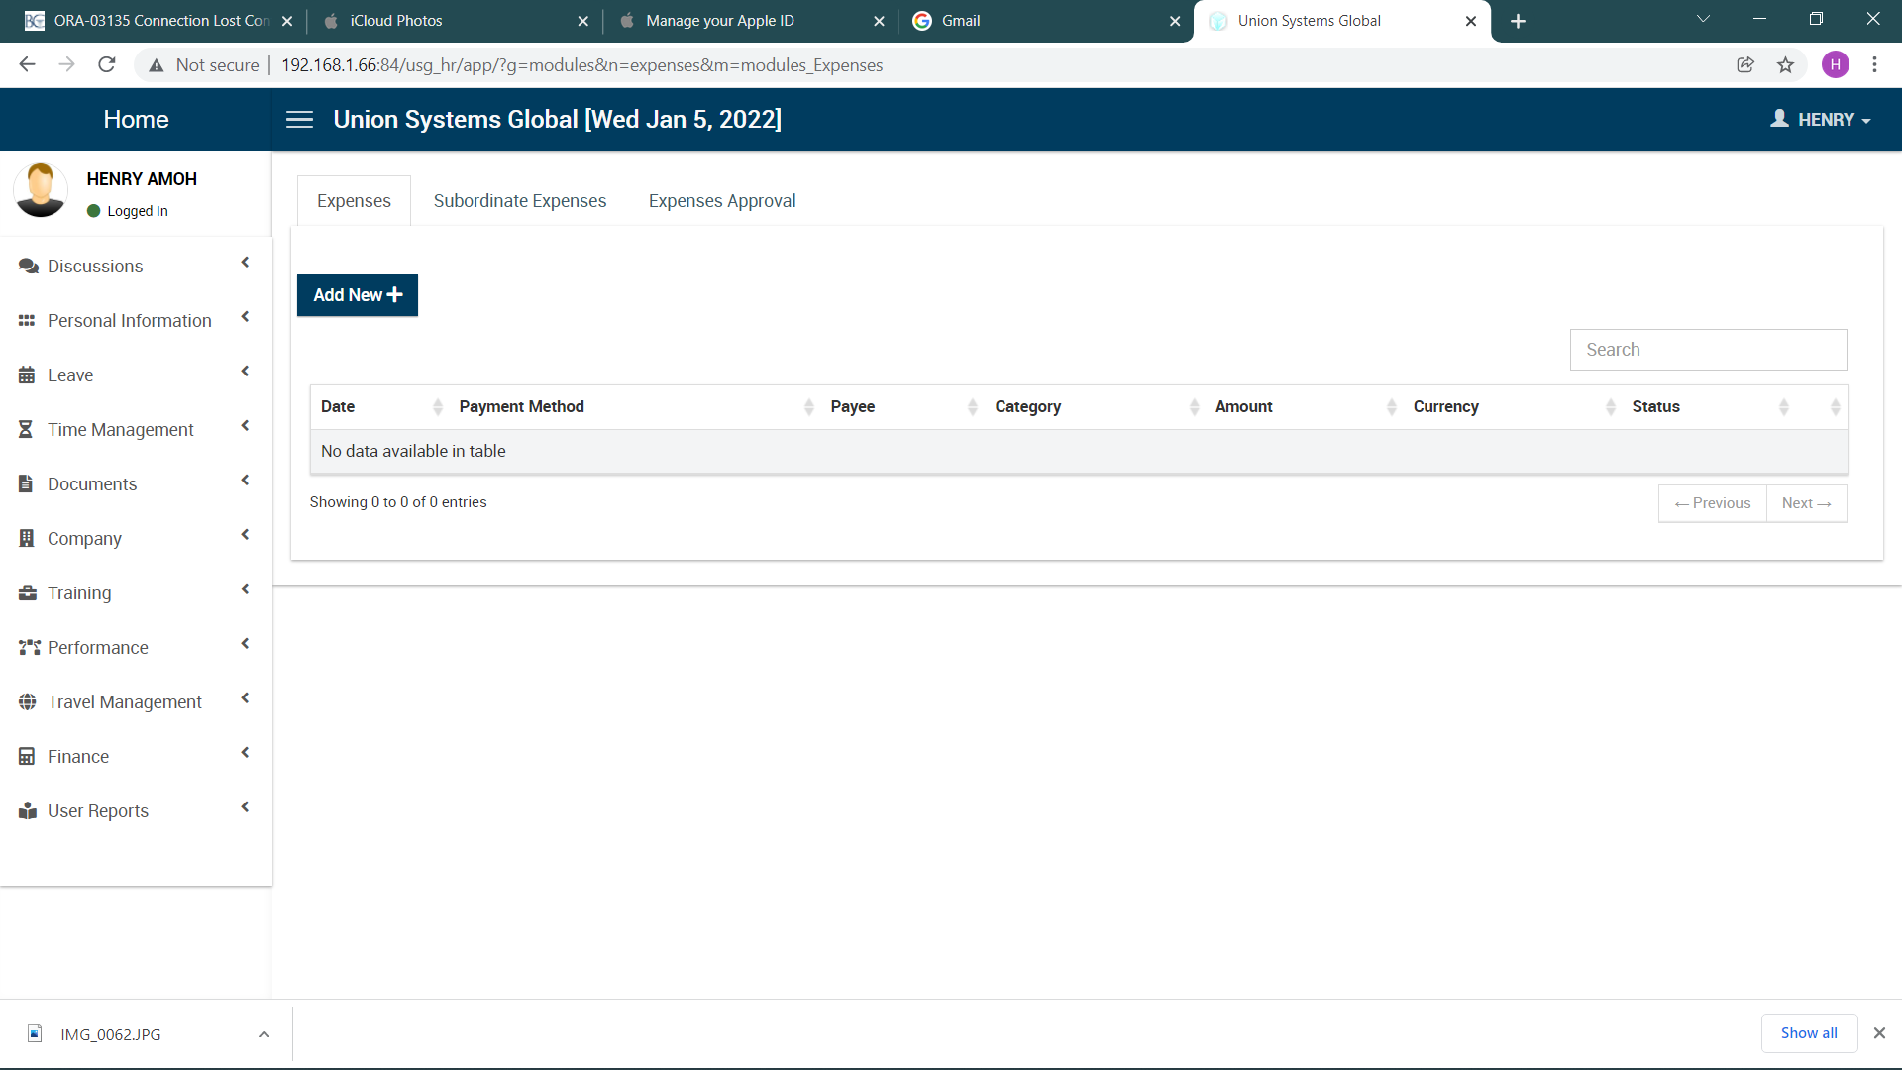The expense module is made up three tabs, the expenses tab, subordinate expenses tab and the expense approval tab

**Expense** – the expense tab is used by users to record expenses made, an expense can be requested by clicking on the **ADD NEW BUTTON**, it has a table that displays all expenses that has been made by the user

**Subordinate Expense** – allows users to see all expenses that have been made by the users’ subordinates

**Expense Approval** –?????????????????????????????

* **DISCUSSION**

The discussion model is made up of two sub models

* Announcement
* Conversation

The announcement model is where the user views all messages that are sent to employees.

The conversation model allows the user to chat with employees.

* **PERSONAL INFORMATION**

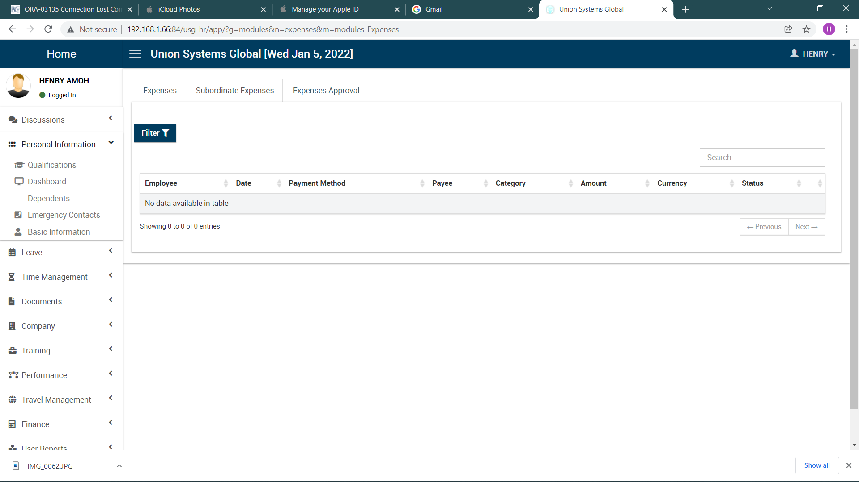

The personal information is a dropdown on the sidenav, with list of 5 items

1. Qualification (Allows the user to edit and add additional information regarding their skills, education, language and certifications
2. Dashboard (The dashboard sends the user to the main dashboard)
3. Dependents (Allows the user to edit, delete and add more information about dependents)
4. Emergency Contacts (Allows the user to edit, delete and add more emergency contacts)
5. Basic Information (Send the user to the profile module)

* **USER REPORTS**

This module is responsible for generating reports for the user

* **TIME MANAGEMENT**

The time management module has two sub modules; the overtime request and the project module.

1. The overtime request module

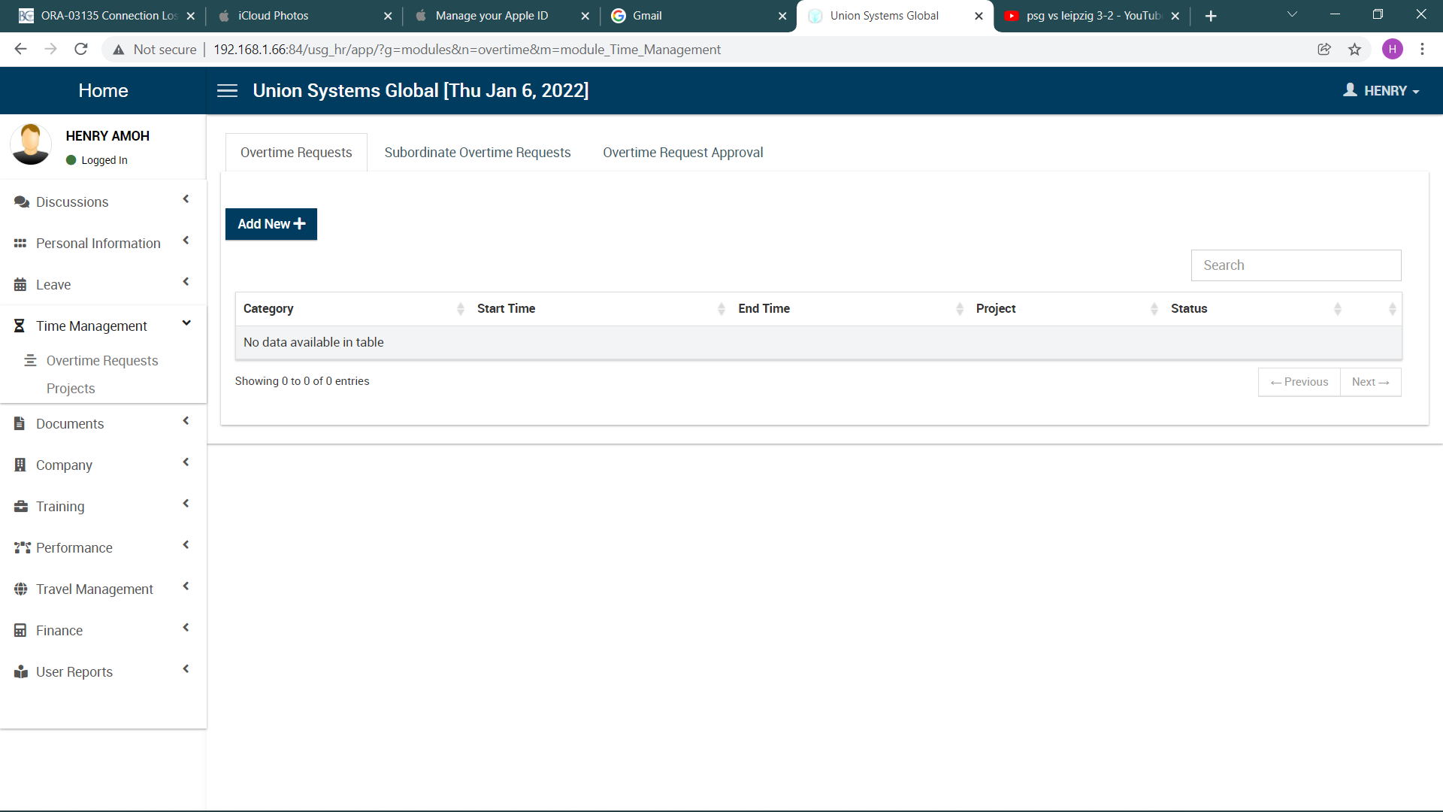The overtime request module has three sections

1. Overtime Request (Used for requesting more time on projects are being worked on).
2. Subordinate Overtime Request (Displays overtime request made by subordinates).
3. Overtime Request Approval -????

**Form for making overtime request**

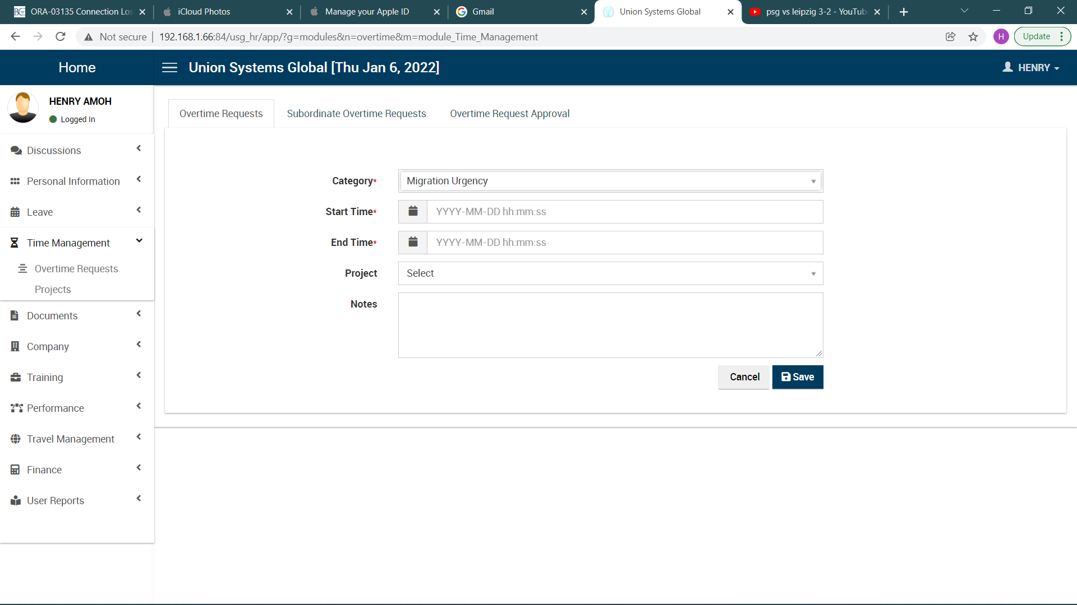

* **COMPANY**