
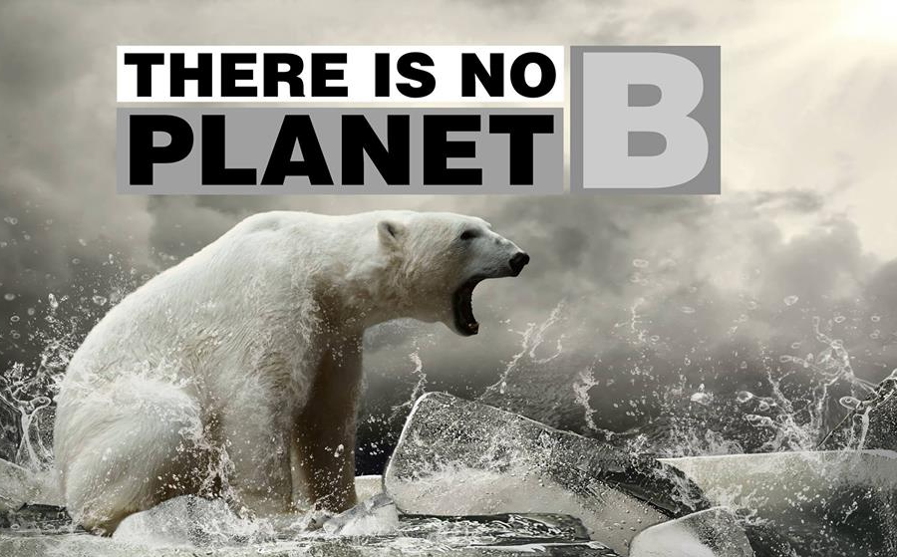

2013 SPONSORSHIP PACKAGE





…….….… page 7

Table of Contents

About QGIC …………………………. 1-2
Reach and Exposure ……………… 3
Sponsorship Levels………………... 4
Budget ………………………………. 5
Sponsorship Form ………………… 6
Become a Part of QGIC …….…..…. 7

Table of contents
About QGIC …………………………. page 1-2
Sponsorship Opportunities ……. page 3
Sponsorship Levels………………… page 4
Budget …………………………………. page 5
Sponsorship Form ………………… page 6
Become a Part of QGIC …….….

Table of contents
About QGIC …………………………. page 1-2
Sponsorship Opportunities ……. page 3
Sponsorship Levels………………… page 4
Budget …………………………………. page 5
Sponsorship Form ………………… page 6
Become a Part of QGIC …….….… page … page 7

About QGIC

What is the Queen’s Global Innovation Conference?

The Queen’s Global Innovation Conference, or QGIC, inspires delegates to care about the most pressing global issues of our time, to innovate solutions to these issues, and to integrate the solutions into their communities. QGIC aims to attract students with different backgrounds to provide a variety of perspectives for the problem solving process. We want to challenge delegates to ask questions about themselves and the systems they operate within. Delegates should leave the conference feeling empowered to make change and equipped with the necessary tools to accomplish their goals.

A New Approach

Solving the complex problems we are faced with will require a different approach than the one we’ve been using. QGIC operates on the following principles:

- Collaborative Innovation

“For every complex problem there is an answer that is clear, simple, and wrong” - H. L. Mencken

No one person holds the solution. Solutions will come from the experiences, insights and creativity of a group of individuals working together toward a common goal. Solutions will require coordination across industries, sectors, disciplines, and silos.

- Systems Thinking

“We can't impose our will on a system. We can listen to what the system tells us, and discover how its properties and our values can work together to bring forth something much better than could ever be produced by our will alone.” - Donella H. Meadows

The challenges we face are increasingly complex and interconnected. Complexity is the nature and condition of living systems and the world we live in. Systems thinking teaches us to work within a system’s constraints to achieve desired results and avoid unintended consequences. It emphasizes wholes rather than parts, and stresses the role of interconnections—including the role we play within the system.

Page 1
- Leadership

“Never doubt that a small group of thoughtful, concerned citizens can change world. Indeed it is the only thing that ever has” - Margaret Mead

Delegates should leave the conference feeling empowered to take action, and equipped with the necessary tools to accomplish their goals. We want to challenge delegates to ask questions about themselves and the systems they operate within, and to be leaders in their communities.

What’s in Store?

Queen’s Global Innovation Conference challenges delegates to learn about global issues and what it takes to make a difference. This year’s theme is “The Power to Change Systems”, focused on building social change leaders and systems thinkers. The conference’s goals will be accomplished through the following venues over the course of two days:

- Speakers: Speakers will cover topics including poverty, hunger and lack of drinking water, the increasing global population, and climate change

- Workshops: Delegates will choose between six workshops, focused on environmental issues and poverty. Run by clubs, Queen’s professors, and organizations from Kingston, these workshops will apply systems thinking to problem solving

- The Innovation Challenge: The most hands-on part of the conference will take the form of a Dragon’s Den-style Innovation Challenge. Delegates will work in inter-disciplinary teams to design a local solution to a global problem. A panel of experts will decide which group receives funding to put their plan into action.

Page 2

Reach and Exposure

Queen’s Global Innovation Conference aims to be the most interdisciplinary conference at Queen’s. We want to get as many perspectives into the room as possible, and will be welcoming delegates from programs such as Engineering, Commerce, Economics, Global Development Studies, Political Science, and more. Undergraduate and graduate students will constitute the majority of the delegate base.

Queen’s Global Innovation Conference provides a number of opportunities to establish your brand among students, build your reputation, and strengthen your partnership with the Queen’s Engineering Society. Depending on what your objectives are, we have created a comprehensive breakdown of reach and exposure that each event offers, so that you can determine your ideal fit.

Benefits to All Sponsors

- Description of organization’s activities in promotional material
- Company logo on conference banners and promotional material displayed before and during the event
- Opportunity to provide material for delegate packages
- Company name and logo featured on QGIC’s website with a link to the company website
- Company name displayed on delegate name tags

Page 3

Sponsorship Levels

Title Sponsor
- $5000+
- The title sponsor will have full sponsorship and naming rights of the closing Saturday Night Dinner and Presentation
- VIP conference registration allowing your representatives to interact and network with delegates
- Opportunity to present a video and presentation during the Saturday Night Dinner relating to your company’s efforts
- Full page advertisement in QGIC’s delegate manual
- Company will be displayed during all of the events and able to be present at each of the workshops
- Showcased as the Title Sponsor throughout the weekend and on all promotional material
- Limited to one Title Sponsor

Platinum Sponsor

- $3000 - $ 5000
- As the Platinum Sponsor, you will have full sponsorship and naming rights to a choice of one of our main events. (The Innovation Challenge, Friday Night Social, Workshops or Speaker Sessions)
- VIP conference registration
- Half page advertisement in QGIC delegate manual
- Company will be displayed during all of the events
- Showcased as Platinum Sponsor throughout the weekend and on promotional material

Gold Sponsor

- $1000 - $3000
- As a Gold Sponsor, you will have full sponsorship and naming rights to your choice of one of the workshops or speakers sessions
- Company will be displayed during all of the events
- Quarter page advertisement in the QGIC delegate manual

Silver Sponsor
- $250 - $1000
- Silver sponsors will receive the Benefits for All Sponsors listed on the previous page

Budget
Page 4

Budget

Projected Expenses

The following is the projected budget for QGIC 2013. In order to make attending the Queen’s Global Innovation Conference feasible for students, the conference team would like to help subsidize the delegate fee as much as possible. Funding from sponsorship would help cover transportation and accommodation costs for speakers, the booking costs associated with the venue, food and beverages for the delegates, marketing and advertising, technical equipment rentals, and speaker recognition.

Expenses
Item | Total Cost
Delegate Name Tags | $50
Delegate Packages | $120
Conference Venue Fees | $2000
Speaker Accommodation | $1000
Food/ Catering | $5000
Promotional Material | $100
Gifts to Speakers | $150
Prizes | $150
Total Expenses | $8570

Become a Sponsor

You can sponsor us by sending a cheque to the address on the next page, along with the sponsorship form that follows. If you so choose, you can make a contribution in kind rather than a monetary donation. This can include contributions in the form of gifts to thank speakers, prizes for delegates or other forms of product sponsorship.

Page 5

Sponsorship Form

Contact Information
Company/Firm Name
Contact |  |  | Title
Billing Address
Phone |  | Fax |  | Email
Cheque for: |  | Note for Sponsorship versus Donation:
○ Sponsorship ○ Donation |  | - Sponsorship allows rights for advertisement however does not allow a tax receipt
○ Sponsorship ○ Donation |  | - Donation allows for tax receipt but no advertising is possible

Financial Donation
Amount | Date

Acknowledgement Information
Please use the following company name in all acknowledgements:

Company Name:

Date:

Please make cheques payable to: Engineers Without Borders Queen's Chapter
Mailing address: The Engineering Society of Queen's University
Beamish-Munro Hall, Room 106
Kingston, ON
K7L 3N6

Page 6

Become a Part of QGIC

Please do not hesitate to contact us for more information, or to discuss any questions or concerns that you may have. We hope that we can work together to create positive change in our community and the world at large.

Andrea D’Amour Olga Khuskivadze
QGIC 2013 Sponsorship Director QGIC 2013 Chair
Queen’s University 2014 Queen’s University 2014
613 453 3345 613 770 3261
qgicfinance@gmail.com qgic.info@gmail.com

Page 7

