**Git Command**

**Basic Useful Commands** (Windows && Download Git Bash App already):

**Upload code to your github**

1. 本地创建git 仓库，找到需要上传项目的根目录，右键选择git bash执行命令 (Construct git repository locally 🡪 Find the file location 🡪execute git command)
2. 将项目添加到本地仓库里

(Add your project to local repository)

**git add .** 🡪 p.s. notice the space

1. 标记文件提交信息便于阅读，如何写好commit message?

(Commit added files, Keep commit message)

**git commit -m “//TODO…..”**

e.g. common used formals

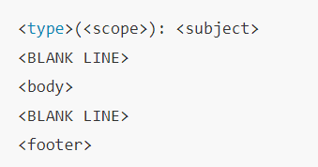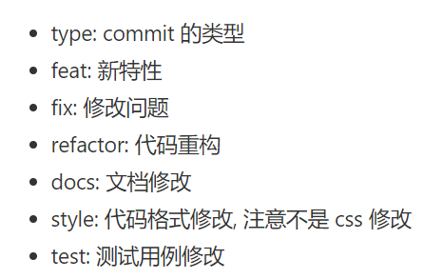

1. 假设github中repository已创建好，复制SSH地址

(Assume repository has been set up in github, then copy SSH address of this)

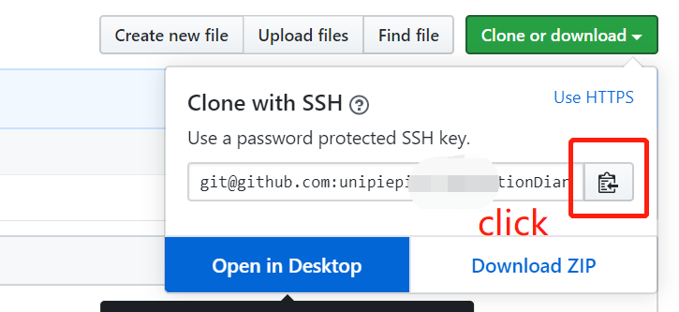

1. 关联本地仓库到github (Connect local repository to github)

**git remote add origin** [**git@github.com/xxxxxx**](mailto:git@github.com/xxxxxx) **( 🡨 copied address)**

1. 上传前先拉取远程仓库以免有冲突 (Pull content from github)

**git pull origin master**

1. 上传代码啦！(Submit your code :)

**git push -u origin master**