Earth2C
air
12 questions · easy 5 / medium 4 / difficult 3 · Set 3 from topic-01-planet-earth.pdf
Easy (a) · 5 questions
1. Earth2Ca · Air · Easy Notes p.3 Answer C
Which of the following has the LOWEST percentage by volume in dry air?
A. Nitrogen
B. Oxygen
C. Carbon dioxide ✓
D. Argon
2. Earth2Ca · Air · Easy Notes p.3 Answer A
Which statement about oxygen is NOT correct?
A. Oxygen is flammable. ✓
B. Oxygen supports burning.
C. Oxygen relights a glowing splint.
D. Oxygen is used for cutting and welding metals.
3. Earth2Ca · Air · Easy Notes p.3 Answer B
Patients with breathing difficulties may be given
A. argon.
B. oxygen. ✓
C. nitrogen.
D. helium only.
4. Earth2Ca · Air · Easy Notes p.3 Answer D
Hydrogen can be tested with a burning splint. A positive result is
A. the splint relights.
B. limewater turns milky.
C. a white precipitate forms.
D. a 'pop' sound. ✓
5. Earth2Ca · Air · Easy Notes p.3 Answer A
Which gas can be used as a refrigerant?
A. Nitrogen ✓
B. Oxygen
C. Argon
D. Neon
Medium (b) · 4 questions
6. Earth2Cb · Air · Medium Notes p.3 Answer B
Which combination correctly matches each gas with one of its uses?
 | Oxygen | Nitrogen | Argon
A. | Food packaging | Light bulbs | Medical use
B. ✓ | Cutting / welding | Making ammonia | Filling light bulbs
C. | Refrigerant | Burning of fuels | Food packaging
D. | Filling light bulbs | Medical use | Making ammonia
7. Earth2Cb · Air · Medium Notes p.3 Answer C
All of the following are uses of oxygen EXCEPT
A. burning of fuels.
B. cutting and welding metals.
C. filling light bulbs. ✓
D. helping patients with breathing difficulties.
8. Earth2Cb · Air · Medium Notes p.3 Answer A
Which sequence correctly describes Stage 1 (purification) of air before liquefaction?
A. Dust filtered; carbon dioxide and water vapour removed as solids ✓
B. Air expanded to -200 °C; then dust filtered
C. Liquid air warmed slowly in a fractionating column
D. Nitrogen gas removed at the top of the column
9. Earth2Cb · Air · Medium Notes p.3 Answer D
A student says: "Air contains 78% oxygen by volume." Why is this statement incorrect?
A. Air contains no oxygen.
B. Oxygen makes up about 0.9% of air.
C. Oxygen makes up about 0.03% of air.
D. Nitrogen, not oxygen, makes up about 78% of air by volume. ✓
Difficult (c) · 3 questions
10. Earth2Cc · Air · Difficult Notes p.3 Answer D
Which statements about the liquefaction of air are correct?
(1) Air is cooled and compressed.
(2) When allowed to expand, the air becomes very cold (about -200 °C).
(3) Liquid air is obtained.
A. (1) and (2) only
B. (1) and (3) only
C. (2) and (3) only
D. (1), (2) and (3) ✓
11. Earth2Cc · Air · Difficult Notes p.3 Answer B
Consider the fractionating column shown below:
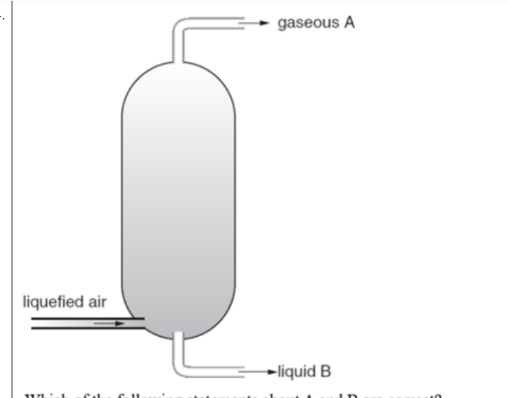
Gaseous A is collected at the top and liquid B at the bottom. Which identification is correct?
A. A is oxygen; B is nitrogen.
B. A is nitrogen; B is mainly oxygen (with argon). ✓
C. A is argon; B is carbon dioxide.
D. A is hydrogen; B is oxygen.
12. Earth2Cc · Air · Difficult Notes p.3 Answer A
Which statement about further separation after the fractionating column is correct?
A. The liquid mixture of oxygen and argon can be further separated by fractional distillation. ✓
B. Oxygen and argon cannot be separated because they have the same boiling point.
C. Only filtration can separate oxygen from argon.
D. Argon must be removed before liquefaction together with dust.

Earth2C Answer key
No. · difficulty · answer · notes location
No. | Diff | Answer | Source
1 | easy (a) | C | topic-01-planet-earth.pdf p.3 (CO2 0.03% lowest of listed)
2 | easy (a) | A | topic-01-planet-earth.pdf p.3 (O2 supports burning; NOT flammable)
3 | easy (a) | B | topic-01-planet-earth.pdf p.3 (medical use of oxygen)
4 | easy (a) | D | topic-01-planet-earth.pdf p.3 (test of hydrogen)
5 | easy (a) | A | topic-01-planet-earth.pdf p.3 (uses of nitrogen: refrigerant)
6 | medium (b) | B | topic-01-planet-earth.pdf p.3 (uses of O2, N2, Ar)
7 | medium (b) | C | topic-01-planet-earth.pdf p.3 (light bulbs = argon)
8 | medium (b) | A | topic-01-planet-earth.pdf p.3 (Stage 1 purification)
9 | medium (b) | D | topic-01-planet-earth.pdf p.3 (N2 78%, O2 21%)
10 | difficult (c) | D | topic-01-planet-earth.pdf p.3 (Stage 2 liquefaction)
11 | difficult (c) | B | topic-01-planet-earth.pdf p.3 (N2 gas top; liquid O2+Ar bottom)
12 | difficult (c) | A | topic-01-planet-earth.pdf p.3 (further fractional distillation of O2/Ar)

