Earth2C
air
12 questions · easy 5 / medium 4 / difficult 3 · Set 4 from topic-01-planet-earth.pdf
Easy (a) · 5 questions
1. Earth2Ca · Air · Easy Notes p.3 Answer B
A gas that supports burning but is itself NOT flammable, and that relights a glowing splint, is
A. nitrogen.
B. oxygen. ✓
C. argon.
D. hydrogen.
2. Earth2Ca · Air · Easy Notes p.3 Answer C
The boiling point of nitrogen is about
A. -183 °C
B. -186 °C
C. -196 °C ✓
D. -80 °C
3. Earth2Ca · Air · Easy Notes p.3 Answer A
Making ammonia (and fertilizer) is a listed use of
A. nitrogen. ✓
B. oxygen.
C. argon.
D. neon.
4. Earth2Ca · Air · Easy Notes p.3 Answer D
Other gases in air (about 0.1%) include
A. carbon dioxide.
B. nitrogen and oxygen.
C. water, radon, hydrogen and helium.
D. water vapour, helium, neon, krypton and xenon. ✓
5. Earth2Ca · Air · Easy Notes p.3 Answer B
The hazard warning type that should appear on a cylinder of oxygen is
A. flammable.
B. oxidizing. ✓
C. toxic.
D. corrosive.
Medium (b) · 4 questions
6. Earth2Cb · Air · Medium Notes p.3 Answer A
The test for hydrogen with a burning splint produces a pop sound. The notes state that this test involves a chemical change because
A. a new substance (water) is produced. ✓
B. only a physical change of state occurs.
C. hydrogen is an element.
D. no heat is released.
7. Earth2Cb · Air · Medium Notes p.3 Answer C
Arrange oxygen, nitrogen and argon in order of increasing boiling point (lowest first).
A. Oxygen, argon, nitrogen
B. Argon, oxygen, nitrogen
C. Nitrogen, argon, oxygen ✓
D. Nitrogen, oxygen, argon
8. Earth2Cb · Air · Medium Notes p.3 Answer B
A student sticks the hazard label shown below on an oxygen cylinder.
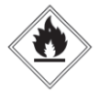
Why is the student incorrect?
A. Oxygen cylinders need no hazard label.
B. Oxygen is oxidizing, not flammable; the label shown is for flammable substances. ✓
C. The label shown is for oxidizing substances, which is wrong for oxygen.
D. Oxygen is toxic, so a toxic label is required instead.
9. Earth2Cb · Air · Medium Notes p.3 Answer D
Which of the following statements about air are correct?
(1) Air contains both elements and compounds.
(2) Argon is present in a higher percentage than carbon dioxide.
(3) Dust particles are filtered out before liquefaction.
A. (1) and (2) only
B. (1) and (3) only
C. (2) and (3) only
D. (1), (2) and (3) ✓
Difficult (c) · 3 questions
10. Earth2Cc · Air · Difficult Notes p.3 Answer A
In Stage 3, liquid air is warmed up very slowly in a fractionating column. Which observations / outcomes match the notes?
(1) Nitrogen gas leaves near the top (about -190 °C region).
(2) Liquid oxygen and liquid argon leave near the bottom (about -187 °C region).
(3) Carbon dioxide is collected as the main top product.
A. (1) and (2) only ✓
B. (1) and (3) only
C. (2) and (3) only
D. (1), (2) and (3)
11. Earth2Cc · Air · Difficult Notes p.3 Answer C
Which pair of boiling points is correctly matched?
Gas | Boiling point
Oxygen | -183 °C
Nitrogen | -196 °C
Argon | -186 °C
A. Only oxygen is correct.
B. Only nitrogen is correct.
C. All three are correct. ✓
D. Only argon is correct.
12. Earth2Cc · Air · Difficult Notes p.3 Answer A
Consider the fractionating column shown below:
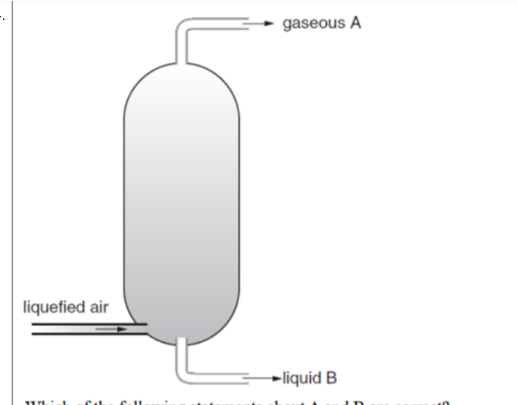
Which statements about gaseous A and liquid B are correct?
(1) A has a lower boiling point than the main component of B.
(2) A takes the greatest percentage of air by volume.
(3) B is pure nitrogen.
A. (1) and (2) only ✓
B. (1) and (3) only
C. (2) and (3) only
D. (1), (2) and (3)

Earth2C Answer key
No. · difficulty · answer · notes location
No. | Diff | Answer | Source
1 | easy (a) | B | topic-01-planet-earth.pdf p.3 (test / properties of oxygen)
2 | easy (a) | C | topic-01-planet-earth.pdf p.3 (N2 b.p. = -196 C)
3 | easy (a) | A | topic-01-planet-earth.pdf p.3 (uses of nitrogen)
4 | easy (a) | D | topic-01-planet-earth.pdf p.3 (other gases 0.1%)
5 | easy (a) | B | topic-01-planet-earth.pdf p.3 (oxidizing label; NOT flammable)
6 | medium (b) | A | topic-01-planet-earth.pdf p.3 (H2 test = chemical change; water)
7 | medium (b) | C | topic-01-planet-earth.pdf p.3 (b.p. N2 -196, Ar -186, O2 -183)
8 | medium (b) | B | topic-01-planet-earth.pdf p.3 (oxidizing NOT flammable)
9 | medium (b) | D | topic-01-planet-earth.pdf p.3 (composition; purification)
10 | difficult (c) | A | topic-01-planet-earth.pdf p.3 (Stage 3 products)
11 | difficult (c) | C | topic-01-planet-earth.pdf p.3 (boiling points of O2, N2, Ar)
12 | difficult (c) | A | topic-01-planet-earth.pdf p.3 (A=N2; B=liquid O2+Ar not pure N2)

