Earth2C
air
12 questions · easy 5 / medium 4 / difficult 3 · Set 5 from topic-01-planet-earth.pdf
Easy (a) · 5 questions
1. Earth2Ca · Air · Easy Notes p.3 Answer B
Complete the sentence: The most abundant gas in air is ______.
A. oxygen
B. nitrogen ✓
C. argon
D. carbon dioxide
2. Earth2Ca · Air · Easy Notes p.3 Answer A
Approximate percentage by volume of argon in air is
A. 0.9% ✓
B. 21%
C. 78%
D. 0.03%
3. Earth2Ca · Air · Easy Notes p.3 Answer C
Cutting and welding of metals is a use of
A. argon.
B. nitrogen.
C. oxygen. ✓
D. neon.
4. Earth2Ca · Air · Easy Notes p.3 Answer D
Which gas relights a glowing splint?
A. Nitrogen
B. Argon
C. Hydrogen
D. Oxygen ✓
5. Earth2Ca · Air · Easy Notes p.3 Answer A
Air can be separated into its components by fractional distillation of liquid air because the components have different
A. boiling points. ✓
B. colours.
C. densities only, with identical boiling points.
D. magnetic properties.
Medium (b) · 4 questions
6. Earth2Cb · Air · Medium Notes p.3 Answer C
Which property / use row is correctly matched?
 | Gas | Boiling point | Use
A. | Oxygen | -183 °C | Filling light bulbs
B. | Nitrogen | -183 °C | Food packaging
C. ✓ | Argon | -186 °C | Filling light bulbs
D. | Oxygen | -186 °C | Medical use
7. Earth2Cb · Air · Medium Notes p.3 Answer B
All of the following gases are listed as components of air EXCEPT
A. neon.
B. radon. ✓
C. krypton.
D. xenon.
8. Earth2Cb · Air · Medium Notes p.3 Answer A
A laboratory technician has three unlabelled gas jars thought to contain oxygen, nitrogen and hydrogen. Which test result identifies oxygen?
A. A glowing splint relights. ✓
B. A burning splint gives a 'pop' sound.
C. The gas turns limewater milky.
D. The gas burns with a lilac flame.
9. Earth2Cb · Air · Medium Notes p.3 Answer A
Which statements about nitrogen are correct?
(1) It has a lower boiling point than oxygen.
(2) It is used in food packaging.
(3) It makes up about 21% of air by volume.
A. (1) and (2) only ✓
B. (1) and (3) only
C. (2) and (3) only
D. (1), (2) and (3)
Difficult (c) · 3 questions
10. Earth2Cc · Air · Difficult Notes p.3 Answer B
Consider the industrial process shown by the fractionating column below:
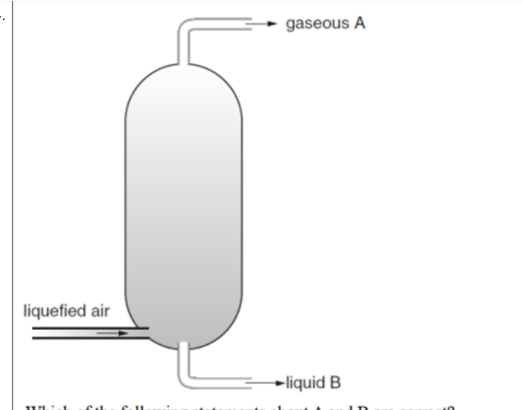
Which description of the overall process is best?
A. Filtration of dust from air using filter paper only
B. Fractional distillation of liquefied air to separate gases with different boiling points ✓
C. Electrolysis of liquid air
D. Crystallization of oxygen from air
11. Earth2Cc · Air · Difficult Notes p.3 Answer C
Which combination of purification conditions is correct according to the notes?
A. CO2 and water vapour removed as gases at -200 °C
B. Dust removed by fractional distillation at -80 °C
C. Dust filtered; CO2 and water vapour removed as solids at about -80 °C ✓
D. Argon removed as a solid before any cooling
12. Earth2Cc · Air · Difficult Notes p.3 Answer A
Which of the following statements is / are correct?
(1) Oxygen supports burning but is not flammable.
(2) An oxygen cylinder should carry an oxidizing hazard warning.
(3) A flammable (flame) hazard label is the correct label for oxygen.
A. (1) and (2) only ✓
B. (1) and (3) only
C. (2) and (3) only
D. (1), (2) and (3)

Earth2C Answer key
No. · difficulty · answer · notes location
No. | Diff | Answer | Source
1 | easy (a) | B | topic-01-planet-earth.pdf p.3 (N2 78%)
2 | easy (a) | A | topic-01-planet-earth.pdf p.3 (Ar 0.9%)
3 | easy (a) | C | topic-01-planet-earth.pdf p.3 (uses of oxygen)
4 | easy (a) | D | topic-01-planet-earth.pdf p.3 (O2 relights glowing splint; N2 does not)
5 | easy (a) | A | topic-01-planet-earth.pdf p.3 (different boiling points)
6 | medium (b) | C | topic-01-planet-earth.pdf p.3 (Ar b.p. -186; filling light bulbs)
7 | medium (b) | B | topic-01-planet-earth.pdf p.3 (other gases: He, Ne, Kr, Xe, water vapour)
8 | medium (b) | A | topic-01-planet-earth.pdf p.3 (test of oxygen)
9 | medium (b) | A | topic-01-planet-earth.pdf p.3 (N2 b.p.; uses; 78% not 21%)
10 | difficult (c) | B | topic-01-planet-earth.pdf p.3 (fractional distillation of liquid air)
11 | difficult (c) | C | topic-01-planet-earth.pdf p.3 (Stage 1 purification at -80 C)
12 | difficult (c) | A | topic-01-planet-earth.pdf p.3 (oxidizing NOT flammable)

