Earth1A
laboratory apparatus
14 questions · easy 7 / medium 3 / difficult 4 · Set 5 from laboratory-safety.pdf
Easy (a) · 7 questions
1. Earth1Aa · Laboratory apparatus · Easy Notes p.1 Answer D
Which of the following apparatus is used to clamp a flask to a retort stand?
A. Wire gauze
B. Pipe-clay triangle
C. Test tube brush
D. Clamp (utility clamp) ✓
2. Earth1Aa · Laboratory apparatus · Easy Notes p.1 Answer B
Consider the glassware shown below:
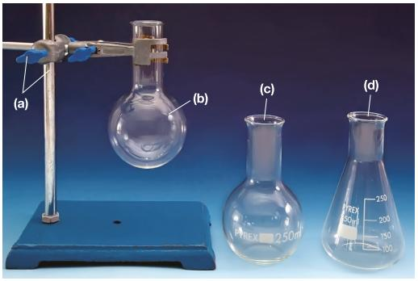
Which flask has a conical body and is commonly used in titrations?
A. Round-bottom flask
B. Conical (Erlenmeyer) flask ✓
C. Gas jar
D. Boiling tube
3. Earth1Aa · Laboratory apparatus · Easy Notes p.2 Answer C
Consider the heating apparatus shown below:
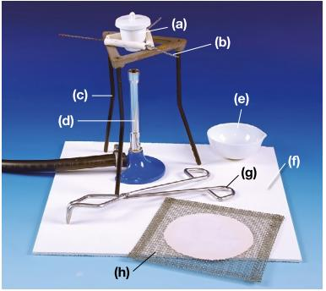
Which apparatus is designed for evaporating a solution to dryness?
A. Gas jar
B. Test tube rack
C. Evaporating dish ✓
D. Measuring cylinder
4. Earth1Aa · Laboratory apparatus · Easy Notes p.2 Answer A
Which of the following correctly matches the apparatus with its use?
A. Crucible - heating a solid strongly ✓
B. Crucible - measuring liquid volume roughly
C. Crucible - collecting a dense gas
D. Crucible - grinding solids into powder
5. Earth1Aa · Laboratory apparatus · Easy Notes p.4 Answer B
Consider the Bunsen burner shown below:
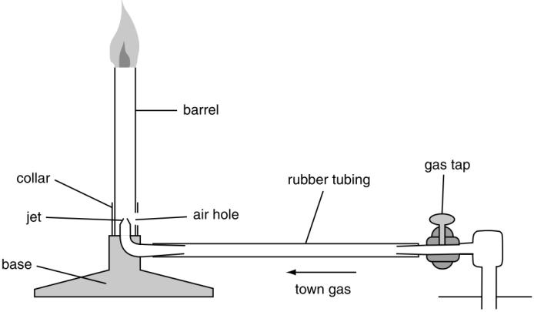
Which part connects the Bunsen burner to the gas tap?
A. Collar
B. Rubber tubing ✓
C. Air hole
D. Jet
6. Earth1Aa · Laboratory apparatus · Easy Notes p.4 Answer C
Which of the following is controlled by turning the gas tap?
A. The size of the air hole only
B. The temperature reading on a balance
C. The supply of town gas to the Bunsen burner ✓
D. The volume of liquid in a measuring cylinder
7. Earth1Aa · Laboratory apparatus · Easy Notes p.2 Answer D
Which of the following apparatus should be used to pick up a hot evaporating dish?
A. Spatula
B. Dropper
C. Glass rod
D. Tongs ✓
Medium (b) · 3 questions
8. Earth1Ab · Laboratory apparatus · Medium Notes p.5 Answer A
Hydrogen is less dense than air. Which collection method is suitable?
A. Upward delivery of air (downward displacement of air) ✓
B. Downward delivery of air only
C. Collecting the gas in an open evaporating dish
D. Heating the gas jar until it is red hot
9. Earth1Ab · Laboratory apparatus · Medium Notes p.5 Answer C
Which of the following set-ups can be used to dry a moist gas?
(1)
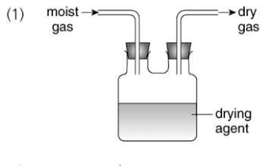
(2)
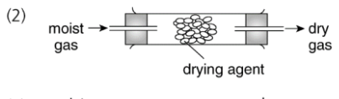
(3)
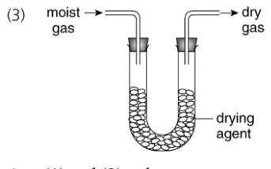
A. (1) only
B. (1) and (2) only
C. (2) and (3) only ✓
D. (1), (2) and (3)
10. Earth1Ab · Laboratory apparatus · Medium Notes p.2 Answer B
Why is a wire gauze often placed between a beaker and a Bunsen flame?
A. To increase the solubility of the liquid
B. To spread the heat more evenly and protect the beaker ✓
C. To measure the mass of the beaker
D. To collect the vapour as a gas jar sample
Difficult (c) · 4 questions
11. Earth1Ac · Laboratory apparatus · Difficult Notes p.4 Answer C
Which sequence is correct for lighting a Bunsen burner safely and then getting a non-luminous flame?
(1) Fully open the air hole.
(2) Put a burning match above the chimney.
(3) Close the air hole.
(4) Turn on the gas tap.
A. (1) → (4) → (2) → (3)
B. (4) → (2) → (1) → (3)
C. (3) → (2) → (4) → (1) ✓
D. (2) → (4) → (3) → (1)
12. Earth1Ac · Laboratory apparatus · Difficult Notes p.4 Answer A
Which of the following describes a luminous flame?
 | Air hole | Flame
A. ✓ | closed | yellow and sooty
B. | fully open | yellow and sooty
C. | closed | blue and roaring
D. | fully open | invisible with no heat
13. Earth1Ac · Laboratory apparatus · Difficult Notes p.4 Answer D
If striking back occurs, which action is incorrect?
A. Turn off the gas tap immediately
B. Allow the barrel to cool before relighting
C. Relight later with the air hole closed first
D. Keep the gas on and fully open the air hole further ✓
14. Earth1Ac · Laboratory apparatus · Difficult Notes p.5 Answer B
The diagram shows collection of a gas over water.
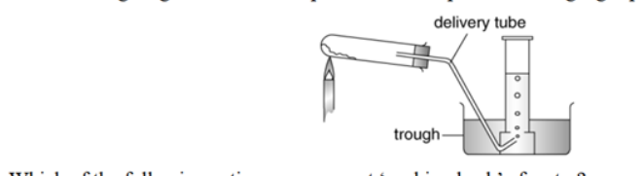
Sucking back is caused mainly by which process after the flame is removed too early?
A. Expansion of hot gas pushing water out of the trough
B. Contraction of cooling gas drawing water back up the delivery tube ✓
C. Evaporation of water in the trough into the gas jar
D. Increase in atmospheric pressure opening the gas tap
Earth1A Answer key
New number → difficulty → answer → notes location
No. | Diff | Answer | Source
1 | easy (a) | D | laboratory-safety.pdf p.1 (flasks / stand)
2 | easy (a) | B | laboratory-safety.pdf p.1 (flasks / glassware)
3 | easy (a) | C | laboratory-safety.pdf p.2 (heating apparatus)
4 | easy (a) | A | laboratory-safety.pdf p.2 (heating apparatus)
5 | easy (a) | B | laboratory-safety.pdf p.4 (Bunsen burner)
6 | easy (a) | C | laboratory-safety.pdf p.4 (Bunsen burner)
7 | easy (a) | D | laboratory-safety.pdf p.2 (heating apparatus)
8 | medium (b) | A | laboratory-safety.pdf p.5 (gas collection)
9 | medium (b) | C | laboratory-safety.pdf p.5 (drying gases)
10 | medium (b) | B | laboratory-safety.pdf p.2 (heating apparatus)
11 | difficult (c) | C | laboratory-safety.pdf p.4 (Bunsen burner)
12 | difficult (c) | A | laboratory-safety.pdf p.4 (Bunsen burner)
13 | difficult (c) | D | laboratory-safety.pdf p.4 (Bunsen burner)
14 | difficult (c) | B | laboratory-safety.pdf p.5 (gas collection)

