Topic 01 Part 4 set 2
1. Metals can be extracted from their ores by different methods. Some examples are shown below:
A. Extraction of gold
Gold can be extracted by mechanical separation such as panning.
B. Extraction of silver
Silver can be extracted by heating silver oxide alone.
C. Extraction of lead
Lead can be extracted by heating lead(II) oxide with carbon.
D. Extraction of sodium
Sodium can be extracted by electrolysis of molten sodium ore.
(a) Consider the extraction of gold. Explain why panning of gold is classified as a physical change.
(1 mark)
______________________________________________________________________
______________________________________________________________________

(b) Consider the extraction of silver.
(i) Write a word equation for the chemical reaction involved in extracting silver from silver oxide.
(1 mark)
______________________________________________________________________
______________________________________________________________________

(ii) Explain why the method in (b)(i) is a chemical change.
(1 mark)
______________________________________________________________________
______________________________________________________________________

(iii) Suggest another metal that can be extracted by heating its ore alone.
(1 mark)
______________________________________________________________________

(c) Consider the extraction of lead.
(i) Write a word equation for the chemical reaction involved in extracting lead from lead(II) oxide.
(1 mark)
______________________________________________________________________
______________________________________________________________________

(ii) Suggest TWO other metals that can be extracted by heating their ores with carbon.
(1 mark)
______________________________________________________________________

(d) Consider the extraction of sodium.
(i) Suggest ONE other metal that can be extracted by electrolysis of its molten ore.
(1 mark)
______________________________________________________________________

(ii) Ore X is the ore of aluminium which mainly contains aluminium oxide. What is the name of ore X?
(1 mark)
______________________________________________________________________

2. The Earth’s crust is made up of rocks and soils.
(a) Consider the extraction of gold from its ore:
(i) Suggest a common extraction method which can extract gold from its ore.
(1 mark)
______________________________________________________________________

(ii) Explain why the method involved in (a)(i) is a physical change.
(1 mark)
______________________________________________________________________
______________________________________________________________________

(b) Consider the extraction of mercury from mercury(II) oxide.
(i) Suggest a common extraction method which can extract mercury from mercury(II) oxide.
(1 mark)
______________________________________________________________________

(ii) With the aid of a word equation, explain why the method involved in (b)(i) is a chemical change.
(2 marks)
______________________________________________________________________
______________________________________________________________________
______________________________________________________________________

(c) Heating zinc oxide alone does not produce zinc. State another additional chemical required in extracting zinc from zinc oxide.
(1 mark)
______________________________________________________________________

(d) Consider the extraction of aluminium from bauxite:
(i) Suggest a common extraction method which can extract aluminium from aluminium oxide.
(1 mark)
______________________________________________________________________

(ii) With the aid of an equation, explain why the method involved in (d)(i) is a chemical change.
(2 marks)
______________________________________________________________________
______________________________________________________________________
______________________________________________________________________

3. Consider the following experimental set-up:
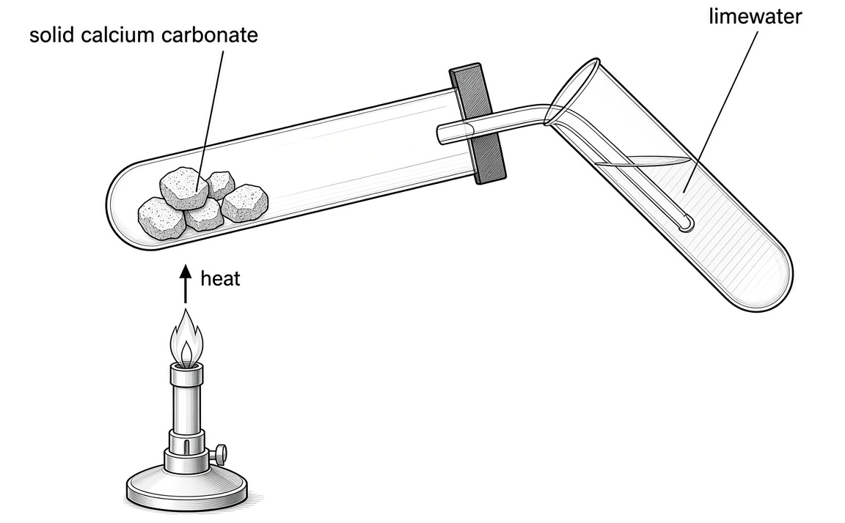
In this experiment, the calcium carbonate is heated strongly until there is no further observable change in the limewater.
(a) Name THREE rocks that mainly contain calcium carbonate.
(1 mark)
______________________________________________________________________

(b) For the reaction(s) in calcium carbonate, write the word equation(s) for the chemical reactions involved and state the expected observable change.
(2 marks)
______________________________________________________________________
______________________________________________________________________
______________________________________________________________________

(c) For the reaction(s) in limewater, write the word equation(s) for the chemical reactions involved and state the expected observable change, if any.
(3 marks)
______________________________________________________________________
______________________________________________________________________
______________________________________________________________________
______________________________________________________________________
4. Limestone is an important resource that can be obtained from the Earth’s crust.
(a) What is the major compound present in limestone?
(1 mark)
______________________________________________________________________

(b) Limestone decomposes upon strong heating to give a colourless gas. Draw a labelled diagram to show the set-up used for testing the gas.
(2 marks)

(c) State the expected observation for the test in (b).
(1 mark)
______________________________________________________________________
______________________________________________________________________

(d) Give ONE daily application of limestone.
(1 mark)
______________________________________________________________________

5. A student used the set-up shown in the diagram below to heat some marble chips and test the gas produced.
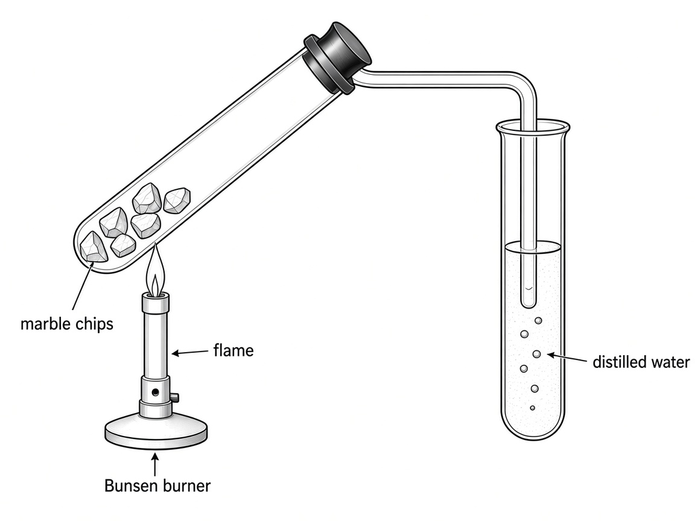
(a) Marble is an ore of calcium. What is the meaning of the term ‘ore’?
(1 mark)
______________________________________________________________________
______________________________________________________________________

(b) State the major chemical constituent of marble.
(1 mark)
______________________________________________________________________

(c) Write a word equation for the chemical change that occurs when marble chips are heated.
(1 mark)
______________________________________________________________________
______________________________________________________________________

(d) What would be observed when the gas formed in the reaction was bubbled into the distilled water?
(1 mark)
______________________________________________________________________

(e) Is the process in (d) a physical change or a chemical change? Explain your answer.
(1 mark)
______________________________________________________________________
______________________________________________________________________

(f) At the end of the experiment, the student turned off the Bunsen burner before taking away the delivery tube from the distilled water. Explain why this is an improper practice.
(2 marks)
______________________________________________________________________
______________________________________________________________________
______________________________________________________________________

6. (a) Write a word equation and state the expected observation (or any heat change) in each of the following reaction.
(i) Calcium carbonate is heated strongly.
(2 marks)
______________________________________________________________________
______________________________________________________________________
______________________________________________________________________

(ii) Water is added to calcium oxide.
(2 marks)
______________________________________________________________________
______________________________________________________________________
______________________________________________________________________

(b) In an experiment, excess dilute hydrochloric acid was added to a test tube with a small piece of chalk in it.
(i) State the major compound present in chalk.
(1 mark)
______________________________________________________________________

(ii) State TWO expected observations in this experiment.
(2 marks)
______________________________________________________________________
______________________________________________________________________

(iii) Was the change involved a physical or chemical change? Explain your answer.
(1 mark)
______________________________________________________________________
______________________________________________________________________

7. Refer to the following diagram showing an experiment.
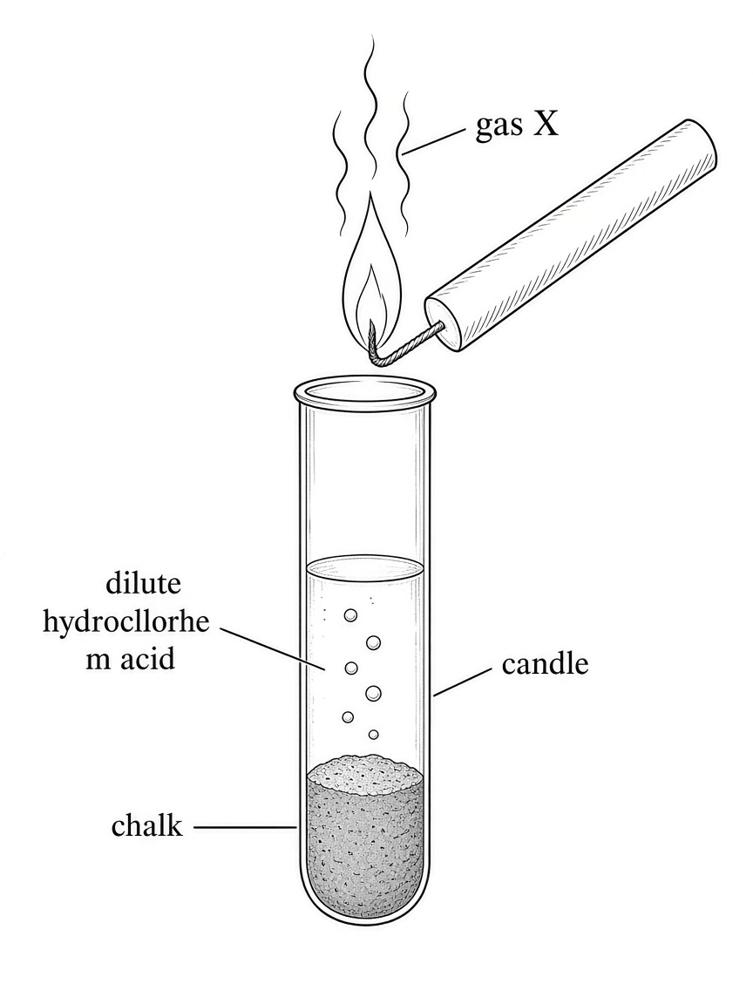
(a) State TWO observable changes in the test tube.
(2 marks)
______________________________________________________________________
______________________________________________________________________

(b) Write a word equation for the reaction occurring in the test tube.
(1 mark)
______________________________________________________________________
______________________________________________________________________

(c) What is gas X?
(1 mark)
______________________________________________________________________

(d) Suggest what will happen to the candle.
(1 mark)
______________________________________________________________________

(e) Based on the suggestion in (d), state ONE application of X in daily life.
(1 mark)
______________________________________________________________________

8. The diagram below shows an experimental set-up of testing the presence of carbonate in a solid sample containing pure calcium carbonate.
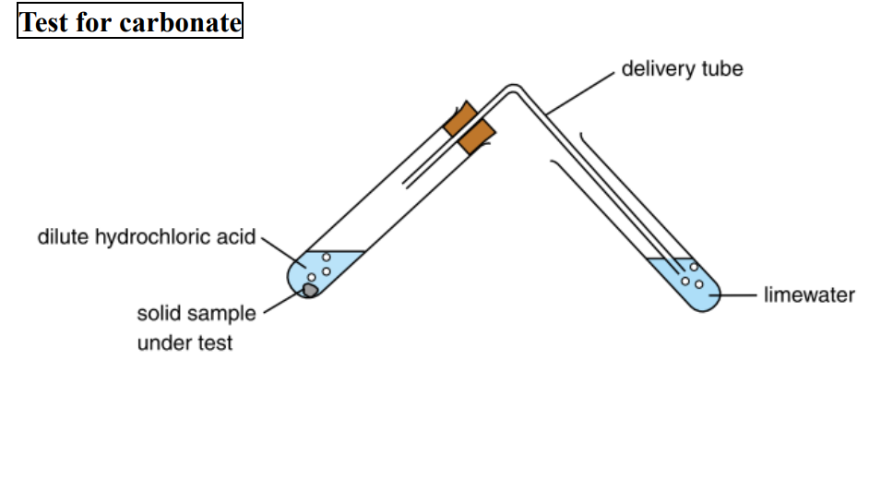
(a) Name THREE common rocks which contain calcium carbonate.
(1 mark)
______________________________________________________________________

(b) Consider the reaction between the solid sample and dilute hydrochloric acid. Write a chemical equation for the reaction involved.
(1 mark)
______________________________________________________________________
______________________________________________________________________

(c) Consider the reaction between limewater and the gas evolved. Write TWO chemical equations for the reaction involved and state the expected observations.
(3 marks)
______________________________________________________________________
______________________________________________________________________
______________________________________________________________________
______________________________________________________________________

(d) Flame test can be carried out to show the presence of calcium in the solid sample.
(i) Briefly describe the steps involved in carrying out flame test.
(2 marks)
______________________________________________________________________
______________________________________________________________________
______________________________________________________________________

(ii) State the expected observation of the test.
(1 mark)
______________________________________________________________________

(e) You are provided with common laboratory apparatus, calcium carbonate and distilled water. Outline the main procedures involved in preparing limewater and give the chemical equations for reactions involved.
(5 marks)
______________________________________________________________________
______________________________________________________________________
______________________________________________________________________
______________________________________________________________________
______________________________________________________________________
______________________________________________________________________

9. Study the flow chart below:
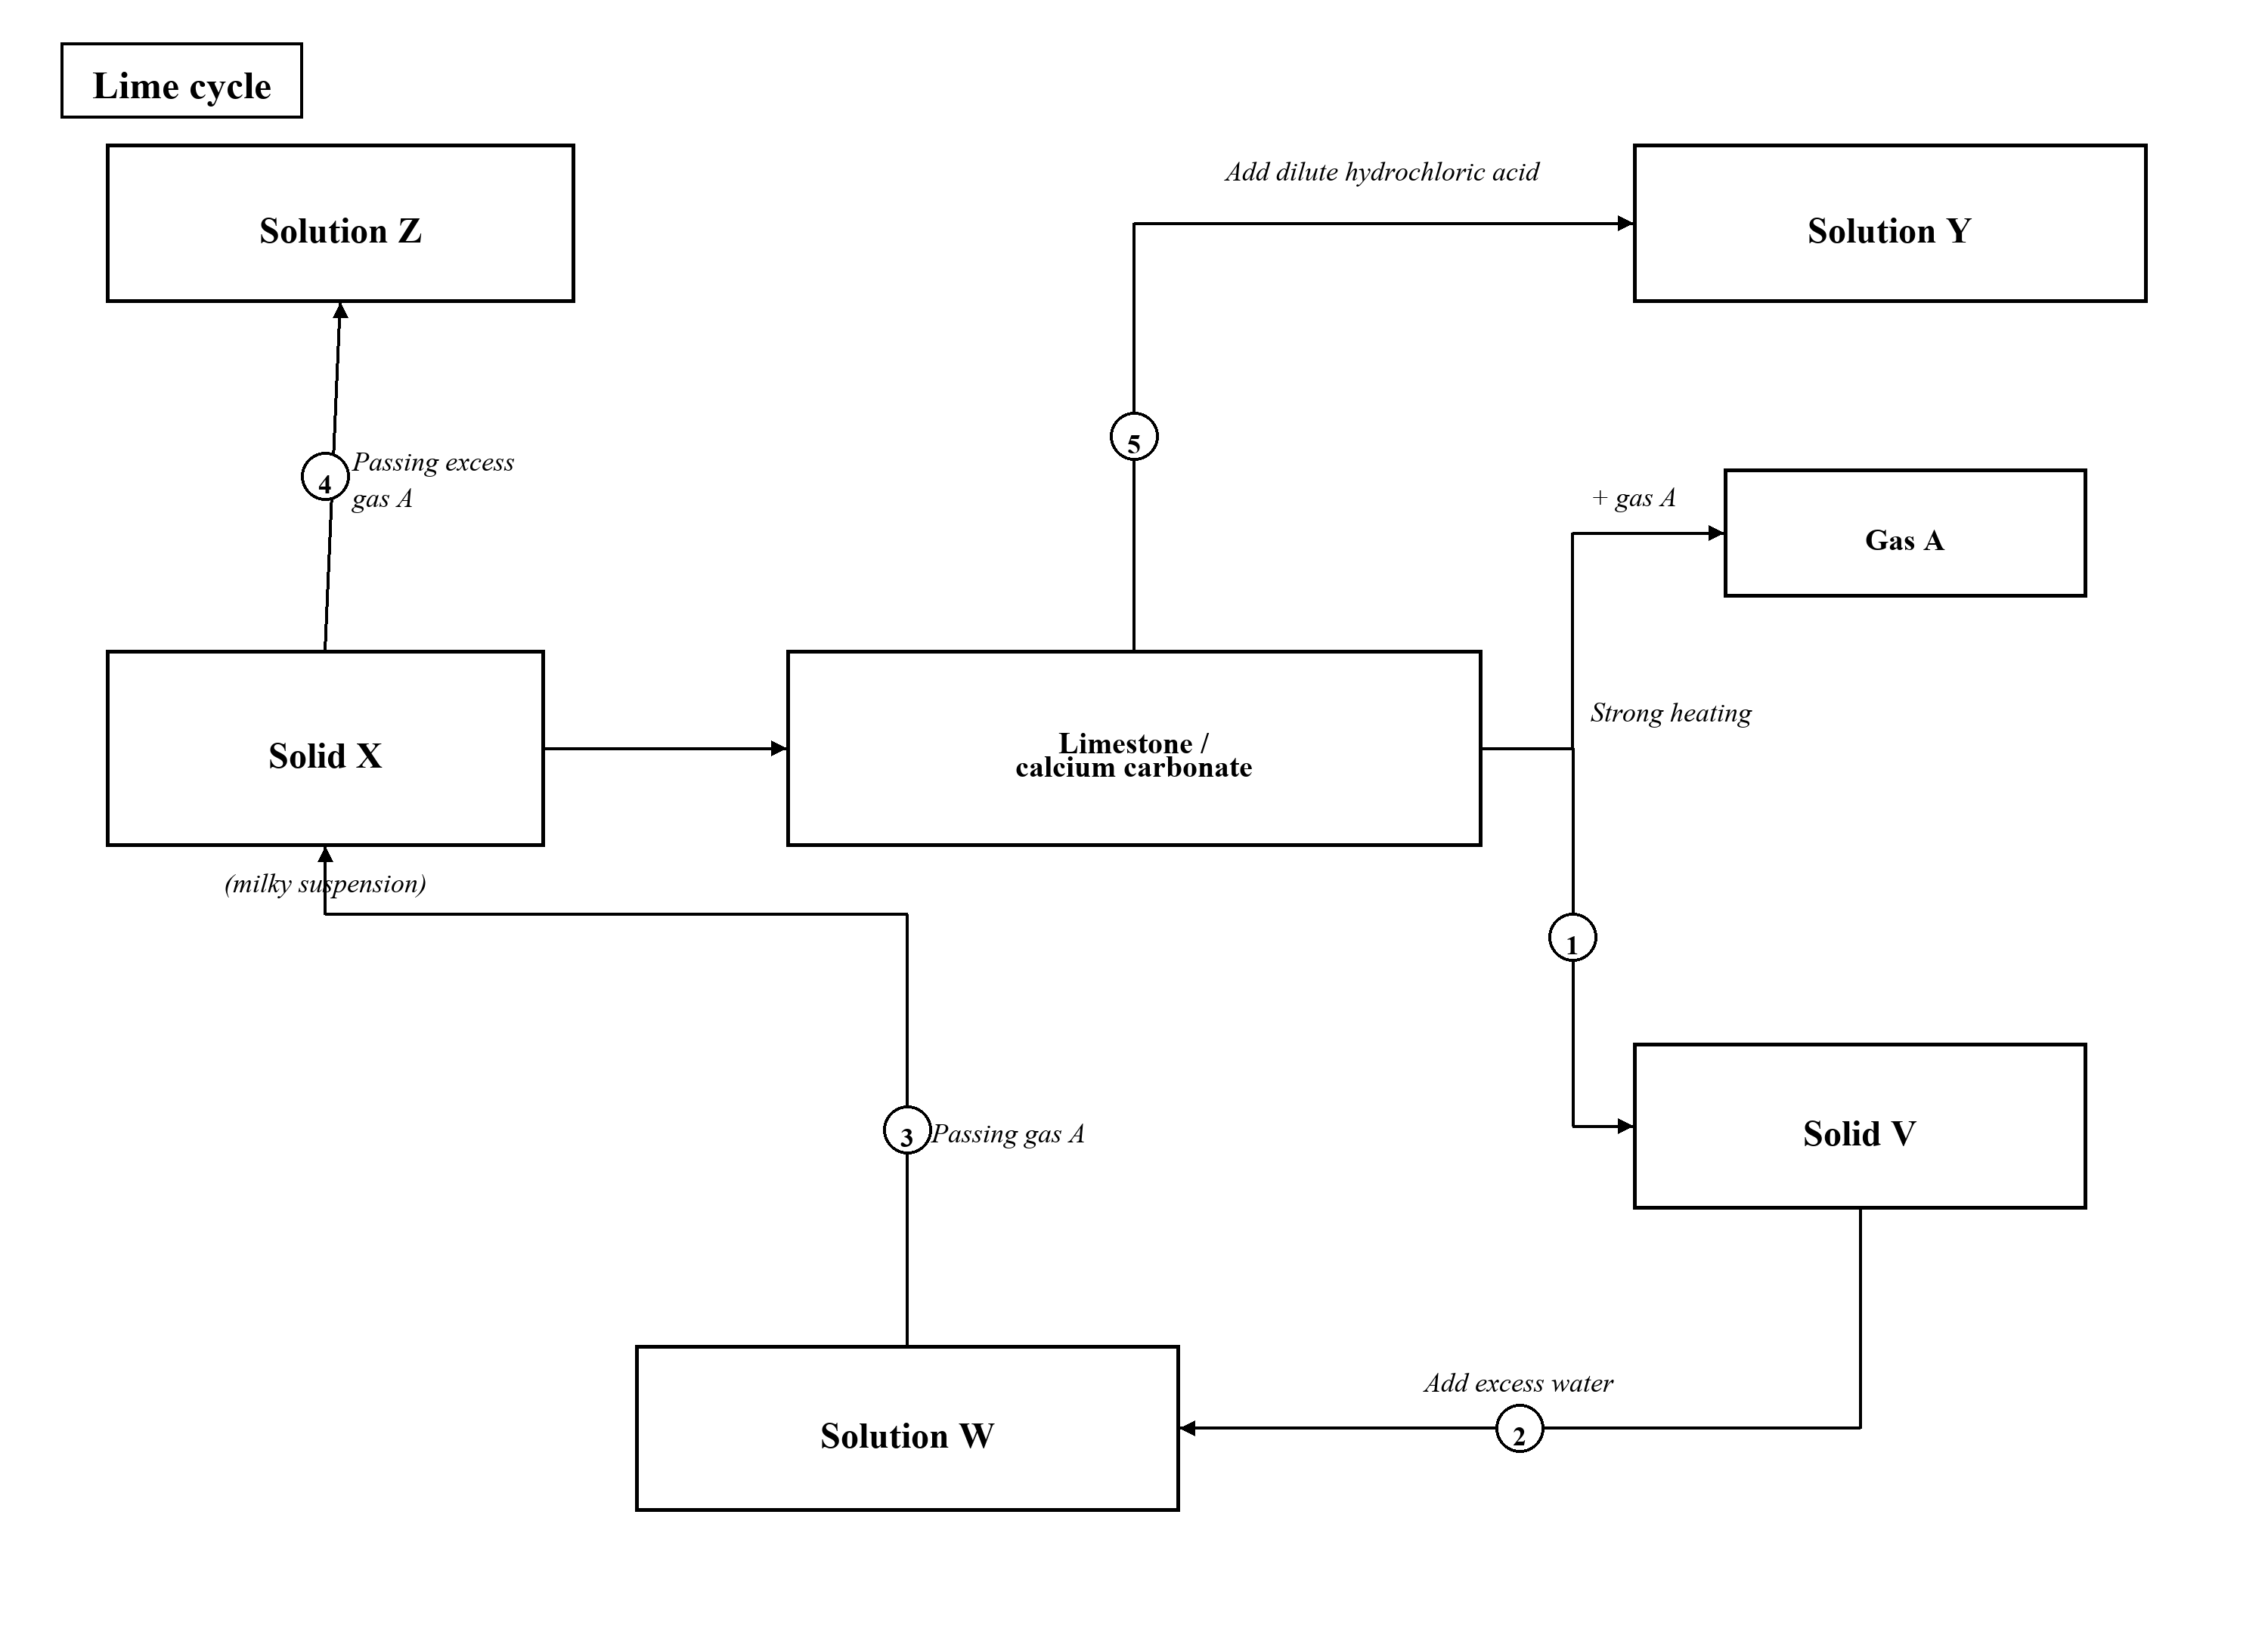
(a) A piece of limestone is heated strongly to give solid V and gas A.
(i) What is solid V?
(1 mark)
______________________________________________________________________

(ii) Suggest a chemical test for gas A.
(1 mark)
______________________________________________________________________
______________________________________________________________________

(b) Write a word equation for the formation of solution W from solid V.
(1 mark)
______________________________________________________________________
______________________________________________________________________

(c) Write a word equation for the formation of solid X from solution W.
(1 mark)
______________________________________________________________________
______________________________________________________________________

(d) When excess gas A is pumped into the above milky suspension containing solid X, further reaction occurs and solution Z is produced.
(i) Apart from heat change, state ONE observable change for the reaction involved.
(1 mark)
______________________________________________________________________

(ii) Write a word equation for the reaction involved.
(1 mark)
______________________________________________________________________
______________________________________________________________________

(e) Solution Y can be obtained by adding dilute hydrochloric acid into solid X.
(i) Name solution Y.
(1 mark)
______________________________________________________________________

(ii) Apart from heat change, state TWO observable changes for the reaction involved.
(1 mark)
______________________________________________________________________
______________________________________________________________________

10. This question is about the weathering and erosion of rocks.
(a) With the aid of chemical equations, briefly describe how rainwater can speed up the weathering of limestone.
(5 marks)
______________________________________________________________________
______________________________________________________________________
______________________________________________________________________
______________________________________________________________________
______________________________________________________________________
______________________________________________________________________

(b) The following diagram shows the conversion of different calcium-containing compounds:
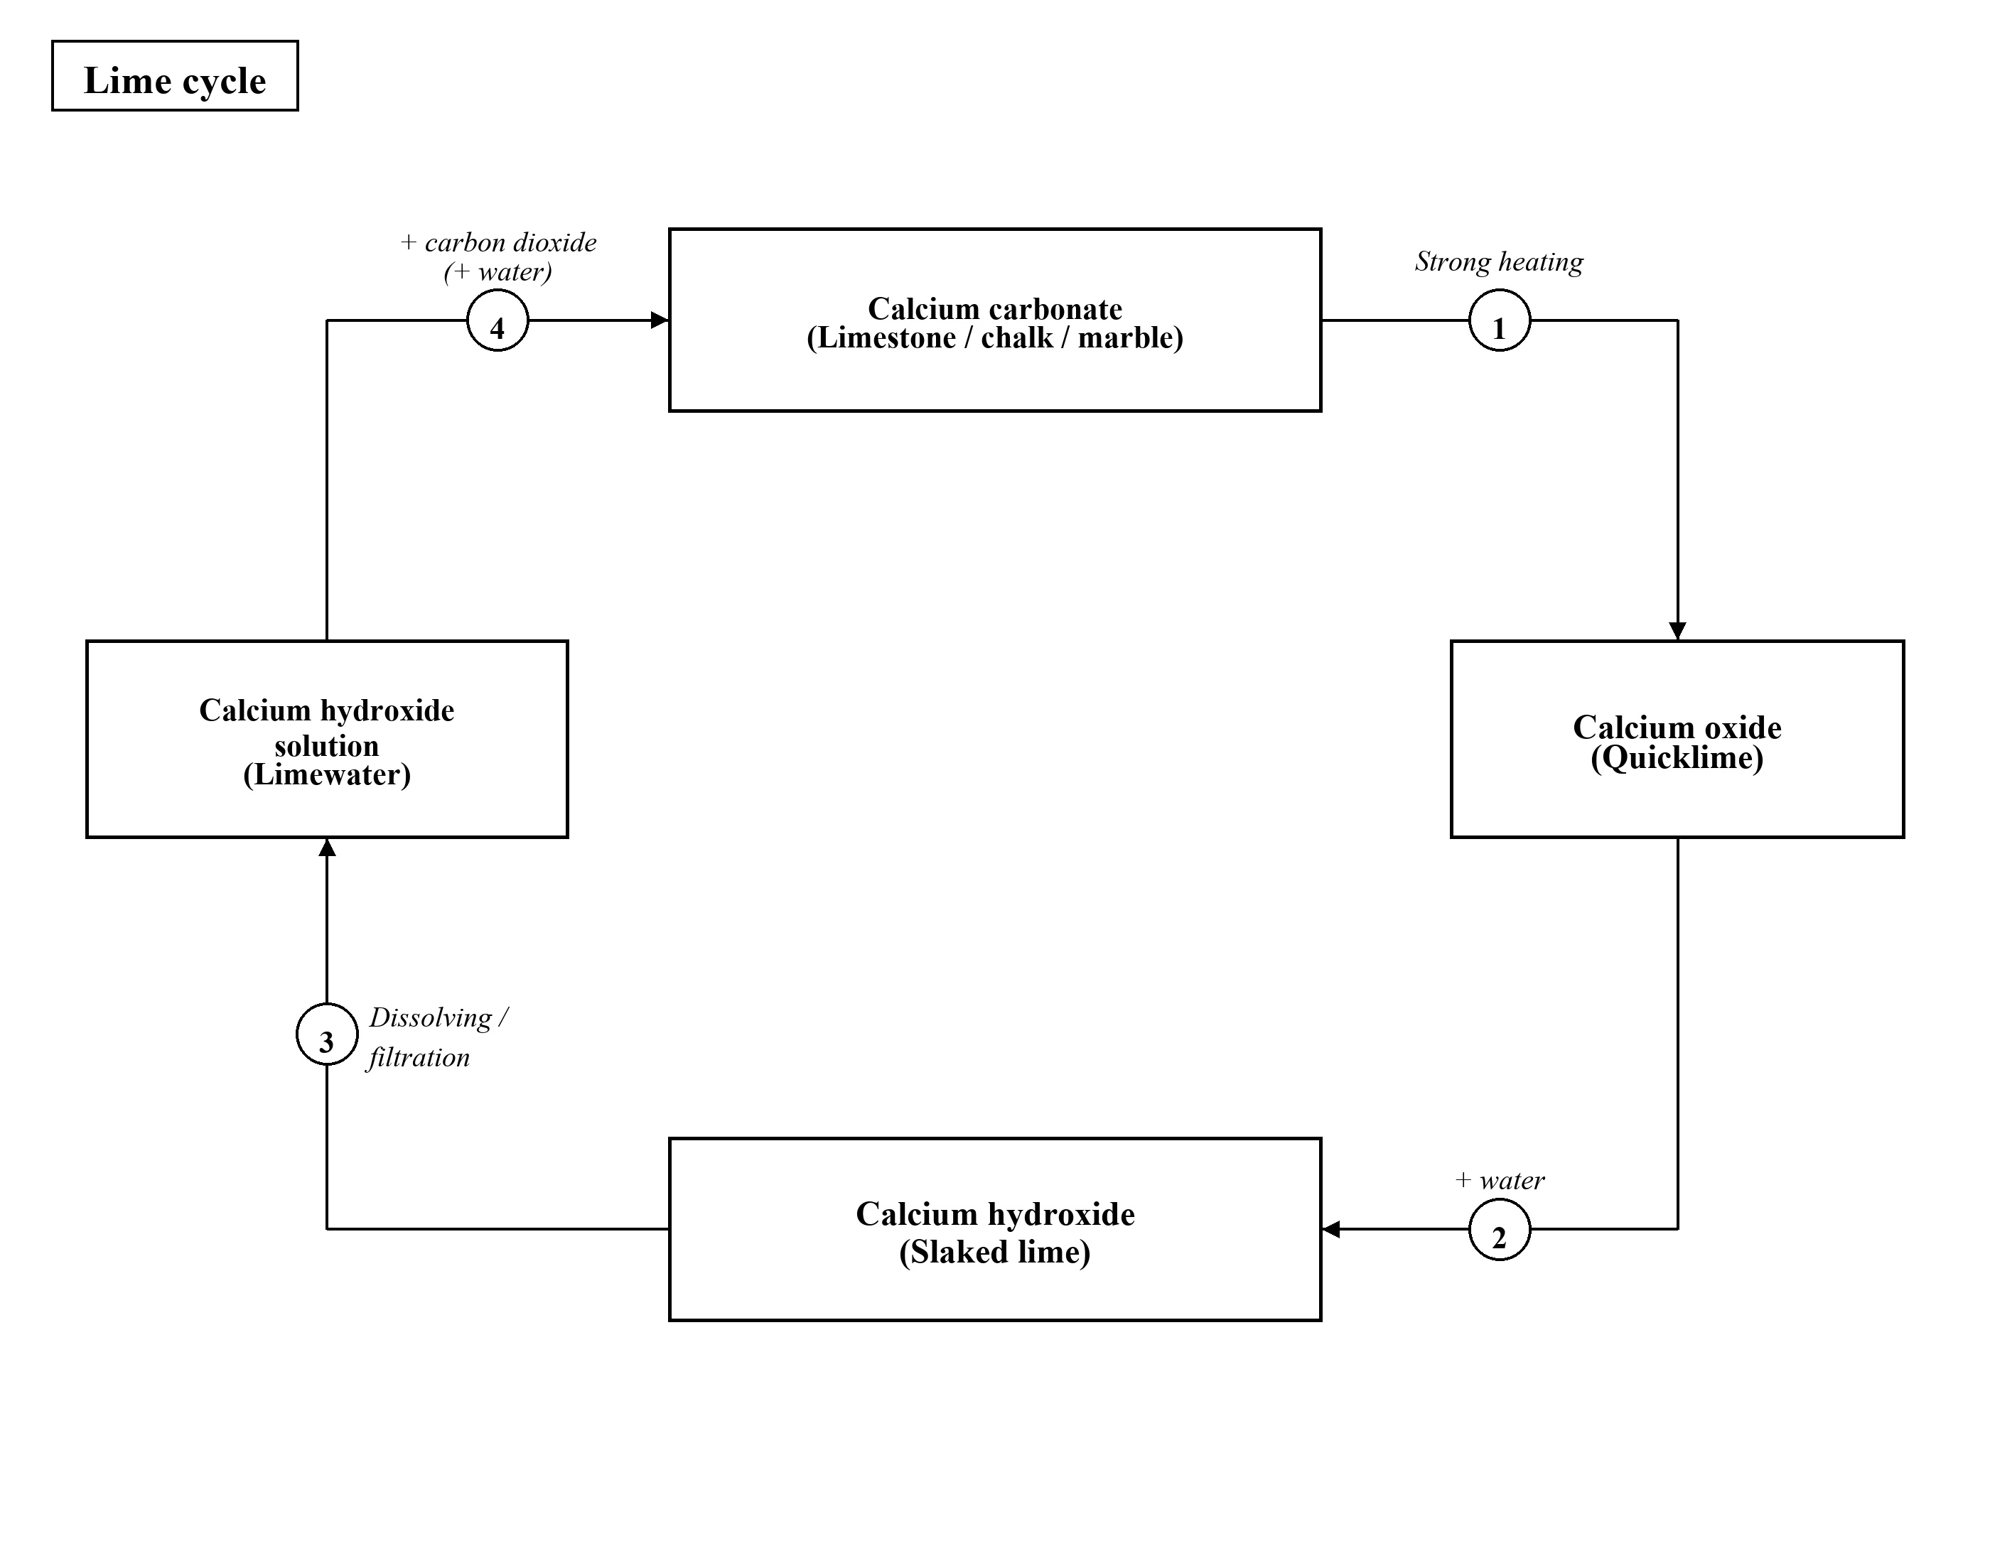
(i) Which of the above steps involves physical change only? Explain your answer.
(1 mark)
______________________________________________________________________
______________________________________________________________________
(ii) Suggest a method to show limestone is a calcium-containing compound. State the expected observation clearly.
(1 mark)
______________________________________________________________________

(iii) Write a word equation for each of the chemical changes involved in the above diagram.
(3 marks)
______________________________________________________________________
______________________________________________________________________
______________________________________________________________________
______________________________________________________________________

11. Two tests are carried out on a sample of white solid and the results are shown below.
Test | Result
Flame test | A brick-red flame is observed
Addition of dilute hydrochloric acid | Colorless gas bubbles of carbon dioxide evolve

(a) What can be concluded from the results of the tests?
(2 marks)
______________________________________________________________________
______________________________________________________________________

(b) How can you show that the colourless gas bubbles evolved after the addition of dilute hydrochloric acid are carbon dioxide?
(1 mark)
______________________________________________________________________
______________________________________________________________________

(c) From the results of the tests, can you conclude that the sample is calcium carbonate? Explain your answer.
(1 mark)
______________________________________________________________________
______________________________________________________________________
______________________________________________________________________

12. The results of three chemical tests for substance X and Y are shown in the table below:
 | X | Y
Test 1: Flame test | Bluish green flame color | Lilac flame color
Test 2: Adding acidified silver nitrate solution to the aqueous solution of the substance | X is insoluble in water | White precipitate formed
Test 3: Adding dilute hydrochloric acid | Colorless gas formed which can turn limewater from colorless to milky | No observable change

(a) According to test 2:
(i) Name the white precipitate formed by the reaction between Y and acidified silver nitrate solution.
(1 mark)
______________________________________________________________________

(ii) What is the acid used to acidify the silver nitrate solution? Explain why it is added to the silver nitrate solution.
(2 marks)
______________________________________________________________________
______________________________________________________________________
______________________________________________________________________

(b) According to test 3, what species is present in X?
(1 mark)
______________________________________________________________________

(c) Give the chemical name of:
(i) X
(1 mark)
______________________________________________________________________

(ii) Y
(1 mark)
______________________________________________________________________

13. A solid sample contains a mixture of calcium carbonate, calcium chloride (a salt that is present in sea water) and sodium chloride.
(a) To obtain calcium carbonate from this solid sample, excess water is first added to the solid mixture. After that the mixture is filtered.
(i) What chemical(s) is / are present in filtrate?
(1 mark)
______________________________________________________________________

(ii) What chemical(s) is / are present in residue?
(1 mark)
______________________________________________________________________

(b) Suggest a chemical test to show the presence of carbonate in the calcium carbonate collected. Give the expected observation and write a word equation for the test.
(3 marks)
______________________________________________________________________
______________________________________________________________________
______________________________________________________________________
______________________________________________________________________

(c) Tom carried out flame test on the above mixture.
(i) Describe the procedures in carrying out flame test.
(2 marks)
______________________________________________________________________
______________________________________________________________________
______________________________________________________________________

(ii) State the characteristic flame color of the following element in flame test.
(1) Calcium
(1 mark)
______________________________________________________________________

(2) Sodium
(1 mark)
______________________________________________________________________

(iii) From the experimental result, only the flame color of sodium can be observed in flame test. Explain why the flame color of calcium cannot be seen.
(1 mark)
______________________________________________________________________
______________________________________________________________________

14. Suggest a test to distinguish each of the following pairs of substances. Give the expected observations.
(a) Water and Oil
(2 marks)
______________________________________________________________________
______________________________________________________________________

(b) Potassium chloride solution and potassium sulphate solution
(2 marks)
______________________________________________________________________
______________________________________________________________________

(c) Copper(II) nitrate and calcium nitrate
(2 marks)
______________________________________________________________________
______________________________________________________________________

(d) Anhydrous copper(II) sulphate powder and sodium chloride powder
(2 marks)
______________________________________________________________________
______________________________________________________________________

(e) Sodium carbonate powder and sodium sulphate powder
(2 marks)
______________________________________________________________________
______________________________________________________________________

(f) Carbon dioxide and nitrogen
(2 marks)
______________________________________________________________________
______________________________________________________________________

(g) Hydrated copper(II) sulphate and anhydrous cobalt(II) chloride
(2 marks)
______________________________________________________________________
______________________________________________________________________

(h) Helium and hydrogen
(2 marks)
______________________________________________________________________
______________________________________________________________________

(i) Sodium carbonate and potassium carbonate
(2 marks)
______________________________________________________________________
______________________________________________________________________

Answer
1.
(a) This method involves physical change as no new substances are produced. / No new substances are produced in the process.
Source: topic-01-planet-earth.pdf p.10
(b) (i) Silver oxide → Silver + oxygen
(ii) This method involves chemical change as new substances (silver and oxygen) are produced.
(iii) Mercury
Source: topic-01-planet-earth.pdf p.10
(c) (i) Lead(II) oxide + Carbon → Lead + Carbon dioxide
(ii) Zinc, iron, copper (any TWO)
Source: topic-01-planet-earth.pdf p.10
(d) (i) Potassium / calcium / magnesium / aluminium (any ONE)
(ii) Bauxite
Source: topic-01-planet-earth.pdf p.10
2.
(a) (i) Mechanical separation (e.g. panning) / Panning
(ii) This method involves physical change as no new substances are produced.
Source: topic-01-planet-earth.pdf p.10
(b) (i) Heating the metal ore alone / Heating mercury(II) oxide alone
(ii) Mercury(II) oxide → Mercury + oxygen
This method involves chemical change as new substances are produced. / New substances (mercury and oxygen) are produced.
Source: topic-01-planet-earth.pdf p.10
(c) Carbon
Source: topic-01-planet-earth.pdf p.10
(d) (i) Electrolysis of molten metal ore / Electrolysis of molten aluminium oxide
(ii) Aluminium oxide → Aluminium + Oxygen
This method involves chemical change as new substances (aluminium and oxygen) are produced.
Source: topic-01-planet-earth.pdf p.10
3.
(a) Limestone, chalk and marble
Source: topic-01-planet-earth.pdf p.11
(b) Calcium carbonate → Calcium oxide + Carbon dioxide
Limestone breaks down into white powder
Source: topic-01-planet-earth.pdf p.12
(c) Limewater turns milky / Limewater turns milky; Milky solution turns colorless in excess carbon dioxide
Calcium hydroxide + Carbon dioxide → Calcium carbonate + Water
Calcium carbonate + Water + Carbon dioxide → Calcium hydrogencarbonate
Source: topic-01-planet-earth.pdf p.12
4.
(a) Calcium carbonate / calcite (a natural form of calcium carbonate)
Source: topic-01-planet-earth.pdf p.11
(b) [Diagram] Gas bubbled into limewater / delivery tube into limewater (labelled)
(c) Limewater turns milky / If the sample contains carbonate, colorless gas will be produced which can turn limewater from colorless to milky.
Source: topic-01-planet-earth.pdf p.12
(d) Construct buildings and roads / Make cement / Make glass / Build sculptures / Neutralize acidic soil (any ONE)
Source: topic-01-planet-earth.pdf p.11
5.
(a) An ore is the type of rock that contains useful minerals, from which a metal can be extracted.
Source: topic-01-planet-earth.pdf p.10
(b) Calcium carbonate / calcite (a natural form of calcium carbonate)
Source: topic-01-planet-earth.pdf p.11
(c) Calcium carbonate → Calcium oxide + Carbon dioxide
Source: topic-01-planet-earth.pdf p.12
(d) No observable change
(e) Chemical change is a change in which one or more new substances are produced. Carbon dioxide + water → Carbonic acid
Source: topic-01-planet-earth.pdf p.2, p.11
(f) The distilled water will be sucked back into the hot boiling tube. This may cause the cracking/breaking of the hot boiling tube.
Source: laboratory safety reasoning as in Topic 01 Part 4 sample Answer 5(f)
6.
(a) (i) Calcium carbonate → Calcium oxide + Carbon dioxide
Limestone breaks down into white powder / (This reaction is also known as thermal decomposition)
(ii) Calcium oxide + Water → Calcium hydroxide
Heat is given off
Source: topic-01-planet-earth.pdf p.12
(b) (i) Calcium carbonate / calcite
(ii) Colorless gas evolved; Calcium carbonate dissolves
(iii) Chemical change. Chemical change is a change in which one or more new substances are produced. / New substances (calcium chloride, carbon dioxide and water) are produced.
Source: topic-01-planet-earth.pdf p.2, p.11–12
7.
(a) Colorless gas evolved; Calcium carbonate dissolves
(b) Calcium carbonate + Hydrochloric acid → Calcium chloride + Carbon dioxide + Water
(c) Carbon dioxide
(d) The candle flame is extinguished.
(e) Making fire extinguishers
Source: topic-01-planet-earth.pdf p.12 (equation/observations); daily application as in Topic 01 Part 4 sample Answer 7(e)
8.
(a) Limestone, chalk and marble
Source: topic-01-planet-earth.pdf p.11
(b) Calcium carbonate + Hydrochloric acid → Calcium chloride + Carbon dioxide + Water
OR CaCO3(s) + 2 HCl(aq) → CaCl2(aq) + CO2(g) + H2O(l)
Source: topic-01-planet-earth.pdf p.12
(c) Calcium hydroxide + Carbon dioxide → Calcium carbonate + Water
Calcium carbonate + Water + Carbon dioxide → Calcium hydrogencarbonate
Limewater turns milky; Milky solution turns colorless in excess carbon dioxide
Source: topic-01-planet-earth.pdf p.12
(d) (i) Dip a clean platinum wire / nichrome wire into concentrated hydrochloric acid. Dip the wire into the sample. Heat the end of the wire strongly in a non-luminous flame. Observe the flame color.
(ii) Brick-red
Source: topic-01-planet-earth.pdf p.8
(e) Heat the calcium carbonate strongly. Calcium oxide can be obtained.
Calcium carbonate → Calcium oxide + Carbon dioxide
Add the calcium oxide into distilled water.
White suspension is formed. Upon filtration, colorless filtrate can be obtained. / Filter to obtain the filtrate which is limewater.
Calcium oxide + Water → Calcium hydroxide
Calcium hydroxide → Calcium hydroxide solution (This is a physical change) (Calcium hydroxide is slightly soluble in water)
Source: topic-01-planet-earth.pdf p.12
9.
(a) (i) Calcium oxide
(ii) It turns limewater milky / Colorless gas will be produced which can turn limewater from colorless to milky.
Source: topic-01-planet-earth.pdf p.12
(b) Calcium oxide + Water → Calcium hydroxide
(c) Calcium hydroxide + Carbon dioxide → Calcium carbonate + Water
(d) (i) Milky solution turns colorless in excess carbon dioxide
(ii) Calcium carbonate + Water + Carbon dioxide → Calcium hydrogencarbonate
(e) (i) Calcium chloride
(ii) Colorless gas evolved; Calcium carbonate dissolves
Source: topic-01-planet-earth.pdf p.12
10.
(a) Rainwater is slightly acidic:
Carbon dioxide + water → Carbonic acid
Carbonic acid reacts with calcium carbonate in limestone to form water-soluble calcium hydrogencarbonate
Calcium carbonate + carbonic acid → calcium hydrogencarbonate
Calcium hydrogencarbonate is soluble in water and thus the limestone is slowly worn away.
Source: topic-01-planet-earth.pdf p.11
(b) (i) Step 3. This is a physical change / Physical change is a change in which no new substances are produced. / No new substances are produced in this step.
(ii) Flame test. Brick-red / Brick-red flame color
(iii) Step 1: Calcium carbonate → Calcium oxide + Carbon dioxide
Step 2: Calcium oxide + Water → Calcium hydroxide
Step 4: Calcium hydroxide + Carbon dioxide → Calcium carbonate + Water
Source: topic-01-planet-earth.pdf p.2, p.8, p.12
11.
(a) It contains calcium ion and carbonate ion
(b) Pass the gas into limewater. If the limewater turns milky / Colorless gas will be produced which can turn limewater from colorless to milky.
(c) No. This is because these tests only show that the white sample contains calcium ion and carbonate ion. They cannot be used to show the presence of other substances in the sample.
Source: topic-01-planet-earth.pdf p.8, p.12; reasoning as in Part 4 sample
12.
(a) (i) Silver chloride / insoluble silver chloride
(ii) Excess dilute nitric acid / Dilute nitric acid
Dilute nitric acid can prevent the formation of other precipitates (e.g. silver carbonate) which are soluble in nitric acid.
Source: topic-01-planet-earth.pdf p.8
(b) Carbonate / carbonate ion (colorless gas … turn limewater from colorless to milky)
Source: topic-01-planet-earth.pdf p.12
(c) (i) Copper(II) carbonate
(ii) Potassium chloride
Source: topic-01-planet-earth.pdf p.8, p.12
13.
(a) (i) Calcium chloride, sodium chloride (and water)
(ii) Calcium carbonate
Source: topic-01-planet-earth.pdf p.5 (Filtration can separate an insoluble solid (As residue) from a liquid or solution (As filtrate))
(b) To test the presence of carbonate, we can add dilute hydrochloric acid to the sample. If the sample contains carbonate, colorless gas will be produced which can turn limewater from colorless to milky.
Calcium carbonate + Hydrochloric acid → Calcium chloride + Carbon dioxide + Water
Source: topic-01-planet-earth.pdf p.12
(c) (i) Dip a clean platinum wire / nichrome wire into concentrated hydrochloric acid. Dip the wire into the sample. Heat the end of the wire strongly in a non-luminous flame. Observe the flame color.
(ii) (1) Brick-red
(2) Golden yellow
(iii) The brick-red flame is masked by the golden yellow flame of sodium.
Source: topic-01-planet-earth.pdf p.8; masking explanation as in Part 4 sample
14.
(a) Test with dry cobalt(II) chloride paper.
If the sample contains water is added to dry cobalt(II) chloride paper, the paper will turn from blue to pink. / Only water can turn the paper from blue to pink.
Source: topic-01-planet-earth.pdf p.9
(b) Test with acidified silver nitrate solution / silver nitrate test.
If white precipitate is produced (due to the formation of insoluble silver chloride), the sample should contain chloride ion. / Only potassium chloride gives white precipitate.
Source: topic-01-planet-earth.pdf p.8
(c) Perform flame test.
Copper: Bluish green; Calcium: Brick-red
Source: topic-01-planet-earth.pdf p.8
(d) Add few drops of water into both solids / Using anhydrous copper(II) sulphate.
If the sample contains water is added to anhydrous copper(II) sulphate, the white solid will turn blue. / Only anhydrous copper(II) sulphate turns from white to blue.
Source: topic-01-planet-earth.pdf p.9
(e) Add dilute hydrochloric acid into both solids.
If the sample contains carbonate, colorless gas will be produced which can turn limewater from colorless to milky. / Only sodium carbonate gives colorless gas which turns limewater from colorless to milky.
Source: topic-01-planet-earth.pdf p.12
(f) Bubble both gases into limewater.
Only carbon dioxide can turn limewater from colorless to milky / Limewater turns milky.
Source: topic-01-planet-earth.pdf p.12
(g) Add water to both solids / Using dry cobalt(II) chloride paper.
If the sample contains water is added to dry cobalt(II) chloride paper, the paper will turn from blue to pink. / Only anhydrous cobalt(II) chloride can turn from blue to pink.
Source: topic-01-planet-earth.pdf p.9
(h) Test with burning splint.
Hydrogen be tested by burning splint and it burns with ‘pop’ sound. / Only hydrogen burns with a ‘pop’ sound.
Source: topic-01-planet-earth.pdf p.3
(i) Perform flame test.
Sodium: Golden yellow; Potassium: Lilac
Source: topic-01-planet-earth.pdf p.8

