1. Complete the following table:
Atomic  number | Mass  number | No. of  proton | No. of  neutron | No. of  electron | Name of element | Full atomic  symbol
1 |  |  | 0
2 | 3
3 |  |  | 4
4 | 9
5 |  |  | 6
6 | 12
7 |  |  | 7
8 | 16
9 |  |  | 10
10 | 20
11 |  |  | 12
12 | 24
13 |  |  | 14
14 | 28
15 |  |  | 16
16 | 32
17 |  |  | 18
18 | 40
19 |  |  | 20
20 | 40
(20 marks)

2. The diagram below shows the simple model of atom X.
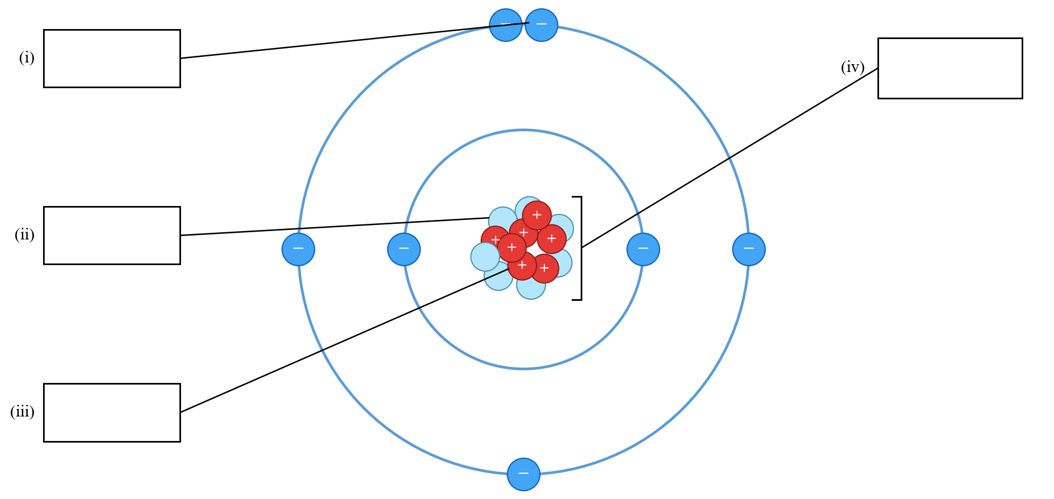

- Label the above diagram. (4 marks)
(b) Write down the atomic number of atom X. (1 mark)
________________________________________________________________________
- Write down the mass number of atom X. (1 mark)
________________________________________________________________________
- With reference to the charges of the subatomic particles, explain why atom X is electrically neutral. (2 marks)
________________________________________________________________________
________________________________________________________________________
(e) (i) Write down the symbol of element that atom X belongs to. (1 mark)
________________________________________________________________________
(ii) Hence, write down the name of the element that atom X belongs to. (1 mark)
________________________________________________________________________

3. The following simplified diagram represents the structure of the atom of a certain element with an atomic number greater than one.
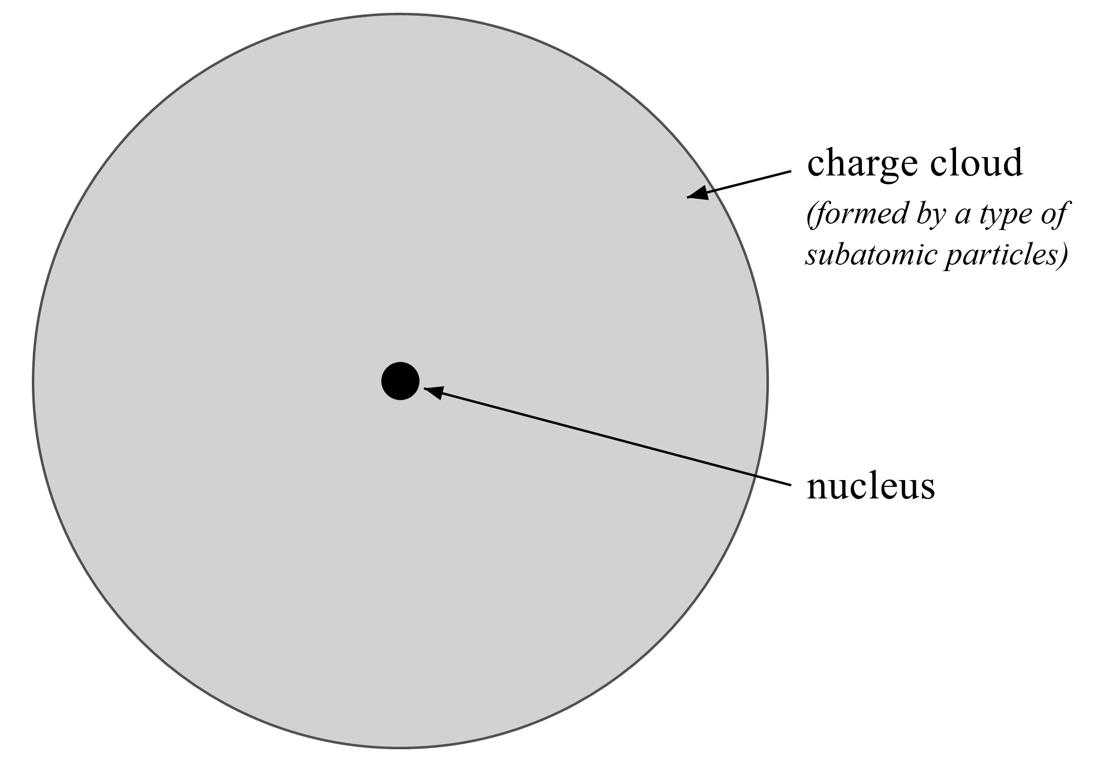

- Does the atom carry any net charges? Suggest why. (1 mark)
________________________________________________________________________
________________________________________________________________________
- What type of subatomic particles can be found in the charge cloud? (1 mark)
________________________________________________________________________
- Name TWO types of subatomic particles that can be found in the nucleus. (2 marks)
________________________________________________________________________
- Explain why most of the mass of the atom is in the nucleus. (2 marks)
________________________________________________________________________
________________________________________________________________________

4. The following diagram shows the structure of an atom of element X. The crosses, black dots and white dots represent three different kinds of sub-atomic particles. The black dots carry a positive charge.
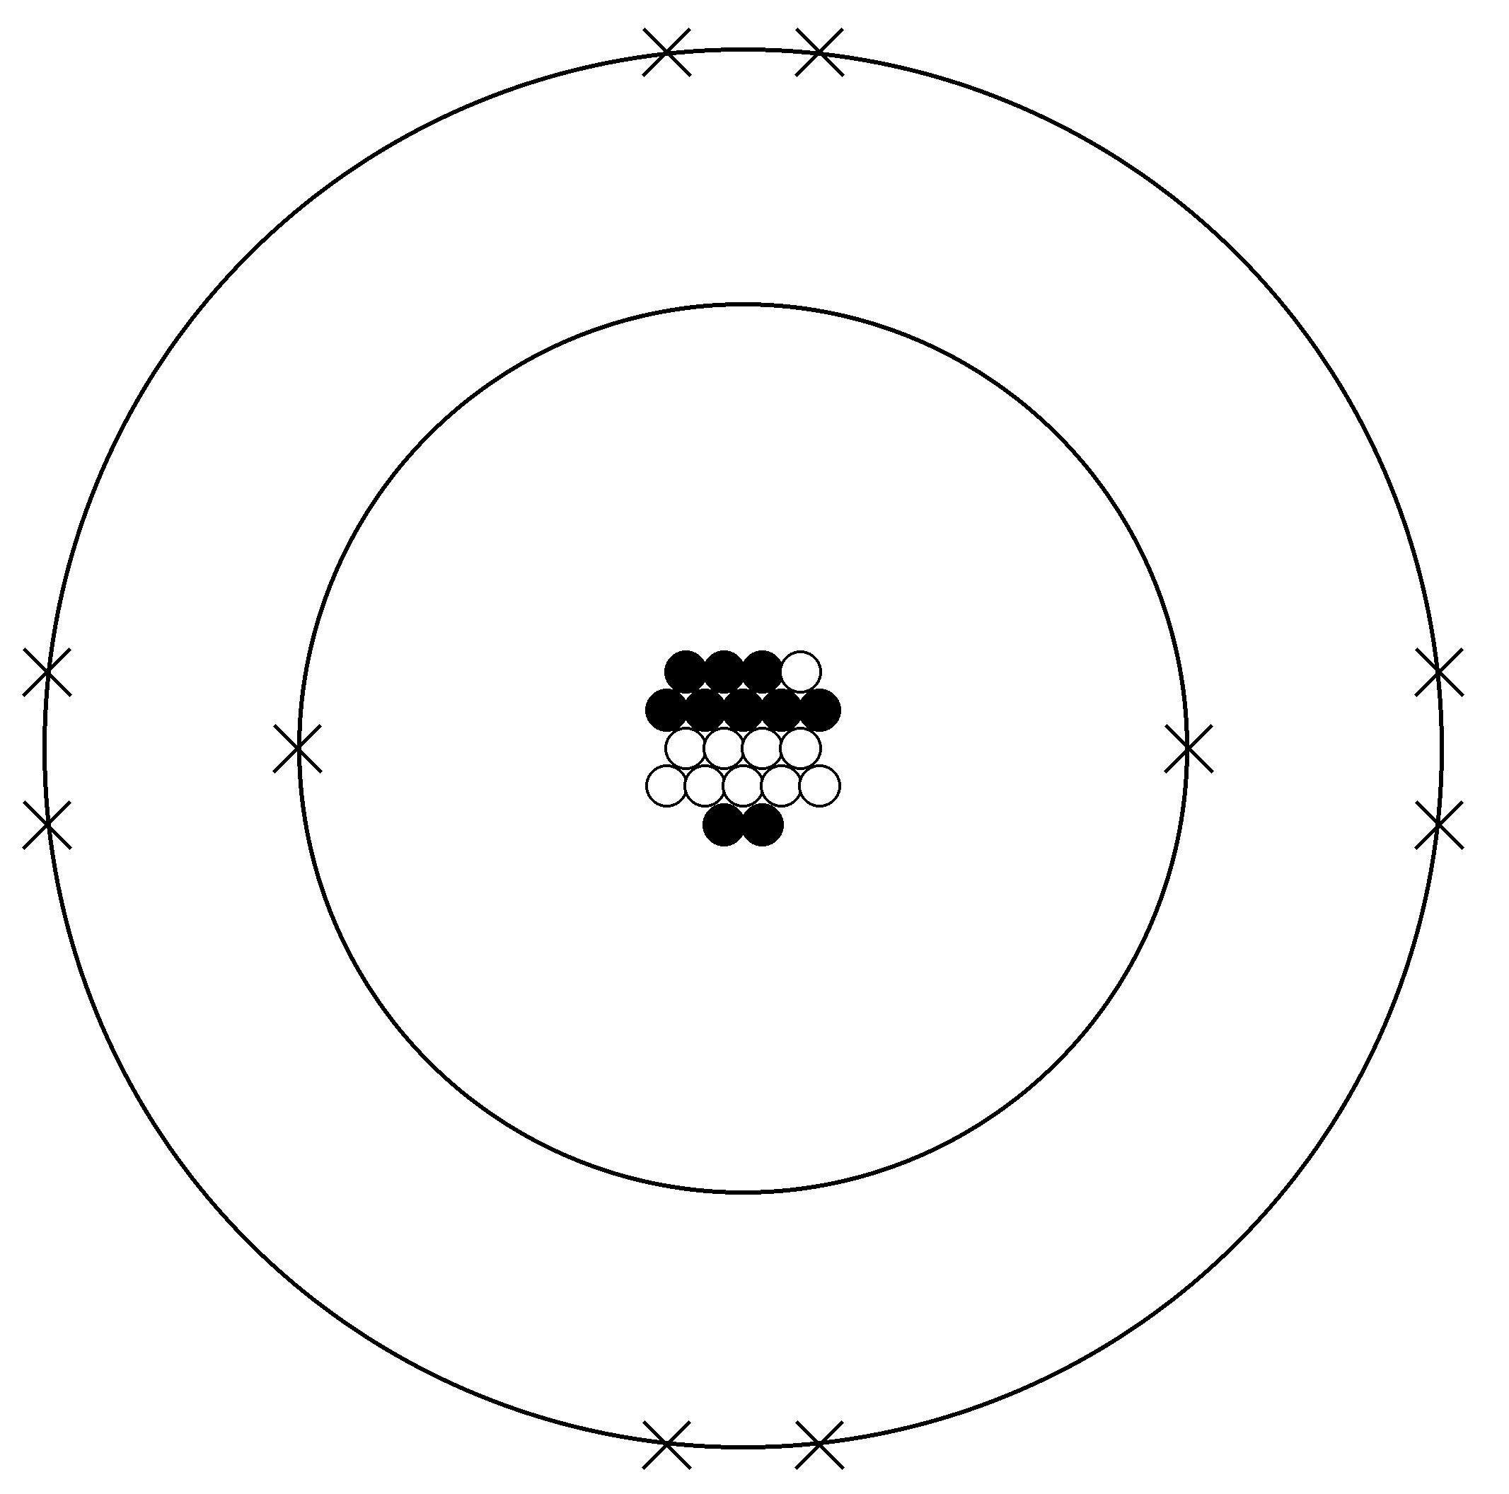

(a) Identify the following sub-atomic particles: (3 marks)
(i) Cross (1 mark)
________________________________________________________________________
(ii) Black dot (1 mark)
________________________________________________________________________
(iii) White dot (1 mark)
________________________________________________________________________
(b) Give the full atomic symbol of the above atom. (1 mark)
________________________________________________________________________
- Explain why an atom is electrically neutral. (1 mark)
________________________________________________________________________
________________________________________________________________________
(d) Tom claims that NOT all atoms contain protons, neutrons and electrons. Give one example to support his claim. (1 mark)
________________________________________________________________________

5. The diagram below shows the nuclei of four atoms W, X, Y and Z.
- 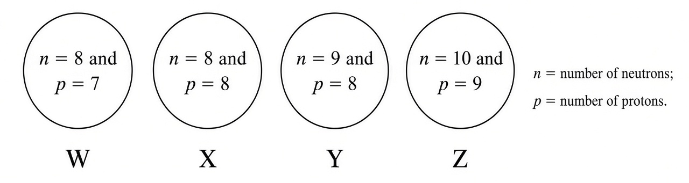
- State and explain which two atoms belong to the same element. (2 marks)
________________________________________________________________________
________________________________________________________________________
- What is the element in (a)? (1 mark)
________________________________________________________________________
- Write the full atomic symbol for each of these atoms. (4 marks)
________________________________________________________________________
________________________________________________________________________
________________________________________________________________________

6. The diagram below represents the structure of an atom of element X. The crosses, black dots and white dots represent three different kinds of subatomic particles.
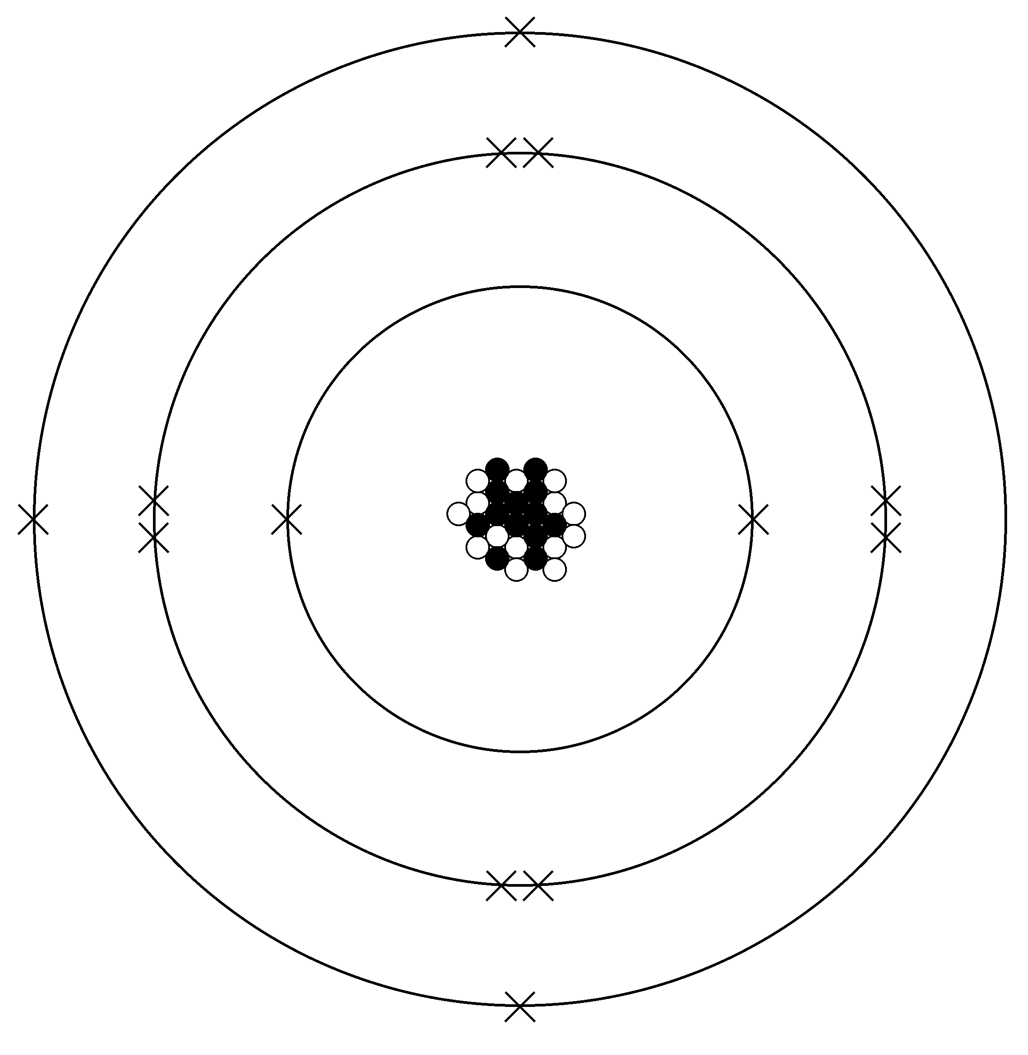
(a) (i) What type of subatomic particle does the black dot represent? (1 mark)
________________________________________________________________________
(ii) State the charge of the black dot. (1 mark)
________________________________________________________________________
(b) Determine the atomic number and the mass number of X. (2 marks)
________________________________________________________________________
- Hence, write the full atomic symbol of X. (1 mark)
________________________________________________________________________
7. Explain why the followings concerning atoms are INCORRECT.
(a) Neutrons exist in ALL atoms. (1 mark)
________________________________________________________________________
________________________________________________________________________
(b) The mass of an atom is evenly distributed within an atom. (1 mark)
________________________________________________________________________
________________________________________________________________________
(c) Isotopes have similar chemical properties. (1 mark)
________________________________________________________________________
________________________________________________________________________
- The relative isotopic mass of an isotope carries a unit. (1 mark)
________________________________________________________________________
________________________________________________________________________
- In modern Periodic Table, elements are arranged in increasing mass number. (1 mark)
________________________________________________________________________
________________________________________________________________________

8. Look at the table. It shows some information about the particles which make up atoms.
Particle | Charge | Relative mass | Position
Proton |  | 1
Neutron |  |  | Nucleus
Electron | -1
- Complete the table. (3 marks)
________________________________________________________________________
(b) Look at the symbol for calcium.
$$_{20}^{40}Ca$$

- What is meant by ‘atomic number’? (1 mark)
________________________________________________________________________
- Write down the electronic arrangement of a calcium atom. (1 mark)
________________________________________________________________________
- A calcium atom is electrically neutral. Explain why. (1 mark)
________________________________________________________________________
________________________________________________________________________

9. Give the names and symbols of the following elements (A to D) from the descriptions given.
Element | Description | Name | Element symbol
A | Its atomic number is 15
B | Its atom has 16 protons
C | Its atom has 10 electrons
D | The electronic arrangement of its atom is 2,8,8,2
(4 marks)
(b) Draw electron diagrams of atoms of the following elements (show electrons in ALL shells): (4 marks)
(i) Nitrogen (1 mark)

(ii) Magnesium (1 mark)

(iii) Argon (1 mark)

(iv) Potassium (1 mark)

10. Chlorine occurs naturally in two stable isotopes, ³⁵Cl and ³⁷Cl. If the abundance of ³⁵Cl is 75.8%, answer the following questions.
(a) Calculate the relative atomic mass of Cl. (2 marks)
________________________________________________________________________
________________________________________________________________________
________________________________________________________________________
- What is meant by the term ‘isotopes’? (1 mark)
________________________________________________________________________
________________________________________________________________________
- State the number of protons and the number of neutrons in ³⁷Cl. (1 mark)
________________________________________________________________________
- Write down the electronic arrangement of a chlorine atom. (1 mark)
________________________________________________________________________
- Is it possible to separate ³⁵Cl and ³⁷Cl by chemical methods? Explain your answer. (2 marks)
________________________________________________________________________
________________________________________________________________________
11. Magnesium occurs naturally in three stable isotopes, ²⁴Mg, ²⁵Mg and ²⁶Mg. If the abundance of ²⁴Mg is 78.6% and the relative atomic mass of Mg is 24.327, calculate the abundance of ²⁵Mg.
(2 marks)
________________________________________________________________________
________________________________________________________________________
________________________________________________________________________
________________________________________________________________________
________________________________________________________________________
12. Bromine occurs naturally in two stable isotopes, ⁷⁹Br and ˣBr. If the abundance of ⁷⁹Br is 50.6% and the relative atomic mass of Br is 79.988, calculate the isotopic mass of ˣBr.
(2 marks)
________________________________________________________________________
________________________________________________________________________
________________________________________________________________________
________________________________________________________________________

13. Refer to the following information about fluorine and sulphur.
 | Fluorine | Sulphur
Atomic number | 9 | 16
(a) (i) Draw the electron diagram of a fluorine atom. (1 mark)

(ii) Draw the electron diagram of a sulphur atom. (1 mark)

(b) All Sulphur atoms have the same atomic number. But some sulphur atoms have different mass numbers. Explain briefly. (1 mark)
________________________________________________________________________
________________________________________________________________________
(c) Fluorine-19 is the only isotope of fluorine. Describe the structure of a fluorine atom. Your answer should include the type and number of the subatomic particles present in the atom, and the location and the charge of each type of these subatomic particles. (3 marks)
________________________________________________________________________
________________________________________________________________________
________________________________________________________________________
________________________________________________________________________

14. (a) Element A occurs naturally in 2 isotopes with the abundance of each isotope shown in the table below:
Isotope | Abundance (%)
⁶A | 7.59
⁷A | ???
Calculate the relative atomic mass of element A. (2 marks)
________________________________________________________________________
________________________________________________________________________
________________________________________________________________________
(b) Element B occurs naturally in 3 isotopes with the abundance of each isotope shown in the table below:
Isotope | Abundance (%)
²⁴B | 79
²⁵B | x
²⁶B | y
The relative atomic mass of B is 24.32. Calculate the value of x. (2 marks)
________________________________________________________________________
________________________________________________________________________
________________________________________________________________________
(c) Element C occurs naturally in 3 isotopes with the abundance of each isotope shown in the table below:
Isotope | Abundance (%)
²⁸C | 92.2
²⁹C | 4.7
ⁿC | 3.1
The relative atomic mass of C is 28.11. Calculate the value of n. (2 marks)
________________________________________________________________________
________________________________________________________________________
________________________________________________________________________
(d) Element D occurs naturally in two isotopes, ⁶³D and ⁶⁵D. If the abundance of ⁶³D is 75%, calculate the relative atomic mass of D.
(2 marks)
________________________________________________________________________
________________________________________________________________________
________________________________________________________________________
(e) There is only one naturally occurring isotope of fluorine, ¹⁹F. Estimate the relative atomic mass of F.
(1 mark)
________________________________________________________________________
15. Silicon (Si) has three naturally occurring isotopes.
(a) What is the meaning of the term ‘isotope’? (1 mark)
________________________________________________________________________
________________________________________________________________________

(b) The relative abundances of these isotopes are shown in the following table.
Isotope | ²⁸₁₄Si | ²⁹₁₄Si | ³⁰₁₄Si
Relative abundance / % | 92.23 | 4.68 | ?
- How many protons and neutrons are there in ²⁸₁₄Si? (1 mark)
________________________________________________________________________
- What is the relative isotopic mass of ²⁸₁₄Si? (1 mark)
________________________________________________________________________
- What is the relative abundance of ³⁰₁₄Si? (1 mark)
________________________________________________________________________
- Calculate the relative atomic mass of silicon. (2 marks)
________________________________________________________________________
________________________________________________________________________
________________________________________________________________________
- Draw the electron diagram of an atom ²⁸₁₄Si. (1 mark)

16. Silver occurs in nature as two isotopes: ¹⁰⁷Ag and ¹⁰⁹Ag. The relative abundance of these isotopes is shown below.
Isotope | Relative abundance / %
¹⁰⁷Ag | 55
¹⁰⁹Ag | 45
- State the meaning of the term ‘relative atomic mass’. (1 mark)
________________________________________________________________________
________________________________________________________________________
- Calculate the relative atomic mass of silver. (2 marks)
________________________________________________________________________
________________________________________________________________________
________________________________________________________________________
- Is it possible to separate the isotopes of silver by chemical means? Explain your answer. (2 marks)
________________________________________________________________________
________________________________________________________________________

17. Element K has 3 naturally occurring isotopes, X, Y and Z. Consider the information below:
Isotope X: Isotopic mass of X is 29
Isotope Y: There are 16 neutrons in Y
Isotope Z: The number of protons, neutrons and electrons in Z are all 14
- Write down the full atomic symbol of X, Y and Z. (3 marks)
________________________________________________________________________
________________________________________________________________________
- If the abundance of X is 5.6% and the relative atomic mass of K is 28.1, calculate the abundance of Y. (2 marks)
________________________________________________________________________
________________________________________________________________________
________________________________________________________________________

18. Consider the information about element copper (Cu) below:
- Atomic number of copper is 29
- First three electron shells of copper are fully filled
- Copper has 4 occupied electron shells
(a) Write the electronic arrangement of a copper atom. (1 mark)
________________________________________________________________________
(b) Copper has TWO isotopes, ⁶³Cu and ⁶⁵Cu. Given that the relative atomic mass of copper is 63.5 (2 marks)
(i) Calculate the abundance of ⁶³Cu. (2 marks)
________________________________________________________________________
________________________________________________________________________
________________________________________________________________________
(ii) A sample of Cu metal contains 30624700 Cu atoms. Calculate the theoretical number of ⁶⁵Cu atoms in the sample. (2 marks)
________________________________________________________________________
________________________________________________________________________
________________________________________________________________________

19. Consider the table below:
Atom | No. of  proton | No. of  neutron | No. of  electron | Relative  abundance
²⁵Mg |  |  |  | 11.0%
²⁶Mg |  |  |  | 10.0%
ᵃMg |  | 12 |  | 79.0%
- Complete the above table. (3 marks)
________________________________________________________________________
________________________________________________________________________
- Calculate the value of a in the above table. (1 mark)
________________________________________________________________________
- Calculate the relative atomic mass of Mg. (2 marks)
________________________________________________________________________
________________________________________________________________________
________________________________________________________________________
- Draw the electron diagram of a Mg atom, showing electrons in ALL SHELLS. (1 mark)

(e) When a sample of ²⁵Mg is heated strongly, a bright white flame can be observed. Predict what will happen if a sample of ²⁶Mg is heated strongly. Explain your answer. (1 mark)
________________________________________________________________________
________________________________________________________________________
- State ONE different property of the three isotopes. (1 mark)
________________________________________________________________________

20. The diagram below represents the structure of an atom of isotope A of an element.
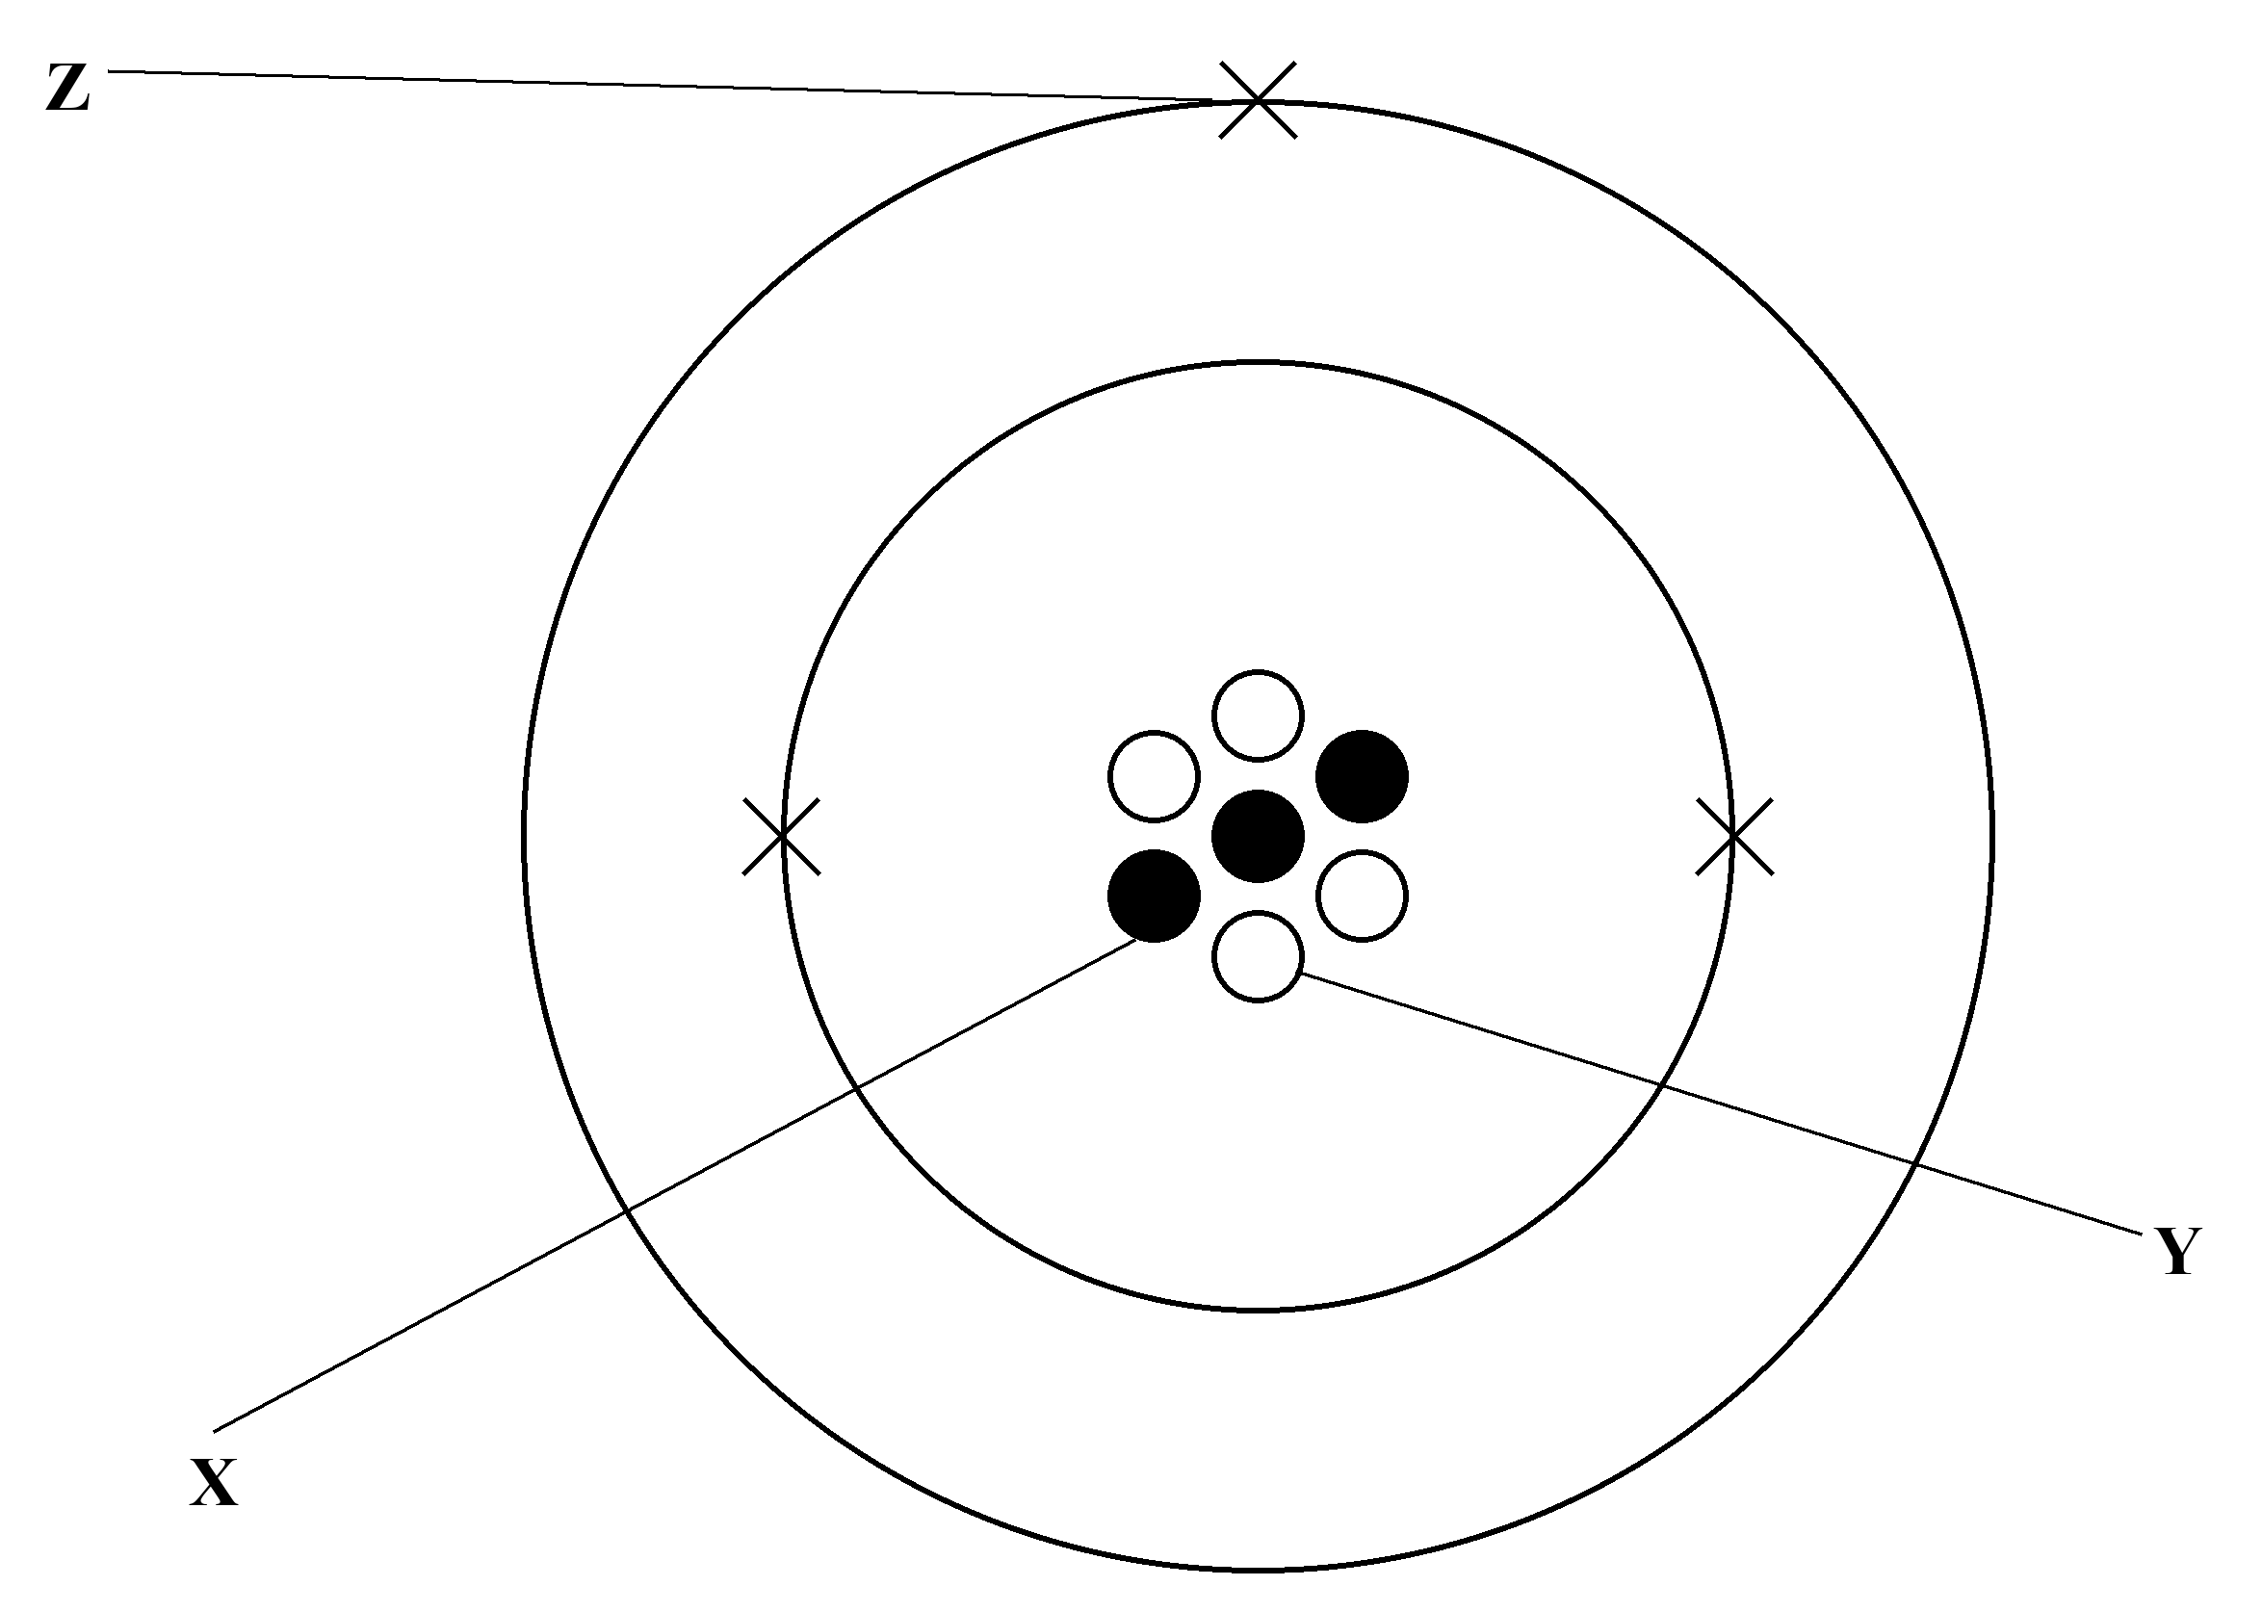
(a) Name the following subatomic particles. (3 marks)
(i) X (1 mark)
________________________________________________________________________
(ii) Y (1 mark)
________________________________________________________________________
(iii) Z (1 mark)
________________________________________________________________________
(b) Write down the FULL ATOMIC SYMBOL of isotope A. (1 mark)
________________________________________________________________________
(c) This element has two naturally occurring isotopes. In another isotope B, the numbers of X, Y and Z are all equal. The ratio of abundance of A to B is 19 : 1
(i) Write down the FULL ATOMIC SYMBOL of isotope B. (1 mark)
________________________________________________________________________
(ii) Calculate the relative atomic mass of this element. (Give your answer in 2 decimal places) (2 marks)
________________________________________________________________________
________________________________________________________________________
________________________________________________________________________
(iii) Explain why isotope A and isotope B have the same chemical properties. (1 mark)
________________________________________________________________________
________________________________________________________________________
(d) In an atom of another element, there are 19 X and 20 Y.
(i) What is the number of Z? (1 mark)
________________________________________________________________________
(ii) State the electronic arrangement of this element. (1 mark)
________________________________________________________________________

(e) Tom claims that X, Y and Z are present in all atoms. Comment on his statement. (1 mark)
________________________________________________________________________
________________________________________________________________________
(f) Do you expect isotope A to carry net charge? Explain your answer. (1 mark)
________________________________________________________________________
________________________________________________________________________

21. The atomic number of element Q is 14. It has three naturally occurring isotopes.
Isotope of Q | Number of neutrons | Relative abundance / %
Q1 | 14 | 92.2%
Q2 | 15 | 4.7%
Q3 | 16 | 3.1%
(a) State the meaning for each of the following terms.
(i) Atom (1 mark)
________________________________________________________________________
________________________________________________________________________
(ii) Isotope (1 mark)
________________________________________________________________________
________________________________________________________________________
(b) Refer to the above table, calculate the relative atomic mass of Q. (2 marks)
________________________________________________________________________
________________________________________________________________________
________________________________________________________________________
- Draw the electron diagram for an atom of Q, showing electrons in the outermost shells only. (1 mark)

22. The electronic arrangement of element Q is 2, 8. It has three naturally occurring isotopes.
(a) State the meaning of the term ‘isotopes’. (1 mark)
________________________________________________________________________
________________________________________________________________________
(b) What is the name of element Q? (1 mark)
________________________________________________________________________
- Refer to the following table, calculate the relative atomic mass of Q. (2 marks)
Isotope of Q | Number of neutrons | Relative abundance / %
Q1 | 10 | 90.48
Q2 | 11 | 0.27
Q3 | 12 | 9.25
________________________________________________________________________
________________________________________________________________________
________________________________________________________________________

Answer
1.
Atomic  number | Mass  number | No. of  proton | No. of  neutron | No. of  electron | Name of element | Full atomic  symbol
1 | 1 | 1 | 0 | 1 | Hydrogen | ¹₁H
2 | 3 | 2 | 1 | 2 | Helium | ³₂He
3 | 7 | 3 | 4 | 3 | Lithium | ⁷₃Li
4 | 9 | 4 | 5 | 4 | Beryllium | ⁹₄Be
5 | 11 | 5 | 6 | 5 | Boron | ¹¹₅B
6 | 12 | 6 | 6 | 6 | Carbon | ¹²₆C
7 | 14 | 7 | 7 | 7 | Nitrogen | ¹⁴₇N
8 | 16 | 8 | 8 | 8 | Oxygen | ¹⁶₈O
9 | 19 | 9 | 10 | 9 | Fluorine | ¹⁹₉F
10 | 20 | 10 | 10 | 10 | Neon | ²⁰₁₀Ne
11 | 23 | 11 | 12 | 11 | Sodium | ²³₁₁Na
12 | 24 | 12 | 12 | 12 | Magnesium | ²⁴₁₂Mg
13 | 27 | 13 | 14 | 13 | Aluminium | ²⁷₁₃Al
14 | 28 | 14 | 14 | 14 | Silicon | ²⁸₁₄Si
15 | 31 | 15 | 16 | 15 | Phosphorus | ³¹₁₅P
16 | 32 | 16 | 16 | 16 | Sulphur | ³²₁₆S
17 | 35 | 17 | 18 | 17 | Chlorine | ³⁵₁₇Cl
18 | 40 | 18 | 22 | 18 | Argon | ⁴⁰₁₈Ar
19 | 39 | 19 | 20 | 19 | Potassium | ³⁹₁₉K
20 | 40 | 20 | 20 | 20 | Calcium | ⁴⁰₂₀Ca
(20 marks) Element names and symbols from the atomic-number table; no. of protons = atomic number; no. of electrons = no. of protons in a neutral atom; mass number = no. of protons + no. of neutrons.
Source: topic-02-microscopic-world-i.pdf p.1
2.
(a) (i) electron (ii) neutron (iii) proton (iv) nucleus
Source: p.1 (Cross/Black/White/Position)
(b) 7
Source: p.1 Atomic number (No. of protons) — Nitrogen
(c) 14
(d) Atoms are electrically neutral because the number of positively charged protons is equal to the number of negatively charged electrons
Source: p.1 Note 3
(e) (i) N
Source: p.1
(e) (ii) Nitrogen
Source: p.1
3.
(a) No. Atoms are electrically neutral because the number of positively charged protons is equal to the number of negatively charged electrons
Source: p.1 Note 3
(b) Electron
Source: p.1 Position: Moving around nucleus
(c) Proton; Neutron
Source: p.1 Position: Nucleus
(d) An atom is mostly empty space. Mass is concentrated in the nucleus of an atom. (Relative mass of proton = 1; neutron = 1; electron = Negligible)
Source: p.1 Note 1 + Subatomic particle table
4.
(a) (i) Cross = electron (Cross moves around nucleus)
Source: p.1 Full atomic symbol notes
(a) (ii) Black dot = proton (Black dot is inside the nucleus, and the numbers of black dot and cross are equal)
Source: p.1
(a) (iii) White dot = neutron (White dot is inside the nucleus)
Source: p.1
(b) ²⁰₁₀Ne
Source: p.1 Neon, atomic number 10
(c) Atoms are electrically neutral because the number of positively charged protons is equal to the number of negatively charged electrons
Source: p.1 Note 3
(d) Protons and electrons exist in ALL atoms, but not neutrons (e.g. ¹₁H atom does not have neutrons)
Source: p.1 Note 2
5.
(a) X and Y. They have the same number of protons.
Source: p.1 Atomic number = No. of protons; p.2 Isotopes
(b) Oxygen
Source: p.1
(c) W: ¹⁵₇N; X: ¹⁶₈O; Y: ¹⁷₈O; Z: ¹⁹₉F
6.
(a) (i) Black dot = proton (Black dot is inside the nucleus, and the numbers of black dot and cross are equal)
Source: p.1
(a) (ii) +1
Source: p.1 Charge of Proton
(b) Atomic number = 13; Mass number = 27
(c) ²⁷₁₃Al
Source: p.1 Aluminium
7.
(a) Protons and electrons exist in ALL atoms, but not neutrons (e.g. ¹₁H atom does not have neutrons)
Source: p.1 Note 2
(b) An atom is mostly empty space. Mass is concentrated in the nucleus of an atom.
Source: p.1 Note 1
(c) Isotopes have SAME chemical properties (NOT SIMILAR) because they are atoms with same electronic arrangement.
Source: p.2 Note
(d) On the ¹²C = 12.00 scale, the relative isotopic mass of an isotope is roughly equal to its mass number. It carries no unit.
Source: p.2
(e) In modern Periodic Table, elements are arranged in increasing atomic number. (NOT mass number)
Source: p.3
8.
Particle | Charge | Relative mass | Position
Proton | +1 | 1 | Nucleus
Neutron | 0 | 1 | Nucleus
Electron | -1 | Negligible | Moving around nucleus
(a) as in completed table above
Source: p.1 Subatomic particle table
(b) (i) Atomic number (No. of protons)
Source: p.1
(b) (ii) 2,8,8,2
Source: p.1 Calcium
(b) (iii) Atoms are electrically neutral because the number of positively charged protons is equal to the number of negatively charged electrons
Source: p.1 Note 3
9.
Element | Description | Name | Element symbol
A | Its atomic number is 15 | Phosphorus | P
B | Its atom has 16 protons | Sulphur | S
C | Its atom has 10 electrons | Neon | Ne
D | The electronic arrangement of its atom is 2,8,8,2 | Calcium | Ca
(a) as in table
Source: p.1
(b) (i) Nitrogen electron diagram — electronic arrangement 2,5
Source: p.1
(b) (ii) Magnesium electron diagram — electronic arrangement 2,8,2
Source: p.1
(b) (iii) Argon electron diagram — electronic arrangement 2,8,8
Source: p.1
(b) (iv) Potassium electron diagram — electronic arrangement 2,8,8,1
Source: p.1
10.
(a) Note that the abundance of ³⁷Cl is 100% – 75.8% = 24.2%. R. A. M. = [(35)(75.8) + (37)(24.2)] / 100 = 35.484
Source: p.2 Example 1
(b) Isotopes are atoms of the element with same number of protons but different number of neutrons
Source: p.2
(c) Number of protons = 17; number of neutrons = 20
Source: p.1 Chlorine atomic number 17
(d) 2,8,7
Source: p.1
(e) No. Isotopes have SAME chemical properties (NOT SIMILAR) because they are atoms with same electronic arrangement. They CANNOT be separated by chemical methods.
Source: p.2 Note
11.
Let x% be the abundance of ²⁵Mg while y% be the abundance of ²⁶Mg. Since 78.6 + x + y = 100, y = 21.4 – x. 24.327 = [(24)(78.6) + (25)(x) + (26)(21.4 − x)] / 100. x = 10.1 (The abundance of ²⁵Mg is 10.1%)
Source: p.2 Example 2
12.
Note that the abundance of ˣBr is 100% – 50.6% = 49.4%. 79.988 = [(79)(50.6) + (x)(49.4)] / 100. x = 81 (The isotopic mass of ˣBr is 81)
Source: p.2 Example 3
13.
(a) (i) Fluorine electron diagram — electronic arrangement 2,7
Source: p.1
(a) (ii) Sulphur electron diagram — electronic arrangement 2,8,6
Source: p.1
(b) Isotopes are atoms of the element with same number of protons but different number of neutrons
Source: p.2
(c) A fluorine atom has atomic number 9 (9 protons) and electronic arrangement 2,7 (9 electrons). For fluorine-19, number of neutrons = 19 − 9 = 10. Proton: Relative mass 1, Charge +1, Position Nucleus. Neutron: Relative mass 1, Charge 0, Position Nucleus. Electron: Relative mass Negligible, Charge −1, Position Moving around nucleus.
Source: p.1
14.
(a) Relative atomic mass = (6)(0.0759) + (7)(1 − 0.0759) = 6.92
(b) 24.32 = (24)(0.79) + (25)(x/100) + (26)((100 − x − 79)/100); x = 10
(c) 28.11 = (28)(0.922) + (29)(0.047) + (n)(0.031); n = 30
(d) Relative atomic mass = (63)(0.75) + (65)(0.25) = 63.5
(e) On the ¹²C = 12.00 scale, the relative isotopic mass of an isotope is roughly equal to its mass number. Estimate = 19
Source: p.2
15.
(a) Isotopes are atoms of the element with same number of protons but different number of neutrons
Source: p.2
(b) (i) Number of protons = 14; number of neutrons = 28 − 14 = 14
Source: p.1 Silicon
(b) (ii) 28 (On the ¹²C = 12.00 scale, the relative isotopic mass of an isotope is roughly equal to its mass number.)
Source: p.2
(b) (iii) (100 − 92.23 − 4.68)% = 3.09%
(b) (iv) Relative atomic mass of Si = 28 × 92.23% + 29 × 4.68% + 30 × 3.09% = 28.1
Source: p.2 (weighted average definition)
(b) (v) Silicon electron diagram — electronic arrangement 2,8,4
Source: p.1
16.
(a) Relative atomic mass is the weighted average of the relative isotopic masses of all of its naturally occurring isotopes of the ¹²C = 12.00 scale
Source: p.2
(b) 107 × 0.55 + 109 × 0.45 = 107.9
(c) No. Isotopes have SAME chemical properties (NOT SIMILAR) because they are atoms with same electronic arrangement. They CANNOT be separated by chemical methods.
Source: p.2 Note
17.
(a) X: ²⁹₁₄Si; Y: ³⁰₁₄Si; Z: ²⁸₁₄Si
Source: p.1 Silicon atomic number 14
(b) (29)(0.056) + (30)(a) + (28)(1 − 0.056 − a) = 28.1; a = 0.022 (2.2%)
18.
(a) 2,8,18,1
Source: p.3 Copper 29Cu
(b) (i) (63)(x) + (65)(1 − x) = 63.5; x = 0.75 (75%)
(b) (ii) (30624700)(25%) = 7656175
19.
Atom | No. of proton | No. of neutron | No. of electron | Relative abundance
²⁵Mg | 12 | 13 | 12 | 11.0%
²⁶Mg | 12 | 14 | 12 | 10.0%
²⁴Mg / ᵃMg | 12 | 12 | 12 | 79.0%
(a) as in completed table (Mg atomic number 12)
Source: p.1
(b) a = 12 + 12 = 24
(c) (24)(0.79) + (25)(0.11) + (26)(0.10) = 24.31
(d) Magnesium electron diagram — electronic arrangement 2,8,2
Source: p.1
(e) Same observation. Isotopes have SAME chemical properties (NOT SIMILAR) because they are atoms with same electronic arrangement.
Source: p.2 Note
(f) isotopes have slightly different physical properties (e.g. mass)
Source: p.2 Note
20.
(a) (i) X = proton (ii) Y = neutron (iii) Z = electron
Source: p.1
(b) ⁷₃Li
Source: p.1 Lithium
(c) (i) ⁶₃Li
(c) (ii) (7)(19/20) + (6)(1/20) = 6.95
(c) (iii) Isotopes have SAME chemical properties (NOT SIMILAR) because they are atoms with same electronic arrangement.
Source: p.2 Note
(d) (i) 19 (electrically neutral atom: electrons = protons)
(d) (ii) 2,8,8,1
Source: p.1 Potassium
(e) Wrong. Protons and electrons exist in ALL atoms, but not neutrons (e.g. ¹₁H atom does not have neutrons)
Source: p.1 Note 2
(f) No. Atoms are electrically neutral because the number of positively charged protons is equal to the number of negatively charged electrons
Source: p.1 Note 3
21.
(a) (i) Atom is the smallest part of an element which has the chemical properties of that element.
Source: p.1
(a) (ii) Isotopes are atoms of the element with same number of protons but different number of neutrons
Source: p.2
(b) R.A.M. = (28)(92.2%) + (29)(4.7%) + (30)(3.1%) = 28.109
(c) Silicon electron diagram (outermost shell only) — 4 outermost electrons; electronic arrangement 2,8,4
Source: p.1
22.
(a) Isotopes are atoms of the element with same number of protons but different number of neutrons
Source: p.2
(b) Neon
Source: p.1 Neon electronic arrangement 2,8
(c) Relative atomic mass of Q = (20)(90.48%) + (21)(0.27%) + (22)(9.25%) = 20.2

