Topic 01 Part 1 Set 3

1. Draw the vertical section diagrams of the following laboratory apparatus:
(a) Petri dish (b) Separating funnel (c) Burette (d) Pipette
(e) Tap funnel (f) Gas jar (g) Reagent bottle (h) Test tube holder
(i) Crucible tongs (j) Bunsen burner (label the barrel, air hole and gas tap)
(8 marks)

2. Name the following apparatus.
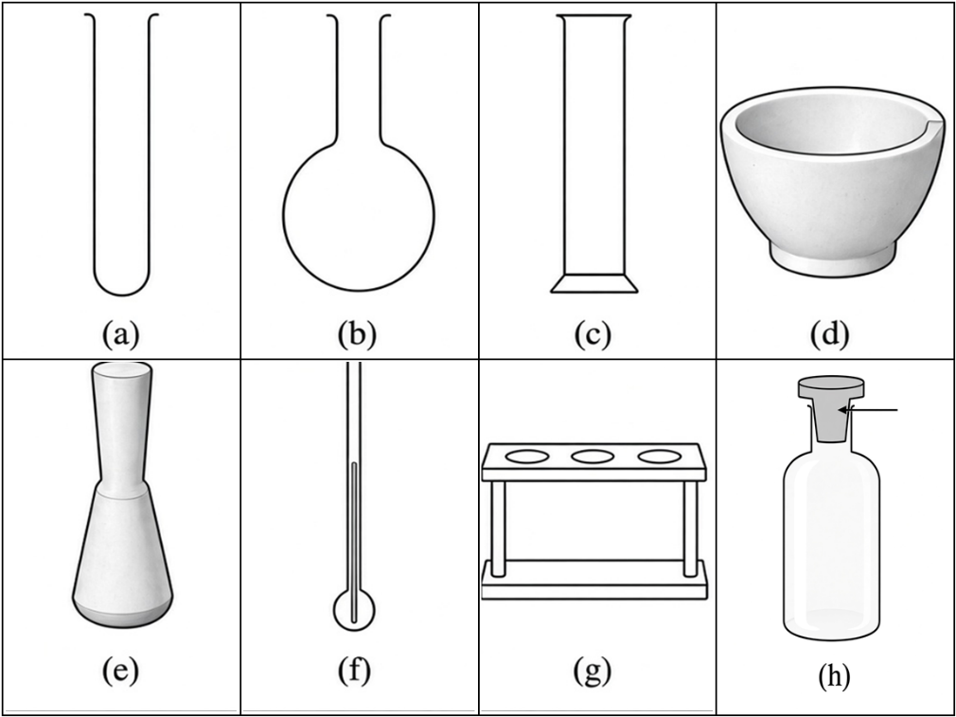
(a) ____________________ (b) ____________________
(c) ____________________ (d) ____________________
(e) ____________________ (f) ____________________
(g) ____________________ (h) ____________________
(8 marks)
3. The diagram below shows an experimental set-up for collecting a gas by displacement of water.
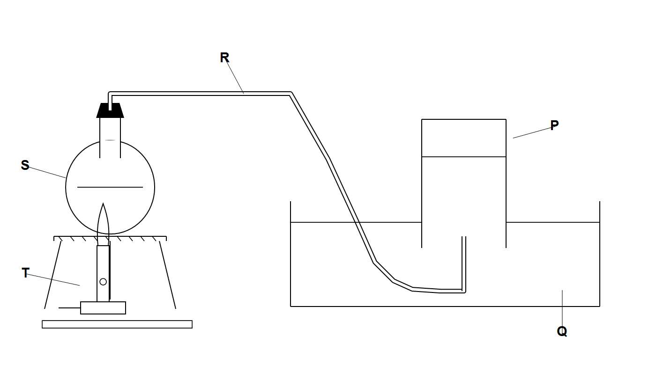

(a) Name the apparatus labelled as P, Q, R, S and T.
P = ____________________ Q = ____________________
R = ____________________ S = ____________________
T = ____________________
(5 marks)
(b) State ONE disadvantage of collecting a gas by this method.
________________________________________________
(1 mark)

4. The diagram below shows a set-up for heating a flammable liquid safely.
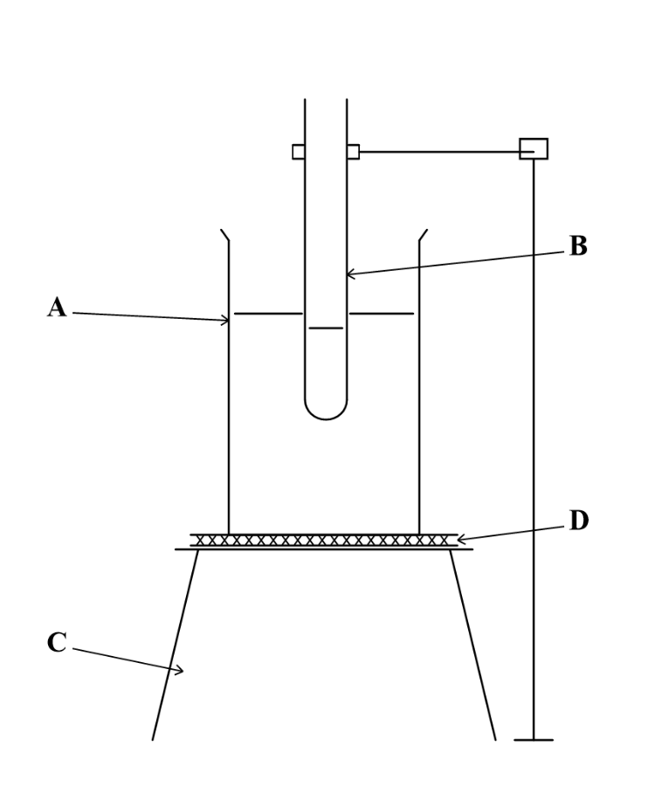

Name the apparatus labelled as A, B, C and D.
A = ____________________ B = ____________________
C = ____________________ D = ____________________
(4 marks)

5. Below are eight pieces of common apparatus in the school laboratory.
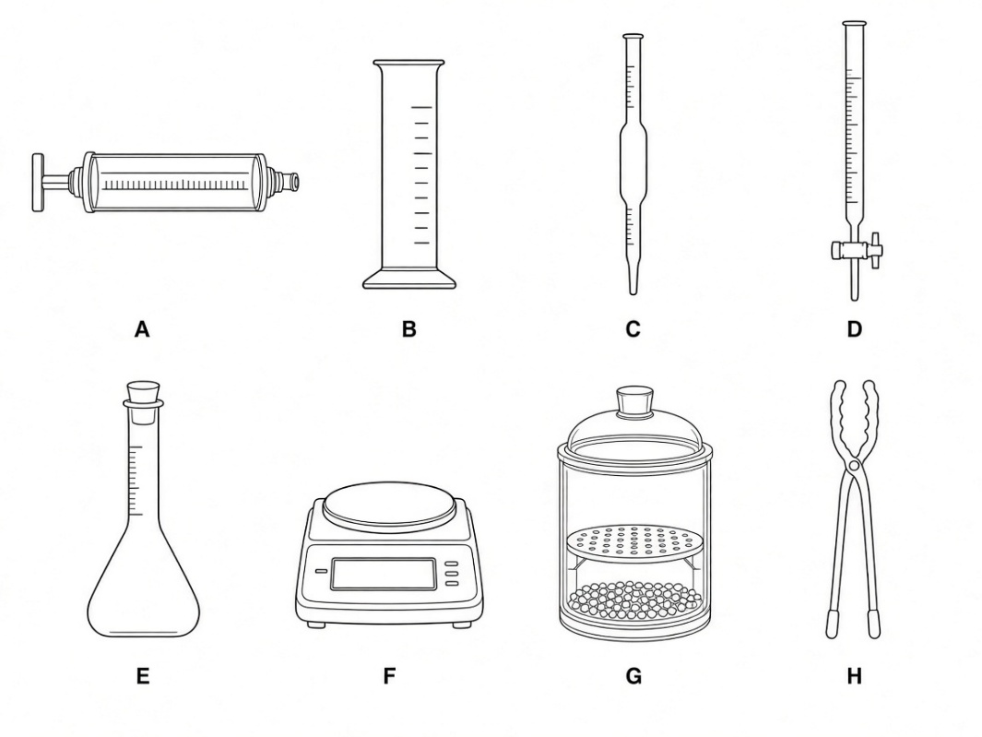
(a) Name each piece of apparatus from A to H.
A: ____________________ B: ____________________
C: ____________________ D: ____________________
E: ____________________ F: ____________________
G: ____________________ H: ____________________
(8 marks)
(b) Which piece(s) of apparatus would you use for each of the following purposes?
(i) Measuring exactly 25.0 cm3 of a solution for titration.
________________________________________________
(1 mark)
(ii) Picking up a hot crucible after strong heating.
________________________________________________
(1 mark)
(iii) Preparing a standard solution of known volume accurately.
________________________________________________
(1 mark)
(iv) Collecting and measuring the volume of carbon dioxide produced in a reaction.
________________________________________________
(1 mark)

6. Hazard warning labels are often found on reagent bottles containing chemicals.
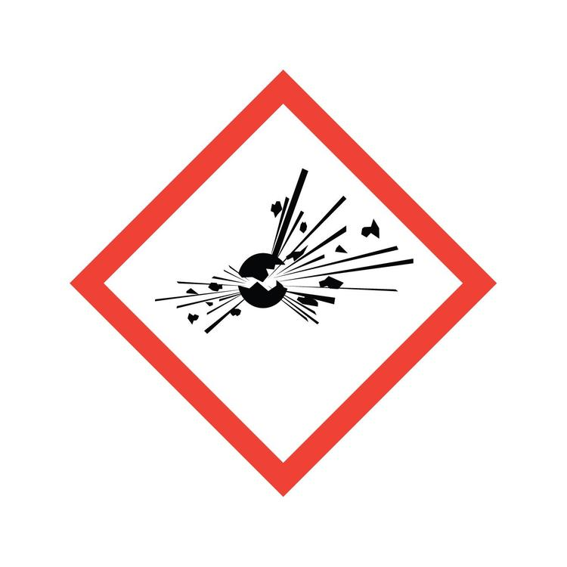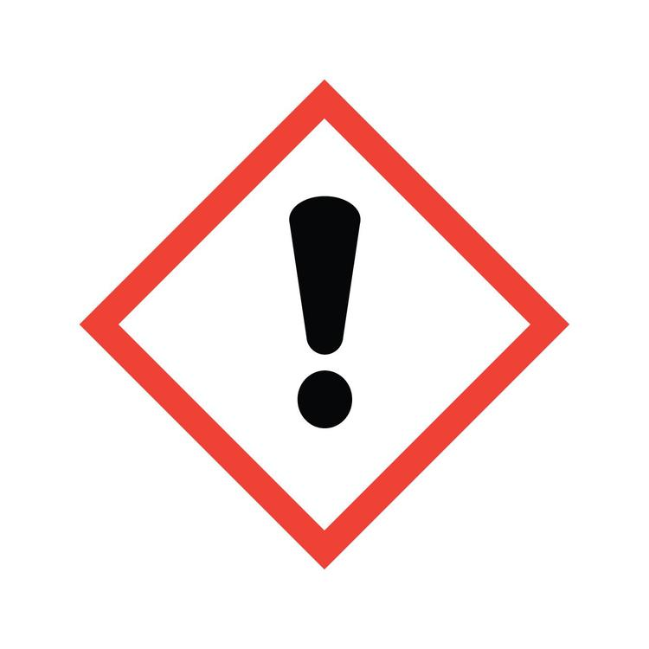
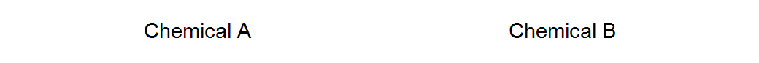
(a) State the hazardous nature of each chemical shown above.
Chemical A: ________________________________________________
Chemical B: ________________________________________________
(2 marks)
(b) Give ONE example of each type of chemical from common laboratory chemicals.
Chemical A: ________________________________________________
Chemical B: ________________________________________________
(2 marks)
(c) Give ONE precaution you should take when handling each type of chemical.
Chemical A: ________________________________________________
Chemical B: ________________________________________________
(2 marks)
7. A bottle of concentrated nitric acid is stored in a brown bottle as shown below.
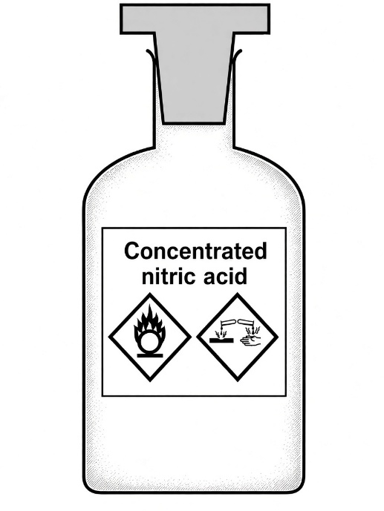

(a) Why is concentrated nitric acid kept in a brown bottle?
________________________________________________
(1 mark)
(b) State TWO hazardous natures of concentrated nitric acid.
________________________________________________
(2 marks)
(c) What should be done if concentrated nitric acid is accidentally spilt onto the skin?
________________________________________________
________________________________________________
(2 marks)

8**. (a) Bromine is a toxic and corrosive substance. (DIFFICULT)
Suggest TWO safety precautions that should be taken when working with bromine in the laboratory.
1. ________________________________________________
2. ________________________________________________
(2 marks)
(b) Carbon monoxide is a toxic gas.
(i) Draw a hazard warning label that should be associated with carbon monoxide.

(1 mark)
(ii) Suggest ONE safety precaution when working with carbon monoxide. Explain your answer.
________________________________________________
________________________________________________
(2 marks)
9. A student tried to collect ammonia gas by downward delivery (upward displacement of air) as shown below.
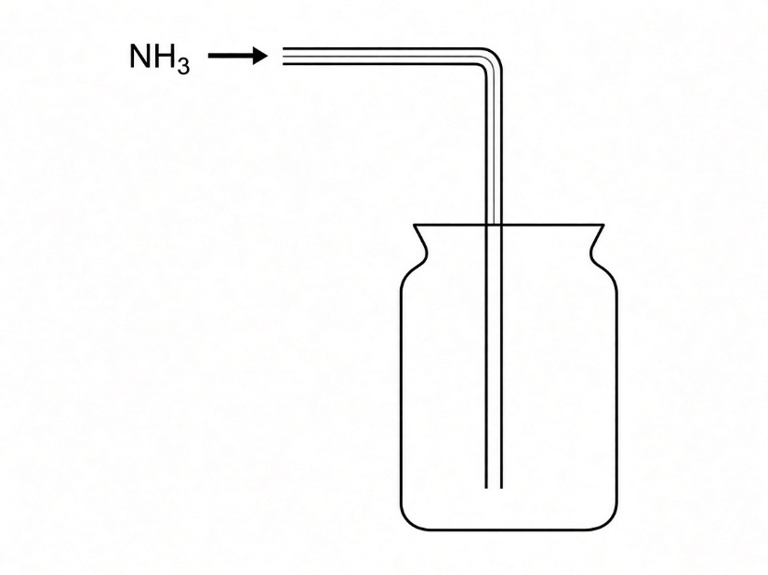

(a) State the mistake in the student's method of collecting ammonia.
________________________________________________
(1 mark)
(b) Describe the correct method to collect ammonia by displacement of air.
________________________________________________
(1 mark)
(c) Explain, in terms of density relative to air, why your answer in (b) is correct. (Molar mass of air is about 28.)
________________________________________________
________________________________________________
(2 marks)

10**. Mary heated a non-flammable liquid in a test tube as shown below. (DIFFICULT)
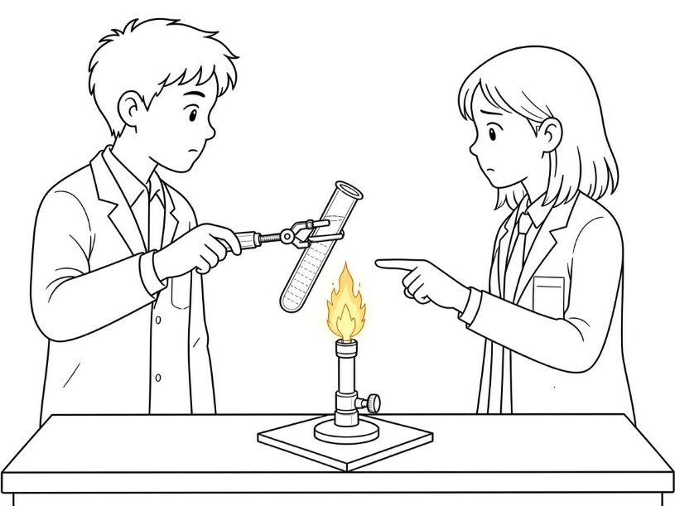
Mary made FOUR mistakes when conducting the experiment. List them out.
1. ________________________________________________
2. ________________________________________________
3. ________________________________________________
4. ________________________________________________
(4 marks)

11**. Study the following diagrams. For each of them, write down one aspect you consider UNSAFE / INCORRECT in the laboratory and explain. (DIFFICULT)
(a)
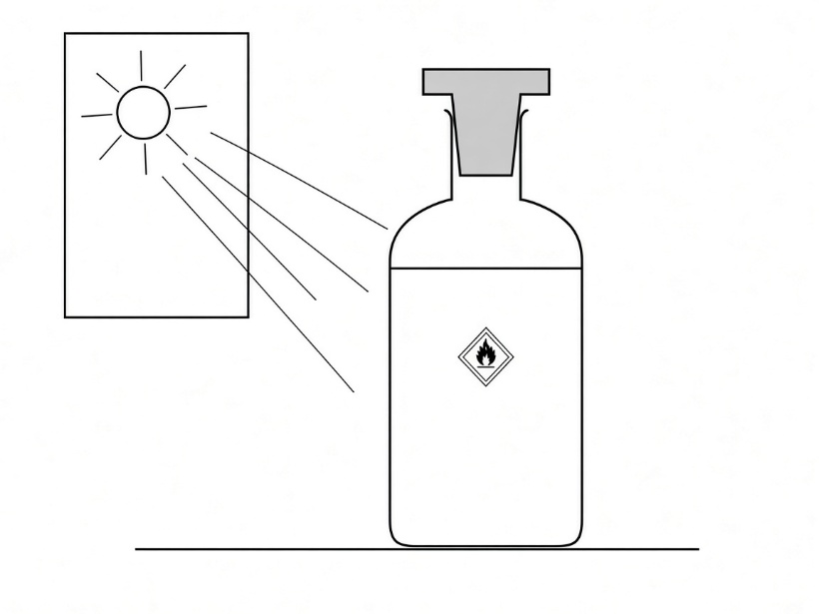
1. ________________________________________________
2. ________________________________________________
(b)
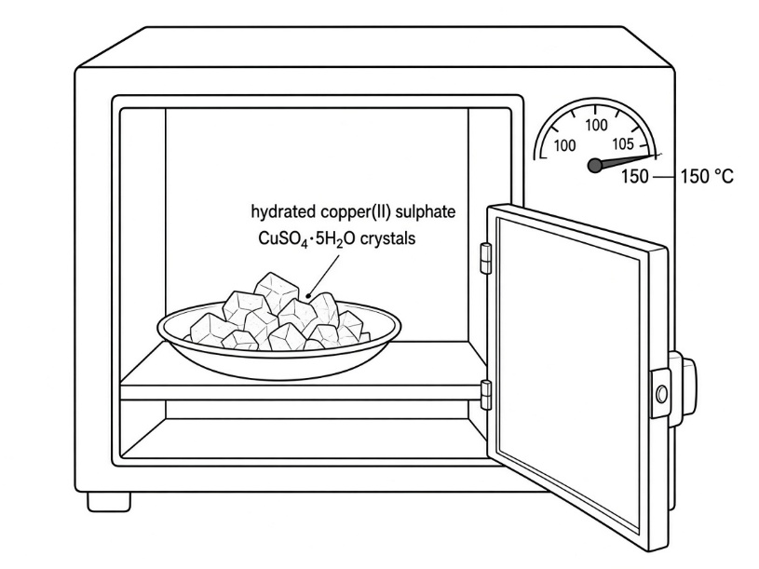
1. ________________________________________________
2. ________________________________________________
(c)
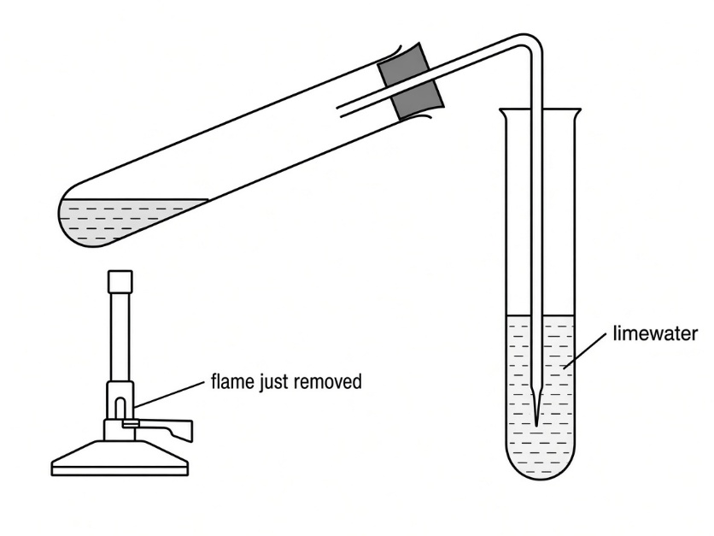
1. ________________________________________________
2. ________________________________________________
(6 marks)

12**. Study the following diagrams. For each of them, write down an aspect you consider UNSAFE / INCORRECT in the laboratory and explain why. (DIFFICULT)
(a)
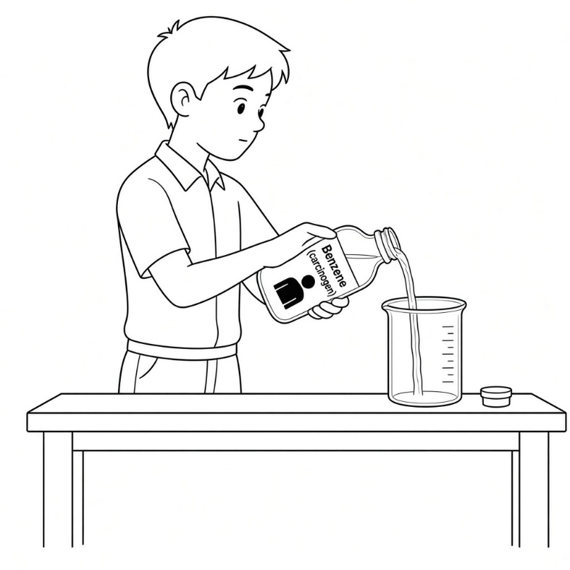
________________________________________________
________________________________________________
(b)
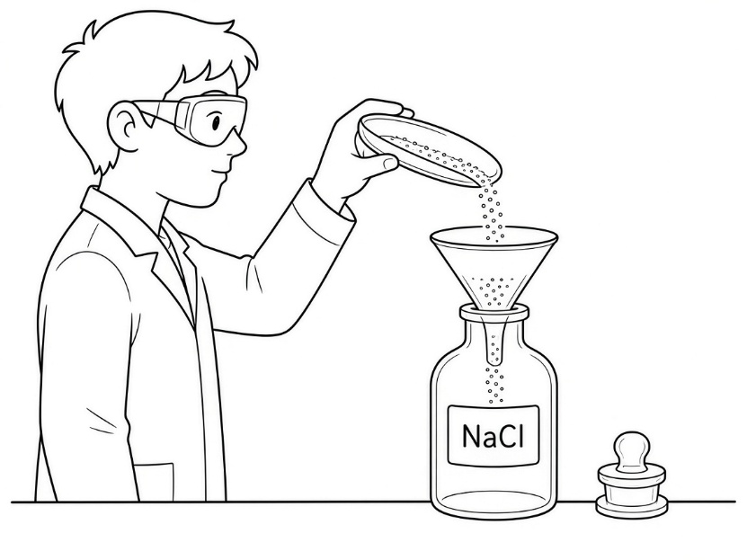
________________________________________________
________________________________________________
(c)
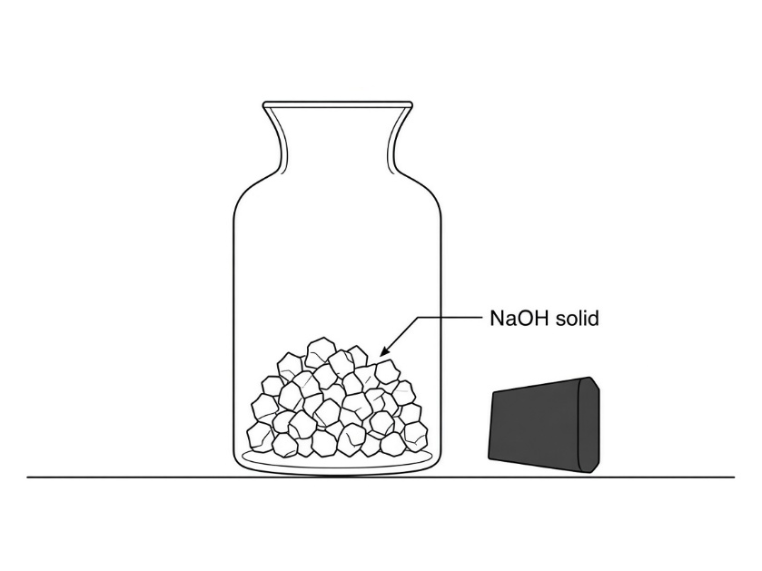
________________________________________________
________________________________________________
(6 marks)
13. (a) Describe the correct procedure for lighting a Bunsen burner.
________________________________________________
________________________________________________
________________________________________________
(3 marks)
(b) Complete the following table.
Air hole Colour of flame Temperature of flame Completeness of burning
Luminous flame ______________ ______________ ______________ ______________
Non-luminous flame ______________ ______________ ______________ ______________
(4 marks)

Answer

1.
(refer to notes)
2.
(a) Boiling tube (b) Round-bottomed flask (c) Measuring cylinder (d) Mortar
(e) Pestle (f) Thermometer (g) Test tube rack (h) Rubber stopper 8

3. (a) P = gas jar Q = (pneumatic) trough / water trough R = delivery tube S = (reaction) flask / boiling tube T = Bunsen burner 5
(b) The gas collected is wet / not suitable for gases that are soluble in water. 1

4. A = beaker (water-bath) B = test tube / boiling tube C = tripod D = wire gauze 4

5. (a) A: Gas syringe B: Measuring cylinder C: Pipette D: Burette
E: Volumetric flask F: Electronic balance G: Desiccator H: Crucible tongs 8
(b) (i) C (pipette) / D (burette) 1
(ii) H 1
(iii) E 1
(iv) A 1

6. (a) Chemical A - explosive 1
Chemical B - harmful / irritant 1
(b) A: potassium / sodium / ammonium dichromate / 2,4-dinitrophenylhydrazine (Any one) 1
B: dilute mineral acids / aqueous ammonia / iodine / oxalic acid (Any one) 1
(c) A: keep away from heat and naked flames / avoid shock or friction / stopper container properly 1
B: Wear safety goggles / Wear protective gloves / Wear lab coat 1

7. (a) Concentrated nitric acid decomposes quickly in the presence of light / to protect it from light. 1
(b) Oxidizing and corrosive 2
(c) Wash the affected area with running water for at least 3 minutes and go for medical check-up. 2

8. (a) Wear laboratory coat, safety spectacles and gloves. 1
Perform the experiment in a fume cupboard. / Avoid contact with eyes and skin. / Stopper container properly. (1)
(b) (i) Toxic hazard symbol 1
(ii) Perform the experiment in a fume cupboard. 1
Carbon monoxide is toxic / may cause serious health risk or death if breathed in. 1

9. (a) Using downward delivery / collecting as if the gas were denser than air (wrong method for ammonia). 1
(b) Upward delivery / downward displacement of air (gas jar mouth downward). 1
(c) Ammonia has molar mass 17, which is much less than 28, so ammonia is less dense than air and rises / should be collected by upward delivery. 2

10. She did not wear safety goggles. 1
The test tube contained too much liquid (more than one-third full). 1
She used a luminous flame / air hole closed (should use a small non-luminous flame). 1
She pointed the mouth of the test tube towards a classmate / someone. 1

11. (a) Flammable/volatile liquid stored in sunlight / near heat. 1
Liquid may evaporate / catch on fire. 1
(b) Oven temperature too high (above 105 C) for drying a hydrated salt. 1
Water of crystallization may be removed. 1
(c) Delivery tube not removed from the testing solution before removing the flame. 1
Risk of sucking back. 1

12. (a) Handling a carcinogen on the open bench / not in a fume cupboard. 1
Not wearing gloves (and/or lab coat / safety spectacles) / may breathe in vapours. 1
(b) Pouring reagents back to reagent bottle. 1
This may contaminate the chemicals in the reagent bottle. 1
(c) Container of a chemical that absorbs water left unstoppered / open. 1
Sodium hydroxide will absorb moisture from air. 1

13. (a) Close the air hole first. 1
Put a lighted match near the top of the barrel. 1
Then turn on the gas tap. (Open the air hole slowly afterwards if a non-luminous flame is needed.) 1
(b) Luminous: air hole closed; yellow; lower temperature; incomplete burning
Non-luminous: air hole open; blue; higher temperature; more complete burning 4

