Topic 01 Part 1 Set 2

1. Draw the vertical section diagrams of the following laboratory apparatus:
(a) Measuring cylinder (b) Round-bottomed flask (c) Crucible (with lid) (d) Thermometer
(e) Teat pipette (f) Boiling tube (g) Thistle funnel (h) Mortar
(i) Heat-resistant mat (j) Stand and clamp
(8 marks)

2. Name the following apparatus.
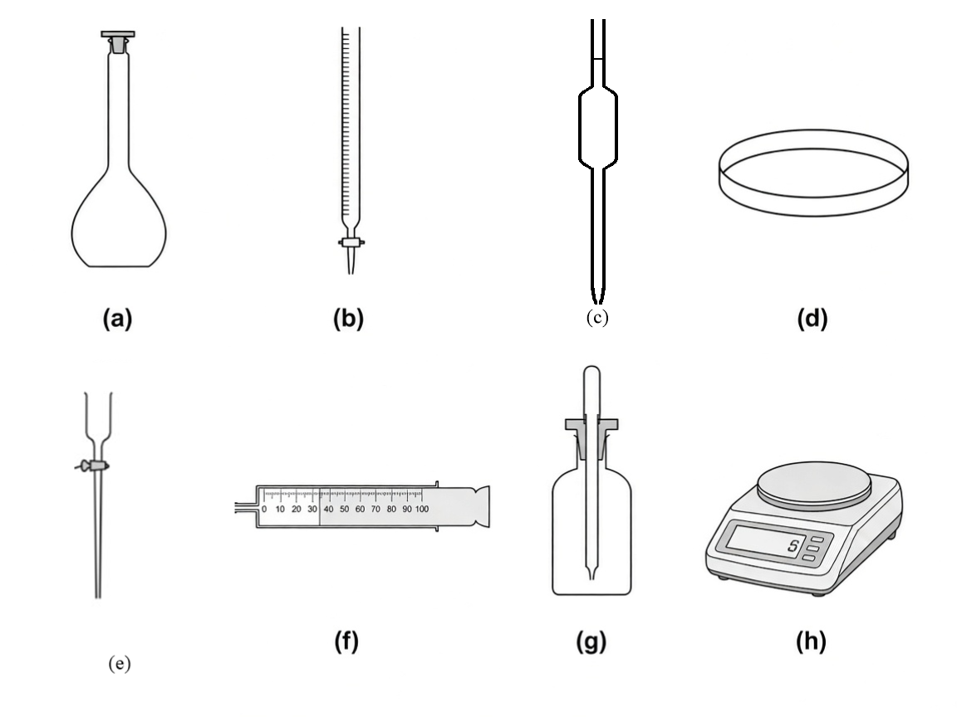
(a) ____________________ (b) ____________________
(c) ____________________ (d) ____________________
(e) ____________________ (f) ____________________
(g) ____________________ (h) ____________________
(8 marks)

3. The diagram below shows an experimental set-up for heating a solid very strongly in the laboratory.
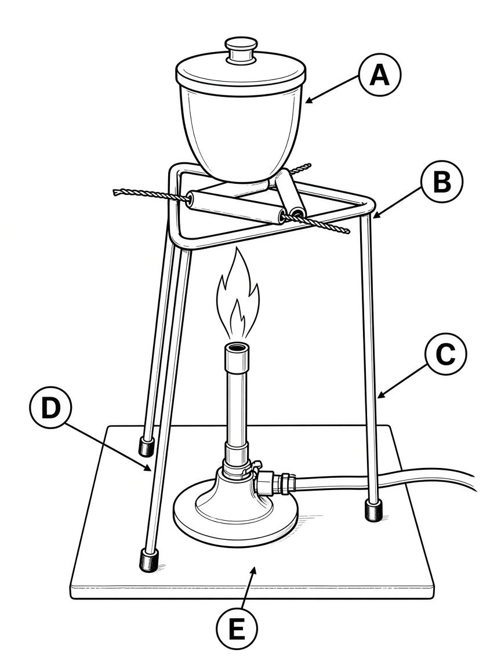
Name the apparatus labelled as A, B, C, D and E.
A = ____________________ B = ____________________
C = ____________________ D = ____________________
E = ____________________
(5 marks)

4. The diagram below shows an experimental set-up for collecting gas.
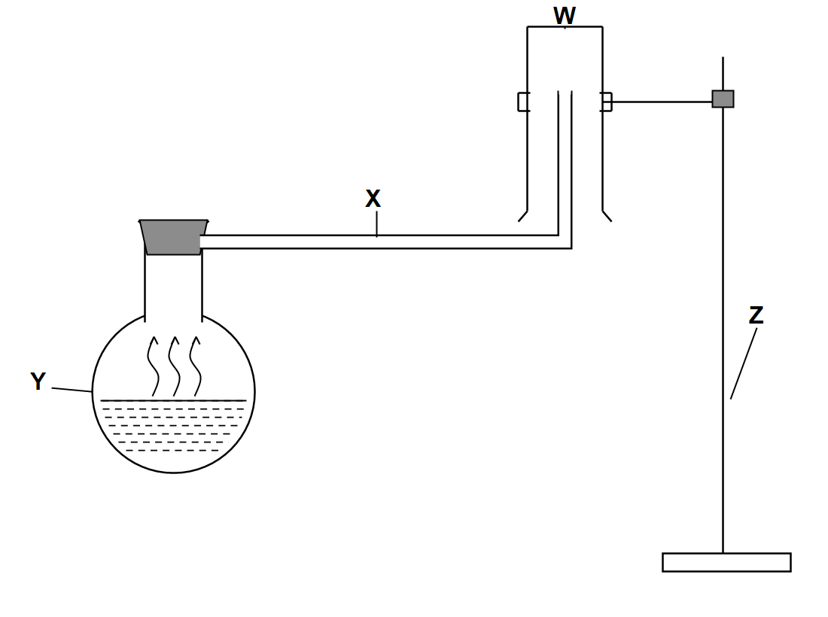
Name the apparatus labelled as W, X, Y and Z.
W = ____________________ X = ____________________
Y = ____________________ Z = ____________________
(4 marks)

5. Name the proper apparatus or instrument which would be used in each of the following:
Step Purpose Apparatus
1 Keep a solid dry using anhydrous calcium chloride ____________________
2 Separate two immiscible liquids ____________________
3 Add liquid during gas preparation while preventing escape of gas ____________________
4 Make a rough measurement of the volume of a liquid ____________________
5 Make an accurate measurement of the volume of a liquid ____________________
6 Grind a solid into fine powder ____________________
7 Measure the temperature of a liquid ____________________
8 Collect any gas (wet or dry) and measure its volume ____________________
9 Temporary storage of a small amount of solid ____________________
10 Weigh a solid without placing chemicals directly on the balance pan ____________________
(10 marks)

6. Below are eight pieces of common apparatus in the school laboratory.
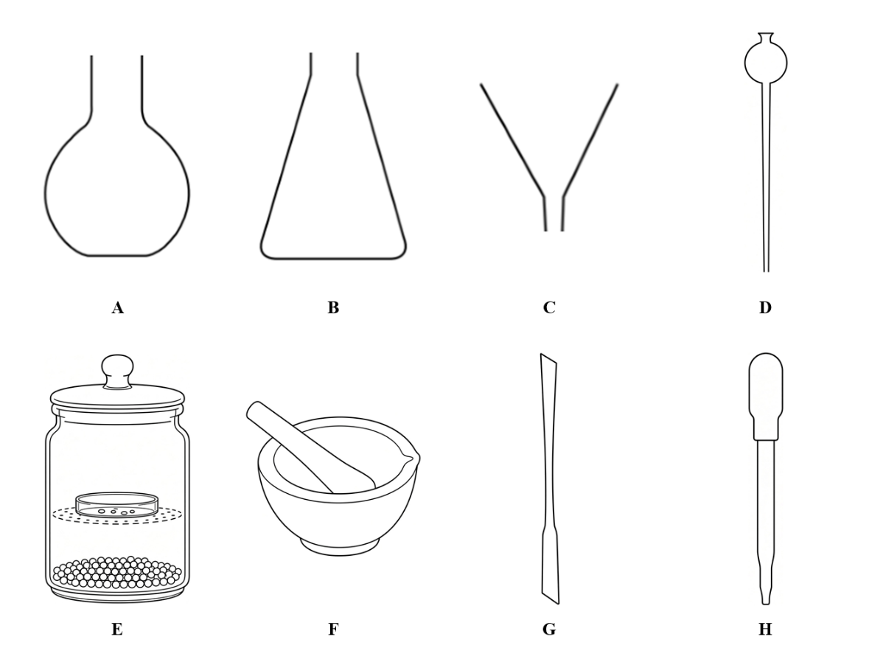
(a) Name each piece of apparatus from A to H.
A: ____________________ B: ____________________
C: ____________________ D: ____________________
E: ____________________ F: ____________________
G: ____________________ H: ____________________
(8 marks)

(b) Which piece(s) of apparatus would you use for each of the following purposes?
(i) Adding concentrated acid slowly into a flask during preparation of a gas, with the stem going below the liquid surface.
________________________________________________
(1 mark)
(ii) Drying freshly prepared crystals by keeping them away from moisture in air.
________________________________________________
(1 mark)
(iii) Transferring a small amount of solid copper(II) sulphate from a bottle into a test tube.
________________________________________________
(1 mark)
(iv) Adding a few drops of indicator into a conical flask.
________________________________________________
(1 mark)

7. Hazard warning labels are often found on reagent bottles containing chemicals.
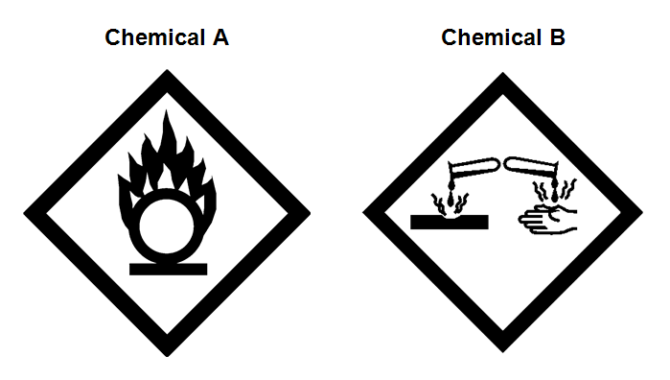
(a) State the hazardous nature of each chemical shown above.
Chemical A: ________________________________________________
Chemical B: ________________________________________________
(2 marks)
(b) Give ONE precaution you should take when handling each of the chemicals. (You may refer to potassium permanganate for A and concentrated sulphuric acid for B.)
Chemical A: ________________________________________________
Chemical B: ________________________________________________
(2 marks)

8. A bottle of ethanol is shown below.
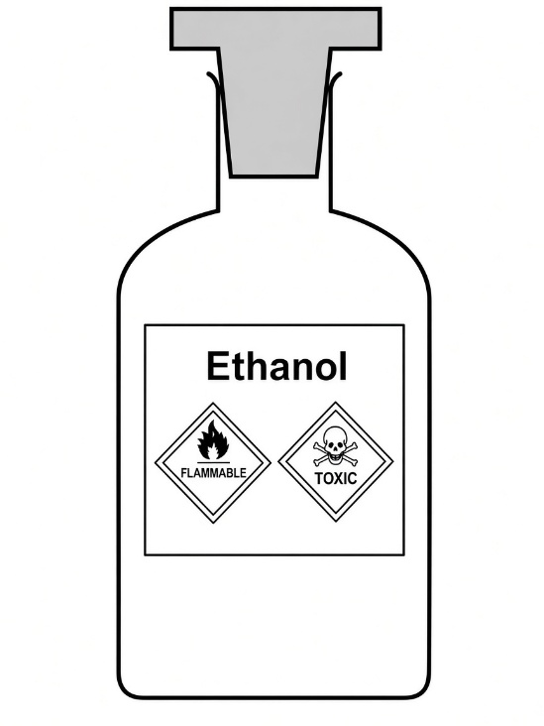
(a) What chemical hazards are associated with ethanol?
________________________________________________
(2 marks)
(b) Suggest TWO safety measures in handling ethanol in the laboratory.
1. ________________________________________________
2. ________________________________________________
(2 marks)
(c) A student lights a Bunsen burner to heat a beaker of water (non-flammable).
(i) State whether the air hole should be open or closed to obtain a non-luminous flame.
________________________________________________
(1 mark)
(ii) Give TWO differences between a luminous flame and a non-luminous flame.
1. ________________________________________________
2. ________________________________________________
(2 marks)
9. (a) Hydrogen sulphide is a toxic gas.
Suggest ONE safety precaution that should be taken when working with hydrogen sulphide in the laboratory. Explain your answer.
________________________________________________
________________________________________________
(2 marks)
(b) Benzene is a known carcinogen.
(i) Suggest why carcinogens should be avoided in school laboratories.
________________________________________________
(1 mark)
(ii) If a carcinogen must be used, state TWO safety precautions that should be taken.
1. ________________________________________________
2. ________________________________________________
(2 marks)

10. Amy heated a solid sample that gives off water vapour during heating. She held the test tube horizontally with the solid forming a shallow layer along the tube.
(a) Explain why Amy's way of holding the test tube was unsuitable.
________________________________________________
________________________________________________
(2 marks)
(b) How should the test tube be held instead? Explain your answer.
________________________________________________
________________________________________________
(2 marks)
(c) Name the apparatus used to hold the test tube during heating.
________________________________________________
(1 mark)

11. Peter strongly heated a solid sample as shown below.
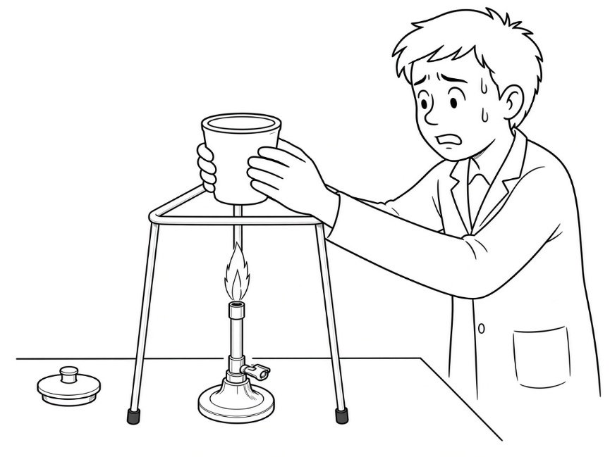
Peter made FOUR mistakes when conducting the experiment. List them out.
1. ________________________________________________
2. ________________________________________________
3. ________________________________________________
4. ________________________________________________
(4 marks)

12. Study the following diagrams. For each of them, write down an aspect you consider UNSAFE / INCORRECT in the laboratory and state the correct method.
(a)
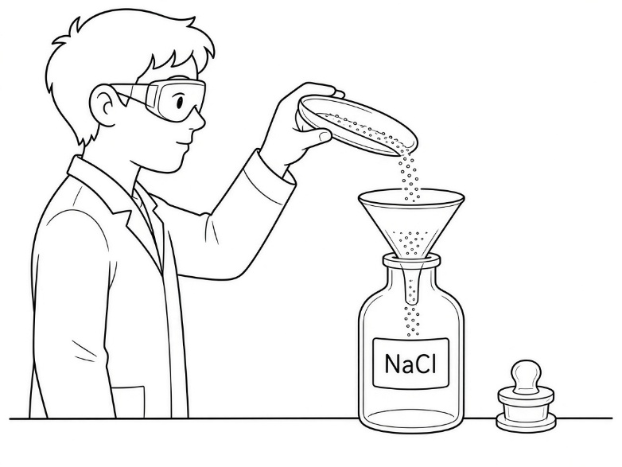

________________________________________________
________________________________________________
(b)
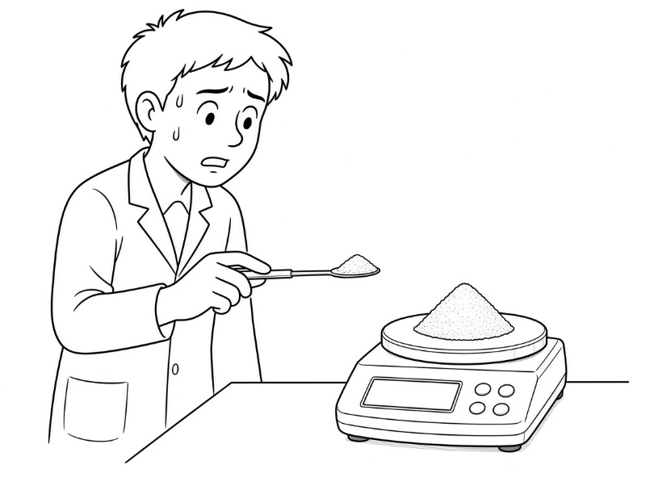
________________________________________________
________________________________________________
(c)
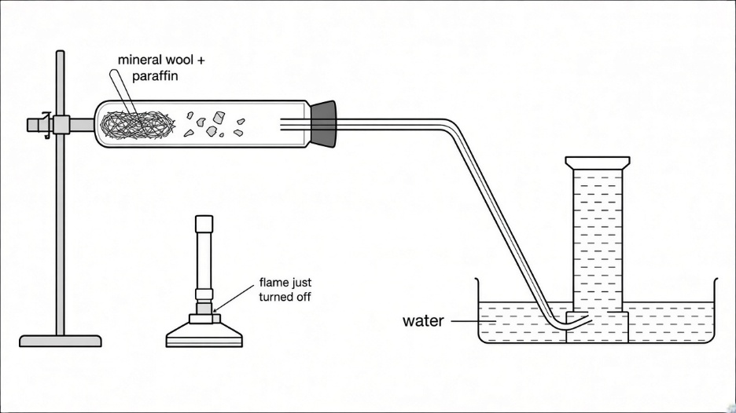
1. ________________________________________________
2. ________________________________________________
(6 marks)

13. Study the following diagrams. For each of them, write down an aspect you consider UNSAFE / INCORRECT in the laboratory. Explain why.
(a)
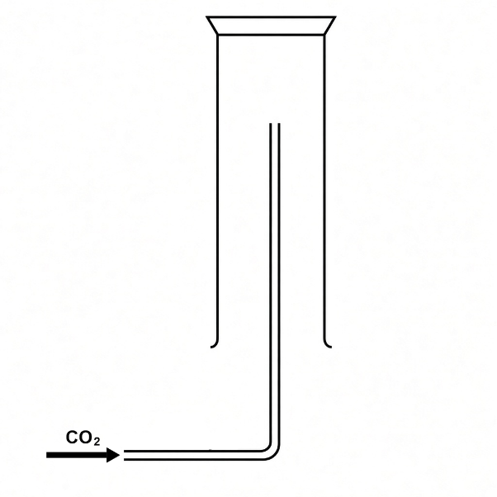
________________________________________________
________________________________________________
(b)
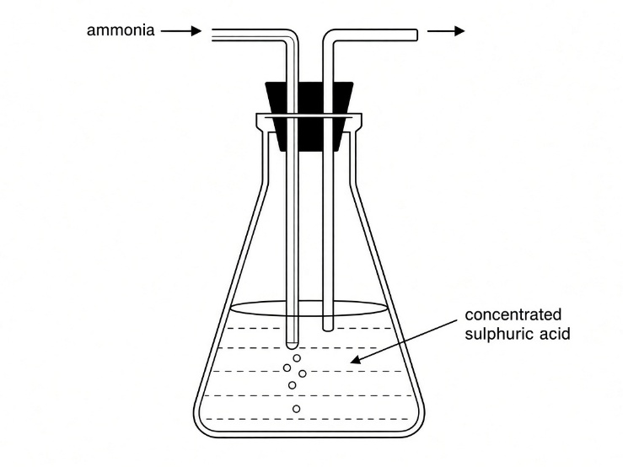
________________________________________________
________________________________________________

(c)
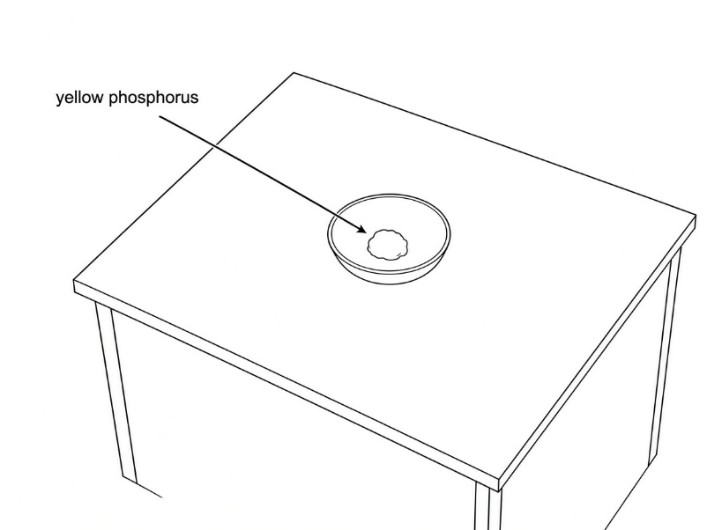
1. ________________________________________________
2. ________________________________________________
(6 marks)

14.
(a) State THREE advantages of carrying out microscale experiments in the school laboratory.
1. ________________________________________________
2. ________________________________________________
3. ________________________________________________
(3 marks)
(b) Sodium and potassium are kept under paraffin oil. Explain why.
________________________________________________
(1 mark)

Answer

1.
(a) Measuring cylinder (b) Round-bottomed flask (c) Crucible (with lid) (d) Thermometer
(e) Teat pipette (f) Boiling tube (g) Thistle funnel (h) Mortar
(i) Heat-resistant mat (j) Stand and clamp

2. 8
(a) Volumetric flask (b) Burette (c) Pipette (d) Petri dish
(e) Tap funnel (f) Gas syringe (g) Dropping bottle (h) Electronic balance / top-loading balance

3. A = crucible (with lid) B = pipe-clay triangle C = tripod D = Bunsen burner E = heat-resistant mat 5

4. W = gas jar X = delivery tube Y = (reaction) flask / test tube (with stopper) Z = stand (and clamp) / support 4

5.
1 Desiccator
2 Separating funnel
3 Tap funnel
4 Measuring cylinder
5 Pipette / burette / volumetric flask
6 Mortar and pestle
7 Thermometer
8 Gas syringe
9 Watch glass / Petri dish
10 Filter paper / weighing bottle (with electronic balance)

6. (a) A: Flat-bottomed flask B: Conical flask C: Filter funnel D: Thistle funnel
E: Desiccator F: Mortar and pestle G: Spatula H: Teat pipette 8
(b) (i) D 1
(ii) E 1
(iii) G 1
(iv) H 1

7. (a) Chemical A - oxidizing / oxidising 1
Chemical B - corrosive 1
(b) Chemical A - keep away from heat and naked flames / keep away from combustible and flammable chemicals / make sure the container is properly stoppered 1
Chemical B - wear laboratory coat, safety spectacles and gloves / avoid contact with eyes and skin / perform experiment in fume cupboard / keep container properly stoppered 1

8. (a) Flammable and toxic 2
(b) Wear safety spectacles and/or protective gloves. 1
Keep away from heat / naked flames. / Handle in a fume cupboard. / Stopper the bottle properly. (1)
(c) (i) Open 1
(ii) Luminous: yellow / lower temperature / incomplete combustion / air hole closed;
Non-luminous: blue / higher temperature / more complete combustion / air hole open (Any two contrasting points) 2

9. (a) Perform the experiment in a fume cupboard. 1
Hydrogen sulphide is toxic / may cause serious health risk or death if breathed in. 1
(b) (i) Carcinogens may cause cancer / involve serious health risk / should avoid using carcinogens at schools. 1
(ii) Wear laboratory coat, safety spectacles and gloves. 1
Perform the experiment in a fume cupboard. / Avoid breathing in vapours. / Stopper container properly. (1)

10. (a) Condensed water at the mouth may run back onto the hot glass and crack the test tube. 2
(b) Hold the test tube slightly sloping downwards (mouth lower than the closed end), so that condensed water does not run back onto the hot glass. 2
(c) Test tube holder 1

11. The crucible was not supported on a pipe-clay triangle / crucible placed directly on the tripod. 1
No heat-resistant mat under the Bunsen burner. 1
Trying to pick up the hot crucible with bare hands / should use crucible tongs. 1
The crucible lid was not used / left aside during strong heating. 1

12. (a) Putting unused chemicals back into the reagent bottle. 1
Pour unused chemicals into another bottle instead. 1
(b) Placing chemicals directly on the balance pan. May corrode or contaminate the pan . 1
Should use filter paper or a weighing bottle. 1
(c) Delivery tube not removed from water before heating stopped, risk of sucking back of water into the hot vessel. 1
Remove delivery tube from water before turning off the heat. 1

13. (a) Wrong collection method for a dense gas. 1
Should use downward delivery (upward displacement of air). 1
(b) Concentrated sulphuric acid should not be used to dry ammonia. 1
Ammonia is basic and reacts with concentrated sulphuric acid / should use anhydrous calcium oxide. 1
(c) Yellow phosphorus exposed to air / not kept under water. 1
Yellow phosphorus is flammable and may catch fire. 1

14. (a) Reduce the amount of chemicals used. 1
Reduce chemical wastes. / Save cost of chemicals. / Complete experiment in a shorter time. / Minimize chemical hazards. (Any three) 2
(b) To prevent contact / reaction with air. 1

