Topic 01 Part 2 set 2
1. Classify each of the pictures below by placing the correct label in the blanks below:
A = Element
B = Compound
C = Mixture of elements
D = Mixture of compounds
E = Mixture of elements and compounds
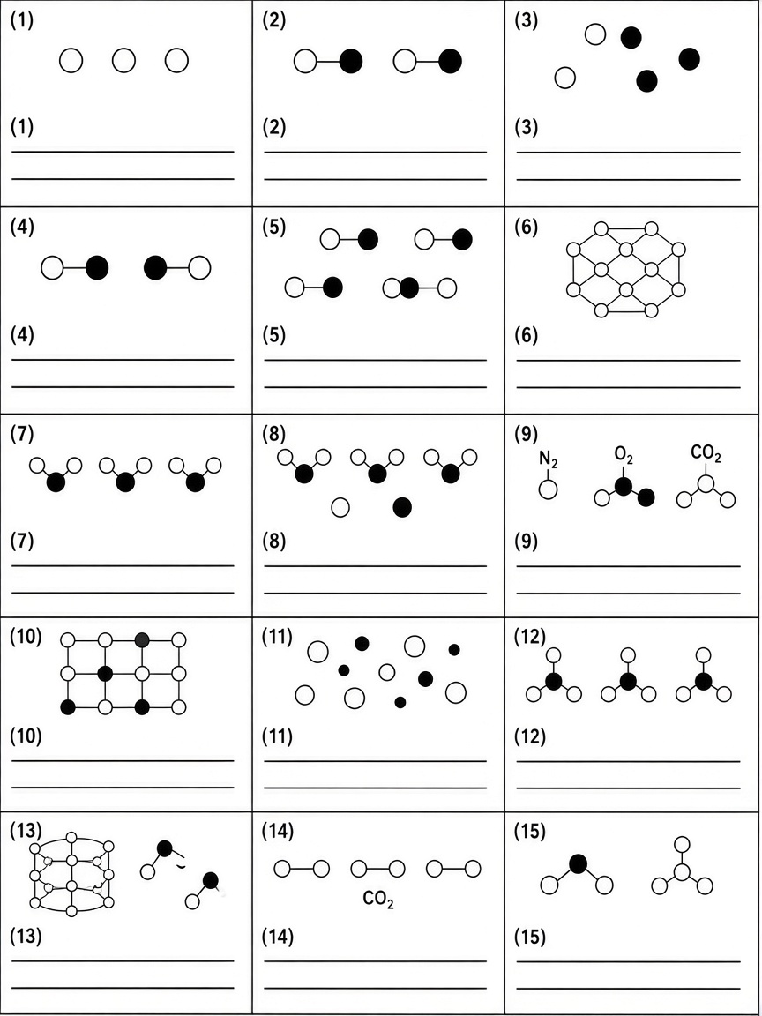
(15 marks)
2. The following shows ten pure substances.
Ammonia Oxygen Chlorine Sodium Hydrogen
Sodium chloride Iron Sulphur Mercury Water
(a) (i) State the meaning of the term 'element'.
(1 mark)
______________________________________________________________________
______________________________________________________________________

(ii) Which of the above substances are elements?
(1 mark)
______________________________________________________________________
______________________________________________________________________

(b) (i) State the meaning of the term 'compound'.
(1 mark)
______________________________________________________________________
______________________________________________________________________

(ii) Which of the above substances are compounds?
(1 mark)
______________________________________________________________________
______________________________________________________________________

(c) If we mix iron and sulphur together, we get a mixture. State the meaning of the term 'mixture'.
(1 mark)
______________________________________________________________________
______________________________________________________________________

3. Iron and sulphur are two elements. They can be mixed to give a mixture. If this mixture is heated, chemical reaction occurs and iron(II) sulphide is produced.
(a) (i) What is meant by the term 'element'?
(1 mark)
______________________________________________________________________
______________________________________________________________________

(ii) What is meant by the term 'compound'?
(1 mark)
______________________________________________________________________
______________________________________________________________________

(b) Is iron(II) sulphide an element, a compound or a mixture?
(1 mark)
______________________________________________________________________

(c) (i) Suggest a simple method that would separate the iron from the iron-sulphur mixture.
(1 mark)
______________________________________________________________________
______________________________________________________________________

(ii) Explain how the method suggested in (c)(i) would separate iron from iron(II) sulphide.
(1 mark)
______________________________________________________________________
______________________________________________________________________
______________________________________________________________________

(d) Complete the following table by circling the correct answer in each box.
 | Mixture | Compound
Composition by mass | Variable / Fixed | Variable / Fixed
General properties | Each constituents retains its own properties / Properties are different from those of its constituent elements | Each constituents retains its own properties / Properties are different from those of its constituent elements
(2 marks)

4. This question is about the properties of iron and sulphur. Powder A is mixture of iron and sulphur while powder B is a compound formed between iron and sulphur.
(a) Powder A can be converted to powder B under suitable conditions.
(i) Suggest how to convert powder A into powder B.
(1 mark)
______________________________________________________________________
______________________________________________________________________

(ii) State the color of powder B.
(1 mark)
______________________________________________________________________

(b) A block of magnet is placed near powder A and powder B. State the observations.
(2 marks)
______________________________________________________________________
______________________________________________________________________
______________________________________________________________________

(c) State the expected observable change when dilute hydrochloric acid is added to powder A.
(1 mark)
______________________________________________________________________
______________________________________________________________________

(d) When dilute hydrochloric acid is added to powder B, another chemical reaction occurs. State the expected observable change for the reaction involved.
(1 mark)
______________________________________________________________________
______________________________________________________________________

(e) Powder C is a mixture formed by mixing powder A and powder B.
(i) When dilute hydrochloric acid is added to powder C, colorless gas bubbles are produced. Name the colorless gas(es) produced.
(1 mark)
______________________________________________________________________
______________________________________________________________________

(ii) State ONE difference in the action of magnet between powder A and powder B.
(1 mark)
______________________________________________________________________
______________________________________________________________________

(iii) State the appearance of powder A and powder B respectively.
(1 mark)
______________________________________________________________________
______________________________________________________________________

5. Classify the following changes as physical or chemical change. Explain your answer.
(a) Dissolving salt / sugar in water
(1 mark)
______________________________________________________________________
______________________________________________________________________

(b) Burning
(1 mark)
______________________________________________________________________
______________________________________________________________________

(c) Separation of a mixture (filtration, distillation etc)
(1 mark)
______________________________________________________________________
______________________________________________________________________

(d) Adding reactive metals (e.g. sodium) in water
(1 mark)
______________________________________________________________________
______________________________________________________________________

(e) All chemical tests
(1 mark)
______________________________________________________________________
______________________________________________________________________

(f) Electrolysis
(1 mark)
______________________________________________________________________
______________________________________________________________________

(g) Change of states
(1 mark)
______________________________________________________________________
______________________________________________________________________

(h) Testing hydrogen by a burning splint
(1 mark)
______________________________________________________________________
______________________________________________________________________

(i) Testing oxygen by a glowing splint
(1 mark)
______________________________________________________________________
______________________________________________________________________

6. Glucose (C6H12O6) is a compound. Constituent element: Carbon (C), hydrogen (H) and oxygen (O). Some statements about glucose are listed below:
Statement | Description
1 | Taste
2 | Burning
3 | Solubility / Dissolving salt / sugar in water
4 | Melting point

(a) Based on the information above, give ONE reason why glucose is a compound NOT a mixture.
(1 mark)
______________________________________________________________________
______________________________________________________________________

(b) Define the term 'physical properties' of a substance.
(1 mark)
______________________________________________________________________
______________________________________________________________________

(c) Which of the above statements show(s) the physical property / properties of glucose?
(1 mark)
______________________________________________________________________

(d) Define the term 'chemical properties' of a substance.
(1 mark)
______________________________________________________________________
______________________________________________________________________

(e) In statement 3, dissolving occurs. Explain whether the solution formed is a compound or a mixture.
(1 mark)
______________________________________________________________________
______________________________________________________________________
______________________________________________________________________

7. Air is a mixture of elements and compounds. Some gases in the atmosphere are listed below:
Carbon dioxide, Oxygen, Nitrogen, Argon
(a) What is meant by the term 'mixture'?
(1 mark)
______________________________________________________________________
______________________________________________________________________

(b) Arrange the above gases in descending order of abundancy in the atmosphere.
(1 mark)
______________________________________________________________________
______________________________________________________________________

(c) Which of the above gases is / are elements? Explain your answer.
(2 marks)
______________________________________________________________________
______________________________________________________________________
______________________________________________________________________

(d) Which of the above gases is / are compounds? Explain your answer.
(2 marks)
______________________________________________________________________
______________________________________________________________________
______________________________________________________________________

(e) State the percentage composition of air: Nitrogen, Oxygen, Argon, Carbon dioxide and Other gases.
(2 marks)
______________________________________________________________________
______________________________________________________________________
______________________________________________________________________

8. Oxygen is often used in studying chemical changes of many substances in the laboratory.
(a) State any one physical property and any one chemical property of oxygen.
(2 marks)
______________________________________________________________________
______________________________________________________________________
______________________________________________________________________

(b) Oxygen reacts vigorously with many substances liberating a large amount of heat. Suggest a hazard warning label that should be displayed on a container of oxygen.
(1 mark)
______________________________________________________________________

(c) Suggest a test for oxygen.
(1 mark)
______________________________________________________________________
______________________________________________________________________

(d) Suggest a test for hydrogen. Explain whether the test involves physical or chemical change.
(2 marks)
______________________________________________________________________
______________________________________________________________________
______________________________________________________________________

9. Air can be separated into different gases.

(a) What is the process used to separate the components of air?
(1 mark)
______________________________________________________________________

(b) Explain why the gases in air can be separated by the above process.
(1 mark)
______________________________________________________________________
______________________________________________________________________

(c) Gas D and water are removed before air is liquefied.
(i) What is gas D?
(1 mark)
______________________________________________________________________

(ii) Explain why gas D and water must be removed before liquefaction.
(1 mark)
______________________________________________________________________
______________________________________________________________________

(d) Give one use of:
(i) Nitrogen
(1 mark)
______________________________________________________________________

(ii) Argon
(1 mark)
______________________________________________________________________

(iii) Oxygen
(1 mark)
______________________________________________________________________

(e) Liquid mixture of oxygen and argon can be further separated by fractional distillation. State the boiling points of nitrogen, argon and oxygen.
(2 marks)
______________________________________________________________________
______________________________________________________________________

10. The table below shows the boiling points of three components in air.
Component | Boiling point / ℃
Argon | -186
Nitrogen | -196
Oxygen | -183

(a) What is the process used to separate the above components in a sample of liquid air?
(1 mark)
______________________________________________________________________

(b) A sample of liquid air is separated using the process that you have stated in (a). Arrange the components in their order of being collected, i.e. from the firstly collected one to the lastly collected one.
(1 mark)
______________________________________________________________________
______________________________________________________________________

(c) Suggest why the components in the sample of liquid air can be separated by the process you stated in (a).
(1 mark)
______________________________________________________________________
______________________________________________________________________

(d) Liquid mixture of oxygen and argon can be further separated by fractional distillation. Explain why.
(1 mark)
______________________________________________________________________
______________________________________________________________________

11.
(a) Arrange the following elements in descending order of percentage abundance by mass in the Earth's crust: Iron, Silicon, Calcium, Oxygen, Aluminium.
(1 mark)
______________________________________________________________________
______________________________________________________________________

(b) Graphite and diamond are carbon in different forms. Are graphite and diamond elements, compounds or mixtures? Explain your answer.
(2 marks)
______________________________________________________________________
______________________________________________________________________
______________________________________________________________________

(c) Pencil lead is a mixture containing mainly graphite and clay. State whether pencil lead is an element, a compound or a mixture. Explain your answer using the meaning of the term 'mixture'.
(2 marks)
______________________________________________________________________
______________________________________________________________________
______________________________________________________________________

(d) Give THREE examples of mixtures from daily life substances.
(1 mark)
______________________________________________________________________
______________________________________________________________________

(e) Give THREE examples of alloys.
(1 mark)
______________________________________________________________________
______________________________________________________________________

12.
(a) Complete the following comparison table by circling the correct answer in each box.
 | Mixture | Compound
1. Composition by mass | Variable / Fixed | Variable / Fixed
2. Changes in formation | No chemical reaction takes place. Usually no heat change. / Chemical reaction takes place. Heat change involved. | No chemical reaction takes place. Usually no heat change. / Chemical reaction takes place. Heat change involved.
3. Melting / boiling point | Melts/boils over a wide range of temperature / Melts/boils at a definite temperature | Melts/boils over a wide range of temperature / Melts/boils at a definite temperature
4. Properties | Each constituents retains its own properties / Properties are different from those of its constituent elements | Each constituents retains its own properties / Properties are different from those of its constituent elements
5. Separation method | Physical method (Based on different physical properties) / Chemical method (e.g. electrolysis of water with few drops of sulphuric acid can give hydrogen and oxygen) | Physical method (Based on different physical properties) / Chemical method (e.g. electrolysis of water with few drops of sulphuric acid can give hydrogen and oxygen)
(5 marks)
(b) Chemical method (e.g. electrolysis of water with few drops of sulphuric acid can give hydrogen and oxygen) can be used to separate a compound. Classify electrolysis as a physical change or a chemical change. Explain your answer.
(2 marks)
______________________________________________________________________
______________________________________________________________________
______________________________________________________________________

13. The following table summarizes information of three unknown gases, B, C and D.
 | B | C | D
Abundance in air | 21% | 0% | 0.03%
Test | Relights glowing splint | Burns with 'pop' sound | —
Classification | Element | Element | Compound

A colorless liquid is produced if a mixture of gas B and gas C are heated. The colorless liquid melts/boils at a definite temperature.
(a) Identify whether producing the colorless liquid from gas B and gas C is a physical change or a chemical change. Explain your answer.
(2 marks)
______________________________________________________________________
______________________________________________________________________
______________________________________________________________________

(b) Name gas B and gas C.
(2 marks)
______________________________________________________________________
______________________________________________________________________

(c) (i) Suggest what gas D is.
(1 mark)
______________________________________________________________________

(ii) From the composition of air in the notes, name TWO other gases included in 'Other gases (0.1%)' besides water vapor.
(1 mark)
______________________________________________________________________
______________________________________________________________________

14. Complete the following table about the properties of iron, sulphur, iron/sulphur mixture and iron(II) sulphide.
 | Iron | Sulphur | Iron sulphur mixture | Iron(II) sulphide
Appearance
Action of magnet
Adding into water
Adding into dilute hydrochloric acid

(a) State the appearance of iron, sulphur, iron sulphur mixture and iron(II) sulphide respectively.
(2 marks)
______________________________________________________________________
______________________________________________________________________
______________________________________________________________________

(b) State the action of magnet on iron, sulphur, iron sulphur mixture and iron(II) sulphide respectively.
(2 marks)
______________________________________________________________________
______________________________________________________________________
______________________________________________________________________

(c) State what happens when dilute hydrochloric acid is added to iron and to iron(II) sulphide respectively.
(2 marks)
______________________________________________________________________
______________________________________________________________________
______________________________________________________________________

(d) How is iron(II) sulphide formed?
(1 mark)
______________________________________________________________________
______________________________________________________________________

Answer
1.
(1) A (2) B (3) C (4) D (5) E (6) A (7) B (8) D (9) E (10) B (11) C (12) B (13) E (14) B (15) D
(Based on Classification of matters: Pure element / Pure compound / Mixture of compounds / Mixture of elements / Mixture of element and compound; examples of elements, mixtures and compounds on p.1.)
2.
(a) (i) Element is a pure substance that cannot be broken down into anything simpler by chemical methods
(ii) Oxygen, Chlorine, Sodium, Hydrogen, Iron, Sulphur, Mercury
(b) (i) Compound is a pure substance made up of two or more elements chemically combined together
(ii) Ammonia, Sodium chloride, Water
(c) Mixture consists of two or more pure substances which have not chemically combined together
3.
(a) (i) Element is a pure substance that cannot be broken down into anything simpler by chemical methods
(ii) Compound is a pure substance made up of two or more elements chemically combined together
(b) Compound
(c) (i) Action of magnet / Only iron is attracted
(ii) No. Iron(II) sulphide: Not attracted / Compound is a pure substance made up of two or more elements chemically combined together / Separation method of compound: Chemical method
(d) (Circle the correct option in each box)
Composition by mass — Mixture: Variable; Compound: Fixed
General properties — Mixture: Each constituents retains its own properties; Compound: Properties are different from those of its constituent elements
4.
(a) (i) Heating / Iron(II) sulphide is formed by heating iron with sulphur.
(ii) Dark brown solid
(b) Powder A: Only iron is attracted; Powder B: Not attracted
(c) Only iron reacts to give hydrogen gas
(d) Gives toxic hydrogen sulphide gas with bad egg smell
(e) (i) hydrogen gas; toxic hydrogen sulphide gas
(ii) Powder A: Only iron is attracted; Powder B: Not attracted
(iii) Powder A: Yellow + Black solid; Powder B: Dark brown solid
5.
(a) Physical change is a change in which no new substances are produced. / Dissolving salt / sugar in water
(b) Chemical change is a change in which one or more new substances are produced. / Burning
(c) Physical change is a change in which no new substances are produced. / Separation of a mixture (filtration, distillation etc)
(d) Chemical change is a change in which one or more new substances are produced. / Adding reactive metals (e.g. sodium) in water
(e) Chemical change is a change in which one or more new substances are produced. / All chemical tests
(f) Chemical change is a change in which one or more new substances are produced. / Electrolysis
(g) Physical change is a change in which no new substances are produced. / Change of states
(h) Chemical change is a change in which one or more new substances are produced. / The above test involves chemical change since new substance (water) is produced.
(i) Chemical change is a change in which one or more new substances are produced. / All chemical tests / It supports burning (NOT flammable), and it relights glowing splint
6.
(a) Compound is a pure substance made up of two or more elements chemically combined together / Glucose (C6H12O6) Carbon (C), hydrogen (H) and oxygen (O) / Composition by mass Fixed
(b) Physical properties are those properties that can be determined without the substance changing into another substance
(c) Statement 1, 3 and 4 (Taste / Solubility / Melting point)
(d) Chemical properties are those properties that describe the ability of that substance to react with other substance(s).
(e) Mixture. Mixture consists of two or more pure substances which have not chemically combined together / Dissolving salt / sugar in water
7.
(a) Mixture consists of two or more pure substances which have not chemically combined together
(b) Nitrogen > Oxygen > Argon > Carbon dioxide
(c) Oxygen, Nitrogen, Argon. Element is a pure substance that cannot be broken down into anything simpler by chemical methods
(d) Carbon dioxide. Compound is a pure substance made up of two or more elements chemically combined together / Carbon dioxide (CO2): Carbon (C) and oxygen (O)
(e) Nitrogen (78%), Oxygen (21%), Argon (0.9%), Carbon dioxide (0.03%), Other gases (0.1%)
8.
(a) Physical property: Appearance / Odour / Boiling point (Oxygen (b.p. = -183 ℃)) / any example of physical properties listed in the notes.
Chemical property: It supports burning (NOT flammable), and it relights glowing splint / Chemical properties are those properties that describe the ability of that substance to react with other substance(s).
(b) Oxidizing (NOT flammable)
(c) It supports burning (NOT flammable), and it relights glowing splint
(d) Hydrogen be tested by burning splint and it burns with 'pop' sound. Chemical change is a change in which one or more new substances are produced. / The above test involves chemical change since new substance (water) is produced.
9.
(a) Fractional distillation of liquid air
(b) Air can be separated by fractional distillation because different gases have different boiling points.
(c) (i) Carbon dioxide
(ii) Filtering water and carbon dioxide is necessary since they will block the pipes when they are solidified.
(d) (i) Food packaging / Refrigerant / Making ammonia (and fertilizer)
(ii) Filling light bulbs
(iii) Medical use (Patients with breathing difficulties) / Burning of fuels / cutting/welding metals
(e) Nitrogen (b.p. = -196 ℃); Argon (b.p. = -186 ℃); Oxygen (b.p. = -183 ℃)
10.
(a) Fractional distillation of liquid air
(b) Nitrogen, Argon, Oxygen
(c) Air can be separated by fractional distillation because different gases have different boiling points.
(d) Liquid mixture of oxygen and argon can be further separated by fractional distillation / different gases have different boiling points / Argon (b.p. = -186 ℃) / Oxygen (b.p. = -183 ℃)
11.
(a) Oxygen > Silicon > Aluminium > Iron > Calcium
(b) Elements. Graphite, diamond (they are carbon in different forms) / Element is a pure substance that cannot be broken down into anything simpler by chemical methods
(c) Mixture. Pencil lead (a mixture containing mainly graphite and clay) / Mixture consists of two or more pure substances which have not chemically combined together
(d) sea water, air, milk, soft drinks etc
(e) steel, stainless steel, bronze etc
12.
(a) (Circle the correct option in each box)
1. Composition by mass — Mixture: Variable; Compound: Fixed
2. Changes in formation — Mixture: No chemical reaction takes place. Usually no heat change.; Compound: Chemical reaction takes place. Heat change involved.
3. Melting / boiling point — Mixture: Melts/boils over a wide range of temperature; Compound: Melts/boils at a definite temperature
4. Properties — Mixture: Each constituents retains its own properties; Compound: Properties are different from those of its constituent elements
5. Separation method — Mixture: Physical method (Based on different physical properties); Compound: Chemical method (e.g. electrolysis of water with few drops of sulphuric acid can give hydrogen and oxygen)
(b) Chemical change is a change in which one or more new substances are produced. / Electrolysis
13.
(a) Chemical change is a change in which one or more new substances are produced. / new substance (water) is produced.
(b) B = Oxygen; C = Hydrogen
(c) (i) Carbon dioxide
(ii) Helium, Neon, Krypton, Xenon (Any TWO)
14.
(a) Iron: Black solid; Sulphur: Yellow solid; Iron sulphur mixture: Yellow + Black solid; Iron(II) sulphide: Dark brown solid
(b) Iron: Attracted; Sulphur: Not attracted; Iron sulphur mixture: Only iron is attracted; Iron(II) sulphide: Not attracted
(c) Iron: Give hydrogen gas; Iron(II) sulphide: Gives toxic hydrogen sulphide gas with bad egg smell
(d) Iron(II) sulphide is formed by heating iron with sulphur.

