Topic 01 Part 3 set 2
1. Rock salt is a naturally occurring mineral containing sodium chloride, clay and sand. Some properties of the components of rock salt are shown in the table.
Component | Colour | Solubility in water
Sodium chloride | White | Soluble
Clay | Brown | Insoluble
Sand | Yellow | Insoluble

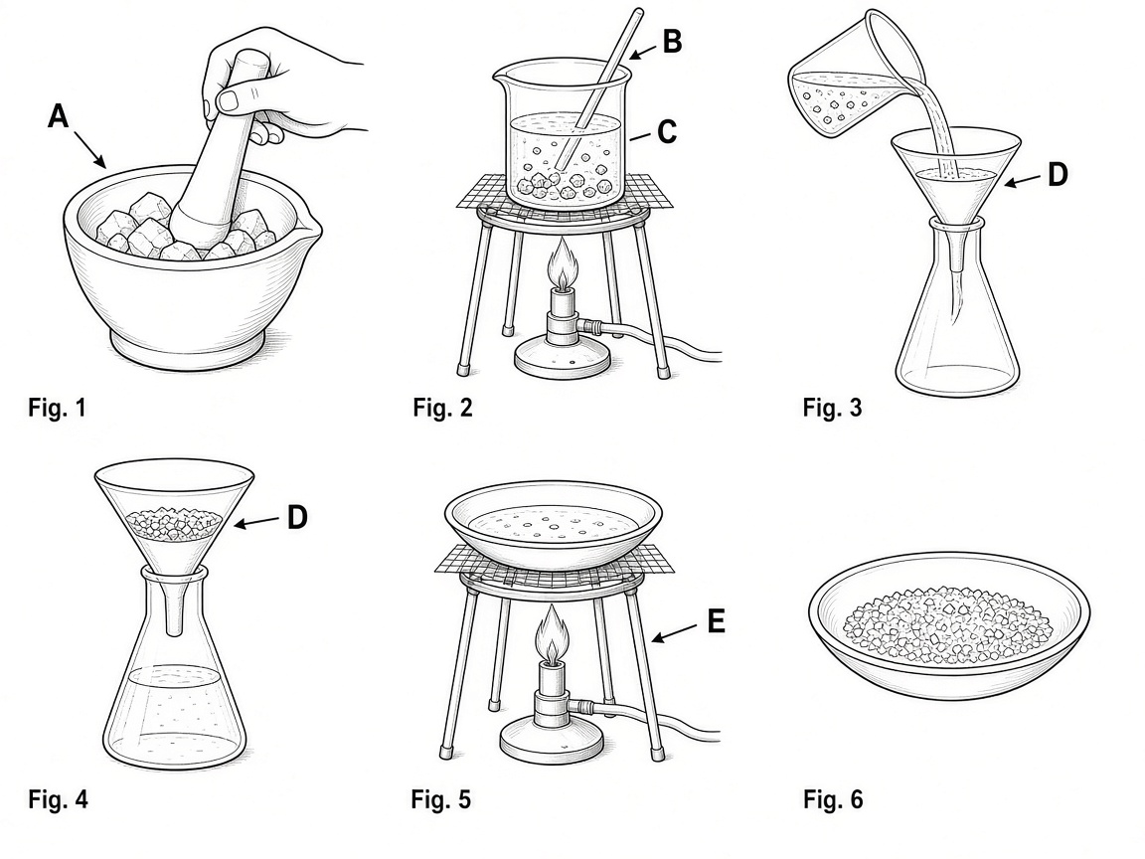
(a) Give the names of the pieces of apparatus labelled A to E in the pictures above. Use only the names given in the box.
Evaporating dish Beaker Bunsen burner Conical flask Filter funnel
Gauze Glass rod Mortar Pipette Tripod
A: ____________________ B: ____________________ C: ____________________
D: ____________________ E: ____________________
(5 marks)
(b) Suggest a reason why the mixture was heated and stirred in Fig. 2.
(1 mark)
______________________________________________________________________
______________________________________________________________________

(c) Name the process shown in Fig. 3.
(1 mark)
______________________________________________________________________

(d) What are the solids left on the paper shown in Fig. 4?
(1 mark)
______________________________________________________________________

(e) Name the white solid left in the evaporating dish in Fig. 6.
(1 mark)
______________________________________________________________________

2. Draw a laboratory set-up for each of the following separations:
(a) Obtaining salt from sea water quickly
(3 marks)

(b) Obtaining sand from a mixture of sand and seawater
(3 marks)

3. Pure water can be obtained by distillation of sea water.
(a) Explain why distillation is considered as a physical change.
(1 mark)
______________________________________________________________________
______________________________________________________________________

(b) Draw a labelled diagram for the experimental set-up of simple distillation of sea water. You are required to use quick-fit apparatus.
(2 marks)

(c) Anti-bumping granules should be placed into the flask before heating. Why?
(1 mark)
______________________________________________________________________
______________________________________________________________________

(d) Outline the underlying principle of simple distillation experiment.
(2 marks)
______________________________________________________________________
______________________________________________________________________
______________________________________________________________________

(e) Suggest a chemical test for water.
(2 marks)
______________________________________________________________________
______________________________________________________________________
______________________________________________________________________

4. The diagram below shows a set-up used to obtain pure water from copper(II) sulphate solution.
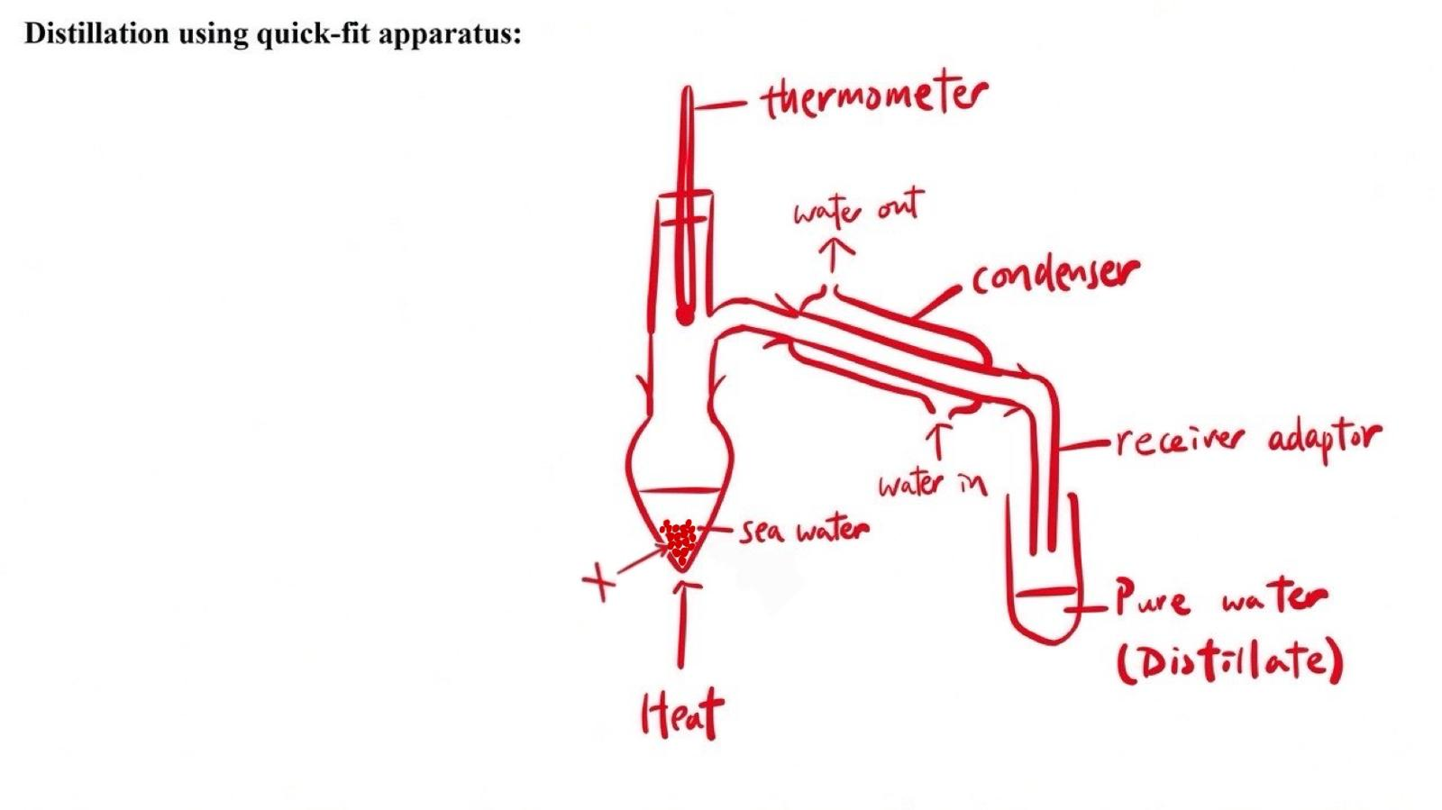
(a) Name the separation method used.
(1 mark)
______________________________________________________________________

(b) Why is a thermometer used in the set-up?
(1 mark)
______________________________________________________________________
______________________________________________________________________

(c) What is substance X? State its function in the experiment.
(2 marks)
______________________________________________________________________
______________________________________________________________________

(d) It is given that copper(II) sulphate solution is blue in color. Predict the colour of the distillate and the colour change of the mixture in the pear-shaped flask at the end of the experiment.
(2 marks)
______________________________________________________________________
______________________________________________________________________
______________________________________________________________________

5. A student proposed using the following set-up to obtain pure water from sea water. 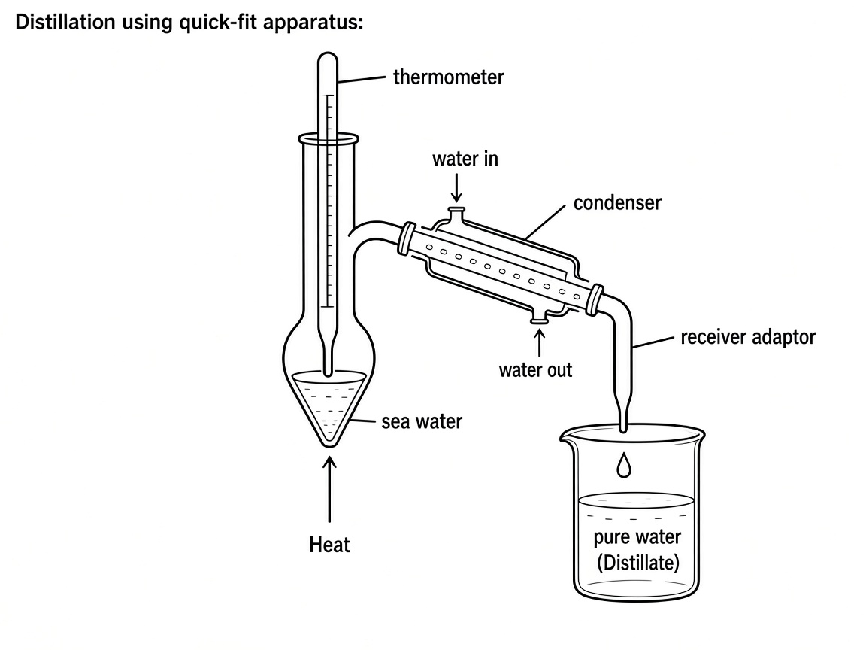
List THREE problems in the above set-up and suggest how the student can correct them.
(6 marks)
______________________________________________________________________
______________________________________________________________________
______________________________________________________________________
______________________________________________________________________
______________________________________________________________________
______________________________________________________________________

6. The following diagram shows an experimental set-up of distillation of sea water using simple apparatus.
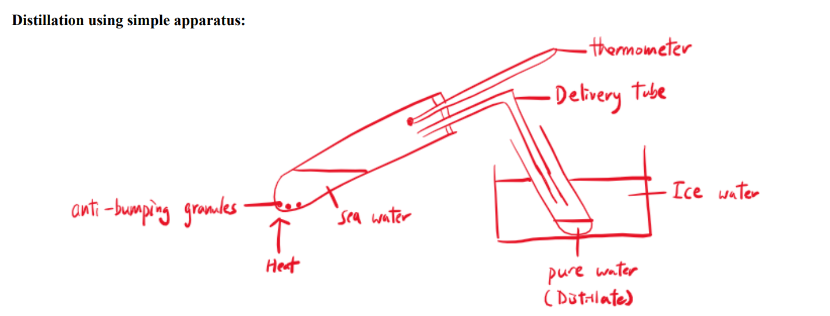

(a) State the use of the following apparatus:
(i) Anti-bumping granule
(1 mark)
______________________________________________________________________
______________________________________________________________________

(ii) Thermometer
(1 mark)
______________________________________________________________________
______________________________________________________________________

(iii) Water immersing the receiver test tube
(1 mark)
______________________________________________________________________
______________________________________________________________________

(b) Explain why the following methods of placing the delivery tube is inappropriate.
(i) Delivery tube placed as in diagram (i)
(1 mark)
______________________________________________________________________
______________________________________________________________________

(ii) Delivery tube placed as in diagram (ii)
(1 mark)
______________________________________________________________________
______________________________________________________________________

7. Three experiments were carried out to obtain sodium chloride.
Experiment 1: Evaporating water in sea water and collect the solid.
Experiment 2: Heat the sea water until it becomes saturated. Cool the solution slowly.
Experiment 3: Evaporate the sea water at room temperature slowly for one week.
(a) Draw a labelled diagram for the set-up used in experiment 1.
(2 marks)

(b) Which of the above experiments can give sodium chloride solids with highest purity / largest crystals?
(1 mark)
______________________________________________________________________

(c) The crystals obtained in experiment 2 can be obtained by filtration.
(i) Explain why crystals can be separated from the mixture by filtration.
(2 marks)
______________________________________________________________________
______________________________________________________________________
______________________________________________________________________

(ii) Explain why sodium chloride CANNOT be obtained by filtration of sea water directly.
(1 mark)
______________________________________________________________________
______________________________________________________________________

(d) To obtain sodium chloride crystals by crystallization, a saturated solution is required.
(i) What is meant by the term 'saturated solution'?
(1 mark)
______________________________________________________________________
______________________________________________________________________

(ii) Suggest a method to test whether a hot solution is saturated.
(2 marks)
______________________________________________________________________
______________________________________________________________________
______________________________________________________________________

(iii) Explain why crystals can be formed when a hot saturated solution is cooled.
(2 marks)
______________________________________________________________________
______________________________________________________________________
______________________________________________________________________

8. A student was trying to prepare magnesium sulphate crystals by crystallization. The experimental procedures are shown below:
Step 1: Add magnesium ribbon to dilute sulphuric acid until in excess. Magnesium sulphate solution is produced.
Step 2: Filter the mixture and collect the filtrate containing magnesium sulphate solution.
Step 3: Heat the filtrate until it becomes saturated. Water is evaporated during crystallization. Cool the solution to room temperature by standing in air.
Step 4: Filter off the crystals formed. Wash the crystals with small amount of cold distilled water.
Step 5: Dry the crystals by filter paper.
(a) When magnesium reacts with dilute sulphuric acid, magnesium sulphate solution and hydrogen gas are produced. Suggest ONE potential hazard of this experiment.
(1 mark)
______________________________________________________________________
______________________________________________________________________

(b) What is meant by the term 'saturated solution'?
(1 mark)
______________________________________________________________________
______________________________________________________________________

(c) Suggest one way to show that a saturated solution has been obtained in step 3.
(2 marks)
______________________________________________________________________
______________________________________________________________________
______________________________________________________________________

(d) Explain why crystals were formed in step 3.
(2 marks)
______________________________________________________________________
______________________________________________________________________
______________________________________________________________________

(e) In step 4, explain why the distilled water used should be cold and in small amounts.
(1 mark)
______________________________________________________________________
______________________________________________________________________

(f) Explain why it is inappropriate to dry the crystals by heating them under Bunsen flame.
(1 mark)
______________________________________________________________________
______________________________________________________________________

9. You are given a mixture of three substances. The information of these substances is tabulated below.
Substance | Melting point / ℃ | Boiling point / ℃ | Solubility in water
Sand | 1710 | 2230 | Insoluble
Magnesium chloride | 714 | 1412 | Soluble
Water | 0 | 100 | ---

Describe briefly how you separate these three substances from the mixture. Explain why each method of separation works.
(3 marks)
______________________________________________________________________
______________________________________________________________________
______________________________________________________________________
______________________________________________________________________
______________________________________________________________________

10. Complete the following table. For each blank, circle the correct separation method(s) from the options given in the cell.
Separating process | Separation method(s)
Separating an insoluble solid from a liquid | (a) Decantation / Distillation / Electrolysis  (b) Filtration / Crystallization / Flame test
Separating a dissolved solid (solute) from a solution | (c) Evaporation / Decantation / Filtration  (d) Crystallization / Distillation / Decantation
Separating the solvent and solute from a solution | (e) Distillation / Filtration / Decantation
(5 marks)
11. Answer the following short questions:
(a) Some metals and metallic compounds can be identified by flame test.
(i) State the flame color of the following compounds.
(1) Sodium carbonate
(1 mark)
______________________________________________________________________

(2) Potassium chloride
(1 mark)
______________________________________________________________________

(3) Calcium nitrate
(1 mark)
______________________________________________________________________

(4) Copper(II) sulphate
(1 mark)
______________________________________________________________________

(ii) Briefly describe the procedure for a flame test.
(3 marks)
______________________________________________________________________
______________________________________________________________________
______________________________________________________________________
______________________________________________________________________

(b) Suggest a chemical test for the presence of chloride in a sample of sodium chloride solid. State the expected observation.
(4 marks)
______________________________________________________________________
______________________________________________________________________
______________________________________________________________________
______________________________________________________________________
______________________________________________________________________

(c) Cobalt(II) chloride paper can be used to test for the presence of water in a sample of seawater.
(i) State the expected observation for the test.
(1 mark)
______________________________________________________________________

(ii) Suggest another chemical test that can be used to test for the presence of water. State the expected observation clearly.
(2 marks)
______________________________________________________________________
______________________________________________________________________
______________________________________________________________________

(iii) Suggest a test that can show that a colorless liquid sample is PURE WATER.
(2 marks)
______________________________________________________________________
______________________________________________________________________
______________________________________________________________________

12. You are given a mixture of mud and sodium chloride solution, and are asked to separate mud, sodium chloride and water from the mixture.
(a) Suggest a physical method that can separate mud from the mixture.
(1 mark)
______________________________________________________________________

(b) Draw a labelled diagram for the set-up used in (a).
(2 marks)

(c) Suggest a physical method that can separate sodium chloride and water from the remaining sodium chloride solution.
(1 mark)
______________________________________________________________________

(d) Draw a labelled diagram for the set-up used in (c).
(2 marks)

(e) Suggest a test to show the presence of sodium and another test to show the presence of chloride in the sodium chloride obtained in (c). State the expected observations.
(4 marks)
______________________________________________________________________
______________________________________________________________________
______________________________________________________________________
______________________________________________________________________
______________________________________________________________________

13. The following is a sample of sea water collected by a student from a beach.
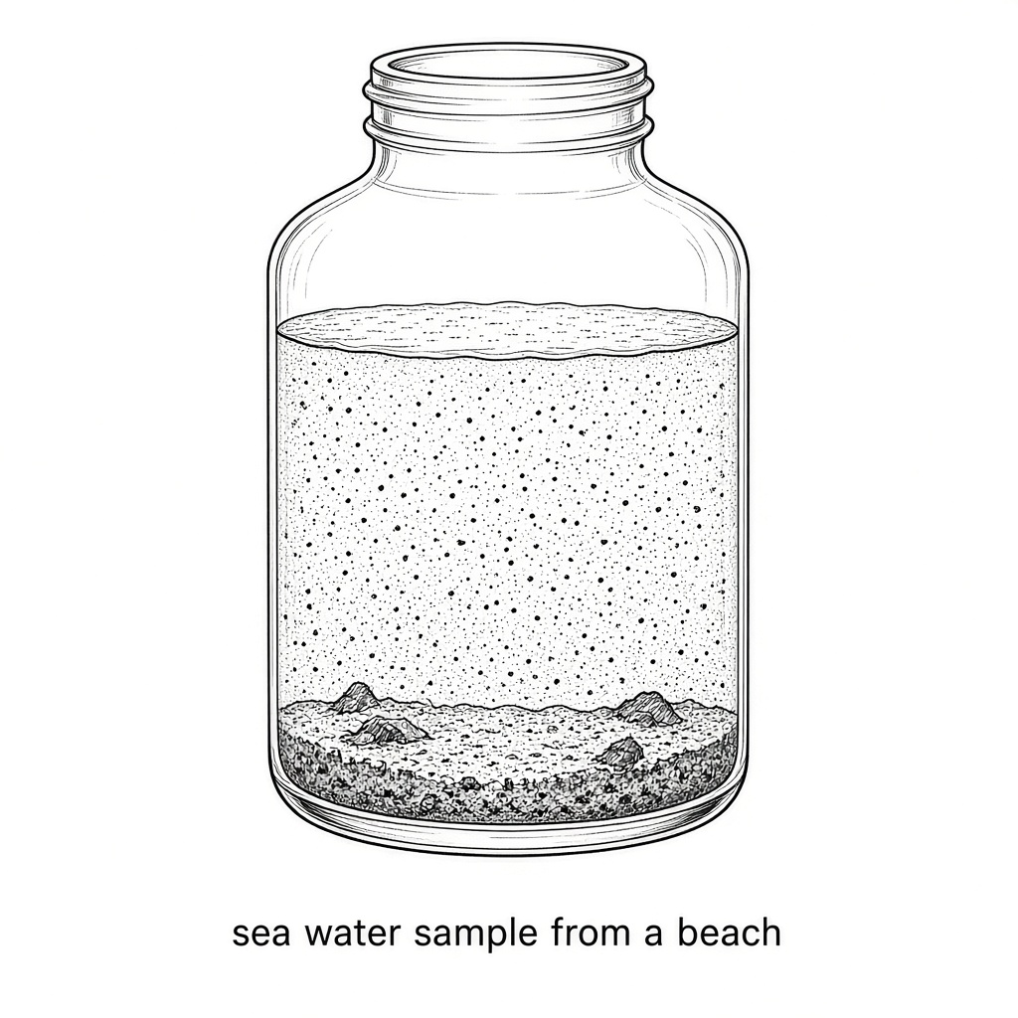
(a) Explain whether the sample is a mixture, an element or a compound.
(1 mark)
______________________________________________________________________
______________________________________________________________________

(b) (i) Suggest a method for removing the sand and mud from the sample.
(1 mark)
______________________________________________________________________

(ii) Draw a labelled diagram of the experimental set-up for the separation method suggested in (i).
(3 marks)

(c) (i) Suggest a method for obtaining solid sodium chloride quickly from the sample of sea water.
(1 mark)
______________________________________________________________________

(ii) Draw a labelled diagram of the experimental set-up for the separation method suggested in (i).
(2 marks)

(iii) Describe how you can show the presence of chloride in the solid obtained.
(2 marks)
______________________________________________________________________
______________________________________________________________________
______________________________________________________________________

(iv) Suggest ONE daily use of sodium chloride.
(1 mark)
______________________________________________________________________

14. The experimental set-up below shows the decomposition of hydrated copper(II) sulphate crystals.
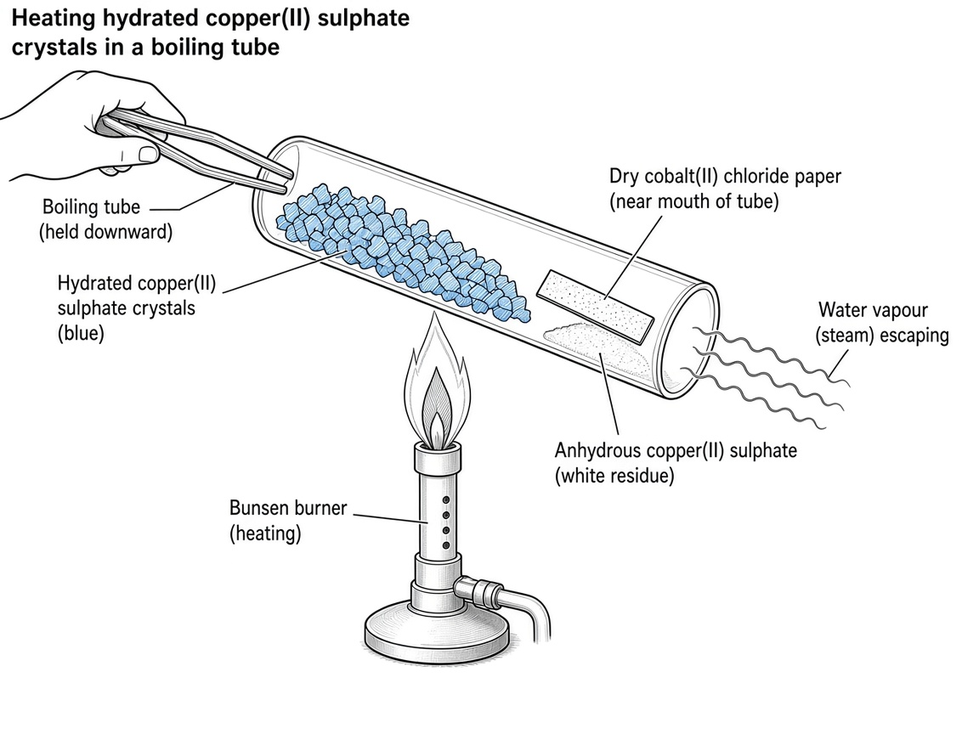
In the decomposition reaction, hydrated copper(II) sulphate crystal is decomposed to form anhydrous copper(II) sulphate solid and steam.
(a) State the color change of the solid.
(1 mark)
______________________________________________________________________

(b) What will be observed if a piece of dry cobalt(II) chloride paper is placed near the mouth of the test tube during the experiment?
(1 mark)
______________________________________________________________________
______________________________________________________________________

(c) What is the flame color when the solid product obtained is subject to flame test?
(1 mark)
______________________________________________________________________

(d) Tom claims that the decomposition of hydrated copper(II) sulphate crystal is a chemical change. Do you agree? Explain your answer.
(1 mark)
______________________________________________________________________
______________________________________________________________________

15. Brine is a solution of sodium chloride. Consider the following set-up for the electrolysis of brine.
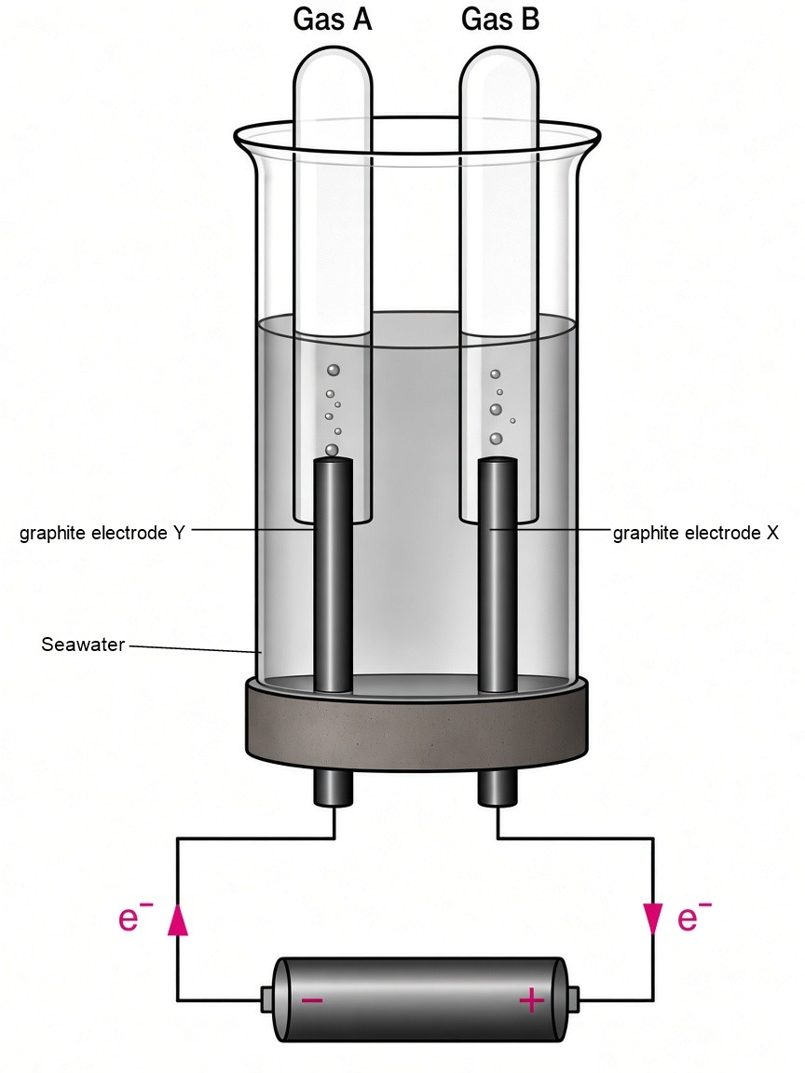
(a) State which electrode is the positive electrode.
(1 mark)
______________________________________________________________________

(b)
(i) What is gas A?
(1 mark)
______________________________________________________________________

(ii) Suggest ONE use of gas A.
(1 mark)
______________________________________________________________________

(c)
(i) What is gas B?
(1 mark)
______________________________________________________________________

(ii) Suggest ONE use of gas B.
(1 mark)
______________________________________________________________________

(d)
(i) What is the solution left in the set-up after electrolysis?
(1 mark)
______________________________________________________________________

(ii) Suggest ONE use of the solution.
(1 mark)
______________________________________________________________________

16. Sea water can be electrolyzed to give different products. Gas X can be obtained in positive electrode while Gas Y can be obtained in negative electrode. In addition, sodium hydroxide solution can also be obtained.
(a) Both Gas X and Gas Y are elements. It is known that pop sound is produced when Gas Y is burnt with a burning splint.
(i) Define the term 'element'.
(1 mark)
______________________________________________________________________
______________________________________________________________________

(ii) Give one use of Gas X.
(1 mark)
______________________________________________________________________

(iii) Give one use of Gas Y.
(1 mark)
______________________________________________________________________

(b) Sodium hydroxide solution is a mixture of compounds.
(i) Define the term 'mixture'.
(1 mark)
______________________________________________________________________
______________________________________________________________________

(ii) Define the term 'compound'.
(1 mark)
______________________________________________________________________
______________________________________________________________________

(iii) Give one use of sodium hydroxide.
(1 mark)
______________________________________________________________________

(iv) Draw a labelled diagram to show how solid sodium hydroxide can be obtained from sodium hydroxide solution quickly.
(2 marks)

(v) Draw a labelled diagram to show how pure water can be obtained from sodium hydroxide solution.
(2 marks)

17. The following diagram shows an experimental set-up of distillation. Tom is going to obtain pure water from seawater using this set-up.
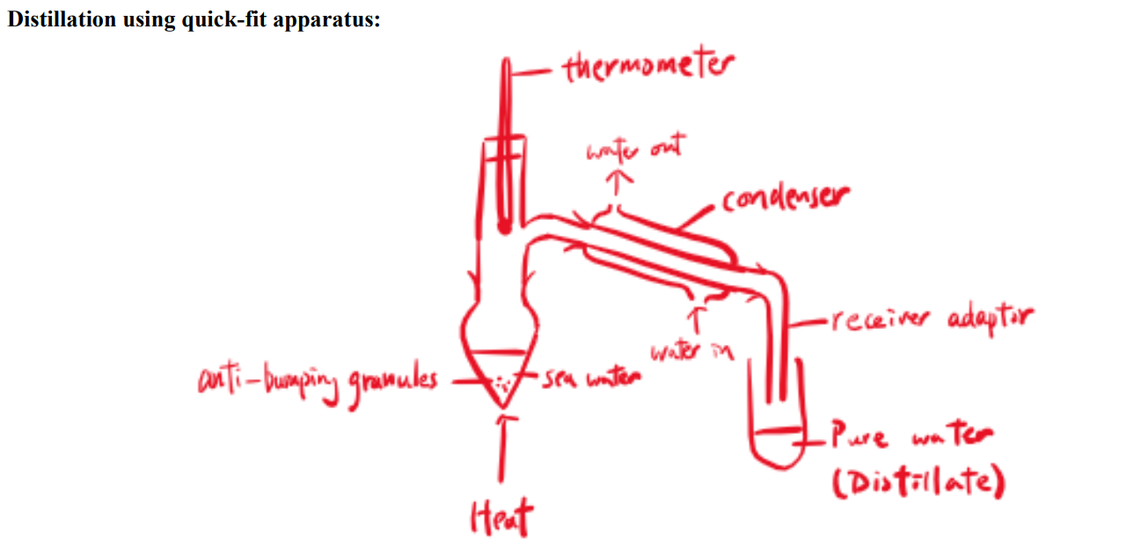 (a) What is the use of:
(i) Anti-bumping granules?
(1 mark)
______________________________________________________________________
______________________________________________________________________

(ii) Thermometer?
(1 mark)
______________________________________________________________________
______________________________________________________________________

(b) Explain why cold running water is passed into the condenser from the lower opening and leaves from the upper opening.
(1 mark)
______________________________________________________________________
______________________________________________________________________

(c) This set-up can also be used to test whether a colorless liquid is pure water. Suggest how to do so.
(1 mark)
______________________________________________________________________
______________________________________________________________________

(d) Electrolysis of seawater can produce gas X, gas Y and solution Z. Gas X can also be obtained by electrolysis of molten rock salt.
(i) What is gas X, gas Y and solution Z respectively?
(3 marks)
______________________________________________________________________
______________________________________________________________________

(ii) State one use of gas Y.
(1 mark)
______________________________________________________________________

(iii) State one use of solution Z.
(1 mark)
______________________________________________________________________

18. Suggest chemical tests to distinguish the following solutions and state the expected observations.
Sodium chloride Sodium nitrate Potassium nitrate
(4 marks)
______________________________________________________________________
______________________________________________________________________
______________________________________________________________________
______________________________________________________________________
______________________________________________________________________
______________________________________________________________________

Answer
1. (a) A: Mortar
B: Glass rod
C: Beaker
D: Filter funnel
E: Tripod
(b) To speed up the dissolving of the salt
(c) Filtration
[Source: topic-01-planet-earth.pdf p.5 — Filtration can separate an insoluble solid (As residue) from a liquid or solution (As filtrate)]
(d) Clay and sand
(e) Sodium chloride
2. (a) Labelled evaporation set-up: evaporating dish with sea water on gauze/tripod heated by Bunsen burner.
[Source: p.5 — Evaporation is a method to obtain solute from a solution quickly.]
(b) Labelled filtration set-up: filter funnel with filter paper; sand as residue; seawater as filtrate.
[Source: p.5 — Filtration can separate an insoluble solid (As residue) from a liquid or solution (As filtrate)]
3. (a) Physical change is a change in which no new substances are produced.
[Source: p.2]
(b) Correct labelled quick-fit distillation set-up of sea water
[Source: p.7 — Distillation is a method to obtain pure water from sea water. (Obtain solvent from solution)]
(c) Anti-bumping granule provides smooth heating and prevents bumping of water.
[Source: p.7]
(d) Water boils at 100 ℃ and turns to water vapor. Salt does not boil since it has a much higher boiling point than water and it is left in the flask as residue. Hot water vapor condenses in the condenser and turns to water again.
[Source: p.7]
(e) If the sample contains water is added to anhydrous copper(II) sulphate, the white solid will turn blue.
OR If the sample contains water is added to dry cobalt(II) chloride paper, the paper will turn from blue to pink.
[Source: p.9]
4. (a) Distillation
[Source: p.7 — Distillation is a method to obtain pure water from sea water. (Obtain solvent from solution)]
(b) Thermometer can check the boiling point of the distillate which helps to check its identity.
[Source: p.7]
(c) Anti-bumping granule. Anti-bumping granule provides smooth heating and prevents bumping of water.
[Source: p.7]
(d) The distillate is colourless / Distillate is water (colourless).
The blue colour of the mixture remaining in the pear-shaped flask will become more intense. / The solid left behind is residue.
5. The direction of water flow in the condenser is wrong.
Cold running water is passed into the condenser from the lower opening and leaves from the upper opening. This provides a better cooling effect for the steam.
[Source: p.7]
The thermometer should not be dipped into the sea water.
Thermometer can check the boiling point of the distillate which helps to check its identity. (Place near the side-arm of the still head.)
There are no anti-bumping granules in the round-bottomed flask.
Anti-bumping granule provides smooth heating and prevents bumping of water.
6. (a) (i) Anti-bumping granule provides smooth heating and prevents bumping of water.
(ii) Thermometer can check the boiling point of the distillate which helps to check its identity.
(iii) Cool the receiver test tube to provide cooling surface for water vapor to condense. / Provide cooling agent.
(b) (i) The end of the delivery tube should be placed above the distillate and below the cooling agent. This can prevent ... water vapor escaping from the test tube.
(ii) The end of the delivery tube should be placed above the distillate and below the cooling agent. This can prevent sucking back of distillate ...
[Source: p.7]
7. (a) Labelled evaporation set-up (Experiment 1)
[Source: p.5 — Evaporation is a method to obtain solute from a solution quickly.]
(b) Experiment 3
[Source: p.6 — Crystals obtained by this method are large crystals. Solute particles have sufficient time to arrange themselves regularly.]
(c) (i) There are many tiny holes in filter paper. These holes allow very small particles (including water and dissolved substances) to pass through as filtrate. Insoluble substances remain on the filter paper as residue.
[Source: p.5]
(ii) Sodium chloride is soluble in water / dissolved substances pass through as filtrate.
(d) (i) Saturated solution: A solution which the solvent has dissolved the maximum amount of solute it can at a specific temperature
[Source: p.4]
(ii) To test whether a solution is saturated, we can dip a glass rod into the solution and take it out. If crystals are formed on it upon cooling, the solution is saturated
[Source: p.6]
(iii) When the temperature of the solution drops, the solubility will decrease. Water cannot hold all the dissolved solute and some of the salt crystals will be formed
[Source: p.6]
8. (a) Hydrogen be tested by burning splint and it burns with 'pop' sound. / Hydrogen is flammable. / Dilute sulphuric acid is corrosive.
(b) Saturated solution: A solution which the solvent has dissolved the maximum amount of solute it can at a specific temperature
[Source: p.4]
(c) To test whether a solution is saturated, we can dip a glass rod into the solution and take it out. If crystals are formed on it upon cooling, the solution is saturated
[Source: p.6]
(d) When the temperature of the solution drops, the solubility will decrease. Water cannot hold all the dissolved solute and some of the salt crystals will be formed
[Source: p.6]
(e) Wash the crystals with small amount of cold, distilled water ... / Reduce the loss of crystals (crystals are soluble in water).
[Source: p.6 procedures]
(f) Evaporation often causes decomposition of crystals.
[Source: p.5]
9. As sand is insoluble in water, it can be separated from the mixture by filtration. Filtration can separate an insoluble solid (As residue) from a liquid or solution (As filtrate).
Distillation is a method to obtain pure water from sea water. (Obtain solvent from solution) Water boils at 100 ℃ and turns to water vapor. Salt does not boil since it has a much higher boiling point than water and it is left in the flask as residue.
The residue left in the distillation flask is magnesium chloride.
[Source: p.5, p.7]
10. (a) Decantation
(b) Filtration
(c) Evaporation
(d) Crystallization
(e) Distillation
[Source: p.4 Decantation; p.5 Filtration / Evaporation; p.6 Crystallization; p.7 Distillation]
11. (a) (i) (1) Golden yellow
(2) Lilac
(3) Brick-red
(4) Bluish green
[Source: p.8 Flame test table]
(ii) 1. Dip a clean platinum wire / nichrome wire into concentrated hydrochloric acid.
2. Dip the wire into the sample.
3. Heat the end of the wire strongly in a non-luminous flame. Observe the flame color.
[Source: p.8 Procedures of flame test]
(b) 1. Dissolve the sample completely with distilled water.
2. Add excess dilute nitric acid into the solution to be tested.
3. Add silver nitrate solution into the acidified solution.
If white precipitate is produced (due to the formation of insoluble silver chloride), the sample should contain chloride ion
[Source: p.8]
(c) (i) the paper will turn from blue to pink.
[Source: p.9 — If the sample contains water is added to dry cobalt(II) chloride paper, the paper will turn from blue to pink.]
(ii) If the sample contains water is added to anhydrous copper(II) sulphate, the white solid will turn blue.
[Source: p.9]
(iii) To test whether a sample contains pure water, we should carry out boiling point test. If a liquid boils at 100 ℃ (under room pressure), it should be pure water.
[Source: p.9]
12. (a) Filtration
[Source: p.5 — Filtration can separate an insoluble solid (As residue) from a liquid or solution (As filtrate)]
(b) Labelled filtration set-up
(c) Distillation
[Source: p.7 — Distillation is a method to obtain pure water from sea water. (Obtain solvent from solution)]
(d) Labelled distillation set-up
(e) Flame test: Golden yellow (sodium)
[Source: p.8 — Sodium / Golden yellow]
Chloride test: Dissolve the sample completely with distilled water. Add excess dilute nitric acid into the solution to be tested. Add silver nitrate solution into the acidified solution. If white precipitate is produced (due to the formation of insoluble silver chloride), the sample should contain chloride ion
[Source: p.8]
13. (a) Mixture consists of two or more pure substances which have not chemically combined together. / Sea water is an example of solution / Examples of mixtures — Most daily life substances (sea water, air, milk, soft drinks etc)
[Source: p.1, p.4]
(b) (i) Filtration
(ii) Labelled filtration set-up
(c) (i) Evaporation
[Source: p.5 — Evaporation is a method to obtain solute from a solution quickly.]
(ii) Labelled evaporation set-up
(iii) Dissolve the sample completely with distilled water. Add excess dilute nitric acid into the solution to be tested. Add silver nitrate solution into the acidified solution. If white precipitate is produced (due to the formation of insoluble silver chloride), the sample should contain chloride ion
[Source: p.8]
(iv) (Accept a reasonable daily use, e.g. table salt / food packaging related uses of NaCl as common salt.)
14. (a) From blue to white / Hydrated copper(II) sulphate will be decomposed to anhydrous copper(II) sulphate
[Source: p.5 — (e.g. Hydrated copper(II) sulphate will be decomposed to anhydrous copper(II) sulphate)]
(b) the paper will turn from blue to pink.
[Source: p.9]
(c) Bluish green
[Source: p.8 — Copper / Bluish green]
(d) Yes. Chemical change is a change in which one or more new substances are produced.
[Source: p.2]
15. (a) X / electrode X
[Source: p.9 — Hydrogen and chlorine are collected in negative and positive electrodes respectively.]
(b) (i) Hydrogen gas
(ii) Making margarine / Making ammonia / As rocket fuel
(c) (i) Chlorine gas
(ii) Sterilizing swimming pool / Making polyvinyl chloride (PVC) / Making hydrochloric acid / Making chlorine bleach
(d) (i) Sodium hydroxide solution
(ii) Making soap / Making drain cleaner / Neutralizing acidic effluent from factory / Making chlorine bleach
[Source: p.9 — Sea water ➔ Hydrogen gas + Chlorine gas + Sodium hydroxide solution.]
16. (a) (i) Element is a pure substance that cannot be broken down into anything simpler by chemical methods
[Source: p.1]
(ii) Sterilizing swimming pool / Making polyvinyl chloride (PVC) / Making hydrochloric acid / Making chlorine bleach
(iii) Making margarine / Making ammonia / As rocket fuel
(b) (i) Mixture consists of two or more pure substances which have not chemically combined together
[Source: p.1]
(ii) Compound is a pure substance made up of two or more elements chemically combined together
[Source: p.1]
(iii) Making soap / Making drain cleaner / Neutralizing acidic effluent from factory
(iv) Labelled evaporation set-up
[Source: p.5 — Evaporation is a method to obtain solute from a solution quickly.]
(v) Labelled distillation set-up
[Source: p.7 — Distillation is a method to obtain pure water from sea water. (Obtain solvent from solution)]
17. (a) (i) Anti-bumping granule provides smooth heating and prevents bumping of water.
(ii) Thermometer can check the boiling point of the distillate which helps to check its identity.
[Source: p.7]
(b) Cold running water is passed into the condenser from the lower opening and leaves from the upper opening. This provides a better cooling effect for the steam.
[Source: p.7]
(c) To test whether a sample contains pure water, we should carry out boiling point test. If a liquid boils at 100 ℃ (under room pressure), it should be pure water.
[Source: p.9]
(d) (i) Gas X = Chlorine gas; Gas Y = Hydrogen gas; Solution Z = Sodium hydroxide solution
[Source: p.9 — Sea water ➔ Hydrogen gas + Chlorine gas + Sodium hydroxide solution.]
[Also p.10 — Rock salt / Sodium (Na); electrolysis of molten metal ore for sodium]
(ii) Making margarine / Making ammonia / As rocket fuel
(iii) Making soap / Making drain cleaner / Neutralizing acidic effluent from factory / Making chlorine bleach
18. Add excess dilute nitric acid into the solution to be tested. Add silver nitrate solution into the acidified solution.
If white precipitate is produced (due to the formation of insoluble silver chloride), the sample should contain chloride ion. Only sodium chloride gives white precipitate.
Perform flame test to the remaining two solutions.
Sodium nitrate: Golden yellow; Potassium nitrate: Lilac
[Source: p.8]

