1. The following table shows some information about some elements. (A to F are NOT the symbols of the elements.)
Element | Melting point / °C | Boiling point / °C | Electrical conductivity
A | −10 | 62 | poor
B | 1535 | 2750 | good
C | −38 | 357 | good
D | −218 | −183 | poor
E | 63 | 760 | good
F | 113 | 445 | poor
(a) Which of the above elements are liquids under room conditions? (1 mark)
________________________________________________________________________
(b) State the temperature range in which F exists as a liquid. (1 mark)
________________________________________________________________________
(c) (i) Which of the above elements are metals? (1 mark)
________________________________________________________________________
(ii) State TWO properties of metals. (2 marks)
________________________________________________________________________
________________________________________________________________________
(iii) A student stated that if a solid can conduct electricity, it must be a metal. Comment on the statement. (1 mark)
________________________________________________________________________
________________________________________________________________________

2. The table gives the melting and boiling points of four pure substances, P, Q, R and S.
 | Melting point / °C | Boiling point / °C
P | −7 | 59
Q | 1480 | 2730
R | 180 | 1340
S | 44 | 280
Use data from the table to answer the questions.
(a) Which substance(s) is / are gas at 400 °C? (1 mark)
________________________________________________________________________
(b) Which substance is a liquid for the largest range of temperature? (1 mark)
________________________________________________________________________
(c) Which substance is a liquid at 900 °C and a gas at 2000 °C? (1 mark)
________________________________________________________________________
(d) Substance P is an element which does not conduct electricity under room conditions. Suggest what P may be. (1 mark)
________________________________________________________________________

3. The melting points and boiling points of four elements at 1 atmosphere are listed in the table below.
Elements | Melting point (°C) | Boiling point (°C)
Neon | −249 | −246
Bromine | −7 | 59
Chlorine | −101 | −35
Iodine | 114 | 184
(a) Which of the above substances exist as a liquid at −90 °C and 1 atmosphere? (1 mark)
________________________________________________________________________
(b) The four substances are non-metals. Write THREE typical properties, besides melting point and boiling point, of non-metals. (3 marks)
________________________________________________________________________
________________________________________________________________________
________________________________________________________________________
(c) Draw electron diagrams for atoms of the following elements: (0 marks)
(i) neon; (1 mark)
________________________________________________________________________
________________________________________________________________________
________________________________________________________________________
(ii) chlorine. (1 mark)
________________________________________________________________________
________________________________________________________________________
________________________________________________________________________

4. If the atomic number of an element is known, its electronic arrangement, period number and group number can be written. Complete the following table without referring to the Periodic Table.
(W, X, Y, Z, M and N are NOT the symbols of the elements.)
Element | Atomic number | Electronic arrangement | Period number | Group number
W | 4
X | 7
Y | 10
Z | 12
M | 14
N | 19
(6 marks)
(b) Which of the above elements is / are (0 marks)
(i) metals? (1 mark)
________________________________________________________________________
(ii) non-metals? (1 mark)
________________________________________________________________________
(iii) a semi-metal? (1 mark)
________________________________________________________________________

5. Element X has an atomic number of 16.
(a) Draw the electron diagram for an atom of X. (1 mark)

(b) In which period and group of the Periodic Table should X be placed? (2 marks)
________________________________________________________________________
________________________________________________________________________
(c) Is X a metal or a non-metal? (1 mark)
________________________________________________________________________

6.
(a) State the meaning of the term atomic number. (1 mark)
________________________________________________________________________
________________________________________________________________________
(b) An atom of element X contains 13 protons, 13 electrons and 14 neutrons.
(i) Which of these is the mass number of this atom? (1 mark)
________________________________________________________________________
(ii) Explain which group of the Periodic Table element X belongs to. (1 mark)
________________________________________________________________________
________________________________________________________________________
(c) The table shows the composition of a sample of a different element, Y, containing two isotopes.
Mass number of isotope | Percentage of isotope in sample
79 | 50.6
x | 49.4
If the relative atomic mass of this sample of element Y is 79.988, calculate the isotopic mass of x. (2 marks)
________________________________________________________________________
________________________________________________________________________
________________________________________________________________________

7. Calcium (Ca) is a metal in Group II of the Periodic Table. It has an atomic number of 20. The electronic arrangement of the calcium atom is 2, 8, r, s.
(a) How many protons does a calcium atom have? (1 mark)
________________________________________________________________________
(b) What are the values of r and s? (2 marks)
________________________________________________________________________
(c) In which period of the Periodic Table should calcium be placed? (1 mark)
________________________________________________________________________
(d) Predict any TWO physical properties of calcium. (2 marks)
________________________________________________________________________
________________________________________________________________________

8. This question is about atoms.
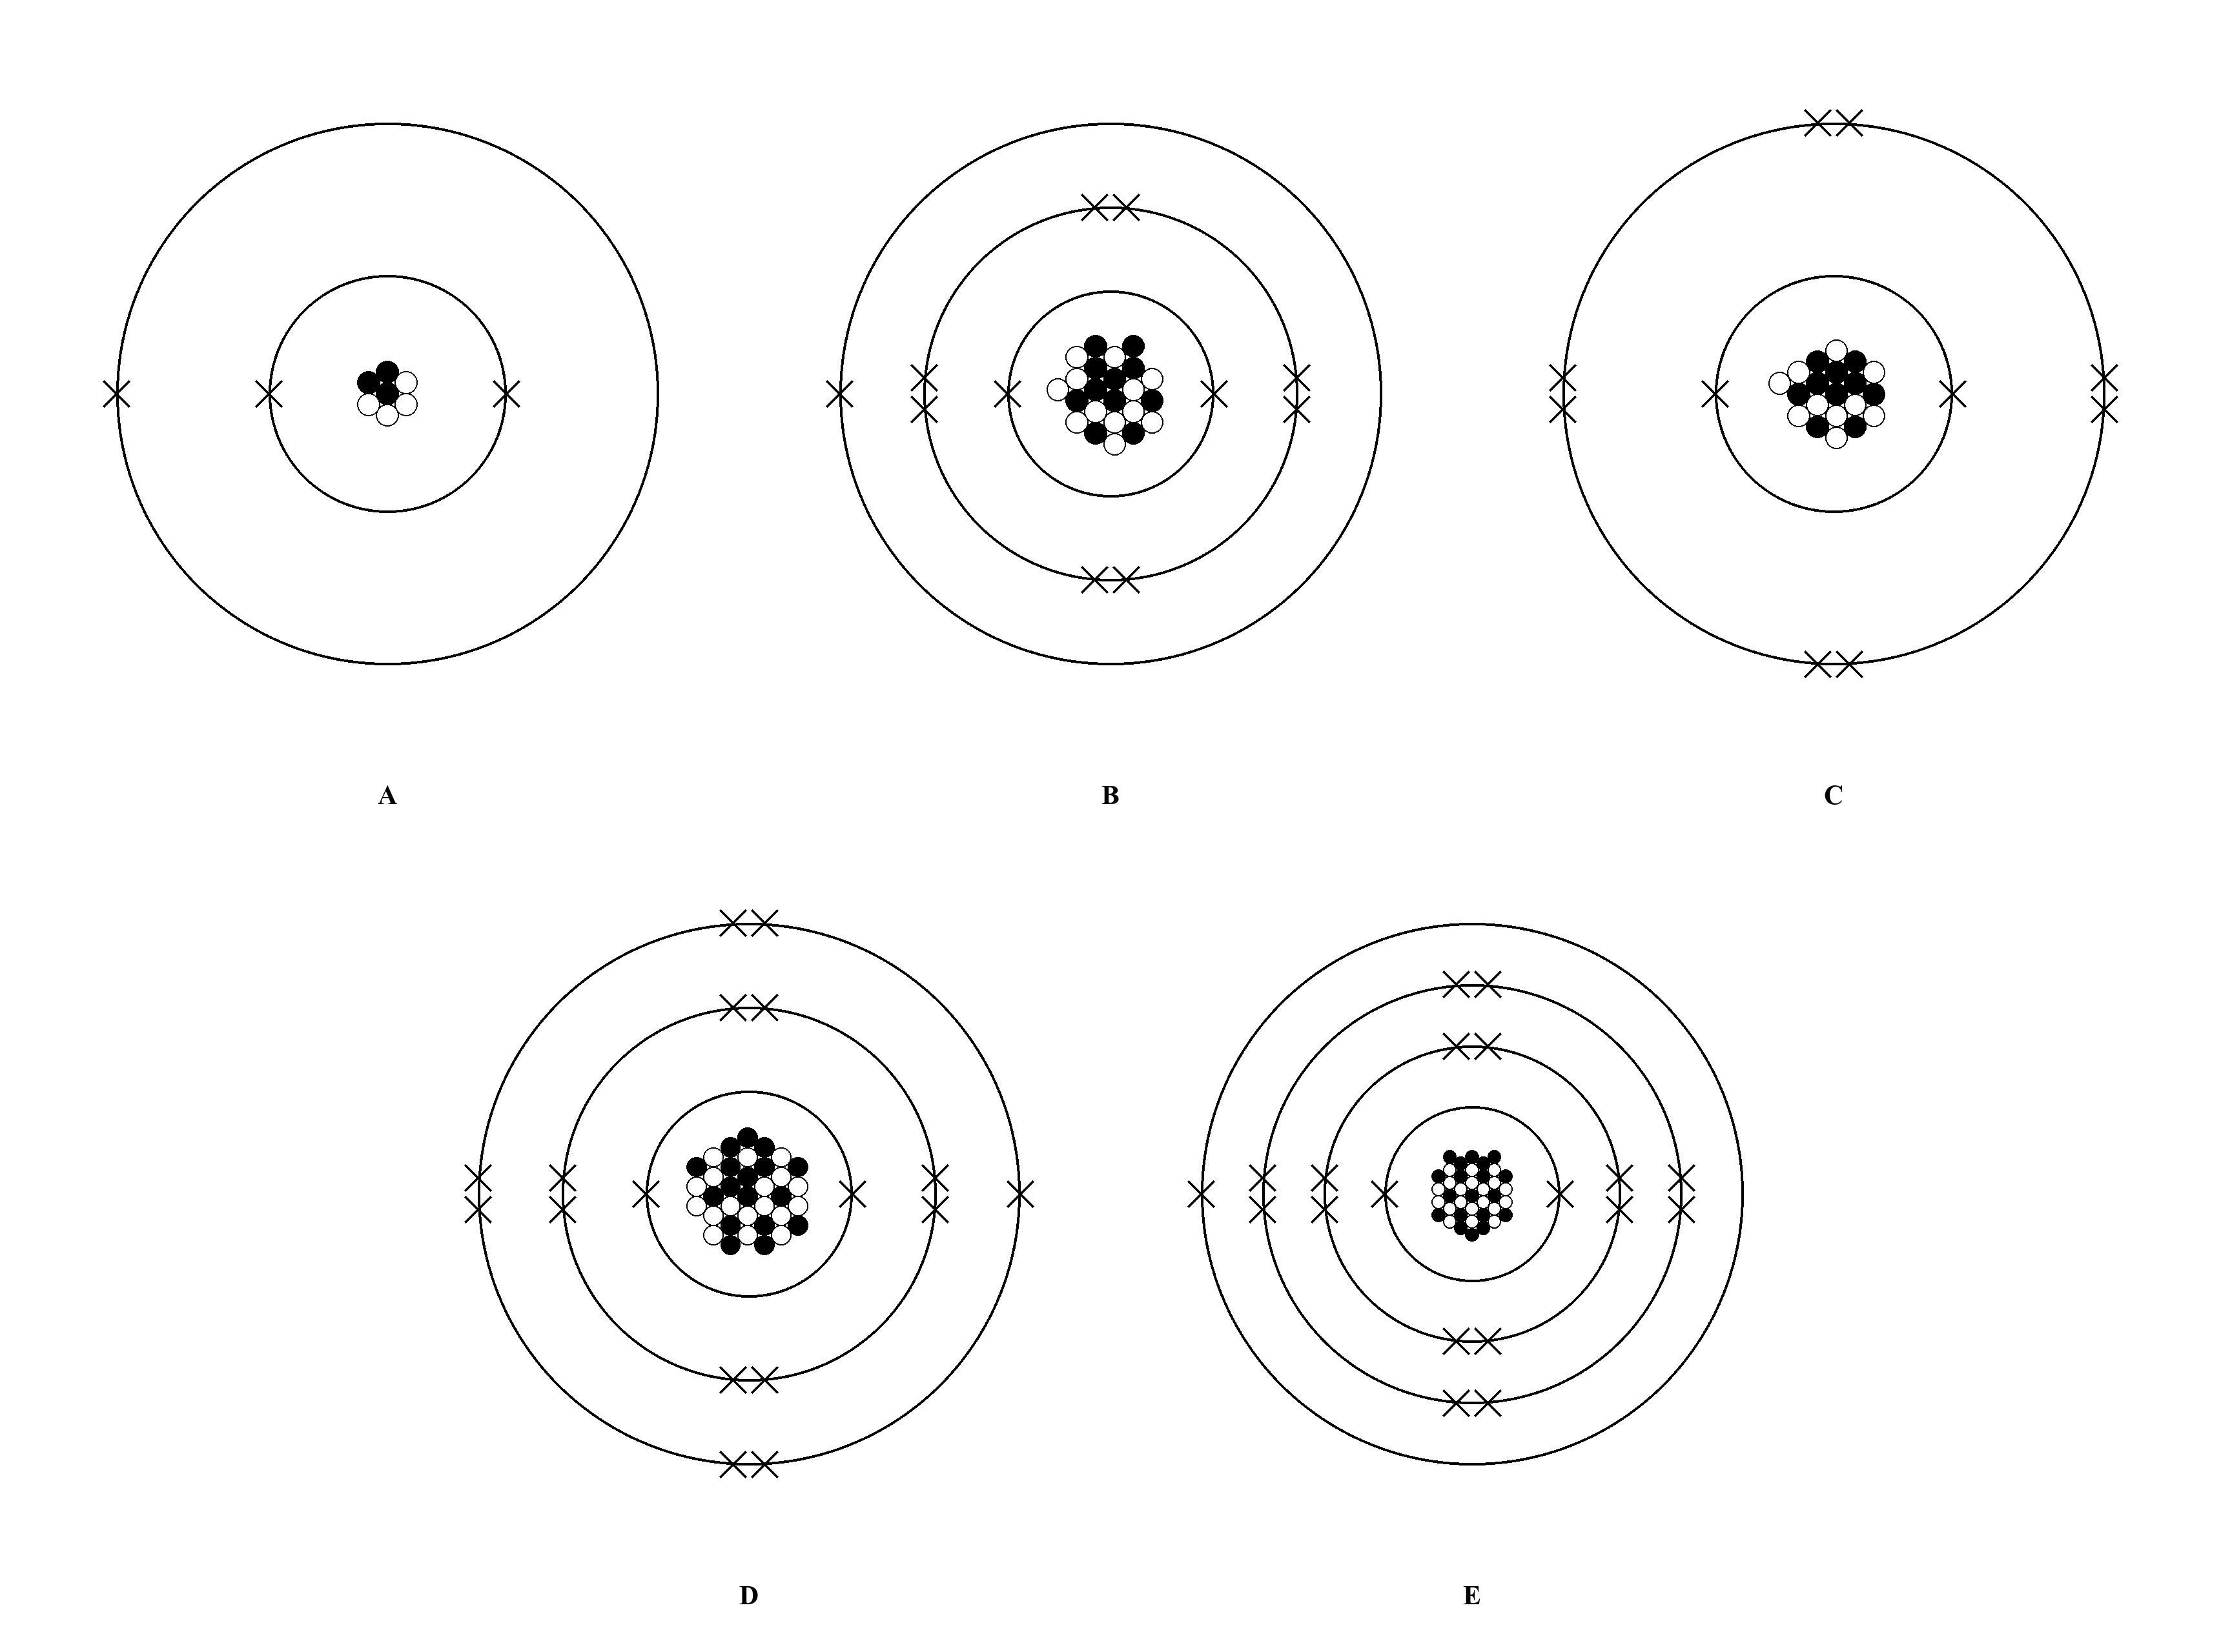
(a) (i) Element B is in Group I. How can you tell? (1 mark)
________________________________________________________________________
(ii) Element E is in Period 4. How can you tell? (1 mark)
________________________________________________________________________

(b) The nucleus of an atom contains protons and neutrons.
(i) Complete the table to show the relative charge and relative mass of a neutron. Circle the correct answer in each box. (2 marks)
 | Relative charge | Relative mass
Proton | +1 | 1
Neutron | +1 / 0 / −1 | 1 / Negligible
(ii) There are two common types of chlorine atom, known as isotopes. Complete the table below. (2 marks)
Symbol | Number of protons | Number of neutrons | Number of electrons
³⁵Cl
³⁷Cl

9. A part of the Periodic Table is shown below, with some elements represented by letters A to H. (Note: the letters are NOT the symbols of the elements.)
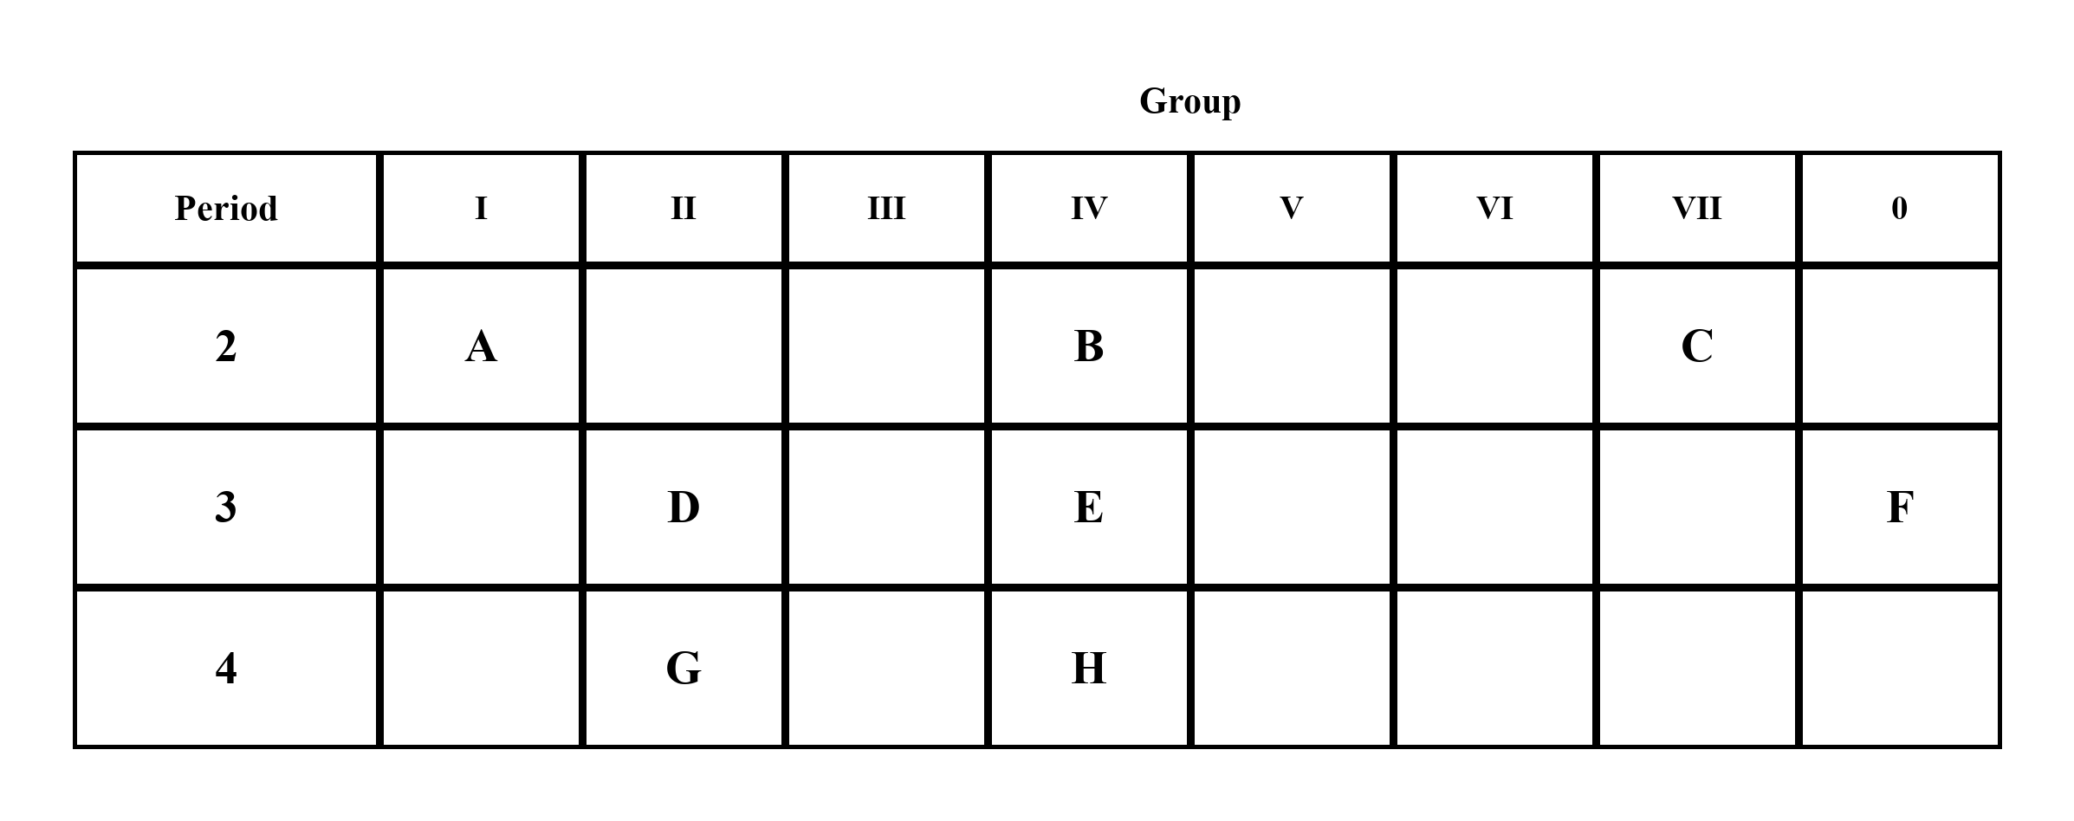
(a) Which element(s) is/are semi-metal(s)? (1 mark)
________________________________________________________________________
(b) State one similarity of atoms of elements D, E and F in terms of the atomic structure. (1 mark)
________________________________________________________________________
________________________________________________________________________
(c) State one similarity of atoms of elements E and H in terms of the atomic structure. (1 mark)
________________________________________________________________________
________________________________________________________________________
(d) With reference to the Periodic Table, calculate the difference in protons between atoms of element G and H. (1 mark)
________________________________________________________________________
________________________________________________________________________
(e) Which element shares similar chemical properties with element G? Explain your answer in terms of atomic structure. (2 marks)
________________________________________________________________________
________________________________________________________________________
________________________________________________________________________
10. A to F are six different elements. Complete the following table according to the descriptions of elements.
Element | Description | Period number | Group number | Electronic arrangement
A | Its atomic number is 13.
B | Its name is helium.
C | Its atom has 9 electrons.
D | Its atom has 2 completely filled shells and 7 electrons in the 3rd shell.
E | It is a non-metal but it can conduct electricity.
F | It is a period 2 metalloid.
(6 marks)
11. Lithium (Li) and potassium (K) are elements in Group I of the Periodic Table.
(a) What is the name commonly given to this group of elements? (1 mark)
________________________________________________________________________
(b) The atomic number of potassium is 19. The electronic arrangement of a potassium atom is p, q, r, 1. What are the values of p, q and r? (1 mark)
________________________________________________________________________
(c) Explain, in terms of electronic arrangements of their atoms, why lithium and potassium have similar chemical properties. (1 mark)
________________________________________________________________________
________________________________________________________________________
(d) Predict, with ONE reason, whether lithium or potassium is more reactive towards chlorine. (1 mark)
________________________________________________________________________
________________________________________________________________________
(e) Suggest how Group I metals are stored in the laboratory. Explain your answer. (2 marks)
________________________________________________________________________
________________________________________________________________________

(f) The table gives some statements about the reaction of potassium with water. Place ticks in three boxes to show which three statements are correct.
Statement | Tick (✓)
potassium reacts more vigorously than sodium when added to water
potassium sinks to the bottom of the water
bubbles of oxygen gas are produced
a lilac flame is seen
potassium moves around
a solution of potassium oxide is formed
(1 mark)
(g) Write the word equation for the reaction between sodium and water. (1 mark)
________________________________________________________________________
________________________________________________________________________

12. This question is about Group II elements.
(a) How many outermost shell electrons do atoms of Group II elements have? (1 mark)
________________________________________________________________________
(b) The chemical properties of Group II elements are generally similar. Explain briefly. (1 mark)
________________________________________________________________________
________________________________________________________________________
(c) Does the reactivity of Group II elements increase or decrease down the group? (1 mark)
________________________________________________________________________
(d) Magnesium has almost no reaction with cold water, while calcium reacts with cold water at a moderate rate. Based on this information, predict the reactivity of beryllium (atomic number = 4) and barium (atomic number = 56) towards cold water. (2 marks)
________________________________________________________________________
________________________________________________________________________
________________________________________________________________________
(e) Write the word equation for the reaction between calcium and water. (1 mark)
________________________________________________________________________
________________________________________________________________________
(f) State any one similarity in physical properties among the Group II elements. (1 mark)
________________________________________________________________________
________________________________________________________________________
(g) Which of the following Group II elements is the least reactive? strontium, magnesium, beryllium, calcium, barium (1 mark)
________________________________________________________________________
13. Fluorine, chlorine, bromine and iodine belong to Group VII of the Periodic Table.
(a) What is the name given to Group VII elements? (1 mark)
________________________________________________________________________
(b) State one similarity in the atomic structures of the Group VII elements. (1 mark)
________________________________________________________________________
________________________________________________________________________
(c) Which of the above elements is the most reactive? (1 mark)
________________________________________________________________________
(d) Fluorine and chlorine are gases under room conditions. Explain why we should NOT distinguish the two gases by smelling them directly. (1 mark)
________________________________________________________________________
________________________________________________________________________
(e) Complete the following table. Circle the correct answer in each box.
Element | State at room temperature and pressure | Color
Chlorine | solid / liquid / gas | Yellow / Yellowish green / Reddish brown / Purple / Black
Bromine | solid / liquid / gas | Yellow / Yellowish green / Reddish brown / Purple / Black
Iodine | solid / liquid / gas | Yellow / Yellowish green / Reddish brown / Purple / Black
(6 marks)
(f) Suggest whether the melting points and boiling points of the Group VII elements increase or decrease down the group. (1 mark)
________________________________________________________________________
(g) Iodine reacts with hydrogen and has almost no reaction even in direct sunlight or upon strong heating. Predict the reaction of astatine with hydrogen. (1 mark)
________________________________________________________________________
________________________________________________________________________
(h) Draw an electron diagram of an atom of chlorine. (1 mark)
________________________________________________________________________
________________________________________________________________________
________________________________________________________________________

14. Xenon is an element in the same group as helium. It is commonly used in flash lamps.
(a) To which group of the Periodic Table does xenon belong? What is the name given to this group of elements? (2 marks)
________________________________________________________________________
________________________________________________________________________
(b) How many outermost shell electrons are there in (0 marks)
(i) a helium atom? (1 mark)
________________________________________________________________________
(ii) a xenon atom? (1 mark)
________________________________________________________________________
(c) Predict the physical state of xenon under room conditions. (1 mark)
________________________________________________________________________
(d) In terms of electronic arrangement, suggest why Group 0 elements are unreactive. (1 mark)
________________________________________________________________________
________________________________________________________________________
(e) Argon is used to fill light bulbs. Why is argon, instead of air, used in electric light bulbs? (1 mark)
________________________________________________________________________
________________________________________________________________________
(f) Suggest ONE use of neon. (1 mark)
________________________________________________________________________
(g) Suggest ONE use of helium. (1 mark)
________________________________________________________________________

15. Look at the diagram. It shows an outline of the periodic table. Choose your answer ONLY from the symbols shown on the outline table.

(a) an element whose atoms have 8 electrons in their outermost shell? (1 mark)
________________________________________________________________________
(b) an element that is a red / brown liquid? (1 mark)
________________________________________________________________________
(c) the element in Group 2 and Period 5? (1 mark)
________________________________________________________________________
(d) an element that is a transition metal? (1 mark)
________________________________________________________________________
(e) a period 3 metalloid? (1 mark)
________________________________________________________________________
(f) the most abundant element in Earth crust among the symbols shown? (1 mark)
________________________________________________________________________

16. A part of the periodic table is shown below.
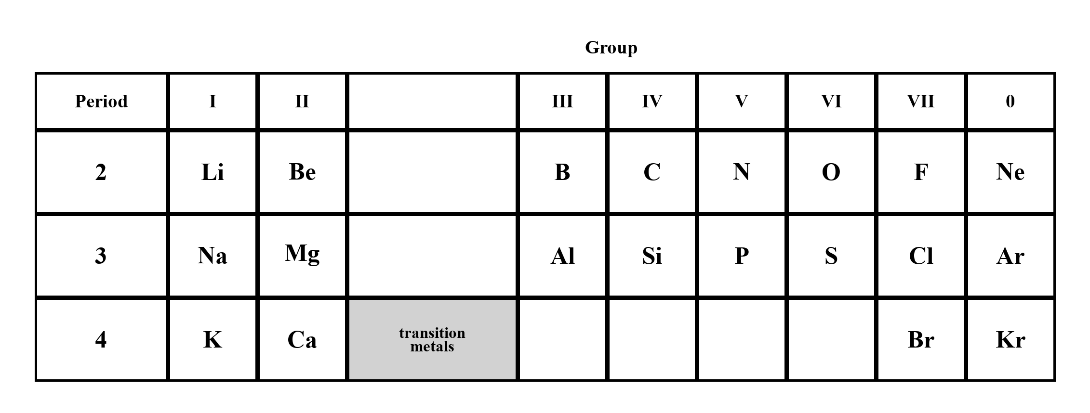
(a) What determines the position of an element in the periodic table? (1 mark)
________________________________________________________________________
________________________________________________________________________
(b) Across a period, elements change from metals through semi-metal to non-metals. Name ONE metalloid in the above table. (1 mark)
________________________________________________________________________
(c) For each of the following pairs of elements, suggest ONE reaction in which they behave similarly. (0 marks)
(i) Sodium and potassium (1 mark)
________________________________________________________________________
________________________________________________________________________
(ii) Chlorine and fluorine (1 mark)
________________________________________________________________________
________________________________________________________________________
(d) In what way are the electronic arrangements of atoms of lithium and sodium (i) similar to each other? (ii) different from each other? (2 marks)
________________________________________________________________________
________________________________________________________________________
________________________________________________________________________
(e) Which metal and non-metal in the above table would react most vigorously with each other? (1 mark)
________________________________________________________________________
(f) The atomic number of krypton (Kr) is 36. The electronic arrangement of a krypton atom is 2, 8, x, y. What are the values of x and y? (1 mark)
________________________________________________________________________
(g) Explain why argon is unreactive. (1 mark)
________________________________________________________________________
________________________________________________________________________

17. Magnesium chloride is formed when magnesium reacts with chlorine.
(a) Explain why magnesium and chlorine are placed in the same period in the Periodic Table. (1 mark)
________________________________________________________________________
________________________________________________________________________
(b) Magnesium occurs naturally in three stable isotopes, ²⁴Mg, ²⁵Mg and ²⁶Mg. If the abundance of ²⁴Mg is 78.6% and the relative atomic mass of Mg is 24.327, calculate the abundance of ²⁵Mg.
(2 marks)
________________________________________________________________________
________________________________________________________________________
________________________________________________________________________
________________________________________________________________________
(c) What is meant by the term ‘isotope’? (1 mark)
________________________________________________________________________
________________________________________________________________________
(d) State the number of protons, neutrons and electrons in a ²⁵Mg atom. (1 mark)
________________________________________________________________________
(e) Write the word equation for the reaction between magnesium and chlorine. (1 mark)
________________________________________________________________________
________________________________________________________________________
(f) Magnesium also reacts with fluorine to give magnesium fluoride similarly. Predict whether chlorine or fluorine is more reactive towards magnesium. Explain your answer. (1 mark)
________________________________________________________________________
________________________________________________________________________

18. Consider the table below about isotopes of silicon.
Atom | Number of protons | Number of neutrons | Number of electrons | Relative abundance
ᵃSi | 14 | 14 |  | 92.2%
ᵇSi | 14 | 16 |  | x
²⁹Si |  |  |  | y
(a) Complete the missing parts of the above table. (3 marks)
________________________________________________________________________
________________________________________________________________________
(b) Calculate the value of a and b in the above table. (2 marks)
________________________________________________________________________
________________________________________________________________________
(c) What is meant by the term ‘relative atomic mass’? (1 mark)
________________________________________________________________________
________________________________________________________________________
________________________________________________________________________
(d) State the electronic arrangement of a Si atom. (1 mark)
________________________________________________________________________
(e) (i) Explain why silicon is classified as a semi-metal. (1 mark)
________________________________________________________________________
________________________________________________________________________
(ii) Suggest another semi-metal with atomic number less than 20. (1 mark)
________________________________________________________________________
(f) Suggest one use of silicon in daily life. (1 mark)
________________________________________________________________________
(g) Germanium (Ge) is also a semi-metal. Silicon and germanium are placed in the same group in the Periodic Table and the atomic number of Ge is 32. Given that Ge is a Period 4 element, state the electronic arrangement of Ge. Explain why Si and Ge have similar chemical properties. (2 marks)
________________________________________________________________________
________________________________________________________________________
________________________________________________________________________

19. Some of the sub-atomic information of atoms A to G is given in the table below.
Atom | Atomic number | Mass number | Proton | Neutron | Electron
A |  |  | 19 | 20
B |  |  | 10 | 10
C | 4 |  |  | 5
D |  |  | 17 | 18
E |  | 40 | 20
F |  | 4 |  |  | 2
G | 14 | 28
(a) Complete the above table. (7 marks)
________________________________________________________________________
(b) Give the special name of the group in the Periodic Table that atom A belongs to. (1 mark)
________________________________________________________________________
(c) Give the special name of the group in the Periodic Table that atom B belongs to. (1 mark)
________________________________________________________________________
(d) Give the FULL atomic symbols of atom A, E and G. (3 marks)
________________________________________________________________________
________________________________________________________________________
(e) Which of the above elements are metals? (1 mark)
________________________________________________________________________
________________________________________________________________________
(f) Give one use of the element of atom F. (1 mark)
________________________________________________________________________
(g) Which of the above atoms has SAME chemical properties with atom A? Explain your answer. (1 mark)
________________________________________________________________________
________________________________________________________________________
(h) Draw the electron diagram of atom A, atom B and atom C. (3 marks)
________________________________________________________________________
________________________________________________________________________
________________________________________________________________________
________________________________________________________________________
________________________________________________________________________

20. The following diagram shows a part of the Periodic table. Referring to the elements indicated in the above diagram only, answer the following questions by using the symbols stated in the above diagram. (A to P are NOT the element symbol.)
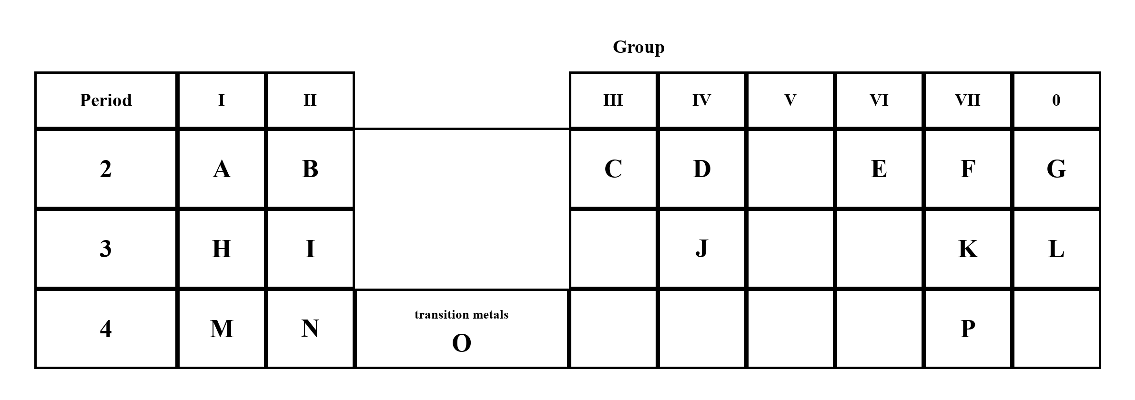
(a) Which of the above elements is the most reactive metal? (1 mark)
________________________________________________________________________
(b) Which of the above elements is the most reactive non-metal? (1 mark)
________________________________________________________________________
(c) Write down the electronic arrangement of the following elements: (0 marks)
(i) K (1 mark)
________________________________________________________________________
(ii) E (1 mark)
________________________________________________________________________
(d) Which of the above elements is / are transition metal? (1 mark)
________________________________________________________________________
(e) Which of the above elements is a liquid non-metal? (1 mark)
________________________________________________________________________
(f) Which of the above halogens has the lowest boiling point? (1 mark)
________________________________________________________________________
(g) Which of the above elements is / are expected to share similar chemical properties with beryllium? Explain your answer. (2 marks)
________________________________________________________________________
________________________________________________________________________
________________________________________________________________________
(h) Identify ONE metalloid in the above elements. (1 mark)
________________________________________________________________________
(i) The isotopic mass of atom X is 23 and it has 12 neutrons. Which element does X belong to? (1 mark)
________________________________________________________________________

Answer
1.
(a) A, C
Source: data table; room conditions; p.3 Only liquid metals: Mercury; non-metal liquid: Bromine
(b) 113 to 445
Source: from given melting point and boiling point of F
(c) (i) B, C, E
Source: p.3 Electrical Conductivity: Metal — Good conductor
(c) (ii) Shiny; Usually hard and strong; Malleable / Ductile Yes; Usually high density; Good conductor; Usually high (m.p. / b.p.) (except Alkali Metals and mercury); Solid (Only liquid: Mercury, ⁸⁰Hg) [any TWO]
Source: p.3 Classification of elements — Property Metal
(c) (iii) The statement is incorrect. Poor conductor (Except graphite).
Source: p.3 Electrical Conductivity of Non-metal
2.
(a) P, S
(b) Q
(c) R
(d) Bromine (Solid or gas (Only liquid: Bromine ³⁵Br); Poor conductor (Except graphite))
Source: p.3 Non-metal State / Electrical Conductivity
3.
(a) Chlorine
(b) Dull; Usually brittle; Malleable / Ductile No; Usually low (density); Poor conductor (Except graphite) [any THREE]
Source: p.3 Classification of elements — Property Non-metal
(c) (i) neon electron diagram — electronic arrangement 2,8
Source: p.1 Neon* Ne 2,8
(c) (ii) chlorine electron diagram — electronic arrangement 2,8,7
Source: p.1 Chlorine* Cl 2,8,7
4.
Element | Atomic number | Electronic arrangement | Period number | Group number
W | 4 | 2,2 | 2 | II
X | 7 | 2,5 | 2 | V
Y | 10 | 2,8 | 2 | 0
Z | 12 | 2,8,2 | 3 | II
M | 14 | 2,8,4 | 3 | IV
N | 19 | 2,8,8,1 | 4 | I
(a) as in completed table. Period = Number of occupied electron shells. Group = Number of electrons in outermost shell.
Source: p.1 electronic arrangement table; p.3 Periodic Table
(b) (i) W, Z, N
Source: p.1 #: Metal — Be, Mg, K
(b) (ii) X, Y
Source: p.1 *: Non-metal — N, Ne
(b) (iii) M
Source: p.1 Silicon^ Si; p.3 Boron and silicon are classified as metalloid / semi-metal.
5.
(a) electron diagram of X — electronic arrangement 2,8,6
Source: p.1 Sulphur* S 2,8,6
(b) Period 3, Group VI
Source: p.3 Horizontal row: Period = Number of occupied electron shells; Vertical column: Group = Number of electrons in outermost shell
(c) non-metal
Source: p.1 *: Non-metal — Sulphur
6.
(a) Atomic number (No. of protons)
Source: p.1
(b) (i) 27
(b) (ii) Group III. Group = Number of electrons in outermost shell. Electronic arrangement of aluminium is 2,8,3.
Source: p.3; p.1 Aluminium# Al 2,8,3
(c) Note that the abundance of x is 100% – 50.6% = 49.4%. 79.988 = [(79)(50.6) + (x)(49.4)] / 100. x = 81 (The isotopic mass of xBr is 81)
Source: p.2 Example 3
7.
(a) 20
Source: p.1 Atomic number (No. of protons) Calcium 20
(b) r: 8; s: 2
Source: p.1 Calcium# Ca 2,8,8,2
(c) Period 4
Source: p.3 Period = Number of occupied electron shells
(d) Shiny; Usually hard and strong; Malleable / Ductile Yes; Usually high density; Good conductor; Usually high (m.p. / b.p.) (except Alkali Metals and mercury) [any TWO]
Source: p.3 Property Metal
8.
(a) (i) Group = Number of electrons in outermost shell. An atom of element B has 1 outermost shell electron.
Source: p.3
(a) (ii) Period = Number of occupied electron shells. An atom of element E has four occupied electron shells.
Source: p.3
(b) (i) Neutron: Relative charge 0; Relative mass 1
Source: p.1 Subatomic particle table
(b) (ii) ³⁵Cl: protons 17, neutrons 18, electrons 17; ³⁷Cl: protons 17, neutrons 20, electrons 17. Isotopes are atoms of the element with same number of protons but different number of neutrons.
Source: p.1 Chlorine atomic number 17; p.2 Isotopes
9.
(a) E (Period 3 Group IV — Silicon^)
Source: p.1 Silicon^ Si; p.3 Boron and silicon are classified as metalloid / semi-metal
(b) Period = Number of occupied electron shells. They have the same number of occupied electron shells.
Source: p.3
(c) Group = Number of electrons in outermost shell. They have the same number of electrons in outermost shell.
Source: p.3
(d) G is calcium (atomic number 20). H is germanium (atomic number 32). Difference in protons = 32 − 20 = 12.
Source: p.1 Calcium 20; p.3 ³²Ge
(e) D. Elements in the same group have SIMILAR chemical properties (NOT SAME) because they have same number of outermost shell electrons.
Source: p.3 Note 4
10.
Element | Period number | Group number | Electronic arrangement
A | 3 | III | 2,8,3
B | 1 | 0 | 2
C | 2 | VII | 2,7
D | 3 | VII | 2,8,7
E | 2 | IV | 2,4
F | 2 | III | 2,3
A: Aluminium# Al 2,8,3
Source: p.1
B: Helium* He 2. In Group 0, Helium has 2 outermost shell electrons while other elements have 8
Source: p.1; p.3 Note 2
C: Fluorine* F 2,7
Source: p.1
D: Chlorine* Cl 2,8,7
Source: p.1
E: Carbon* C 2,4. Poor conductor (Except graphite).
Source: p.1; p.3
F: Boron^ B 2,3. Boron and silicon are classified as metalloid / semi-metal.
Source: p.1; p.3
11.
(a) Alkali metals
Source: p.4 Group I: Alkali metals
(b) p = 2, q = 8, r = 8
Source: p.1 Potassium# K 2,8,8,1
(c) Elements in the same group have SIMILAR chemical properties (NOT SAME) because they have same number of outermost shell electrons.
Source: p.3 Note 4
(d) Potassium is more reactive. Reactivity of Group I elements increases down the group.
Source: p.4
(e) store in paraffin oil to prevent reaction with oxygen
Source: p.4 Very reactive (store in paraffin oil to prevent reaction with oxygen)
(f) Tick: potassium reacts more vigorously than sodium when added to water; a lilac flame is seen; potassium moves around. (Potassium (K) Melts to form a silvery ball which moves very quickly on the water surface. Giving off hydrogen very rapidly. The metal burns with a lilac flame. Reactivity of Group I elements increases down the group.)
Source: p.4
(g) Sodium + Water → Sodium hydroxide + Hydrogen
Source: p.4 Word equation for the reaction between sodium and water
12.
(a) 2
Source: p.1 Magnesium# Mg 2,8,2 / Calcium# Ca 2,8,8,2; Group = Number of electrons in outermost shell
(b) Elements in the same group have SIMILAR chemical properties (NOT SAME) because they have same number of outermost shell electrons.
Source: p.3 Note 4
(c) increase
Source: p.4 Reactivity of Group II elements increases down the group.
(d) Beryllium (Be) Does not react with water or steam. Barium (Ba) Reacts even more vigorously than strontium does.
Source: p.4 Element Reaction with water
(e) Calcium + Water → Calcium hydroxide + Hydrogen
Source: p.4 Word equation for the reaction between calcium and water
(f) All have low densities. However, they are denser than Group I elements of the same period.
Source: p.4 Group II: Alkaline earth metals
(g) beryllium
Source: p.4 Beryllium (Be) Does not react with water or steam; Reactivity of Group II elements increases down the group.
13.
(a) Halogens
Source: p.5 Group VII: Halogens
(b) Group = Number of electrons in outermost shell. They have same number of outermost shell electrons. / All are colored. / All are toxic.
Source: p.3; p.5
(c) Fluorine
Source: p.5 Reactivity of Group VII elements decreases down the group.
(d) All are toxic
Source: p.5
(e) Chlorine: gas, Yellowish green*; Bromine: liquid, Reddish brown; Iodine: solid, Black*. (*Normal state under room conditions)
Source: p.5 Color table
(f) increase
Source: p.5 Melting points and boiling points of the Group VII elements increase down the group
(g) Reactivity of Group VII elements decreases down the group. Iodine (I) Has almost no reaction even in direct sunlight or upon strong heating. Therefore astatine has almost no reaction even in direct sunlight or upon strong heating.
Source: p.5
(h) chlorine electron diagram — electronic arrangement 2,8,7
Source: p.1 Chlorine* Cl 2,8,7
14.
(a) Group 0; Noble gases
Source: p.5 Group 0: Noble gases
(b) (i) 2 (ii) 8. In Group 0, Helium has 2 outermost shell electrons while other elements have 8
Source: p.3 Note 2
(c) colorless gas at room conditions / All are colorless gas at room conditions
Source: p.5
(d) Noble gases are unreactive / inert since they have an octet structure (duplet in helium) in their outermost shell. All are very unreactive, They have little or no reaction with other elements. (May have reactions under extreme conditions)
Source: p.5
(e) Fill light bulbs (Argon does not react with the metal filament in the bulb)
Source: p.5
(f) Fill advertising signs (Neon does not react with glass tube)
Source: p.5
(g) Fill balloons and airships (Helium has low density and does not burn)
Source: p.5
15.
(a) Ne / Ar / Kr / Xe (In Group 0, Helium has 2 outermost shell electrons while other elements have 8)
Source: p.3 Note 2
(b) Br (Solid or gas (Only liquid: Bromine ³⁵Br); Color in liquid state: Reddish brown)
Source: p.3; p.5
(c) Sr
Source: p.3 ³⁸Sr Period 5 Group II
(d) Sc / Ti / Fe / Cu / Zn (Elements between Group II and Group III are transition metals)
Source: p.3 Note 3
(e) Si (Boron and silicon are classified as metalloid / semi-metal.)
Source: p.3
(f) O (Top 5 most abundant elements in Earth crust are O > Si > Al > Fe > Ca.)
Source: p.1 Note 1
16.
(a) In modern Periodic Table, elements are arranged in increasing atomic number. (NOT mass number)
Source: p.3
(b) Boron / silicon. Boron and silicon are classified as metalloid / semi-metal.
Source: p.3
(c) (i) React with water to give metal hydroxide (alkaline solution) and hydrogen gas / Sodium + Water → Sodium hydroxide + Hydrogen
Source: p.4
(c) (ii) All react with metals to give ionic compounds / All react with non-metals to give covalent compounds / Hydrogen + Chlorine → Hydrogen chloride
Source: p.5
(d) (i) similar: they have same number of outermost shell electrons (1). (ii) different: Period = Number of occupied electron shells (Li 2,1 has 2 occupied electron shells; Na 2,8,1 has 3 occupied electron shells).
Source: p.3 Note 4; p.1 Lithium# Li 2,1; Sodium# Na 2,8,1
(e) K and F. Reactivity of Group I elements increases down the group. Reactivity of Group VII elements decreases down the group.
Source: p.4; p.5
(f) x = 18, y = 8
Source: p.3 ³⁶Kr 2,8,18,8
(g) Noble gases are unreactive / inert since they have an octet structure (duplet in helium) in their outermost shell.
Source: p.5
17.
(a) Period = Number of occupied electron shells. Magnesium# Mg 2,8,2 and Chlorine* Cl 2,8,7 both have 3 occupied electron shells.
Source: p.3; p.1
(b) Let x% be the abundance of ²⁵Mg while y% be the abundance of ²⁶Mg. Since 78.6 + x + y = 100, y = 21.4 − x. 24.327 = [(24)(78.6) + (25)(x) + (26)(21.4 − x)] / 100. x = 10.1 (The abundance of ²⁵Mg is 10.1%)
Source: p.2 Example 2
(c) Isotopes are atoms of the element with same number of protons but different number of neutrons
Source: p.2
(d) protons 12, neutrons 13, electrons 12
Source: p.1 Magnesium atomic number 12
(e) Magnesium + Chlorine → Magnesium chloride
Source: p.4
(f) Fluorine is more reactive. Reactivity of Group VII elements decreases down the group.
Source: p.5
18.
(a) All have 14 protons and 14 electrons. ᵃSi: 14 neutrons already given, electrons 14. ᵇSi: electrons 14. ²⁹Si: protons 14, neutrons 15, electrons 14.
Source: p.1 Silicon^ Si atomic number 14; Atoms are electrically neutral because the number of positively charged protons is equal to the number of negatively charged electrons
(b) a = 28; b = 30 (mass number = protons + neutrons)
(c) Relative atomic mass is the weighted average of the relative isotopic masses of all of its naturally occurring isotopes of the ¹²C = 12.00 scale
Source: p.2
(d) 2,8,4
Source: p.1 Silicon^ Si 2,8,4
(e) (i) Boron and silicon are classified as metalloid / semi-metal. They have properties of both metals and non-metals. They conduct electricity under high temperature / with impurities.
Source: p.3
(e) (ii) Boron
Source: p.1 Boron^ B; p.3
(f) Silicon is used in making computer chips
Source: p.3
(g) 2,8,18,4. Elements in the same group have SIMILAR chemical properties (NOT SAME) because they have same number of outermost shell electrons.
Source: p.3 ³²Ge 2,8,18,4; Note 4
19.
Atom | Atomic number | Mass number | Proton | Neutron | Electron
A | 19 | 39 | 19 | 20 | 19
B | 10 | 20 | 10 | 10 | 10
C | 4 | 9 | 4 | 5 | 4
D | 17 | 35 | 17 | 18 | 17
E | 20 | 40 | 20 | 20 | 20
F | 2 | 4 | 2 | 2 | 2
G | 14 | 28 | 14 | 14 | 14
(a) as in completed table. Atomic number (No. of protons). Atoms are electrically neutral because the number of positively charged protons is equal to the number of negatively charged electrons.
Source: p.1
(b) Alkali metals
Source: p.4 Group I: Alkali metals; p.1 Potassium#
(c) Noble gases
Source: p.5 Group 0: Noble gases; p.1 Neon*
(d) A: ³⁹K (atomic number 19); E: ⁴⁰Ca (atomic number 20); G: ²⁸Si (atomic number 14)
Source: p.1 Full atomic symbol / Atomic number
(e) A, C, E
Source: p.1 #: Metal — Potassium, Beryllium, Calcium
(f) Fill balloons and airships (Helium has low density and does not burn)
Source: p.5 Helium (He)
(g) None. Isotopes have SAME chemical properties (NOT SIMILAR) because they are atoms with same electronic arrangement. Elements in the same group have SIMILAR chemical properties (NOT SAME). None of B–G is an isotope of A.
Source: p.2 Note; p.3 Note 4
(h) A: 2,8,8,1; B: 2,8; C: 2,2
Source: p.1 K, Ne, Be
20.
(a) M (Reactivity of Group I elements increases down the group.)
Source: p.4
(b) F (Reactivity of Group VII elements decreases down the group.)
Source: p.5
(c) (i) 2,8,7 (letter K is chlorine)
Source: p.1 Chlorine* Cl 2,8,7
(c) (ii) 2,6 (letter E is oxygen)
Source: p.1 Oxygen* O 2,6
(d) O (Elements between Group II and Group III are transition metals)
Source: p.3 Note 3
(e) P (Solid or gas (Only liquid: Bromine ³⁵Br))
Source: p.3
(f) F (Melting points and boiling points of the Group VII elements increase down the group)
Source: p.5
(g) I and N. Elements in the same group have SIMILAR chemical properties (NOT SAME) because they have same number of outermost shell electrons. (B is beryllium; I is magnesium; N is calcium.)
Source: p.3 Note 4
(h) C or J (Boron and silicon are classified as metalloid / semi-metal.)
Source: p.3
(i) H (isotopic mass roughly equal to mass number; 23 − 12 = 11 protons → Sodium# Na)
Source: p.2 On the ¹²C = 12.00 scale, the relative isotopic mass of an isotope is roughly equal to its mass number.; p.1 Sodium 11

