A

Synopsis

On



**Gym Website**

Minor Project

For

Partial fulfillment of

Diploma Computer Science & Engineering

Session (2022-23)

Submitted By:

**Atul Rajput (203500015)**

Submitted to:

**DEPARTMENT OF COMPUTER SCIENCE & ENGINEERING**

**UNIVERSITY POLYTECHNIC**

**G.L.A UNIVERSITY, MATHURA (U.P.)**

**1 Introduction**

**1.1 Basic Introduction**

When we look back on the evolution of the fitness industry in India, it is fascinating to see how the demand for fitness products and services has grown by leaps and bounds over the last decade. The inflection point that the sector is currently at, points towards a lot of positive developments in the future. The advent of technology and the democratization of information has been one of the many crucial factors that have led to the surge in consumers taking a greater interest in fitness and actively seeking products and services to help them remain fit.

Most products and services in the market today are geared towards providing consumers with new and exciting ways to maintain good health and well-being. While many of these people visit gyms and fitness clubs to get in better shape or gain more strength, those with the want to become more fit and lead more active lifestyles having a no better option.

Several start-ups in the fitness sector are now targeting urban consumers across various age groups to market a range of solutions depending on what they need. This includes everything from wearable fitness devices, digital platforms where people can sign up for open gym memberships, to even state-of-the-art fitness equipment. With the entry of technology and digitization in the fitness domain, the current structure of the market is in the midst of a major

Overhaul, market way for more consolidation in the market.

**1.2 Objective**

**My gym website is where members will view your fitness class schedule, make a booking, and find out what services you offer. A great fitness website example is F45 Training.**

**1.3 Scope of the Project**

India is story of a growing middle class. With millions joining the workforce every year competing to sustain their careers, there is a competing to sustain their careers, there is a compromise made unknowingly. Increasing Physical inactivity, bad diets, and falling health get ignored to survive the rigor of the work-life. Frenetic work schedules, extensive travel, awry sleep patterns, and diets bursting with trans fats have only made us more prone to serious health disorders than ever before. Lifestyle diseases are becoming endemic to our society and almost always, the solution begins with getting off your couch and making simple lifestyle changes.

India has the largest number of diabetics (72 Million) with type at 50 million. At least 150 million people in the country, affected by mental disorders, require active medical intervention. 26 percent of all deaths in India happen due to cardiovascular diseases. Small Studies suggest that one in 10 percent adults suffers from hypothyroidism. Globally, 14.2 million people between the ages of 30-69 years, die prematurely each year from diseases like heart attack, diabetes, and high blood pressure.

**2.Block Diagram of the Proposed Project**

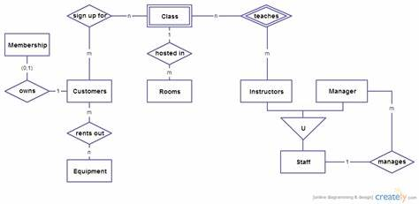

**3.Software to be used**

* **VS Code**

**4.Time**

This project will take about 4-5 months to be completed fully & to be Implemented.

**4.Ghant chart**

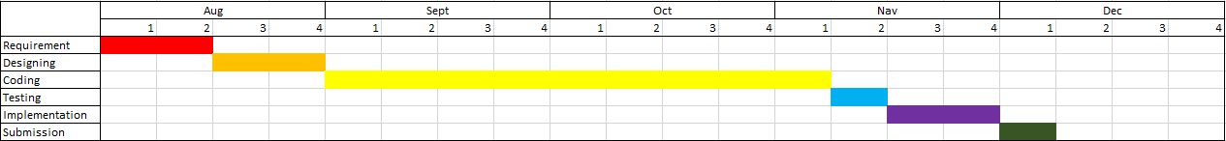

**5. Conclusion**

The aim of this project is that every person is to be Fit & Healthy.