Contiloe Pictures

Web Application Issue List

*Give New page for each issue*

**Point No.** 0001 **/ Date of Creation:** 11/10/2019

**Menu Option Name:**

Expense v/s Budget Report

**Details of the Changes/Issue/Feedback:**

Extra hour break up report by giving hyperlink

**Status:**

Completed (12/10/2019)

**Screen Shot:**

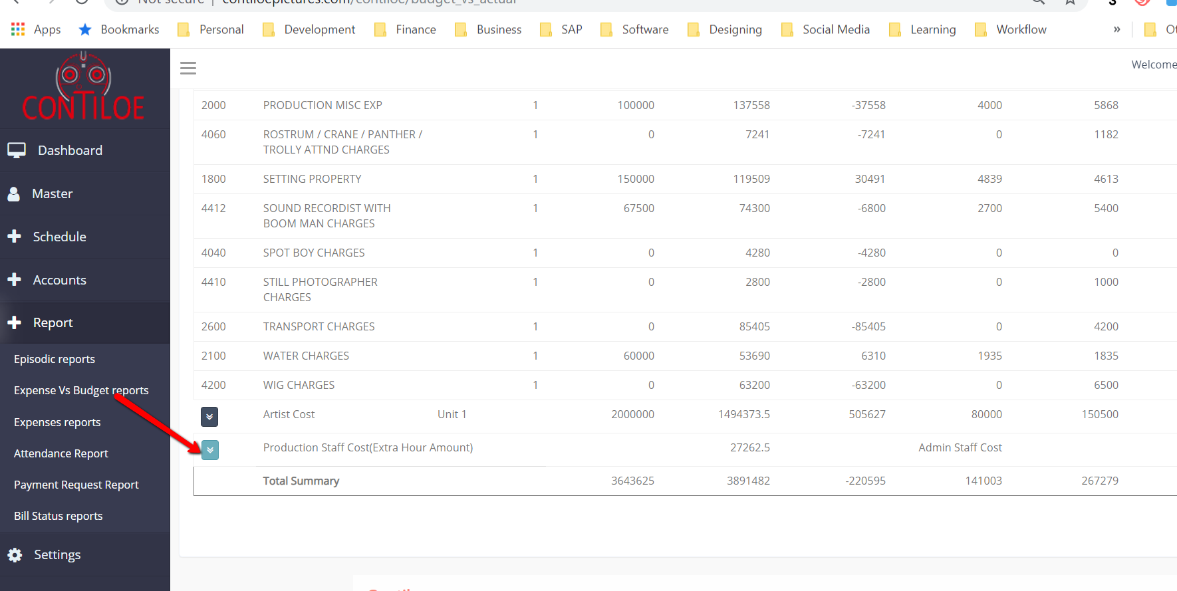

**Point No.** 0002 **/ Date of Creation:** 11/10/2019

**Menu Option Name:**

Episodic Report

**Details of the Changes/Issue/Feedback:**

Day-wise footage breakup report detail by giving hyperlink

**Status:**

Completed (15/10/2019)

**Screen Shot:**

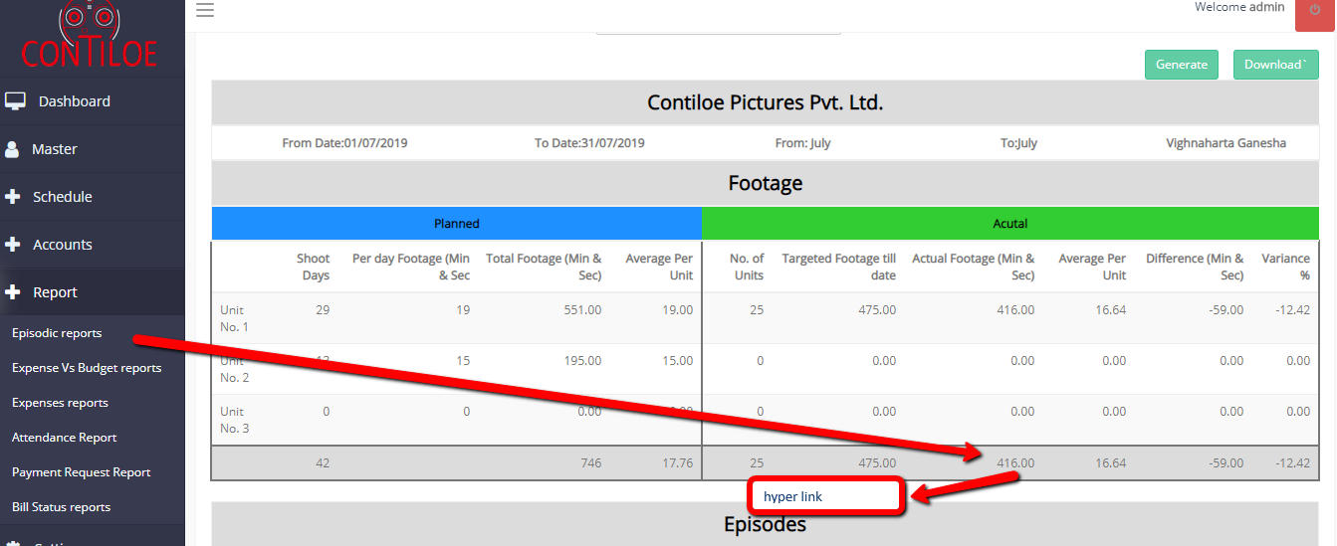

**Ie:**

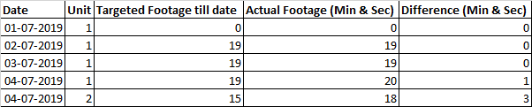

**Point No.** 0003 **/ Date of Creation:** 11/10/2019

**Menu Option Name:**

Episodic Report

**Details of the Changes/Issue/Feedback:**

Episodic Staff cost breakup report

**Status:**

Completed (16/10/2019)

**Screen Shot:**

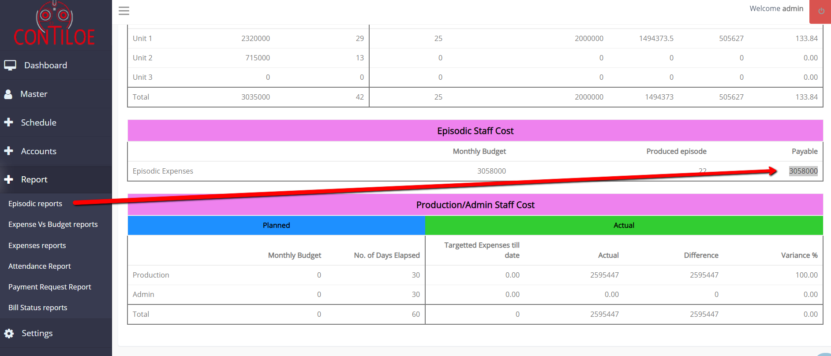

**Direct display on report**

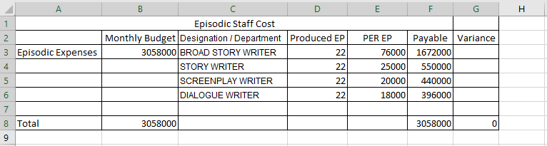

**Point No.** 0004 **/ Date of Creation:** 11/10/2019

**Menu Option Name:**

**Details of the Changes/Issue/Feedback:**

Production/Admin staff cost not matching with monthly attendance report

**Status:**

Completed (15/10/2019)

**Screen Shot:**

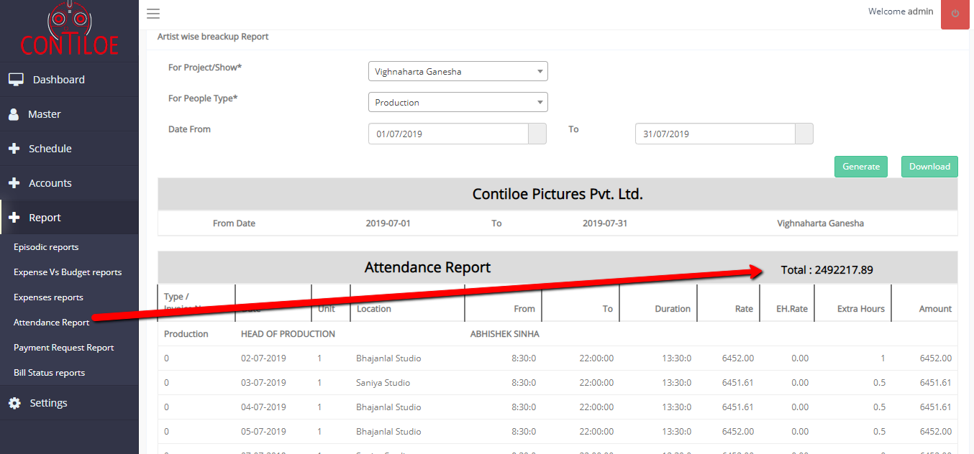

**____________________________________________________________________________**

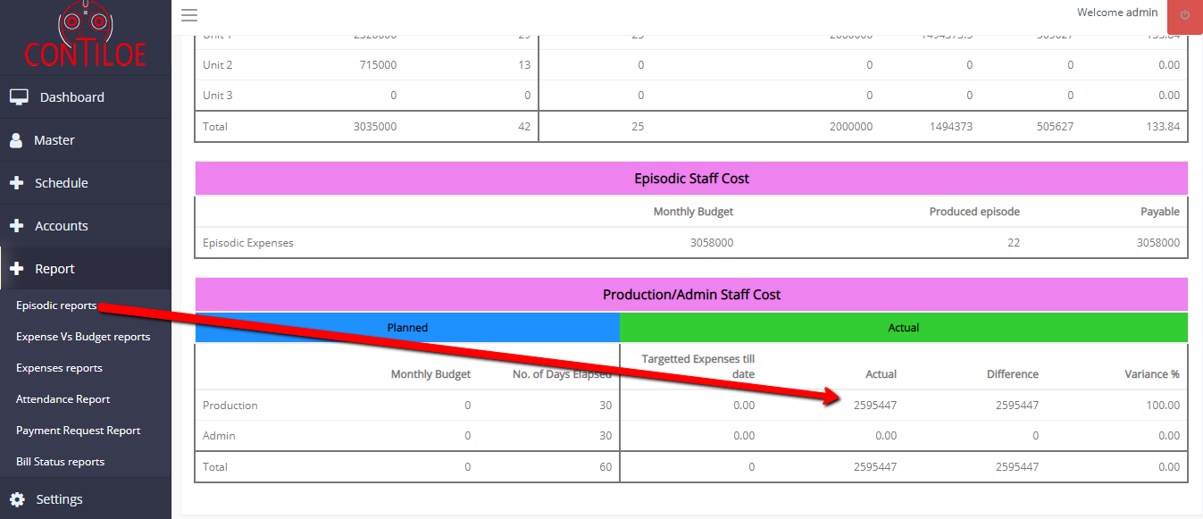

**Point No.** 0005 **/ Date of Creation:** 11/10/2019

**Menu Option Name:**

Episodic Report

**Details of the Changes/Issue/Feedback:**

Expenses v/s budget report not showing in Episodic report due to which Total cost not updated in episodic report - (Check screen shot and Notes)

**Status:**

Completed (16/10/2019)

**Remarks:**

Expenses v/s budget report merge in episodic report

**Screen Shot:**

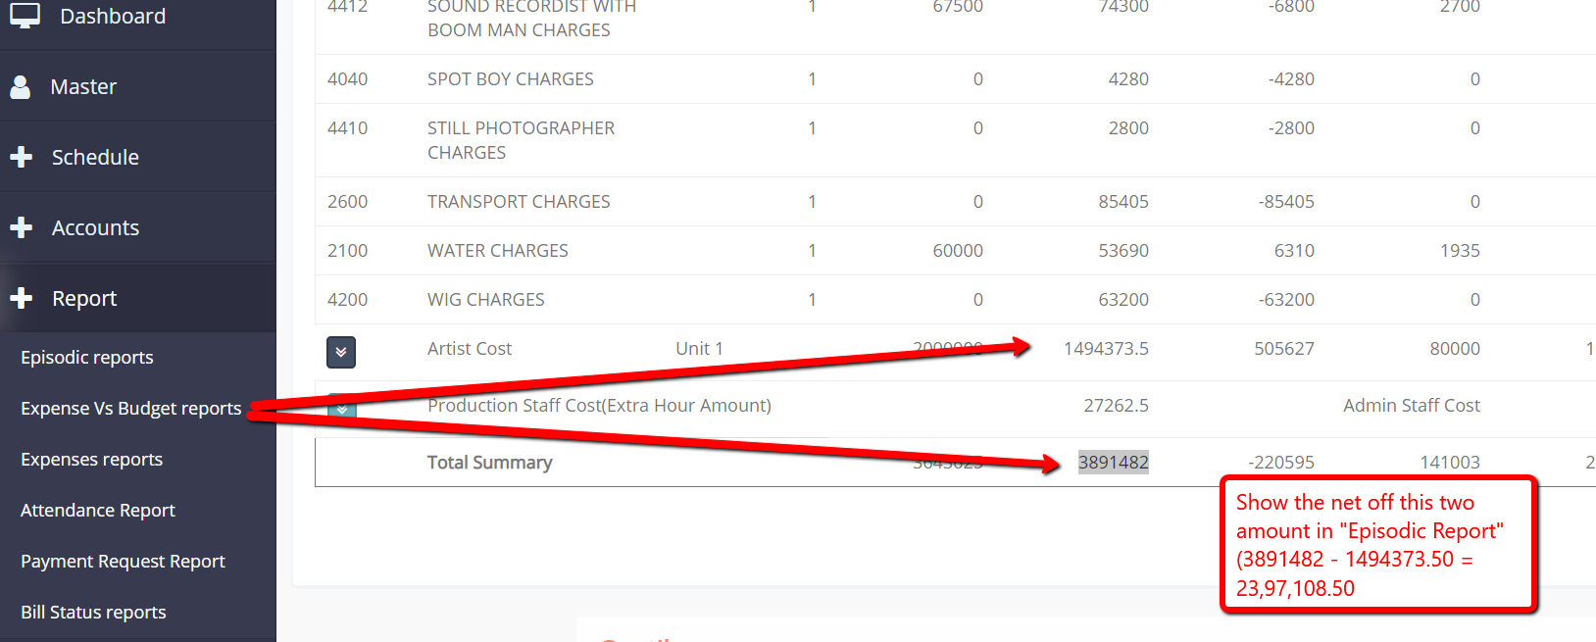

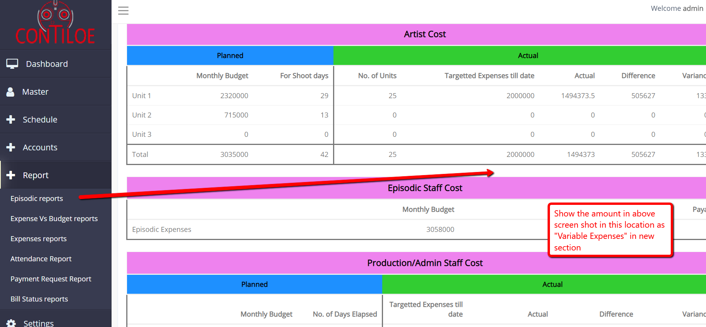

**Point No.** 0006 **/ Date of Creation:** 11/10/2019

**Menu Option Name:**

Payment Request Report

**Details of the Changes/Issue/Feedback:**

Payment request report not coming as per due date.

**Status:**

Completed (15/10/2019)

**Screen Shot:**

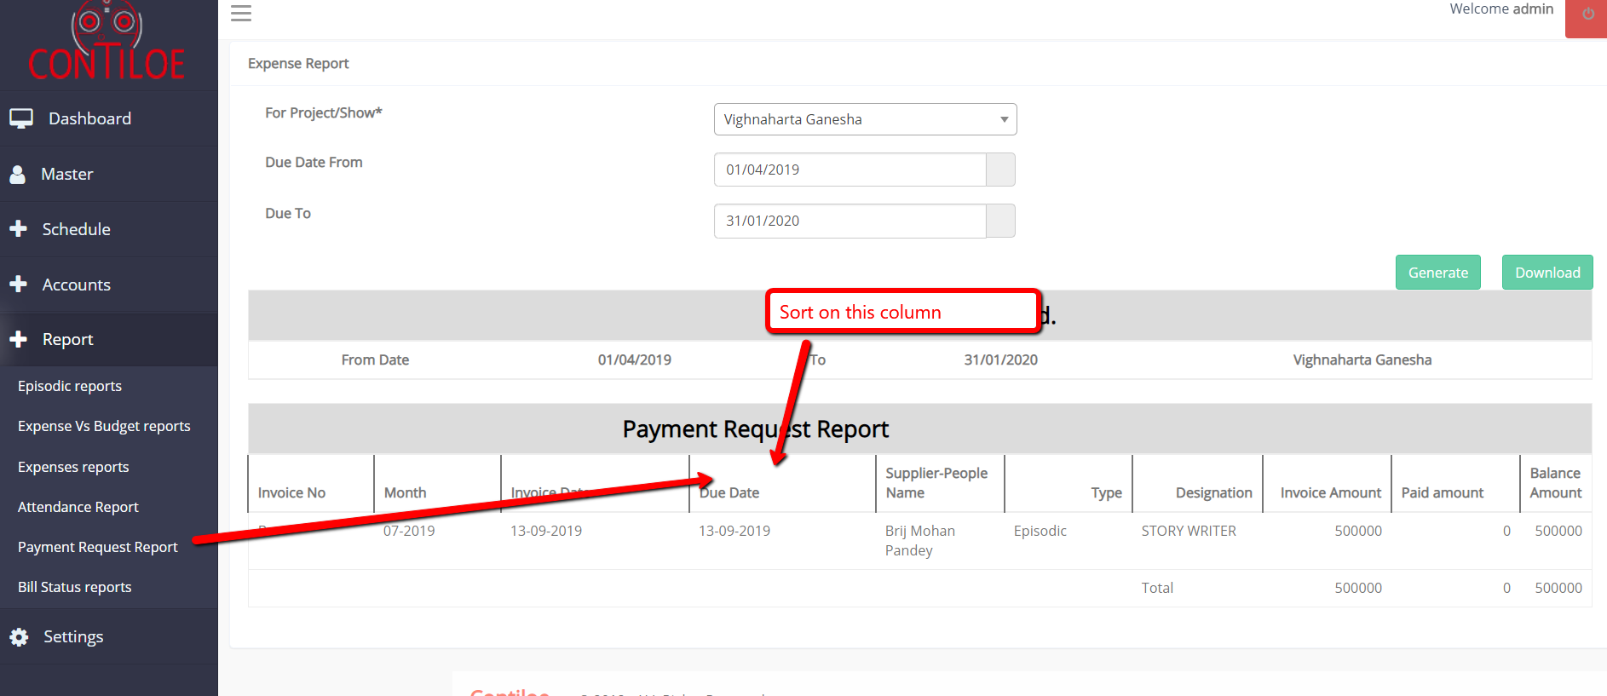

**Point No.** 0007 **/ Date of Creation:** 11/10/2019

**Menu Option Name:**

Bill Status report

**Details of the Changes/Issue/Feedback:**

When we delete Invoice from Invoice entry module still it is showing in bills status report, should not happen…..

**Status:**

Completed (15/10/2019)

**Screen Shot:**

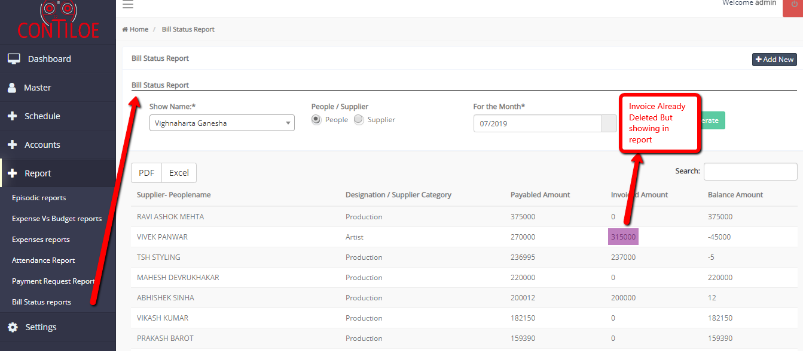

·

**Point No.** 0008 **/ Date of Creation:** 11/10/2019

**Menu Option Name:**

Invoice Entry

**Details of the Changes/Issue/Feedback:**

Negative amount of Invoices accepting which should not accept...

**Status:**

Completed (15/10/2019)

**Screen Shot:**

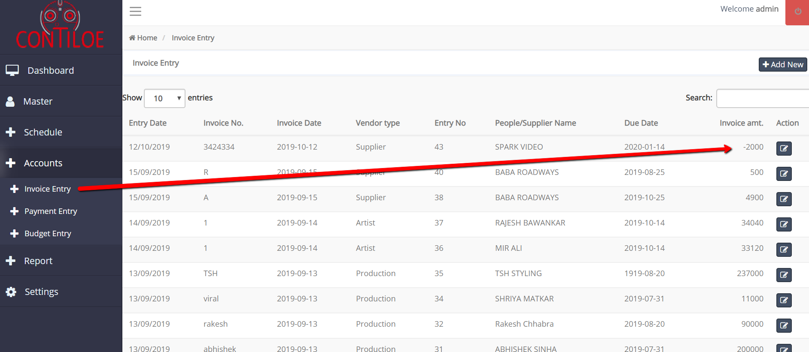

**Point No.** 0009 **/ Date of Creation:** 04/11/2019

**Menu Option Name:**

Project Master

**Details of the Changes/Issue/Feedback:**

Do not allow to delete master - Artist / Production / Episodic if it has been used in Planning or Actual Schedule

When pressed on “Delete” icon,

System should check usage in above transactions

If not found

* Display message “Are you sure you want to delete this?” Yes (Delete it) No (Do not Delete”

If found

* Display message “Can’t Delete this record, People is used in Planning / Actual “ Close Button

**Status:**

Pending

**Screen Shot:**

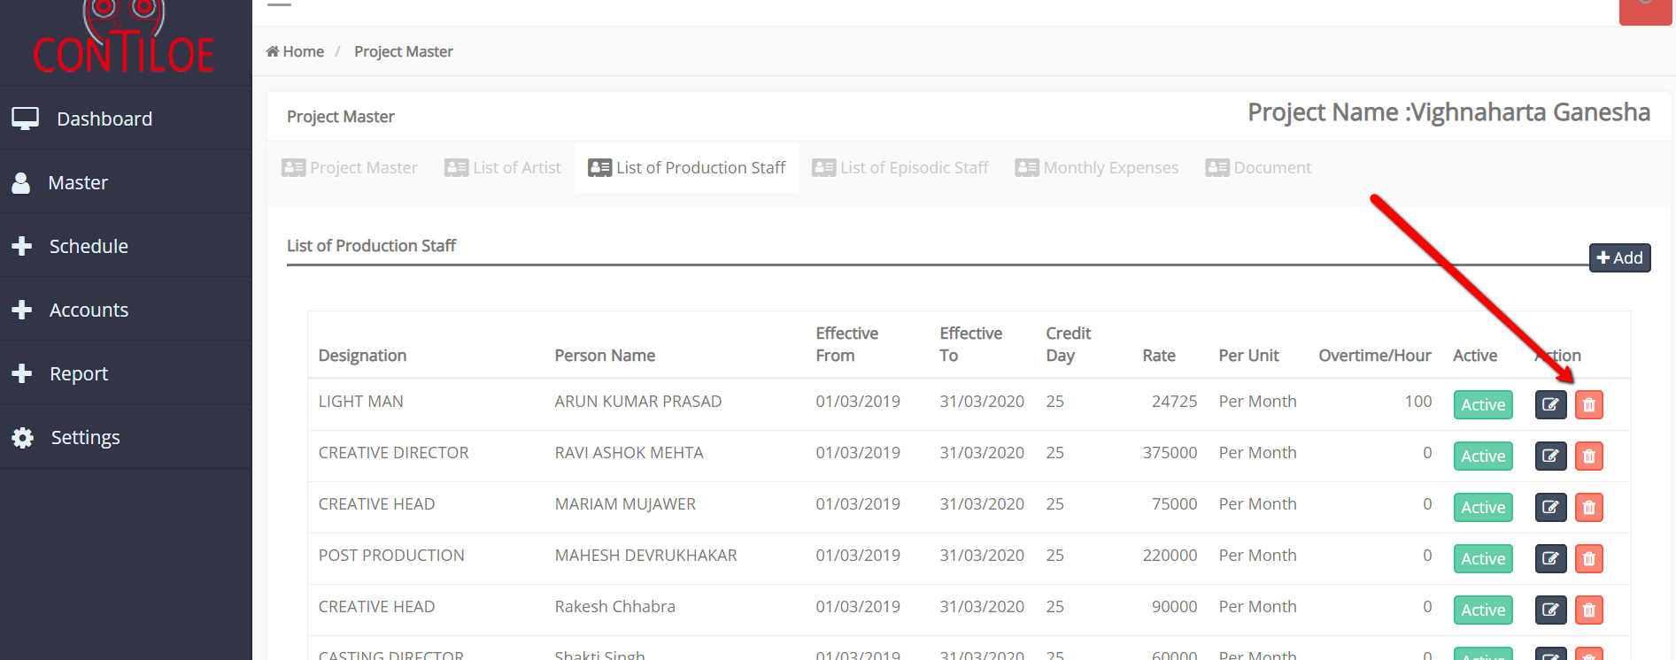

**Point No.** 0010 **/ Date of Creation:** 04/11/2019

**Menu Option Name:**

Episodic Report and Expense v/s Budget Report

**Details of the Changes/Issue/Feedback:**

Amount mismatch for Artist in both reports (Check screen shot)

**Status:**

Ready for Testing

**Screen Shot:**

Episodic Report - Month July 2019 - 06/07/2019 to 06/07/2019

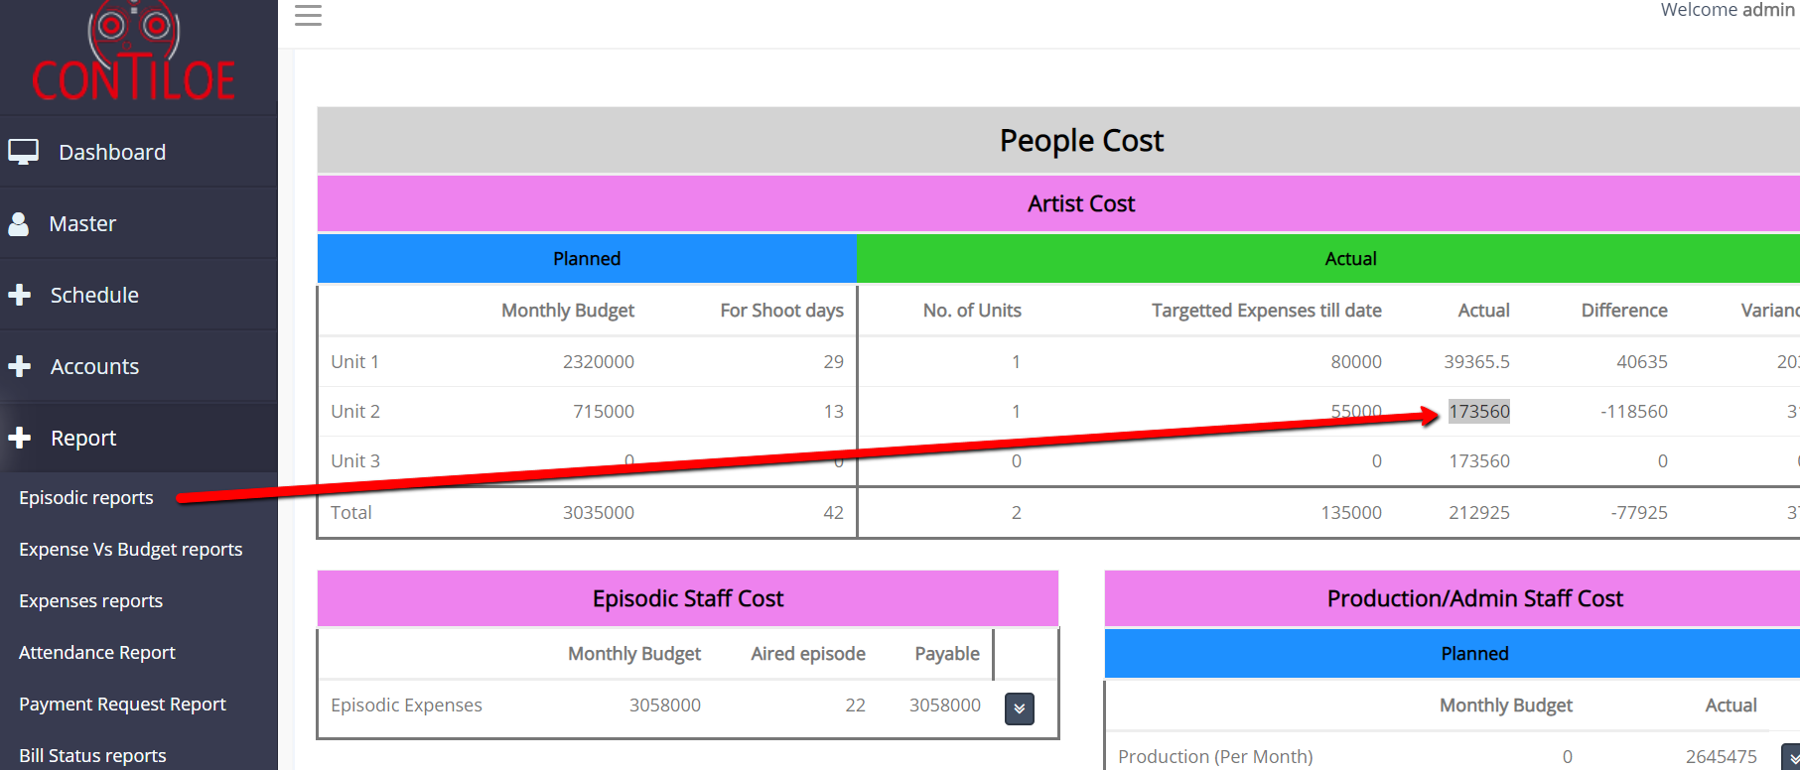

Expenses v/s Budget Report - Month July 2019 - As on Date - 06/07/2019

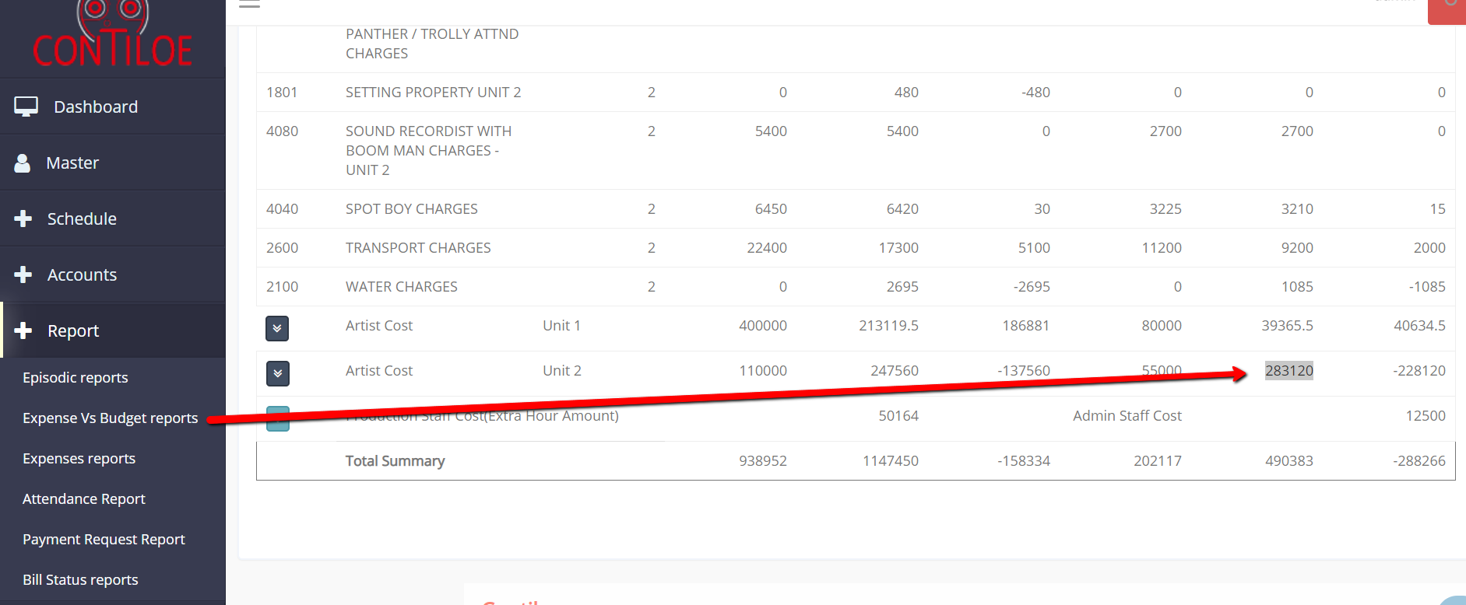

**Point No.** 0011 **/ Date of Creation:** 13/11/2019

**Menu Option Name:**

Project Master

**Details of the Changes/Issue/Feedback:**

Following fields should be added in “Monthly Expenses” Tab in Project master

* Effective From 99/99/9999 to 99/99/9999
* Status - Active / Inactive
* Attach Agreement

**Status:**

Pending

**Screen Shot:**

Artist Screen

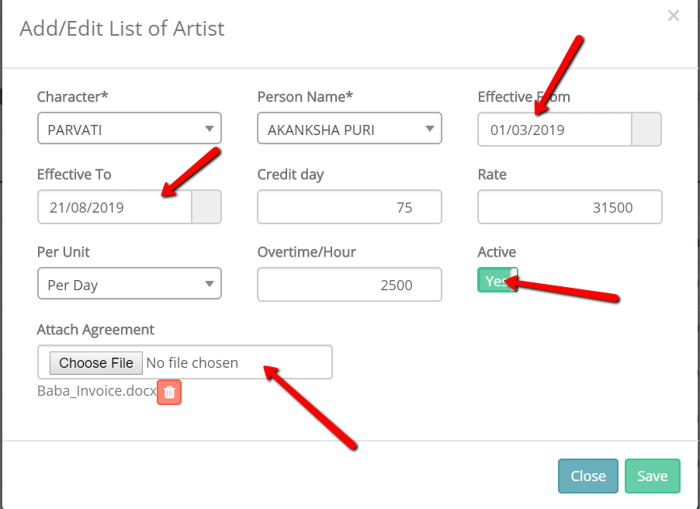

Monthly Expenses Screen

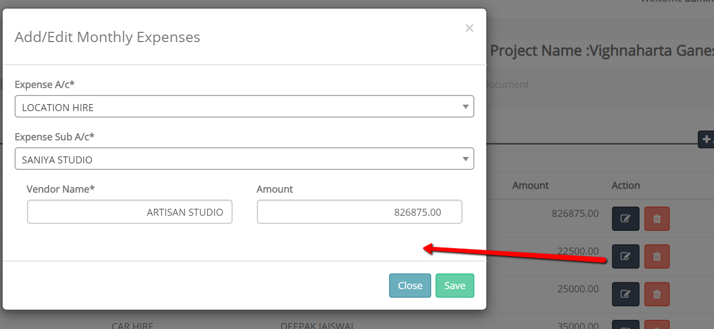

**Point No.** 0012 **/ Date of Creation:** 13/11/2019

**Menu Option Name:**

Project master

**Details of the Changes/Issue/Feedback:**

Delete option is not working in the “Monthly Expenses” tab in Project master

**Status:**

Pending

**Screen Shot:**

Monthly Expenses Screen

