罗湖外语初中学校

初二英语学业水平评估试卷（第十周）

班级:______ 姓名：______

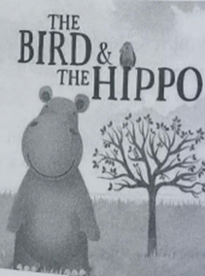Once upon a time, a hippo lived in a river next to a big tree. One day, a bird came and built its nest in the tree. The bird could sing beautiful songs. The __21__ of the bird filled the hippo with so much envy (羡慕) that he couldn’t __22__ anything else. Every day he would think why he wasn’t born to be a bird even though the bird told him many times he was so __23__ to be so big and such a good swimmer.

Finally, the hippo made up his mind that he would come out of the river, climb the __24__ and start singing. However, it was very clear that the hippo didn’t have wings, nor claws to climb with. Realizing that he would never climb up the tree, he __25__ hit the tree until it came crashing to the ground. Then he stood on the leaves of the __26__ tree, and began singing.

Unfortunately, hippos can’t sing, either. All that came from his mouth were __27__ noises, and when the other animals heard this, they all came around to __28__ the hippo.

He was so sorry for this. He also felt __29__ about having knocked the tree down. He used all his power to __30__ the tree back and raise it up again, and he took care of it until it completely got well.

21．A．nests B．songs C．feather D．wings

22．A．think of B．prepare for C．agree with D．decide on

23．A．healthy B．satisfied C．happy D．lucky

24．A．bank B．hill C．tree D．stairs

25．A．angrily B．quietly C．excitedly D．faithfully

26．A．strange B．shaken C．fallen D．dangerous

27．A．serious B．relaxing C．beautiful D．terrible

28．A．play against B．make fun of C．mix with D．lie around

29．A．sad B．bored C．tired D．sick

30．A．pay B．water C．grow D．push