**罗湖外语初中学校**

**初三英语学业水平评估试卷(第5周)**

**阅读理解 第一节** 阅读下列短文，从每小题所给的A、B、C、D四个选项中选出最佳选项，并在答题卡上将相应字母编号涂黑。

lmagine waking up to find a cup of coffee ready and floor swept. With smart devices(装置) controlled by AI, all housework can be done while you are asleep.

Now your kids can try these devices at the small home, shown in our community science centre from August 1st to August 14th. Here in the centre, we have many fun activities. Children can also try our cleaning robot Little Q. It is a cute robot with a round head, two big eyes and two long legs. It's like a big toy. Your children will love it.

Opening Hours: 1:00 p.m.-9:00 p.m., from Tuesday to Sunday,closed on Monday.

Visitors; People of all ages are welcome.Children under 12 should come along with their parents.No pets are allowed.

Food & Drinks: No outside food or drinks.Visitors can buy food and drinks in the centre.

Tickets: Please call 769520 to book a ticket.Kindly note that you CAN'T book a ticket on our website or through e-mail. And it is NOT possible to buy a ticket at our ticket office as it is closed.

21. What can the smart devices in Paragraph 1 do?

A. Farming. B. Business. C.Housework. D.Schoolwork.

22. What does Little Q look like?

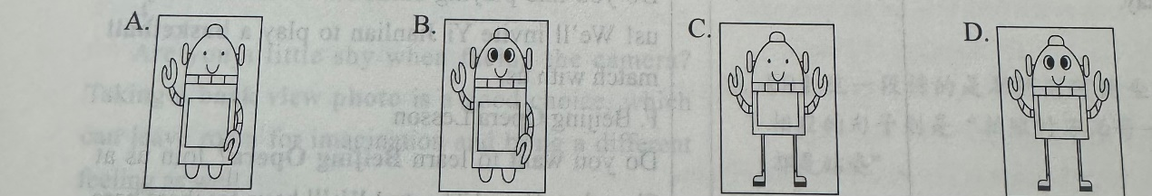

23. When can a visitor enter the science centre?

A. On Monday morning. B. On Sunday morning.

C. On Monday afternoon. D.On Sunday afternoon.

24. Who can be allowed to visit the centre?

A. A man with a cat. B. An 8-year-old boy alone.

C. A man with his 3-year-old son. D. A girl with food from outside.

25. How can a visitor book a ticket?

A. By making a phone call. B. By sending an e-mail.

C. By visiting the website. D. By going to the ticket office.

**第二节 短文填空** 请阅读下面的短文，并从下列方框里的六个句子中选择五个还原到原文中，使原文的意思完整、连贯，并在答题卡上将相应的字母编号涂黑。

|  |
| --- |
| A. Greek people often wear a blue necklace hoping to protect themselves against evils.  B. So if you want to eat less, some suggest that eating from blue plates can help.  C. The answer depends largely on cultural values as well as personal experiences.  D. Red can cause a person's blood pressure to rise and increase people's appetites.  E. It has the ability to reduce pain and relax people both mentally and physically.  F. Therefore, what colour do you like best? |

Why is pink or purple a colour for girls and blue or brown for boys?

26.____To the Egyptians, green is a colour that represents the hope and joy of spring. Red is a symbol of good luck in many cultures. In China, children are given money in a red envelope to bring good fortune in the New Year. For many nations, blue is a symbol of protection and religious beliefs.

27._____

People's choice of colours is also influenced by their bodies’ reactions toward them. Green is said to be the most restful colour.28.____People who work in green environments have been found to have fewer stomachaches.

29. ______Many decorators will include different shades of red in the restaurant. Similarly, many commercial websites will have a red “Buy Now” button because red is a colour that easily catches a person's eye.

Blue is another calming colour. Unlike red, blue can cause people to lose appetite. 30.____

The next time you are deciding on what to wear or what colour to decorate your room, think about the colour carefully.