**Sanjivani College of Engineering,**

**Department of Computer Engineering.**

**DATABASE MANAGEMENT SYSTEM LABORATORY.**

* Name: Nikita Rajendra Bhawar
* Class: SY A
* Roll No.:18
* PRN No. : UCS21F1018
* Assignment No.:5
* Problem Statement:-

PL/SQL Stored Procedure and Stored Function. Write a Stored Procedure namely proc_Grade for the categorization of student. If marks scored by students in examination is <=1500 and marks>=990 then student will be placed in distinction category if marks scored are between 989 and900 category is first class, if marks 899 and 825 category is Higher Second Class Write a PL/SQL block for using procedure created with above requirement. Stud_Marks(name, total_marks) Result(Roll,Name, Class) Frame the separate problem statement for writing PL/SQL Stored Procedure and function, inline with above statement. The problem statement should clearly state the requirements.

* Create database :-

use assi7;

Database changed

* Create table and insert values:-

CREATE TABLE Stud_Marks(

-> RollNo INT PRIMARY KEY,

-> Sname VARCHAR(20),

-> Total_Marks INT

-> );

INSERT INTO Stud_Marks VALUES

-> (1, 'Vidyut', 995),

-> (2, 'Pratap', 828),

-> (3, 'Kailash', 945),

-> (4, 'Mukund', 1500),

-> (5, 'Girish', 900),

-> (6, 'Neeraj', 850),

-> (7, 'Prashant', 800),

-> (8, 'Raj', 899),

-> (9, 'Hari', 1300),

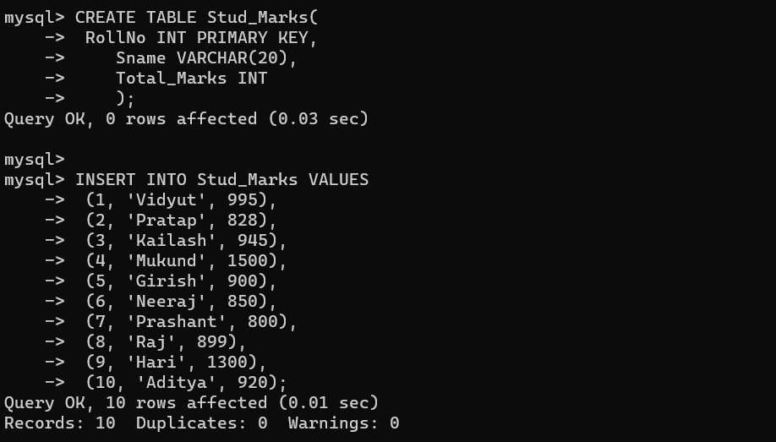 -> (10, 'Aditya', 920);

CREATE TABLE Result(

-> RollNo INT REFERENCES Stud_Marks(RollNo),

-> Sname VARCHAR(20),

-> Marks INT,

-> Grade VARCHAR(20)

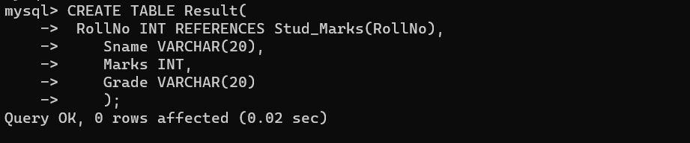 -> );

* Code:-

mysql> DELIMITER $$

mysql> CREATE PROCEDURE proc_Grade(

-> IN roll INT,

-> IN marks INT

-> )

-> BEGIN

-> DECLARE student VARCHAR(20);

-> DECLARE EXIT HANDLER FOR SQLEXCEPTION SELECT 'ENTRY NOT FOUND' AS EXCEPTION;

->

-> IF NOT EXISTS(SELECT * FROM Stud_Marks WHERE RollNo = roll AND Total_Marks = marks) THEN

-> SIGNAL SQLSTATE '45000';

-> END IF;

->

-> SELECT Sname INTO student

-> FROM Stud_Marks

-> WHERE RollNo = roll AND Total_Marks = marks;

->

-> IF marks >= 990 AND marks <= 1500 THEN

-> INSERT INTO Result

-> VALUES(roll, student, marks, "Distinction");

-> ELSEIF marks >= 900 AND marks <= 989 THEN

-> INSERT INTO Result

-> VALUES(roll, student, marks, "First Class");

-> ELSEIF marks >= 825 AND marks <= 899 THEN

-> INSERT INTO Result

-> VALUES(roll, student, marks, "Higher Second Class");

-> ELSE

-> INSERT INTO Result VALUES(roll, student, marks, NULL);

-> END IF;

->

-> SELECT * FROM Result;

-> END $$

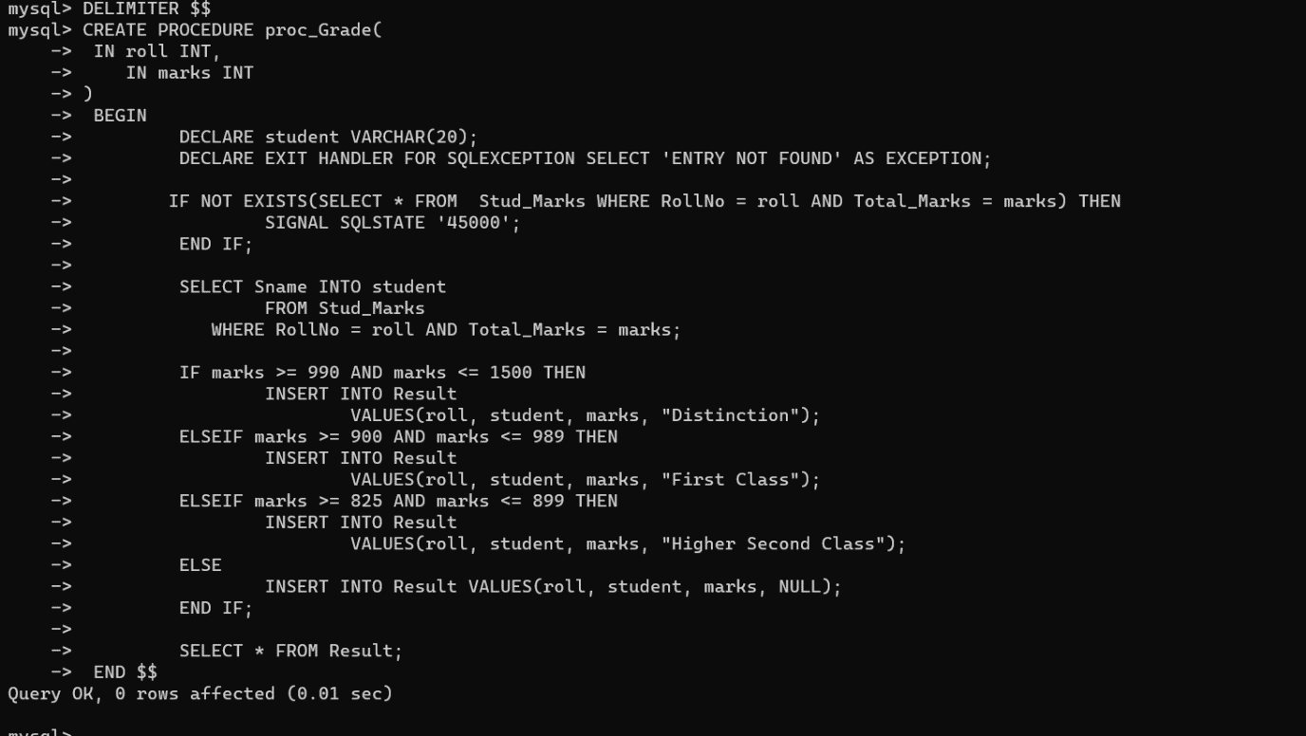

* Calling the function:-

CALL proc_Grade(1, 995);

CALL proc_Grade(2, 828);

CALL proc_Grade(3, 945);

CALL proc_Grade(4, 1500);

CALL proc_Grade(5, 900);

CALL proc_Grade(6, 850);

CALL proc_Grade(7, 800);

CALL proc_Grade(8, 899);

CALL proc_Grade(9, 1300);

CALL proc_Grade(10, 920);

CALL proc_Grade(11, 828);

