**Houston Restaurant Opening**

**Introduction**:

A business owner would like to open a restaurant in Houston, Texas. He would like to know two questions:

* What type of restaurant/cuisine he should consider?
* Where is the location in Houston he should open his restaurant. He would like a Data Scientist to help him to identify the most popular cuisine in Houston and the best location/neighborhood to potential have the highest traffic and customers.

Target audience: Business owner want to open a new restaurant in Houston.

**Data**:

* 1) List of Houston all restaurants, can be obtained from Yelp or other sources, to analyze and gain insights of current opened restaurants
* 2) Location of all restaurants
* 3) Review/Ratings of all restaurants, can be obtained from Foursquare or Yelp.
* 4) Houston district information, can be obtained from Wikipedia or Houston city government web

**Methodology:**

1. Scraping all restaurants information from Yelp, including name, number of review, ratings, address, etc.
2. Exploratory Data Analysis:
   1. Find the cuisine type have the most number of restaurants

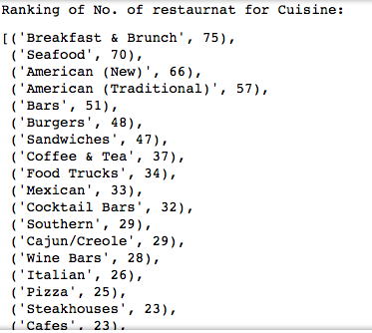

* 1. Find the most popular restaurants based on Ratings and Number of Reviews, and how many are those for each cuisine type

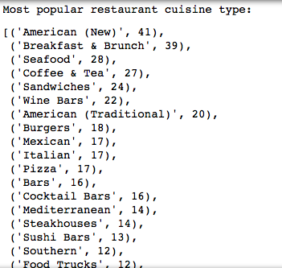

1. Scraping all Houston neighborhood information from Wikipedia
2. Find the latitude/longitude of each restaurants
3. Find the latitude/longitude of each neighborhood
4. Map:
   1. Plot Houston map
   2. Plot Neighborhood on map

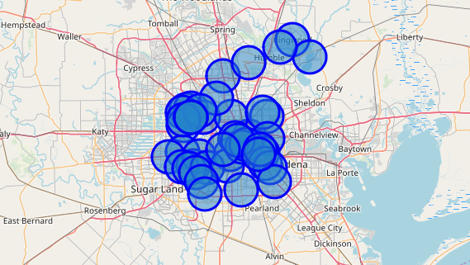

* 1. Plot the most popular neighborhood on map

1. Machine Learning: Clustering analysis, find the neighborhood that has the most number of most popular restaurants

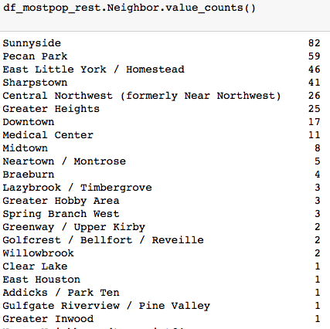

**Results:**

1. Map showing the neighborhood has the most number of most popular restaurants

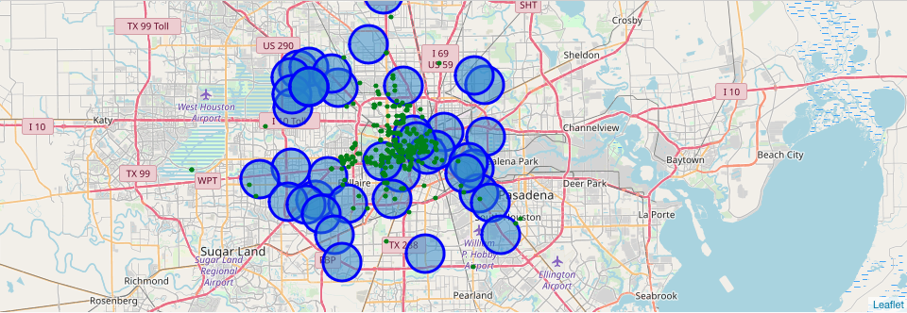

**Discussion & Conclusion:**

From the analysis, type of restaurants that are most popular in Houston are: American, Breakfast & Brunch, Seafood, Coffee & Tea and Sandwiches are the most popular restaurants in Houston

For location, the neighborhood has the most number of most popular restaurants are: Sunnyside, Pecan Park, East Little York, Sharpstown, Central Northwest.

Therefore, to open a new restaurants in Houston, best choice of cuisine types are: American, Breakfast & Brunch, Seafood, and open at Sunnyside, Pecan Park, East Little York neighborhood.