Technical Report: Intelligent EBS Volume Optimization

# 🏗️ Architecture Diagram

The following diagram illustrates the workflow of the EBS volume optimization project:

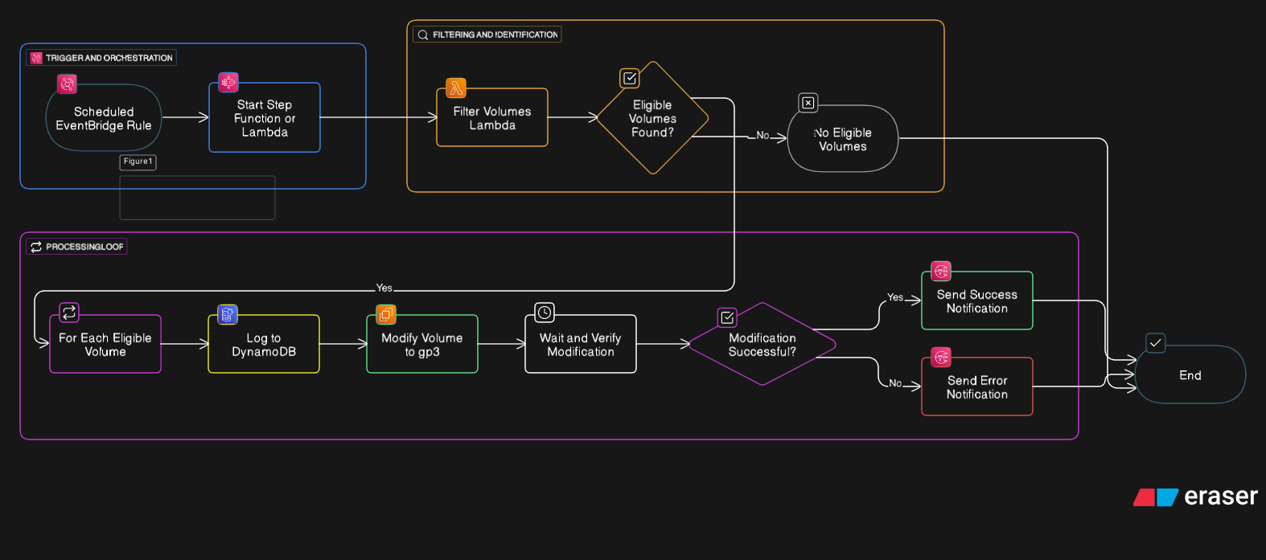

# 📦 Each Component and Its Role

|  |  |
| --- | --- |
| Component | Role |
| EC2 & EBS Volumes | Test environment to simulate gp2 volumes requiring conversion. |
| AWS Lambda | Core logic to identify gp2 volumes, convert them to gp3, and log results to DynamoDB. |
| AWS Step Functions | Orchestrates the workflow: calls Lambda → logs to DynamoDB → sends SNS notification. |
| DynamoDB | Stores audit logs of each conversion with details (VolumeId, InstanceId, Time, Region). |
| SNS (Simple Notification Service) | Sends email notifications after each successful conversion. |
| CloudWatch Logs | Captures execution logs of Lambda for monitoring and debugging. |
| EventBridge Scheduler | Automates daily execution of Step Function at 6:00 AM IST. |

# 🔐 Security Best Practices

1. Scoped IAM Roles:  
 - Created a dedicated IAM Role for Lambda (LambdaEBSConversionRole) with only:  
 - ec2:DescribeVolumes  
 - ec2:ModifyVolume  
 - dynamodb:PutItem  
 - sns:Publish  
 - logs:CreateLogGroup and logs:PutLogEvents  
 - Step Function and EventBridge have separate roles to enforce least privilege.  
  
2. Resource-specific Access:  
 - Restricted DynamoDB and SNS permissions to specific table and topic ARN.  
 - Lambda cannot access other resources beyond its scope.  
  
3. Notification Security:  
 - SNS allows only verified subscribers to receive notifications.  
  
4. Audit Trail:  
 - DynamoDB logs serve as a tamper-proof audit trail for compliance.

# ⚡ Real-world Challenges Simulated

|  |  |
| --- | --- |
| Challenge | Solution |
| Lambda failing when no gp2 volumes exist | Added logic to gracefully exit with statusCode: 200 and a message. |
| EBS volume in optimizing state blocking modification | Checked volume modification state before calling ModifyVolume. |
| Step Function failure on empty Lambda output | Used Choice state to skip DynamoDB and SNS when Lambda returns empty. |
| Automating daily workflow without manual intervention | Integrated EventBridge Scheduler to trigger Step Function daily. |

# 🎯 Summary

This project demonstrates a cost-saving automation for AWS environments, reducing human effort and ensuring consistent, secure, and scalable operations. It follows AWS best practices for security and reliability, making it suitable for real production workloads.