**Trekker’s Information Management System Software**

SmartCard based Visitor’s Information Management System (SCBVIMS) is envisioned to be an effective tool to track tourists, trekkers, guides, porters and other people involved in tourism industry at each strategic locations and provide information for GLOF and other climate-induced disaster risks management for effective rescue operation to lessen human and material losses. SCBVIMS is intended to automate the tourist information entry system and keep track of tourist/trekkers. The ancillary purpose is to provide tourists and trekkers climate hazard information within Khumbu region. Additionally the system should also allow check posts to check if the Tourists have paid the tax for trekking.

When any tourist visits the area, the tourist information is first entered into a computer system at Jorsale. The tourist also can get permit from Kathmandu. The easy graphics user interface allows information to be entered into the database easily. Thus, the information is uploaded and stored into a database through the internet. The tourist information is then written into the smart card using a smartcard writer.

The information stored in the smart card should be secured using a key. A different key for write and read access has to be provided.

The application should be designed with Service Oriented Architecture (SOA), preferably using JSON Format and secured web services is implemented so that integration with other existing systems is possible.

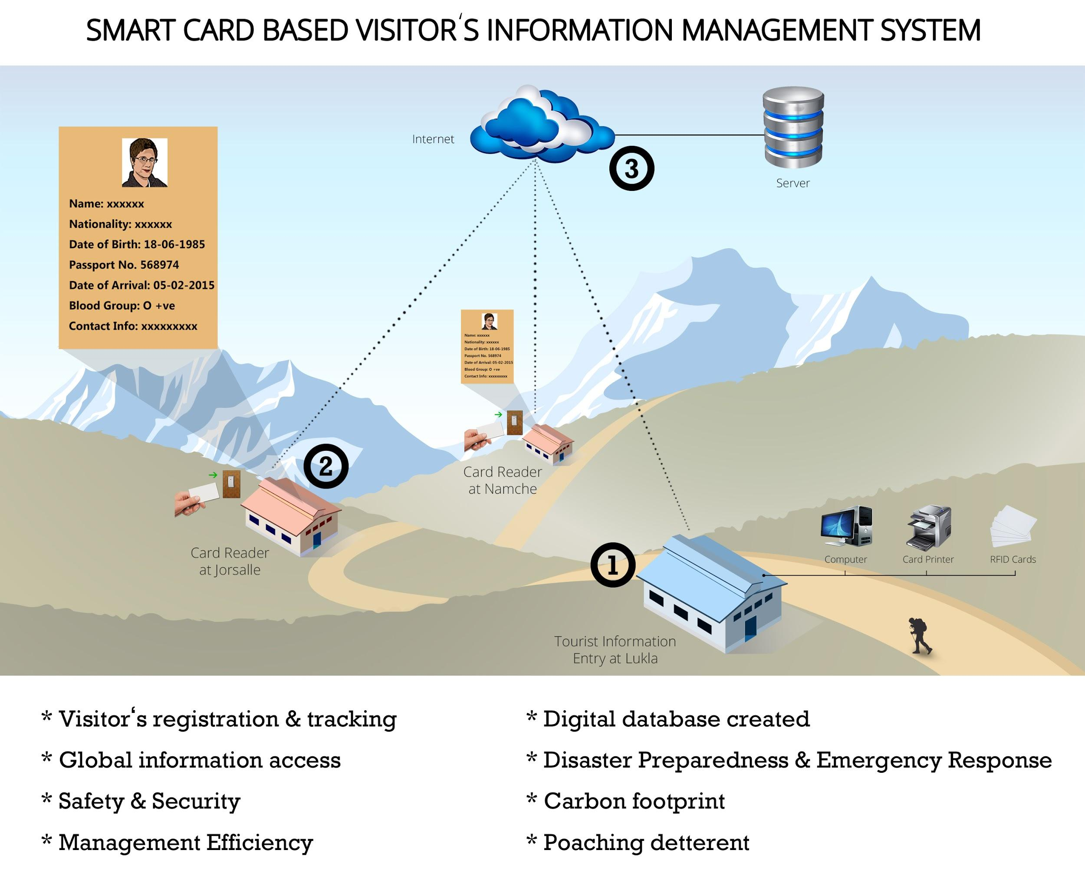

1. **Software for Registration**
   1. Read/write visitor information from/to the desfire smart card
   2. Interface for users to create visitor profiles and write them to Smart cards, the sample visitor profile is as indicated below:
      1. Name
      2. Nationality
      3. Passport Number
      4. Email address
      5. Local Mobile Number
      6. Photo of the visitor
      7. Blood type
      8. Details of the emergency contact
      9. Date, time and amount of tax paid
   3. Keep track of the check-in and check-out made by the issued card
   4. Broadcast or send information or warning to specific or all check points
   5. An easy user interface to print the smart card using a card printer.
2. **Software for Checkpost (Check in Client Software)**

* Should work with the embedded computer to be installed at Checkposts using Linux OS or valid windows certificate.
* Read visitor information from Smart card.
* Provide a display to see all the information of the visitor to whom the card was issued including picture of the visitor in order to verify the visitor quickly.
* Inform the main server that the visitor has passed the checkpoint, going in or going out.
* Data logged should be logged off-line and data posted to the server, when internet connection is available.
* Inform the checkpoint police if a blacklisted visitor has checked in.

1. **Central Server Software**
   1. Database system for recording various kinds of information
   2. Web based interface for reporting
   3. See real time statistics such as:
      1. Number of visitors inside a certain geographical region at a specific date and time
      2. Nationality of visitors and their frequency
      3. Monthly and Annual reports about visitors, their nationalities, age etc.
   4. Data Visualization using graphs and tables
2. **Data Hosting for one year**
   1. The cost should include data hosting for one year ( SNP receives around 60,000 tourists every year.) The storage space should be enough for this.
   2. The hosting server should be available 99% of the time.

**Software for Phaplu Display Board**

A software is to be designed that will run on the embedded computer in Phaplu. The main aim of the software is to show data from the Automatic Weather Station (AWS) in Imja Lake and Chaurikharka. The data from these stations will be in DHM’s server.

Additionally the display should also show number of tourists in the Khumbu region, by collecting the data from the Trekker’s Information Management System Software. During GLOF conditions, or when heavy precipitation is observed, the display will also act as an early warning system, displaying data from various GLOF sensors and precipitation stations.

The software should be able to acknowledge the warning message by using the touch screen monitor, by which the audible warning message should turn off.