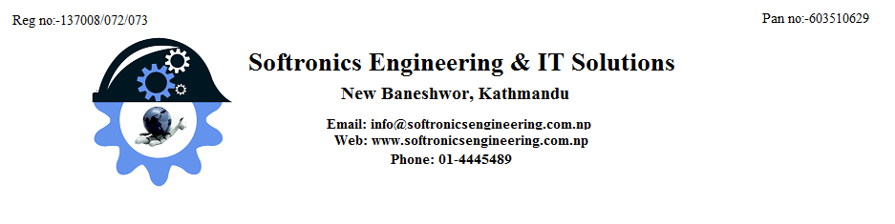

|  |  |  |  |  |
| --- | --- | --- | --- | --- |
| **To**  Damak | | | **Date :** 12/8/2015  Email: sameepchudal@gmail.com  Quotation No:072/73/10 | |
| **Warranty:** 1 year standard Warranty | | | **Delivery:** 10 days | |
| **Vat :** Exclusive of 13% | | | **Final Destination Of Goods:** Damak | |
| **Validity:** 1 Weeks | | | **Payement Terms:** Cash/Cheque | |
| **Item no.** | **Subject** | **Description** | **Qty** | **Price** |
| 1. | IR Dome Camera | **IR Doom Camera**  Model:VS-C858M  **Min. Illumination: 0.5 lux/F1.2**  **Base Resolution 520 TV Line**  **Image Sensor: 1/4” Cmos CCD**  Lens: 3.6 mm board lens  **Power Supply: DC 12V** | 1 unit | 7,000.00 |
| 2 | IR Box Camera | **SUPER HAD CCD Ⅱ**  Model No: VS-R779  **Type: Box**  Base: 1/3 Sony  IR Led: **42 pcs**  **650TVL , DWDR , OSD, 3DNR, Sense up**  **Min. Illumination: 0 lux (IR on)**  Image Sensor: 1/3” Sony CCD  Lens : 2.8 - **12mm 2M Pixels lens**  Resolution: **650TVL**  line  Scanning System: 650lines 50 fields/sec.  Horizontal Resolution: 650 TVL  **IR distance 30m**  Operation Temperature: 25.C-50c Line  Power supply: DC 12 | 1 set | 17,000.00 |
| 3. | **Weatherproof & Vandal proof IR Dome** | **Weatherproof & Vandal proof IR Dome**  **Type: Box**  Model: VS-R811E  Base: Sony  **Min. Illumination: 0.5 lux/F1.2**  Imege Sensor: 1/3” Sony CCD  Low Illumination  Resolution: 520 TV line  Lens: 2.8-12mm Manual Zoom Lens  Camera Water Resistance: IP66  3-Axis Bracket Built-in  ￠5X30PCS IR LEDS,  IR Distance: 25M  Bracket is Included | 1 set | 30,000.00 |
| 4. | Stand Alone DVR  16 Channel  32 channel  **960H DVR** | **960H Stand Alone DVR**  **Channel: 16 Ch**  **Model:**  **VS-DVR2508Z**  **16ch 960H DVR**  **Support 1 SATA HDD**  **Support HDMI** | 1 set | 35,000.00  80,000.00 |
| 5. | **IP Camera** | **IP Camera Dome**  **Brand: Vista**  **Model: VS- IP557M-1M**  **1.0M 720P CMOS IP Camera .**  **IR Leds:48PCS IR LED.**  **3.0 Megapixel**  **3.6 mm fixed lens.**  **With IR CUT, White** | 1 unit | 15,000.00 |
| 6. | **IR IP Camera** | **IR IP Box Camera**  **Brand: Vista**  **Model: VS-IPB1001M**  **HS3518C+1/4" OV9712 1M CMOS sensor**  **RESOLUTION (TVL): 1MP 720P**  **IR CUT: With IR Cut**  **IR Leds: 42pcs* ￠5mm IR-LED**  **Lens: 3.0 Megapixel 2.8-12mm varifocal lens** | 1 set | 24,000.00 |
| 7. | NVR  16 channel | **Network Video Recorder ( NVR)**  **Channel: 16 channel**  **Decoding, Support 3G/WIFI, Spot output, 1/4/9/16 Screen preview, 10M/100M/1000M network.Hi3535 ,Support Maximum 2× 4T SATA HDD, Include Total Client Software, VGA,HDMI,PTZ,IR controller, Mouse, Power supply, Adapter** | 1 set | 64,000.00 |
| 8. | NVR  32 Channel | **Network Video Recorder ( NVR)**  **Channel: 32 channel**  **Decoding, Support 3G/WIFI, Spot output, 1/4/9/16 Screen preview, 10M/100M/1000M network.Hi3535 ,Support Maximum 2× 4T SATA HDD, Include Total Client Software, VGA,HDMI,PTZ,IR controller, Mouse, Power supply, Adapter** | 1 set | 96,000.00 |
| 9. | CCTV Adaptor | Adaptor  1 AH | 1 unit | 500.00 |
| Adaptor  12v 2 Ah | 1 unit | 800.00 |
| 10. | DVR Adaptor | Adaptor  12 V 2.5 Ah | 1 unit | 2000.00 |
| 11. | Co-axial wire | 90 ohm | 90m | 3,000.00 |
| 12. | Cat-6 wire |  | 300m(1 drum) | 9,000.00 |
| 13. | BNC connector |  | 1 unit | 50.00 |
| 14. | Connection charge |  |  | 1,000.00/ camera |
| 15. | Harddisk | 1 TB  2 TB | 1 unit  1 unit | 8,000.00  15,000.00 |

**Terms and conditions**

* ***13% vat will be extra added on above mentioned price.***
* 60% of payment should be made before starting the job.
* No warranty will be provided for any physical damage, high voltage, thundering and lightening.
* No service charge for three months

We hope for your positive response.

**With best regards**

**Ganga Prasad Shah**

Manager- Business Development

Cell: 9849977973, 9801175518

Sofrtonics Engineering & IT solutions

Putalisadak, Kathmandu