Wood Types – Benefits & Stats

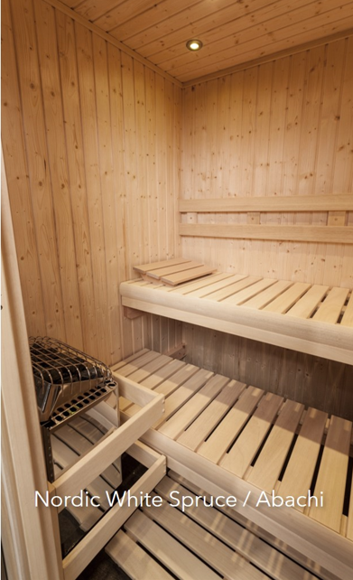
Nordic White Spruce
- Worldwide more than 90% of all saunas have been built with NWS
- Light colors, clean lines, and natural materials (rustic with knots)
- Wood is sourced from Finland (near the Artic Circle!)
- Softwood without the porous characteristics of other whitewoods
- “European Grade A” wood (German grading standards)
  - Wood comes from the tops of the trees about 80 years old
- Whitewood gives a lighter, brighter, cleaner appearance to the inside of the sauna room
- Stain resistance – only need “normal” cleaning (wipe down with a mild detergent and water)
- Will stay original color and condition throughout time
- Unmistakable smell of pine when it becomes warm – like sitting in the forest – comes from the resin in the wood
- The most cost-effective type of wood we offer

Abachi
- Wood originates from Africa – also called “Obeche”
- Whitewood with fast/high growth rate
- Poor thermal conductivity = high insulating properties
- Knot-poor (free of knots), splinter-free and resin-free (so it doesn’t feel “sticky”)
- Often used to build benches, trim pieces, accessories, and handles
- Soft to the touch
- It does absorb some moisture (minor worry about mold/mildew)
- Not FSC-certified, as it’s grown in the second-largest rainforest on Earth and the supply is overexploited

Aspen
- Deciduous tree in the willow family that is fast growing
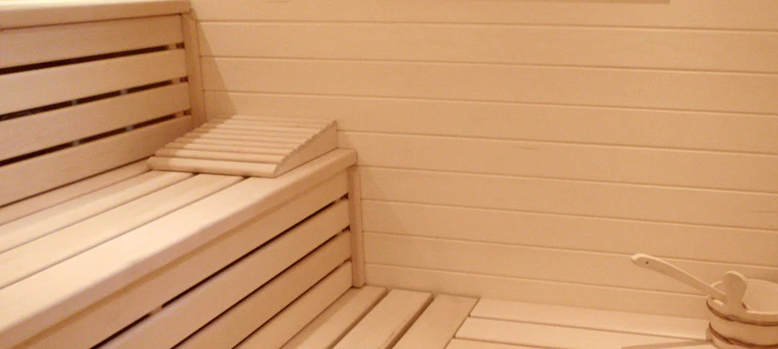
- No resin
- Not easy to splinter
- Stays cool to the touch
- Light tone “Whitewood”
- Relatively soft / smooth texture
- Brittle, but stays stable in shape with changing moistures
- Allow for material to dry-out after each sauna use
- Low thermal conductivity

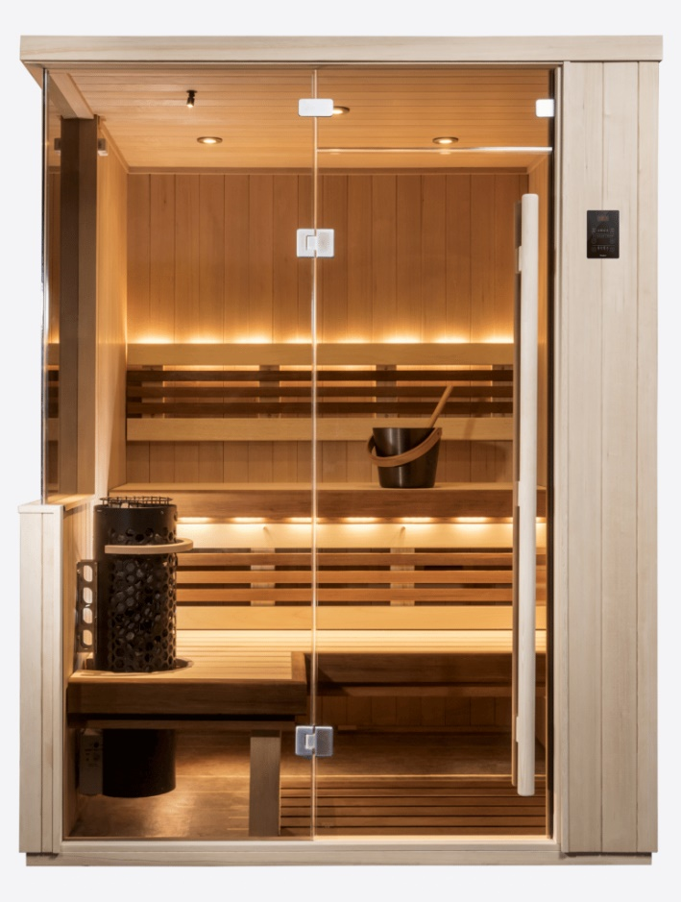
Heat-Treat Alder
- Beautiful, dark color to a bright reddish tone
- Member of the birch family, a deciduous tree
- Small collection of twig knots throughout material
- Durable and able to handle moisture changes
- Fine, even structure
- Soft to the touch
- Light, relatively soft wood of medium density
- Absorbs very little heat
- Adds a pop of color!

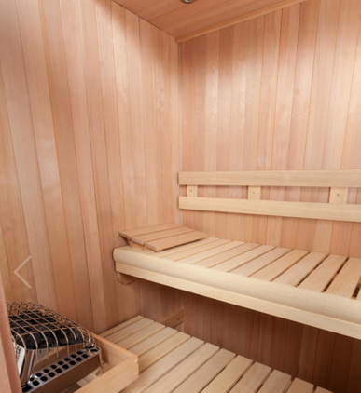
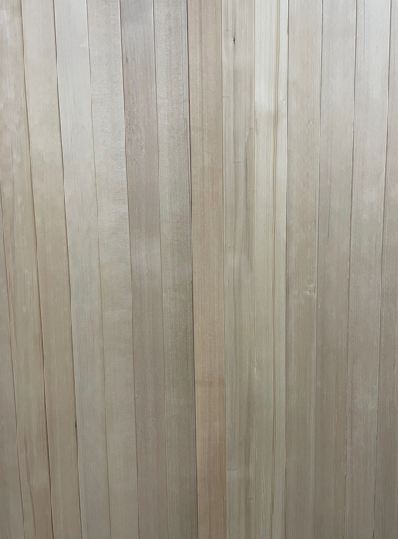
Hemlock
- Grown in Canada!
- Clear, vertical grain with no knots!
- Light and bright in appearance
- White to light brown tint – color doesn’t allow the wood to hold heat and will be cool to the touch
- Cost-effective when compared to cedar
- Extremely moisture-resistant
- Durable & stable
- Low in resin which means little to no scent – practically odorless
- Fully hypo-allergic!

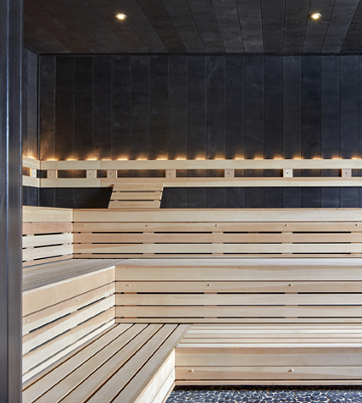

Taika
- Birch plywood treated with a special natural coasting to make it black
- Safe for sauna usage without off-gassing

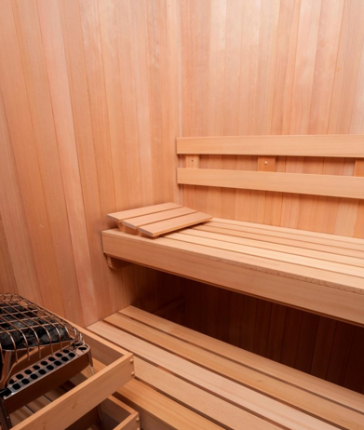
Western Red Cedar
- Resistant to mold
- Highly resistant to decay and warping
- Repels insects
- Low maintenance
- Hardly prone to splintering
- Color of the wood varies! Varies from light to dark.
- Clear, vertical grain with no knots!
- Wood warms up quickly but will not be warm to touch, but warmer than Hemlock or other whitewoods
- Soft and cool for use in a sauna (doesn’t retain heat)
- Antimicrobial / hygienic properties – due to natural resins, oils, and tannin
- Distinct smell of the cedar – gives off phenols (non-toxic) – characteristic of the wood
- Highest stability
- Most costly type of wood
