Welcome
Welcome to the Unique Pools Spas and Billiards family! The following guide is to help you understand what is involved in building your new semi-inground pool.

Your Stealth pool installation requirements:
- Mark the desired location of the pool and equipment and excess dirt and excess dirt
- Order the necessary sand for the size of your pool
*If needed for buildup of site, order necessary gravel
- Check with your local codes office for permits and other requirements
- Bring a water sample into any of our showrooms after installation for a free water test. Our water care specialists will determine the chemicals you need to achieve clean, clear water all season long.
If you have any questions, at any point in the process, please reach out to us directly at the numbers listed below.
Support@UniquePSB.com
Orlando 321-382-5444
Jacksonville 904-604-7722
Daytona Beach 386-946-6923

Homeowner’s Pre-Installation Checklist
- Underground Lines: Locate and clearly mark electric, phone, cable, or any other utility lines, septic tank, and field lines on or near pool site prior to excavation. Contact 811 Private utilities such as electrical lines to outbuildings, gas grills and light lines will not be marked by them and are the customer’s responsibility to accurately mark their location. Unique Pools Spas and Billiards is not responsible for damage to unmarked utilities during the excavation or build process.
- Permits/HOA: Check with local, county, and state codes departments and provide any permits required to issue complete compliance with all code ordinances. If HOA approval is required, please attain approval.
- Pool Plus Pump & Filter Location: Locate and mark the pool site and filter location prior to excavation and in accordance with all state and local codes.
- Identify Path Access: Provide at least 6’ access path for excavation equipment. Galaxy Home Recreation will not be responsible for damage to the yard, driveway, or any obstacles in access path. We do not drive over septic or field lines.

Homeowner’s Post-Installation Checklist
- Fill Pool: Furnish water and fill the pool to the proper level (approximately 1/2 way up the skimmer opening) before starting filter system. See “Filling Instructions.”
- Install Steps: we DO NOT assemble the steps during installation. It is the homeowners responsibility to assemble and install the steps in the pool.
- Grading Services: Grade, Remove, Spread, and/or backfill any excess dirt or sand left around the pool. (Note: We DO NOT provide grading or haul off services in our installation) this is the homeowner responsibility.
- Extra Services: Pay for any excavation beyond what is included. Requests for additional work should have been made prior to installation, as reviewed in the contract. Payment is to be made to the excavator.
- Pool Safety: Teach pool safety to family and guests, specifically NO DIVING, SHOVING, PUSHING, or HORSE PLAY. Install and use alarms and all other safety devices ensuring compliance with all safety regulations.
Note: Unique Pools Spas and Billiards IS NOT RESPONSIBLE FOR WATER REPLACEMENT FOR ANY REASON.

Electrical Requirements
The customer must provide a 20 amp 110v power source for the pump that is protected by a Ground Fault Circuit Interrupter (G.F.C.I.). Fully inground Stealth pools may require additional electrical requirements. This service should be provided by a qualified electrician in accordance with state and local codes after the pool has been installed. Bonding of the pool is the electrician’s responsibility (water bonding and pool bonding) per local codes and permitting. Depending on any equipment upgrades, a 6-pack outlet may be needed. Some upgraded equipment may need to be hardwired. Please arrange electrical work after installation.
Note: An extension cord does not meet electrical codes and will void the pump manufacturers warranty.
You will need to schedule your electrical the DAY OF or AFTER the pool is installed, not before.

Laying Out Your Pool
To begin, make sure that the pool site is not within 15’ of any overhead power lines, and 10’ from any trees. The pool cannot be built over any part of a septic system, and you are responsible for making sure the pool is not infringing on any property lines, easements, or built over any utility lines. We do our best to accommodate the customer’s chosen site for the pool sometimes it does need to be moved once we are on site and that will be at the discretion of the excavator.
Note: Required distances from property lines vary in every community. Most of this information can be obtained when you get your permit. Note any specific code/permit limitations (ex. distance from house, property line, etc.) Also, Galaxy needs 8’ access on at least 3 sides to avoid adding charges for concrete & backfill.
Round Pools: Once you have chosen your site, place a screwdriver into the ground at the center of the pool. Secondly, measure a section of string that is half of the diameter of your pool, plus an extra 2’. For example, a 24’ pool would require a 14’ string. The extra 2’ is for the over dig of the pool site. We will need to have a minimum of 2’ around the pool to have the room for proper installation. Next, tie one end of the string to the screwdriver, and while pulling the string tight, walk the circumference of the pool and mark it with several stakes or paint.
Oval & Freeform Pools: Oval / Freeform pools are done in about the same manner. Keep in mind that due to the side braces on an oval / Freeform pool, the “overdig” requires the dimensions of the pool, plus 2’ on the length and 3’ on the width. For example, an 18’ x 33’oval / Freeform would be staked out at 21’ x 34’. Stake out or paint the area as best you can, and the installer will verify and square up the site for you.
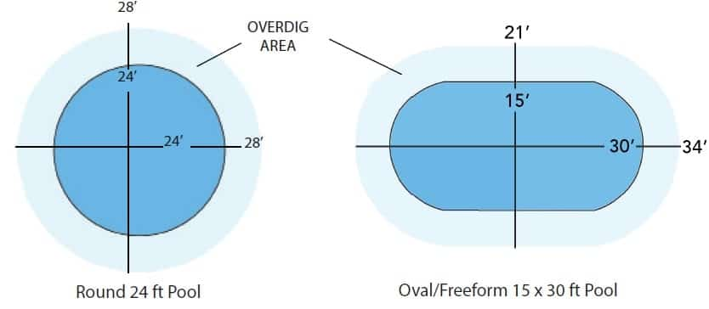
So remember these keys questions:
- Approximately how far out of level is the pool site (Inches)?
- Are there overhead power lines near the pool site?
- Are there underground utilities?
- Are there any trees or tree stumps near the pool site?
- Do you have a septic system?

Installation Photos
Most homeowners would like to know what their project will look like after installation. Below are some great photos of our installation and what to expect after the project is completed.
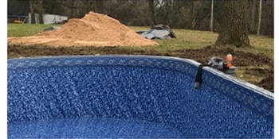This is left over pool sand on the job site. It is more cost saving to order more sand and have a little left over than to order and pay another delivery charge if you don’t have enough.
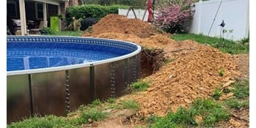This pool had a very small slope, but you can see how much dirt is left behind. Additional excavation, grading and dirt work may be available by bid only, made prior to install date, and paid directly to the excavator.
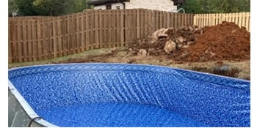Some jobs have a little rock in the ground when we dig, so be aware that your yard could have the same. It is important for the bottom of the pool base around the outside to have dirt pushed up around it to help contain the sand.
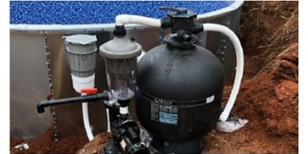This is a picture of your pump and filter. Notice the dirt ground after digging out the pool. This is very common, and most homeowners plant seed and straw to grow back the grass after installation, or you can use decorative gravel.
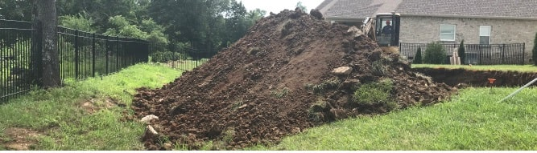This picture shows where a homeowner asked us to move the dirt to the end of his property. This can be done by paying the excavator directly after the pool is installed. A local excavation Company can be found to move dirt and grade your yard after the build for an affordable rate.

Installation with an Existing Deck
If you have a partial existing deck around your pool, we can still install a new pool. The illustration below shows what your new pool will look like if your pool size is different and also the up to 24” inch gap that may be left when installing the same size pool. Even when replacing an identical size pool, difference in manufacturers and pool models often vary slightly in dimensions or number of uprights. This can result in the need for a carpenter to modify your deck before or after the installation.
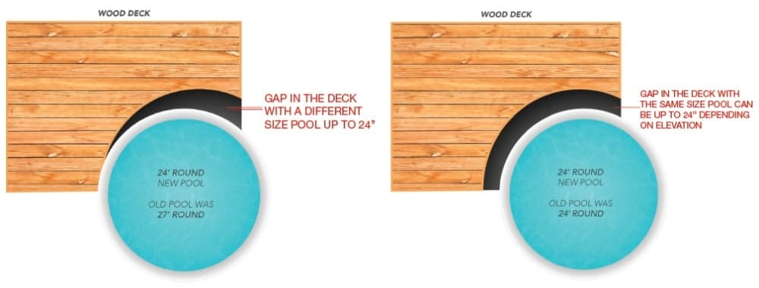
Note: Due to varying conditions involving pool installations beside pre-existing decks, Galaxy Home Recreation and/or their installers will not be responsible for precise pool placement, elevation, or joining of pools beside pre-existing decks.
The installers will attempt to place pool as close as possible to pre-existing deck, but a gap of up to 24 inches may occur. Galaxy Home Recreation and their installers are not responsible for any gap up to the 24-inch range.

Steps
The assembly and placement of steps (if purchased) into the pool after filling with water is your responsibility (excluding Fiberglass steps). We will leave the steps a few feet away from the pool. The reason for this is you have to wait until the pool is 100% filled, before putting the steps in the pool. Since the homeowner will fill the pool, this is their responsibility to put the steps in the water. Note: we DO NOT install the steps during installation.
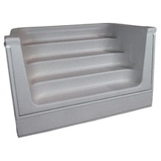
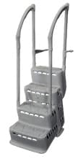
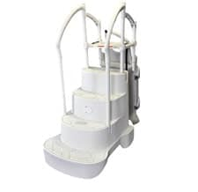

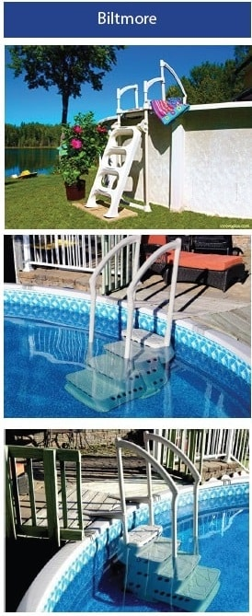
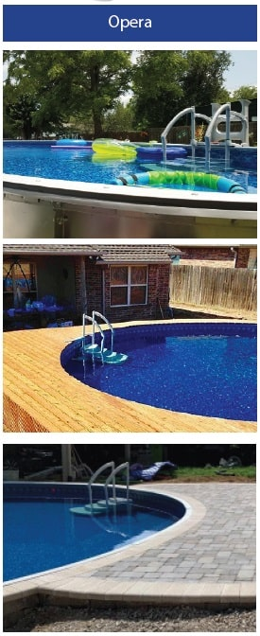

Filling Instructions
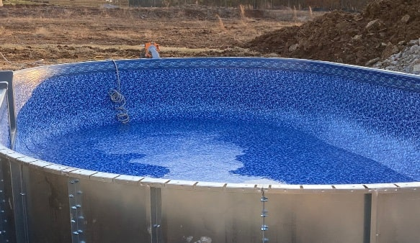
Pool liners are designed to stretch slightly as they fit the pool during filling. Weather conditions and air temperature directly affect the pace in which the filling can be completed. If the pool is filled at night, or too quickly during the day without sunlight reaching the pool, the liner can buckle the wall or pull down causing a sag in the wall pattern. These are not usually structural problems. However, they are unattractive. The installation guarantee does not cover the liner sags or wall buckles caused by improper filling. We have included detailed suggestions below to help prevent these issues from happening.

32-65 Degree Filling:
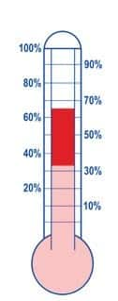
During the final stages of installation, the installers will begin to fill the pool to seat the liner. They will remove any folds from the packaging and position the liner evenly around the wall and floor. After the installers have left, continue filling the pool until you reach a total of 6 inches. Please do not continue to fill the remainder of the pool for the rest of the day. The following days if weather allows, begin to add 2 to 3 inches of water each day.
Special Instructions:
A. Only add water on days that direct sunlight is reaching the pool.
B. Do not add more than 3 inches unless the water is 65 degrees. If it is above 65 degrees and direct sunlight is reaching the pool, do not add more than 6 inches.
C. Continue this process until you reach a total of 24 inches. After 24 inches you may fill the remainder of the pool. Only add water on the days that have direct sunlight reaching the pool.

65 Degrees & Warmer Filling:
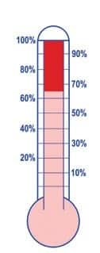
During the final stages of installation, the installers will begin to fill the pool to seat the liner. They will remove the folds from the packaging and position the liner evenly around the wall and floor. After the installers have left, continue filling the pool until direct sunlight is no longer reaching the pool. Please DO NOT continue to fill the pool for the remainder of the day. The following day (if the sun allows), begin to add water as direct sunlight is reaching the pool each day.
Special Instructions:
A. Only add water on days that have direct sunlight reaching the pool.
B. If the temperature is above 65 degrees and direct sunlight is reaching the pool, you may continue filling the pool until direct sunlight is no longer reaching the pool.
C. Continue this process until you reach a total of 24 inches. After reaching 24 inches, you may fill the remainder of the pool.

Decking & Landscaping
Designs for Completing Your Pool Build

Wood / Synthetic Deck
- If you hire a contractor you can expect cost to be $15-$30 per foot (cost will vary depending on source) DIY Cost $8-$20 per foot
- If the pool is buried halfway in the ground, we suggest backfilling with left over dirt.
- If your pool is half in the ground and half out, make sure there is adequate drainage on the low side.
- If you purchased capping the wood deck would transition up against it, otherwise, the wood deck could be placed over your pool wall as your capping.
- Use caution with the placement of the mounting joist against the pool wall as this can cause possible damage.
- Make sure the filter location allows for easy access under or beside the deck.
- Be sure to inspect the underside of the pool deck area twice a year for plumbing connections and structural stability.
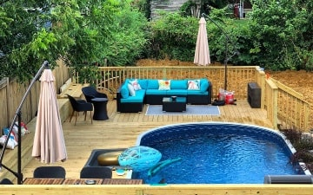
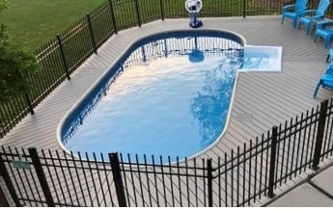
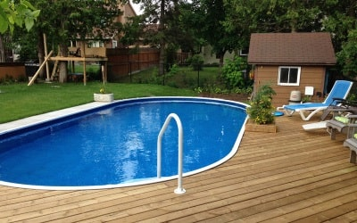

Hardscape / Paver Stones Deck
- Consider coping options:
  - Stone will require a gravel backfill and a brick footer around perimeter of top of pool. Contractor cost is $15-$30 per foot for coping edge.
  - A stealth PVC capping can be installed around the pool perimeter allowing hardscapes to transition up against the capping. Capping cost averages $1000-$1500.
- If using pavers, gravel compaction is required. Please see the MFG suggested recommendations. Gravel is approximately $500-$700 a load of 20 tons. Depending on pool elevation and slopes it can take several loads. Recommended stone type ¾” washed limestone or #57.
- Take caution not to damage electrical bonding wire or electrical conduits. Always ensure a licensed electrician is contracted.
- Take caution not to damage plumbing lines. Backfill by hand until pipes are covered. Always take extreme care operating machinery around the pool edge.
- Expect that you will have cleanup work to do after the project, as many Stone contractors are not familiar with pool cleanup.
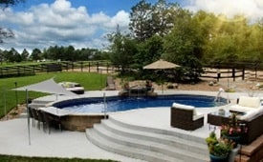
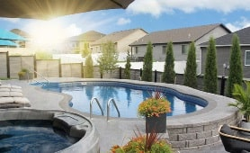
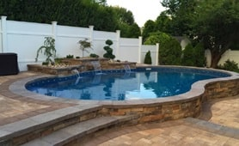

Concrete Deck
- Always hire a licensed electrician to install grounding halo and lighting conduit.
- Consider coping options:
a. Stone, brick, pavers or cantilever concrete $15-$30 per foot
b. Cantilever poured coping must be performed by an experienced concrete contractor that has experience with Styrofoam forms.
c. Stealth closed PVC capping. $1000-$1500
- Regardless of what type of coping is used, ¾” washed lime stone will be required for backfill or also known as #57.
- We highly recommend only using concrete contractors with experience pouring around swimming pools.
- If attempting to pour your own concrete the cost for concrete is approximately $2 per foot excluding gravel.
- If hiring an experienced concrete company to install your deck, this could range between $6-$12 per foot depending on total square footage and the type of finish chosen.
- Expect that you will have cleanup work to do after the project, as many Stone contractors are not familiar with pool cleanup.
- Take caution when setting forms to pour that the water runs away from the pool edge.
- Expect some cracks after concrete is poured usually within 2-3 days. Expansion joints every 6’-8’ are highly recommended to minimize this from happening in between.
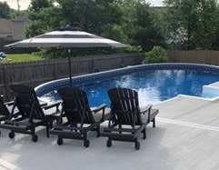
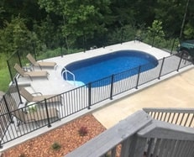
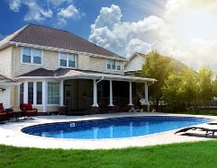
Your backyard will be a construction site until all the decking around your pool is complete. It is not recommended to bring in landscapers or fences contractors until all of these things are complete.
Always check with your local codes and ordinances for correct fencing height, pool alarms, gate latches, and window/door alarms to comply with all of your necessary safety requirements set forth by your city/location.
A good landscaper can generally straighten out your yard and lay sod/seed in a couple of days. Although your backyard might look bad during the construction process it will look beautiful when everybody is done with their part!

Additional Expenses
For services not provided by Galaxy Home Recreation

Additional Install Expenses
- Electrical work for pump and filter package and Accessores
- Sand for the pool bottom
- Water to fill the pool
- Hardscapes / Decking and Landscaping
- Permit if required

Potential Additional Install Expenses
- Rock hammer during the pool dig
- Retaining wall for yards with greater slopes
- Dirt haul off if nowhere to stage dirt
- Rock haul off
- Electrical work and conduit to run lighting (In-Ground lighting)
- Gravel buildup for wet, solid rock or unlevel areas
- Survey Fees
- Mileage if further than 30 miles from nearest showroom
- Additional LEVELING / burial over 24” and maximum of 36”
- Tree or stump removal
- Disassembling of an existing pool
- Moving an existing overhead power line or underground septic/field line
- Pump & filter upgrade for placement more than the 10 ft from skimmer.
- Additional electric or gas line possible if purchasing a heater or heat pump
- A sump pump(s) might be needed if there are heavy rains during or shortly after the pool build to remove the excess water or water resulting from ground water issues.
- Fence costs
- If unable to access the yard with a concrete truck a concrete pump may be needed

What to expect on the day of install…
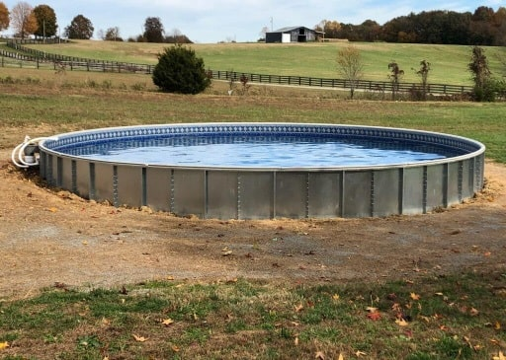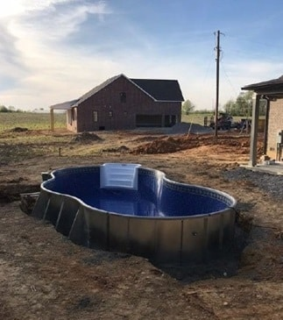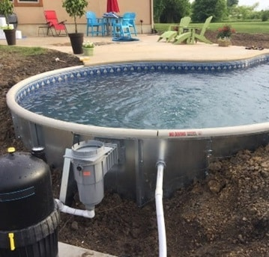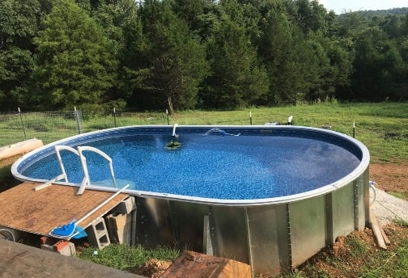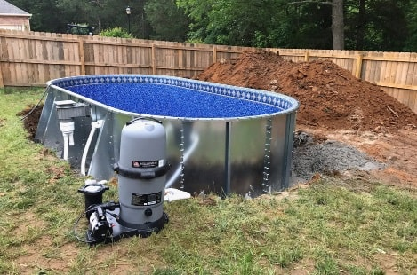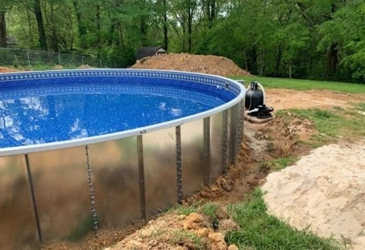

Other Important Information:
Unique Pool Spa and Billiards does NOT recommend ‘Quick Filling’ methods such as water tanker, fire hydrant and/ or multiple hose use. If these methods are the only source of filling available, please do not attempt to fill the pool unless
the temp is above 75 degrees and direct sunlight is reaching the pool. Also, please request the lowest level of water pressure is used during the filling.
DO NOT ENTER THE POOL AND/OR STAND ON THE LADDER/STEP SYSTEM BEFORE THE POOL IS COMPLETELY FULL OR THE SAND BOTTOM WILL BE COMPROMISED. (I.E. FOOTPRINTS, HEEL INDENTIONS, ETC.). THE INSTALLATION GUARANTEE DOES NOT COVER THESE OCCURRENCES.
LINER DAMAGE CAUSED BY NUTGRASS, INSECTS, NEGLECT, WATER CHEMISTRY, SAND WASHOUT FROM IMPROPER BACKFILL, MOLES, CRAWDADS, OR ACTS OF NATURE ARE NOT COVERED UNDER ANY WARRANTY.
YOU ARE NOW READY TO ENJOY THE SUMMER IN
THE SAFETY AND COMFORT OF YOUR VERY OWN POOL!
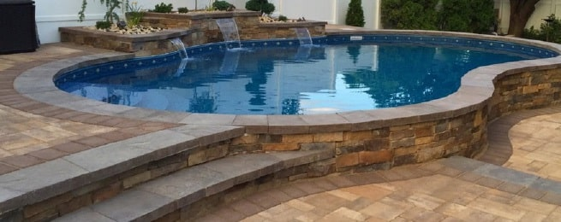
On behalf of everyone at Unique Pools Spas and Billiards, we would like to take a moment to thank you for choosing us to be your swimming pool installer. The building of a Stealth swimming pool can be an exciting and quick process.
For any future service or operational needs, please contact us at the numbers listed below:
Orlando 321-382-5444
Jacksonville 904-604-7722

Daytona Beach 386-946-6923

Balancing Your Pool Water
Maintaining your pool water in the proper balance pays big rewards. As a result, it makes for more comfortable swimming and less maintenance. If the pool water is not properly balanced, it could cause a number of costly problems:
- Damage to liner
- Damage to pump, filter, and equipment
- Burning of eyes and skin
- Cloudy water
- Algae growth
- Bacteria/unsafe swimming conditions
All of these factors affect proper water balance:
- How often you use the pool
- Weather (rain, sun, wind)
- Dust debris
- Circulation
- Number of swimmers
- Animals
- Water treatment products used

The following shows the ranges for basic water chemistry balancing
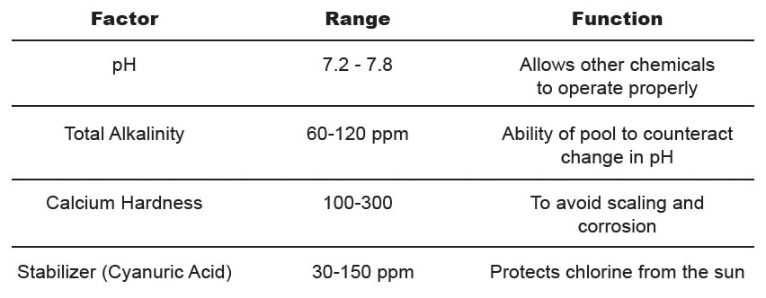

Definitions

pH Balance Chart
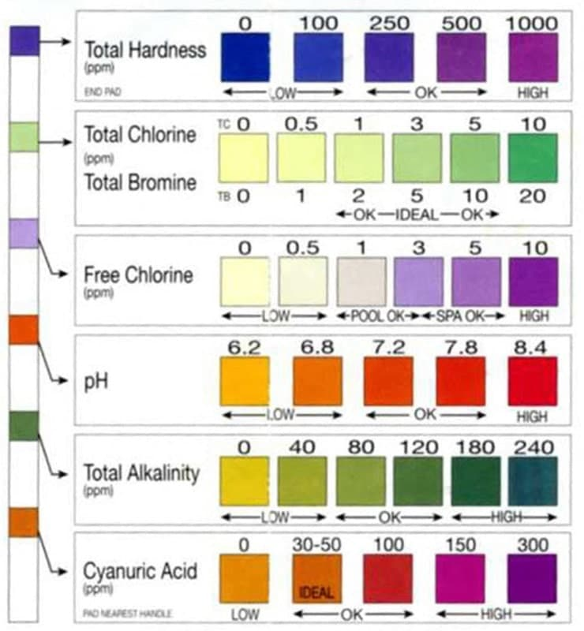
pH: Proper pH levels allow other chemicals to do their work. It is important to note that low and high levels can cause damage to the liner. Under the right circumstances with pH below 7.0, the liner can actually grow and develop unsightly wrinkles, staining of walls, chlorine loss, and skin/eye irritation. High pH greatly accelerates the aging process and shortens the life of the liner. High pH can also cause chlorine inefficiency, plugged filters, and skin/eye irritation. Make sure to test your pH regularly with your test strips so these things can be avoided. If your pH appears to be off on your test
strips, bring your pool water sample to Galaxy Home Recreation and we’ll professionally test your water for free.
Total Alkalinity (TA): This refers to the quantity of alkaline materials dissolved in water, which act as a buffer in controlling pH change. If the TA is below 60 ppm the pH will not stay in proper range. The pool water may promote cloudy or clear green water, corrosion, and cause damage to the pool fixture and equipment. TA that is above 120 can cause cloudy water or scale, and can also create an ideal environment for algae growth.
***Note: Cyanuric Acid (stabilizer) will interfere with the test for TA, therefore it is necessary to compensate for this interference. For pools with a CyA above 50 ppm, the correction formula is: TA – 1/3 CyA = True Total Alkalinity
Cyanuric Acid (CyA) (stabilizer): If you are using any chlorine-based sanitizing product, the firs thing you need to do to the water is stabilize it. By stabilizing the water you are protecting the chlorine from the sun’s UV rays, and greatly reducing your chlorine usage. Think of the stabilizer as an invisible umbrella over your pool. The only way stabilizer
leaves the water is by dilution or evaporation.
Calcium Hardness: This refers to the calcium and magnesium content of the pool. It is wise to check this regularly to prevent problems with the liner and filter system.
Metals: Having high levels of metal in the water is the leading cause of pool stains. Test these levels monthly or bring a water sample to Galaxy Home Recreation.

Volume in Gallons by Pool Size & Shape
Use this chart to find the approximate volume of your pool in gallons.
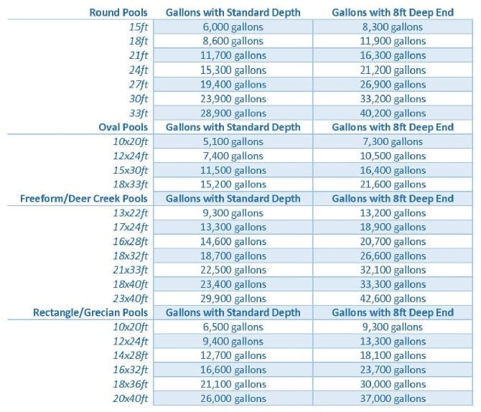

If you do not see your pool shape and size here, you can easily calculate it.

Round Pools:
Gallons = Diameter (ft) x Diameter (ft) x Average Depth (ft) x 5.9

Oval Pools:
Gallons = Length (ft) x Width (ft) x Average Depth (ft) x 5.9

Freeform/Deer Creek/Grecian/Rectangle:
Gallons = Length (ft) x Width (ft) x Average Depth (ft) x 7.5
Average Depth = (Shallowest Depth in feet + Deepest Depth in feet) / 2

Pristine Blue & Advanced Pool Start Up Instructions
PristineBlue & Advanced Pool is a copper-based non chlorine program for pools and spas with a once every 14 day (bi-weekly) treatment that is compatible with chlorine, bromine and lithium sanitizers. In the PristineBlue line there are six products. They are all designed to work together to get the best benefit from your investment.
Before you begin: We suggest you start by bringing a water sample in for a complete analysis of your water by our water care specialist. Make sure your pool is clean and all equipment is functional. Remove lwaves and other debris and then vacuum. Check to make sure pump, heater and other equipment are operational. Clean or backwash the filter. Run the filter continuously throughout this start-up process.

1. Balance your water
Balance water to the following ranges. Pristine Blue test strips are best to use when testing for pH & Alkalinity
- Alkalinity should be between 50 and 90 ppm
- pH should be between 7.2 to 7.6
- Calcium Hardness should be between 100 to 400 ppm
NOTE: It is unlikely, but achieving optimal water balance may take several days.

2. Prep
2a. Add 2 ounces of PristineCheck or Advanced Prep per 1,000 gallons of pool water. Run filter for 6 hours.
2b. Add 1 pound of PristineExtra or Advanced Shock per 10,000 gallons of pool water. Continue running your filter pump for a minimum of 12 hours before proceeding.
2c. Backwash filter or clean cartridge thoroughly with Galaxy cartridge cleaner

3. Add Pristine Blue
PristineBlue & APSP Products may be added directly to your pool water without mixing. It is not necessary to wait between applications of the different products. DO NOT pour into skimmer.
3a. NEW USERS: Add 2 ounces of PristineBlue or Advanced XXX Blue per 1,000 gallons of pool water.
3b. SPRING OPENING/CURRENT USERS: Test the PristineBlue level and add PristineBlue according to
the Top-off Chart below.
REMINDER: Test periodically to ensure pH is within the 7.2 to 7.6 range after start-up.
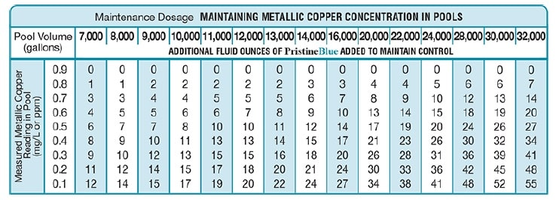

Pristine Blue & Advanced Pool Maintenance

Maintenance Cycle- Every 2 weeks:
Before you begin: To avoid unnecessary waste of useful chemicals, ALWAYS backwash sand filter, or clean your cartridge filter PRIOR to performing these steps.
PristineBlue & Advanced Pool is a copper-based non chlorine program for pools and spas with a once every 14 day (bi-weekly) treatment that is compatible with chlorine, bromine and lithium sanitizers. In the PristineBlue line there are six products. They are all designed to work together to get the best benefit from your investment.
Balancing the water may take several days, but is well worth the wait.

1. Balance
Pristine Blue Test Strips are best to use when testing for pH and Alkalinity
- Alkalinity should be between 50 and 90 ppm
- pH should be between 7.2 to 7.6
- Calcium Hardness should be between 100 to 400 ppm

2. Prep
NOTE: We recommend to shock once a week or after: 1) heavy bather load, 2) excessive rain.
2a. Shock with 1 pound of PristineExtra or Advanced Shock per 10,000 gallons of pool water. (preferably at night)
2b: (Optional) Add 2 ounces of Turbo Blue Clarifier per 10,000 gallons of pool water.

3. Add PristineBlue
PristineBlue & APSP Products may be added directly to pool water without mixing. It is not necessary to wait between applications of the different products. DO NOT pour into skimmer.
3a: Test for residual PristineBlue or Advanced Blue level of your pool. (Use Mini Test Kit or bring to store for testing)
3b: Add 2 ounces of PristineClean or Advanced Clean per 10,000 gallons of pool water.
3c: According to top off chart below add appropriate ounces of PristineBlue or Advanced Blue and relax!
REMINDER: Test periodically to ensure pH is within the 7.2 to 7.6 range after start-up.
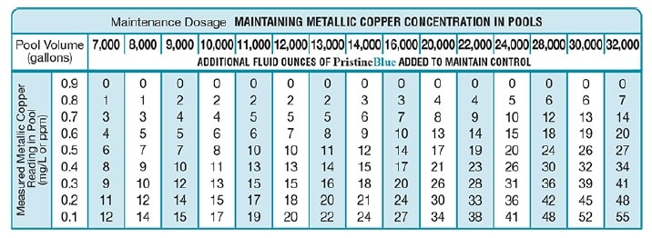

Nature’s Pure Start Up Instructions
Nature’s Pure is an inline copper ionizer that releases microscopic mineral ions which control bacteria & algae. This allows you to reduce the chemicals you put in your pool.

1. Balance your water
Keeping your water balanced will help your copper ionizer last longer and be more effective.
- Alkalinity should be between 80 and 120 ppm
- pH should be between 7.2 to 7.6
- Calcium Hardness should be between 200 to 300 ppm
- TDS (Total Dissolved Solids) Should be between 1000 & 2000 ppm

2. Prep your water
If your pool was green at prior to starting your ionizer please shock daily until water is clear.
2a. Add 1lb of Shock per 10,000 gallons. (preferably at night)
- Run filter for 6 hours then rinse cartridge filter
2b. Add 20lbs of Galaxy Borate (New Pools Only)
- Broadcast over entire pool surface and brush any undissolved product from bottom of pool
- pH will rise as a normal reaction to the introduction of this product
- Let it circulate for 2 hours
2c. Add 15lbs of Galaxy pH Reducer (New Pool Only)
- Broadcast evenly over entire pool surface and brush any undissolved product from bottom of pool
- Retest after 24 to 48 hours
- Do Not add additional products until the pH is between 7.2 – 7.6
2d. Add Galaxy Stabilizer 2lb per 10,000 gallons to increase the stabilizer to between 20-50 PPM.
- Add directly to the skimmer with the pump on high & don’t clean the filter for 72 hours.
- The pool will need to run continuously on high for the first 72 hours.
2e. Add 4 oz Algaecide60 per 10,000 gallons
- Add directly in front of the return jet with pump on high
2f. Add 4oz water polish
- Add directly in front of the return jet with pump on high.
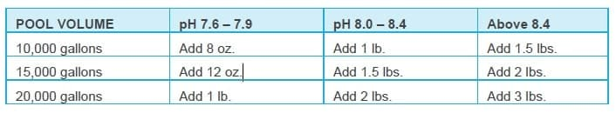

3. Turn Ionizer on and set at level 3
Important: Maintain a chlorine level of 1-3 ppm while copper level is reaching to .3 – .5 ppm.
3a. Keep your pump on high speed for the first week or until your copper reading is between .3 and .5 ppm. The
active light will only be on when your pump is on high speed.

4. Add Tablet to Skimmer
Important: For tablet to dissolve properly DO NOT turn pump off for more than 3 hours at a time.
4a. Add 1 NST tablet per 10,000 gallons to the skimmer basket

Nature’s Pure Maintenance

Maintenance Cycle- Every Week:

1. Balance
You only need to test for Borate early in the season to establish a level of 30-50 ppm. Borate does not dissipate
and usually does not need to be tested until late in the season
1a. Test water using pool test strips and mini test kit for copper or bring a water sample to one of our stores.
1b. Add chemicals, if necessary, to balance water to appropriate ranges below:
- Alkalinity should be between 80 and 120 ppm
- pH should be between 7.2 to 7.6
- Copper should be between .3 and .5 ppm
- FCl (Free Chlorine) should be between .5 to 3 ppm

2. Ionizer Settings
Reminder: The Ionizer is only releasing copper when the power and active light are on.
2a. Once your copper level reaches 0.3-0.5 you can put your pump on low speed for 16 to 18 hours a day. Make
sure your pump is on high speed for a minimum of 6-8 hours/day to maintain copper level.
2b: If your copper level drops below .3 you can turn up the level setting on your ionizer or run pump on high more.

3. Add Shock
NOTE: Shock pool once a week or additionally after heavy bather load or excessive rain.
3a. Turn pump on high and broadcast the shock over the entire pool then run pump for 6-8 hours minimum.
3b. Alternate Galaxy Oxy Shock with Galaxy Shock each week.
- It is preferable to sock your pool at night when using Galaxy Shock

4. Algaecide and Polish
Note: For best results. Add 12 hours after shock to help restore water clarity
4a. Add 1oz of Algaecide 60 per 10,000 gallons directly in front of return jet.
4b. Add 1oz of water polish per 10,000 gallons directly in front of return jet.

5. Add Tablet
Important: For the tablet to dissolve properly DO NOT turn pump off for more than 3 hours at a time.
4a. Add 1 tablet per 10,000 gallons to the skimmer basket
- If FCl (Free Chlorine) reading is ever higher than 3ppm reduce the frequency that you add a tablet to the
skimmer.

Nature’s Pure Troubleshooting
While working correctly, 1) Power light will be on, 2) Active light will be on when pump is on high, 3) Chamber light will be off
Issue 1: Power light is not on | Issue 2: Power light is on & Active light is off | Issue 3: Chamber light is on
1. Is unit plugged into 110v/20amp GCFI  2. Is power cord pushed in on unit?  3. Unplug and plug the unit back in.  4. Check the breaker. | 1. Unplug, plug back in, wait 5 minutes  then power on.  2. Is pump on high?  3. Is TDS level over 1000? | 1. Is the active light on?  2. Has the unit been working all season?  If yes to both, your copper anodes may  need to be replaced.
If none of the above works, check to see that your unit has been plumbed correctly. An arrow on the black part of the unit will indicate the correct direction of water flow.

SunSalt Pool Sanitation System
Use this checklist to help start up and maintain your Sunsalt System
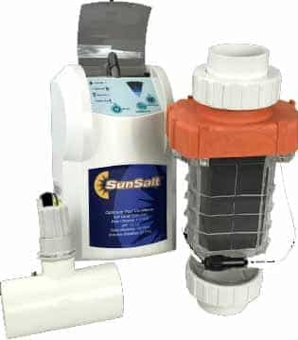

1. BALANCE YOUR WATER
- Test water and balance
  - pH 7.2 – 7.6
  - Alkalinity 80 – 120 ppm
  - Calcium Hardness 100 – 300 ppm
  - Stabilizer 50 – 80 ppm (60 is best)
  - TDS below 1500 ppm
- Make sure no phosphates are present in water. Phosphates can affect the way the salt cell works. If you have phosphates purchase a Galaxy phosphate remover.
- Make sure no metals are present in the water. If you have metals purchase a Galaxy metal remover.
- Testing can be done at your local store or by using test strips. Test strips for salt are available and are separate from test strips that test for pH, Alkalinity, Hardness, and Cyanuric Acid (Stabilizer). TDS can only be tested in the store.

2. Add Salt
- Once your water is balanced and free of phosphates and metals you can add salt.
- Ideal salt level is 3500 ppm.
  - Only use granulated pool salt
  - How much salt to add? See chart below
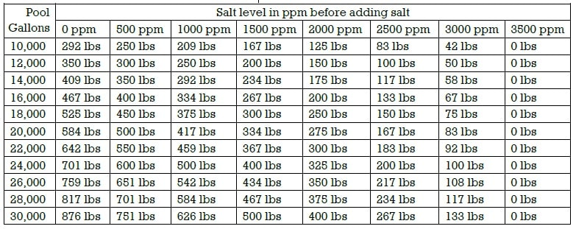

Testing Frequency
- WEEKLY: Test for Free chlorine (should be between 1-3ppm) and pH between 7.2 – 7.6
- MONTHLY: Test for Salt, Alkalinity, Stabilizer, and Calcium
- Inspect cell every three months and clean as needed with vinegar or diluted muriatic acid

Maintenance Chemicals
- Shock pool weekly (or after heavy rain) with 1 lb of shock per 10,000 gallons
- Add algaecide monthly or weekly per instructions on your algaecide bottle
- Add salt any time the level drops below 3500 ppm, use chart above to measure how much salt to add
- Maintain pH by testing weekly and after heaving rain and adjusting as necessary based on package instructions for dosage
- Maintain Alkalinity, Stabilizer and Calcium levels based on monthly testing and reference package instructions for dosage

Equipment and Electrical Requirements
- Sunsalt can be run on 110 or 220 volt power
- Comes with 4 parts: Power supply box, electrolytic cell, flow/temp sensor, and zinc anode

Winterizing
- Measure salt level, balance water, add scale and stain sequestering agent, add oxidizer and algaecide
- Follow instructions for winterizing the cell, pump, filter, and pool in the winter closing section of this book or on our website.

Sand Filter System & Operation
ALWAYS turn the pump motor off before changing positions!
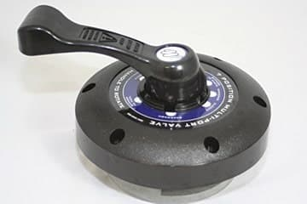
ONLY turn the multi-port valve in a clockwise position! There is a gasket inside of the valve that will rip, tear or wear prematurely if the valve is turned the opposite way.
Under normal conditions expect to backwash the filter every two weeks. You’ll know when it’s time when the pressure gauge reads 7-10 psi above the normal running pressure, or when the pressure of the water coming out of the return jets lowers. To determine your normal running pressure watch the gauge for the first week or two, each pool varies slightly. If you have a fountain installed this will change the reading from normal.
After backwashing for approximately 1-2 minutes, ALWAYS rinse for half the time you backwashed.
Starting the pump and motor for the first time: When the water level is in the middle of the skimmer, turn the multi-port valve to backwash position. Turn on the pump, backwash for 1-2 minutes then turn the pump off. Turn the multi-port valve to the rinse position, turn the pump back on and rinse for 30 seconds. Turn the pump back off and turn the multi-port valve to the filter position and turn the pump on. This is to ensure that sand does not go into the pool water through the return jet.
- Filter Position: To help prevent algae and reduce chemical costs, we recommend running your pump 24/7 on low speed. But no less than 12 hours a day.
- Bypass to Waste/Drain/Waste: Used in lowering water level, or vacuuming algae and heavy debris. To vacuum on this position, you must firs fil the pool above the skimmer. Never allow the water level to get below the skimmer, while vacuuming on this position keep a garden hose running in the pool.
- Backwash Position: This position churns the sand and runs water backwards through it to get rid of any debris that has been trapped. This position is used when the pressure gauge is 7-10 pounds above normal running pressures. Backwash for approximately 1-2 minutes.
- Rinse Position: This position rinses the top layer of the sand to compact it down after backwashing; this is to prevent sand from
shooting into the pool through the return jet when it is put back on the filter position. Rinse for half the time you backwashed.
- Bypass to Pool/Recirculate/Whirlpool: This position circulates water in the pool without passing through the sand filter. This position is rarely used and is not recommended for normal filtration Only use this position if we recommend it.
- Closed Position/Test: This position is used to close the return line, the only time this needs to be used is when you are checking
your pump basket, cleaning your sand filter, and taking off or replacing any other components of the pump or filter.
- Winterize Position: This position is used when winterizing your pool.
For more sand filter instructions visit www.galaxyhomerecreation.com/learning-center

Cartridge Filter System & Operation
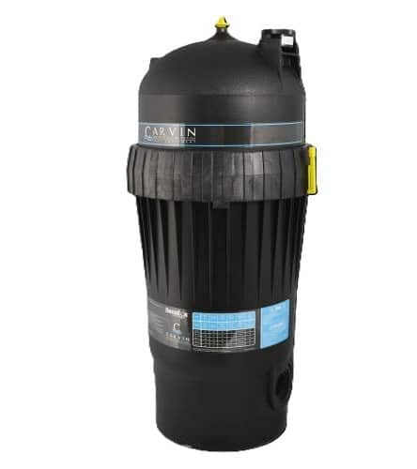

Start-Up Tip
Determine the baseline PSI on your pressure gauge. It is a good idea to do this at install when the filter is new and clean.

Cartridge Filter Start-up
Step 1: Make sure the water has reached the middle of the skimmer.
Step 2: Make sure all valves are open.
- Gate valves are closed when the gate handle is lowered and rotated to lock it in place
- Ball valves are closed when the handle is turned clockwise.
Step 3: Open air pressure release valve on top of the filter housing.
Step 4: Turn pump on (Remember to never plug your pump into an extension cord. Always use a 20 amp receptacle.)
Step 5: Air will come out of the air pressure release valve and then water will begin to shoot out. This means that the air has come out of the system. Immediately close the air pressure release valve by turning clockwise until it stops turning.
Step 6: Check the PSI on the pressure gauge and make note of it as your baseline.
- For pumps that have a low and high option, the pressure gauge will usually only register when the pump is on high.
Step 7: Check for any leaks.
- Often small leaks can happen immediately after install due to o-rings not sitting just right or fittings needing to be tightened.
- If you notice any drips or leaks follow step 8.
Step 8: Rectifying any leaks.
- Turn pump off
- Close any valves that are open or if you don’t have valves, use a plug in the skimmer and return jet.
- O-rings are located on filter canister, trap body lid of pump, and in bridge between the pump and filter.
- Ensure o-rings are clean and free of debris.
- When putting the canister lid back on make sure air pressure release valve is open and that you press the lid down firmly and not twist it. Twisting can cause the o-ring to pop out of place and cause leaks.
Step 9: Put top of the filter housing back on and put the Lock Ring back on securely.
Step 10: Start back at Step 2 to get your filtration system going again.
When to Clean? When the PSI is 8 to 10 higher than the baseline. This is an indication that it is time to clean your cartridge filter.

Vacuuming Your Pool
- Attach the telescopic pole and vacuum hose to the vacuum head. Make sure that the swivel cuff end of the hose is on the vacuum head. If you have an inground pool make sure the main drain is turned off and only one skimmer has suction.
- Sink the vacuum head under water along with the vacuum hose.
- Take the free end of the vacuum hose and put it in front of the return jet to fill the hose full of water. (This primes the hose and removes all the air.)
- When the air is out the hose, he hose will sink to the bottom.
- Once this happens keep the hose under water and connect the hose to the vacuum plate inside the skimmer.
- If you vacuumed a lot of fine dirt, make sure to backwash and rinse your sand filter or spray off your cartridge filter after vacuuming. Backwash for approximately 1-2 minutes and rinse for approx. 15-30 seconds.
Sand Filter Systems – Always vacuum on filter position (pg. 15), unless there is algae or heavy debris in the pool, in which case you should vacuum to waste by using the waste position on the multiport.
Cartridge Filter Systems – Keep filter in canister unless there is algae. For an above ground pool take filter out, close off return line, and open drain cap to vacuum out waste. For an inground pool (if you don’t have a built-in waste line) follow the same procedures.
REMEMBER TO KEEP A GARDEN HOSE IN THE POOL.
IF WATER LEVEL DROPS LOW IN SKIMMER, STOP AND REFILL POOL.
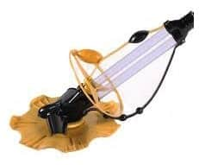


Thank you for choosing Unique Pools Spas and Billiards!

