

Functional Safety Concept Lane Assistance

**Document Version: [Version]**

**Template Version 1.0, Released on 2017-06-21**



# Document history

**[Instructions: Fill in the date, version and description fields. You can fill out the Editor field with your name if you want to do so. Keep track of your editing as if this were a real world project.**

**For example, if this were your first draft or first submission, you might say version 1.0. If this is a second submission attempt, then you'd add a second line with a new date and version 2.0]**

|  |  |  |  |
| --- | --- | --- | --- |
| Date | Version | Editor | Description |
| 20/05/2018 | 1.0 | Trijeet | Attempt 1 |
|  |  |  |  |
|  |  |  |  |
|  |  |  |  |
|  |  |  |  |

# Table of Contents

**[Instructions: We have provided a table of contents. If you change the document structure, please update the table of contents accordingly. The table of contents should show each section of the document and page numbers or links. Most word processors can do this for you. In** [**Google Docs**](https://support.google.com/docs/answer/116338?co=GENIE.Platform%3DDesktop&hl=en)**, you can use headings for each section and then go to Insert > Table of Contents.** [**Microsoft Word**](https://support.microsoft.com/en-us/help/285059/how-to-create-a-table-of-contents-by-marking-text-in-word) **has similar capabilities]**

Document history

Table of Contents

Purpose of the Functional Safety Concept

Inputs to the Functional Safety Analysis

Safety goals from the Hazard Analysis and Risk Assessment

Preliminary Architecture

Description of architecture elements

Functional Safety Concept

Functional Safety Analysis

Functional Safety Requirements

Refinement of the System Architecture

Allocation of Functional Safety Requirements to Architecture Elements

Warning and Degradation Concept

# Purpose of the Functional Safety Concept

The purpose of the functional safety concept is to identify the high level system requirements without diving deep into the technical aspects. Different parts of the item architecture are allocated with the responsibility of fulfilling these requirements. The result of this leads to construction of the technical safety requirements from it. Validation and verification instructions for these requirements are also laid down in this. Finally, these requirements will be considered while hardware and software implementation of the system.

# Inputs to the Functional Safety Concept

## Safety goals from the Hazard Analysis and Risk Assessment

[Instructions:

REQUIRED:

Provide the lane departure warning and lane keeping assistance safety goals as discussed in the lessons and derived in the hazard analysis and risk assessment.

OPTIONAL:

If you expanded the hazard analysis and risk assessment to include other safety goals, include them here.

]

|  |  |
| --- | --- |
| **ID** | **Safety Goal** |
| Safety_Goal_01 | The oscillating steering torque from the lane departure warning shall be limited |
| Safety_Goal_02 | The lane keeping assistance shall be time limited. The additional steering torque shall end after a given time interval so that the driver can not misuse the system for autonomous driving |
| Safety_Goal_03 | The lane departure warning and the lane keeping assistance shall be disabled as soon as the cameras malfunction; followed by an alarm to notify the driver about this incident. |

## Preliminary Architecture

The architecture is depicted in the following image:

## 

### Description of architecture elements

**[Instructions: Provide a description for each of the item elements; what is each element's purpose in the lane assistance item? ]**

|  |  |
| --- | --- |
| **Element** | **Description** |
| Camera Sensor | Captures the scene in front of the car and feeds the image to the camera sensor ECU. |
| Camera Sensor ECU | Processes the image to detect the components in the image (such as lane lines, free road, pedestrians, other obstacles etc) and computes the car’s position on the lane. |
| Car Display | Notifies the driver with alerts, warnings and status messages from the lane departure warning and lane keeping assistance functions. |
| Car Display ECU | Controls the signals and content to be displayed on the car display. |
| Driver Steering Torque Sensor | Measures the torque that is currently being applied on the steering wheel |
| Electronic Power Steering ECU | Computes the torque that is further required to keep the car on lane, based on the inputs from the lane departure warning and lane keeping assistance functions. |
| Motor | Actuates the torque on the steering wheel. |

# Functional Safety Concept

The functional safety concept consists of:

* Functional safety analysis
* Functional safety requirements
* Functional safety architecture
* Warning and degradation concept

## Functional Safety Analysis

**[Instructions: Fill in the functional safety analysis table below.]**

|  |  |  |  |
| --- | --- | --- | --- |
| **Malfunction ID** | **Main Function of the Item Related to Safety Goal Violations** | **Guidewords (NO, WRONG, EARLY, LATE, MORE, LESS)** | **Resulting Malfunction** |
| Malfunction_01 | Lane Departure Warning (LDW) function shall apply an oscillating steering torque to provide the driver a haptic feedback | MORE | The lane departure warning cause a very high oscillating steering torque amplitude which exceeds max limit. |
| Malfunction_02 | Lane Departure Warning (LDW) function shall apply an oscillating steering torque to provide the driver a haptic feedback | MORE | The lane departure warning cause a very high oscillating steering torque frequency which exceeds max limit. |
| Malfunction_03 | Lane Keeping Assistance (LKA) function shall apply the steering torque when active in order to stay in ego lane | NO | The lane keeping assistance function is not constrained in time limit which might lead to misuse. |

## Functional Safety Requirements

**[Instructions: Fill in the functional safety requirements for the lane departure warning ]**

Lane Departure Warning (LDW) Requirements:

|  |  |  |  |  |
| --- | --- | --- | --- | --- |
| **ID** | **Functional Safety Requirement** | **ASIL** | **Fault Tolerant Time Interval** | **Safe State** |
| Functional  Safety  Requirement  01-01 | Lane departure warning function shall ensure that the lane departure oscillation torque amplitude stays below Max_Torque_Amplitude | C | 50 ms | Oscillation torque amplitude maintained below Max_Torque_Amplitude |
| Functional  Safety  Requirement  01-02 | Lane departure warning function shall ensure that the lane departure oscillation torque frequency stays below Max_Torque_Frequency | C | 50 ms | Oscillation torque amplitude maintained below Max_Torque_Frequency |
| Functional  Safety  Requirement  01-03 | Lane departure warning shall be disabled when the camera sensors malfunction. | C | 10 ms | Function disabled |

Lane Departure Warning (LDW) Verification and Validation Acceptance Criteria:

|  |  |  |
| --- | --- | --- |
| **ID** | **Validation Acceptance**  **Criteria and Method** | **Verification Acceptance**  **Criteria and Method** |
| Functional  Safety  Requirement  01-01 | Check that the Max_Torque_Amplitude is enough for the driver to detect it while not losing of control over the car. | Check that the lane departure warning is disabled once it exceeds Max_Torque_Amplitude |
| Functional  Safety  Requirement  01-02 | Check that the Max_Torque_Frequency is enough for the driver to detect it while not losing control over the car. | Check that the lane departure warning is disabled once it exceeds Max_Torque_Frequency |
| Functional  Safety  Requirement  01-03 | Check that the lane departure warning whenever there is a malfunction in the camera sensors | Check that the lane departure warning is disabled as soon a camera malfunction is detected. |

Lane Keeping Assistance (LKA) Requirements:

|  |  |  |  |  |
| --- | --- | --- | --- | --- |
| **ID** | **Functional Safety Requirement** | **ASIL** | **Fault Tolerant Time Interval** | **Safe State** |
| Functional  Safety  Requirement  02-01 | The electronic power steering ECU shall ensure that the lane keeping assistance torque is applied for no more than Max_Duration | B | 500 ms | Lane keeping assistance torque is set to 0 |
| Functional  Safety  Requirement  02-02 | The lane keeping assistance shall be deactivated when the electronic power steering ECU detects a camera malfunction. | C | 10 ms | Function disabled |

Lane Keeping Assistance (LKA) Verification and Validation Acceptance Criteria:

|  |  |  |
| --- | --- | --- |
| **ID** | **Validation Acceptance**  **Criteria and Method** | **Verification Acceptance**  **Criteria and Method** |
| Functional  Safety  Requirement  02-01 | Check that the Max_Duration is chosen such that the driver disengage himself from autonomous driving. | Check that the system is disabled as and when the lane keeping assistance torque is applied for a duration that exceeds Max_Duration. |
| Functional  Safety  Requirement  02-02 | Check that the lane keeping assistance whenever there is a malfunction in the camera sensors | Check that lane keeping assistance is disabled as soon a camera malfunction is detected. |

## Refinement of the System Architecture

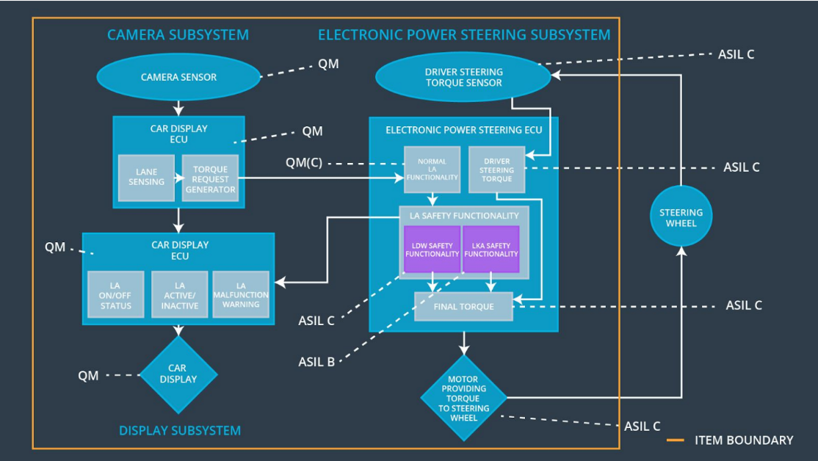

## Allocation of Functional Safety Requirements to Architecture Elements

|  |  |  |  |  |
| --- | --- | --- | --- | --- |
| **ID** | **Functional Safety Requirement** | **Electronic Power Steering ECU** | **Camera ECU** | **Car Display ECU** |
| Functional  Safety  Requirement  01-01 | The lane keeping assistance function shall ensure that the lane departure oscillation torque amplitude stays below Max_Torque_Amplitude | **X** |  |  |
| Functional  Safety  Requirement  01-02 | The lane keeping assistance function shall ensure that the lane departure oscillation torque frequency stays below Max_Torque_Frequency | **X** |  |  |
| Functional  Safety  Requirement  01-03 | Lane departure warning shall be disabled when the camera sensors malfunction. | **X** |  |  |
| Functional  Safety  Requirement  02-01 | The electronic power steering ECU shall ensure that the lane keeping assistance torque is applied for no more than Max_Duration | **X** |  |  |
| Functional  Safety  Requirement  02-02 | The lane keeping assistance shall be deactivated when the electronic power steering ECU detects a camera malfunction. | **X** |  |  |

## Warning and Degradation Concept

|  |  |  |  |  |
| --- | --- | --- | --- | --- |
| **ID** | **Degradation Mode** | **Trigger for Degradation Mode** | **Safe State invoked?** | **Driver Warning** |
| WDC-01 | Disable lane departure warning | Malfunction_01,  Malfunction_02 | Yes | Alert on car display: Lane departure warning malfunction |
| WDC-02 | Disable lane keeping assistance | Malfunction_03 | Yes | Alert on car display: Lane keeping assistance malfunction |