LIVE-VQC STS Orignial
GM-LOG 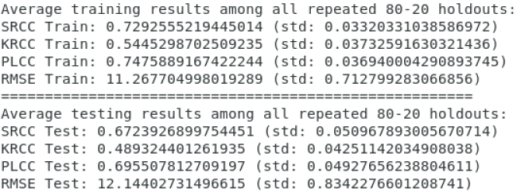 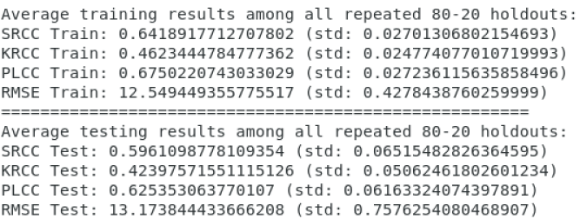
BRISQUE 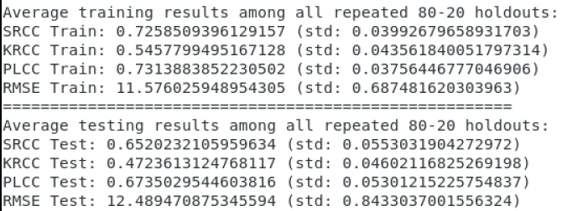 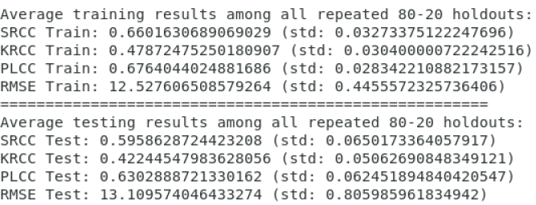

KoNVid
GM-LOG 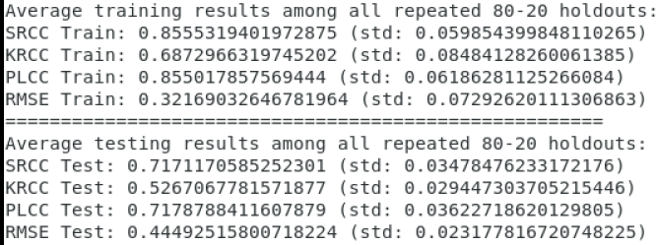 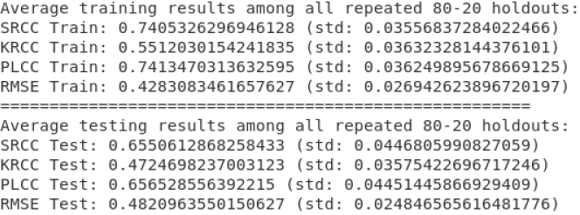
BRISQUE 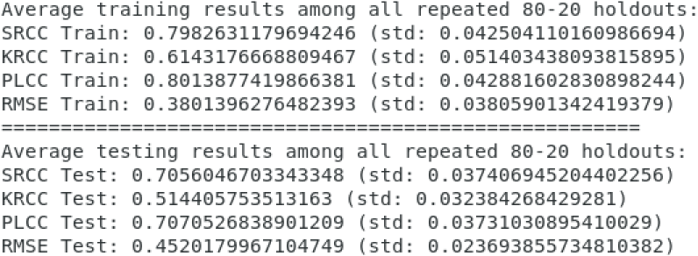 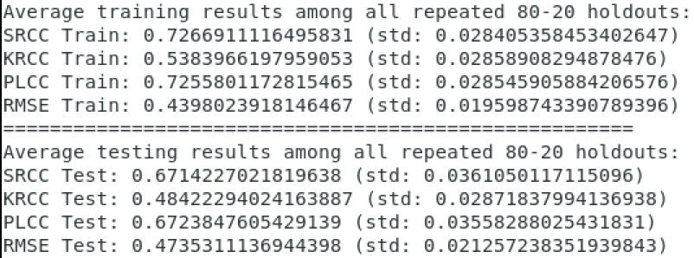

RGB : HIGRADE, 72
FRIQEE, NIQE

XY--T, (10,75)-->mean
XT--Y,(11,75)
YT--X, (10,75)

(10, 75*3)--->(1,75*3)-->1 video
Mean first

VQA:TLVQM, 75*3

