1 SVR 3 SVR

LIVE_VQC RN_RP_FV [0:2048] [2048:2728] [2728:3000]

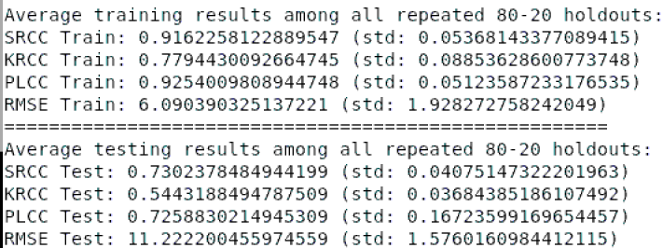 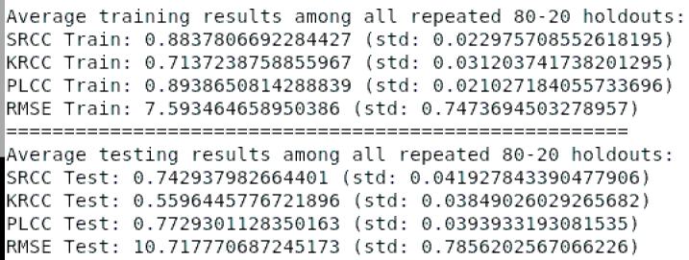

Youtube-UGC HG_RP_FV [0:216] [216:896] [896:1168]

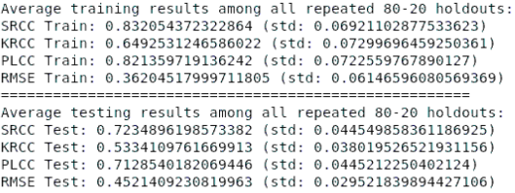 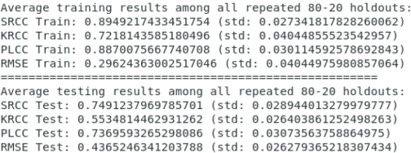

KoNVid FV_RP_FV [0:272] [272:952] [952:1224]

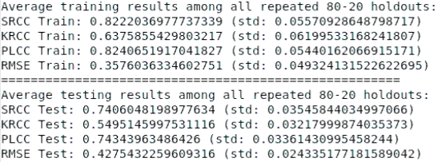 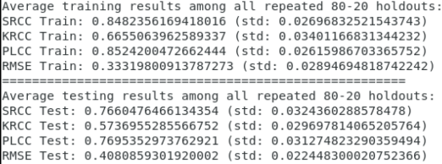

LIVE_GAME RP_FV_FV [0:680] [680: 952] [952:1224]

