**Basic concept of Limit**

A limit is the value that a function (or sequence) "approaches" as the input (or index) "approaches" some value in mathematics. Limits are used to define continuity, derivatives, and integrals in calculus and mathematical analysis.

A function's limit is often represented in formulae as:

Lim x→af(x)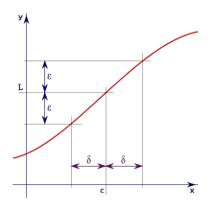

As an example:

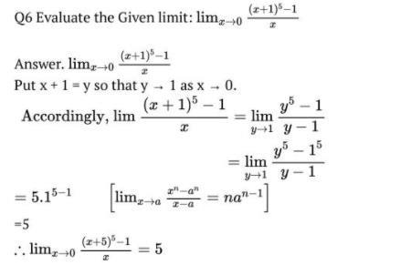

**Gradients of curve and differentiation**

Gradient of a Curve The gradient at some extent on a curve is that the gradient of the tangent to the curve at that time. A line parallel to the x-axis with equation of the shape y = k (k constant), has a  
gradient of zero. As a line becomes closer to vertical its gradient gets larger and bigger. The  
gradient function is usually called the derived function or the derivative.

Three functions (in pink) and their gradient functions (in red) are shown below:

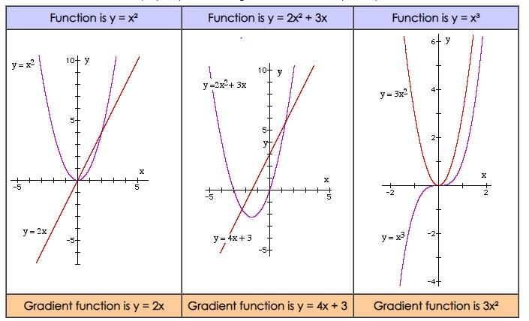

**Differentiation**

Differentiation is the process of determining the derivative, or rate of change, of a function in mathematics. In contrast to the abstract character of the theory, the practical approach of differentiation may be carried out using solely algebraic manipulations, utilizing three fundamental derivatives, four rules of operation, and knowledge of how to manipulate functions.

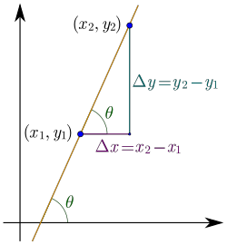

equating x to the power of something

1) If y = x n , dy/dx = nx n-1

2) If y = kx n , dy/dx = nkx n-1 (where k is a constant- in other words a number)

furthermore, To differentiate x from the power of anything, place the power in front of the x and then lower the power by one.

**Definition of Differentiation with examples**



Assume that y = f(x) is a function of x. Then, for each unit change in "x," the rate of change of "y" is given by:

𝑑𝑦

𝑑𝑥

If the function f(x) receives an infinitesimal change of 'h' at any point 'x', the function's derivative is determined as:

limh→0f(x+h)–f(x)h

**equating x to the power of something**

* If y = x n , dy/dx = nx n-1
* If y = kx n , dy/dx = nkx n-1 (where k is a constant- in other words a number)

Furthermore, to determine x from the power of anything, bring the power down to in front of the x and then lower the power by one.

**Examples**

If y = x 4 , dy/dx = 4x 3

If y = 2x 4 , dy/dx = 8x 3

If y = x 5 + 2x -3 , dy/dx = 5x 4 - 6x -4

**Differentiation by first principle**

**a. Algebraic Operation**

An algebraic function is any function that can be derived by generating linear combinations, products, quotients, and fractional powers from the identity function y=x.

For example:

**b. Logarithmic Function**

Logarithmic differentiation refers to the process of differentiation functions by first calculating logarithms and then differentiating. In cases where it is easier to differentiate the logarithm of a function than the function itself, we use logarithmic differentiation.

For example:

**c. Exponentiation Function**

Exponential functions are defined as f(x)=ax, where an is the base. The base is usually a positive number greater than or equal to one.

**d. Trigonometric function**

As we know, the differentiation of a trigonometric function can be determined in the same way as the differentiation of an algebraic function is calculated using the first principle. As a result, we may determine from fundamental principles that the formula is:

**Basic Rules for Differentiation**

The basic rules for differentiation are enlisted below:

**Differentiation of Parametric Function**

We may add a third quantity or variable to make things simpler to grasp since some relationships between two numbers or variables are so complicated. In mathematics, this third number is referred to as a parameter. Instead of one equation linking x and y, we have two, one connecting x to the parameter and the other connecting y to the parameter. In this section, we'll look at various instances of these curves and explain how to calculate their rates of change with parametric differentiation.

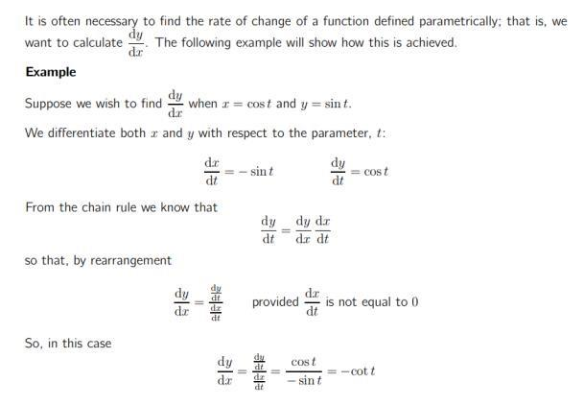

**Differentiation of Implicit Function**

We differentiate each side of an equation with two variables (typically x and y) by considering one of the variables as a function of the other. This requires the use of the chain rule.

"Integration by Substitution" (also called "u-Substitution" or "The Reverse Chain Rule") is a

method to find an integral, but only when it can be set up in a special way.

The first and most important step is to be able to write our integral in the following format:

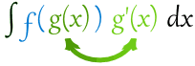

It is important to note that we have g(x) and its derivative g' (x).

As in the example below:



Here, f=cos, and g=x 2 and its derivative 2x are given. This integral is ready to use.

When we have our integral set up in this way, we can make the following substitution:

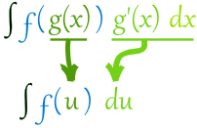

Then we may integrate f(u) and end by turning g(x).

**Application of derivatives**