**Question - 1 )**

SoundHound, Internet telephony, 3D movie

**Question -2 )**

* People = Ross Cutler, Yong Rui, Anoop Gupta, JJ Cadiz, Ivan Tashev, Li-wei He, Alex Colburn, Zhengyou Zhang, Zicheng Liu, Steve Silverberg
* Place = Microsoft Research One Microsoft Way, Redmond, WA, USA

**Question -3)**

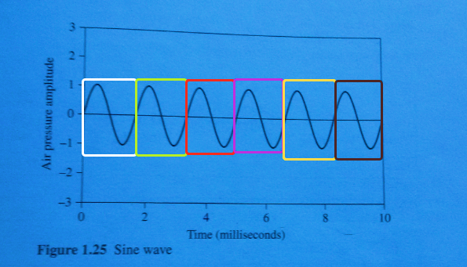

10 ms = 6 repeat

f = 6 * 100 = 600 Hz

w = 2 * pi * f = 2 * pi * 600 = 1200 * pi

y(t) = sin(wt) = sin(1200 * pi * t) angular frequency

**Question -4)**

This is a quantization problem because when we try to sample image we pased some color point on the scale and we miss some part.

**Question -5)**

Green is brighter to the eye than the color with more blue and red. This weighting is required because we see green well, much better than we see red and blue, and we also see red well than blue. That number comes closest color for real color that calculate with testing.