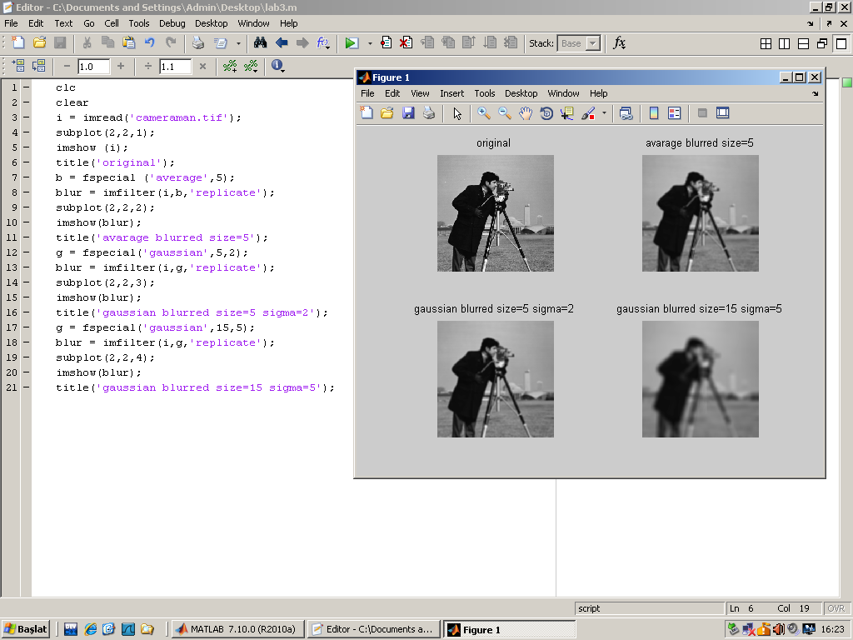

clc
clear
i = imread('cameraman.tif');
subplot(2,2,1);
imshow (i);
title('original');
b = fspecial ('average',5);
blur = imfilter(i,b,'replicate');
subplot(2,2,2);
imshow(blur);
title('avarage blurred size=5');
g = fspecial('gaussian',5,2);
blur = imfilter(i,g,'replicate');
subplot(2,2,3);
imshow(blur);
title('gaussian blurred size=5 sigma=2');
g = fspecial('gaussian',15,5);
blur = imfilter(i,g,'replicate');
subplot(2,2,4);
imshow(blur);
title('gaussian blurred size=15 sigma=5');
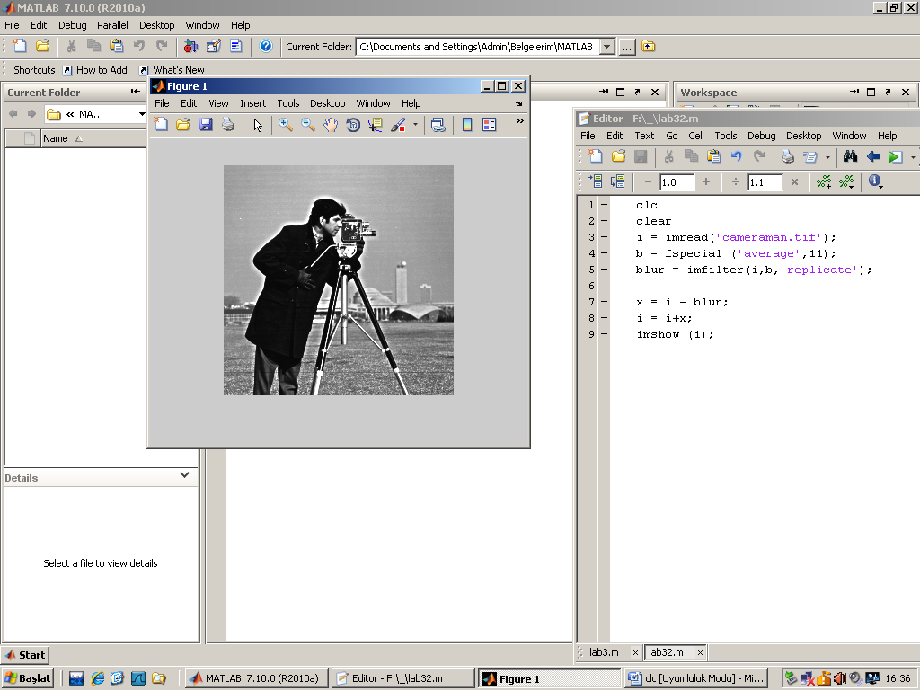

clc
clear
i = imread('cameraman.tif');
b = fspecial ('average',11);
blur = imfilter(i,b,'replicate');

x = i - blur;
i = i+x;
imshow (i);

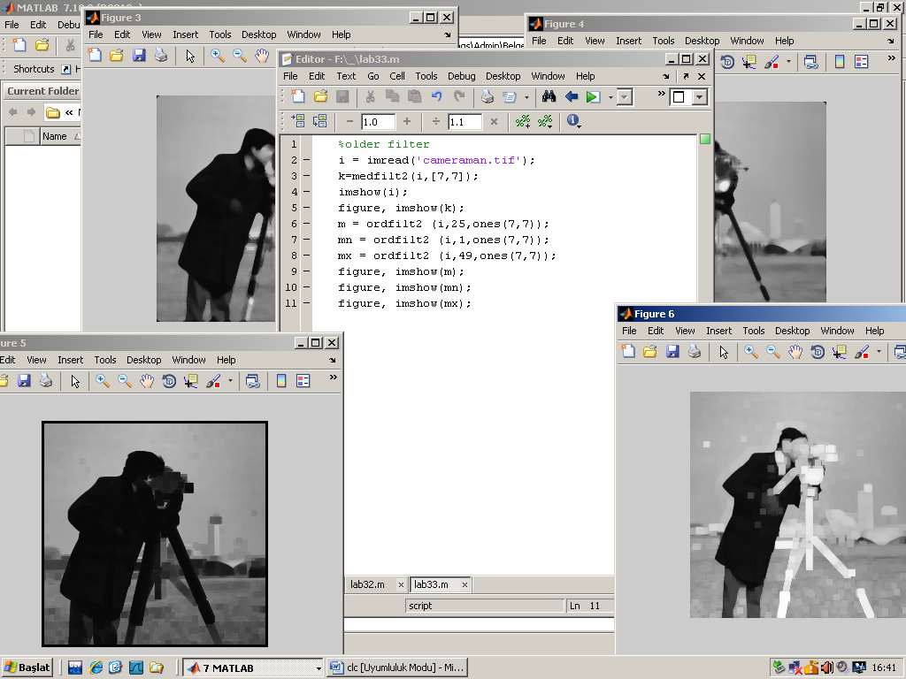
%older filter
i = imread('cameraman.tif');
k=medfilt2(i,[7,7]);
imshow(i);
figure, imshow(k);
m = ordfilt2 (i,25,ones(7,7));
mn = ordfilt2 (i,1,ones(7,7));
mx = ordfilt2 (i,49,ones(7,7));
figure, imshow(m);
figure, imshow(mn);
figure, imshow(mx);

