Başkent University

Department of Electrical and Electronics Engineering

EEM 214 Electronics I

Experiment 2

Diode Characteristics

Aim:

The aim of this experiment is to investigate the i-v characteristics of diode.

Theory:

The diode is a device formed from a junction of n-type and p-type semiconductor material. The lead connected to the p-type material is called the anode and the lead connected to the n-type material is the cathode. In general, the cathode of a diode is marked by a solid line on the diode.
The pn junction diode is the electronic equivalent of a mechanical check valve, it permits current flow in one direction in a circuit, but prevents movement of current in the opposite direction.
The current(i_{D}) in the diode is determined by the voltage(v_{D}) applied across the diode terminals, and the diode is shown with voltage applied in Fig.1a. The relationship between the current in the diode and the voltage applied to diode is called the i-v characteristics of diode and graph of i-v characteristics of pn junction diode is shown in Fig.1b.The pn junction diode’s i-v characteristics is not linear as seen from its graph. As the voltage increases above zero, the current remains nearly zero until the voltage v_{D} exceeds approximately 0.5 to 0.7. At this point diode current increases rapidly and the voltage across the diode becomes almost independent of current. The voltage required to bring the diode into significant conduction is called turn on voltage of diode. As the voltage decrease below zero(reverse voltage increases), diode eventually enters the reverse bias region. The current in reverse bias region is not actually zero but it reaches a limiting very small value labeled as I_{s} which is the saturation current. Further increase in the reverse voltage can result in damage to the diode.
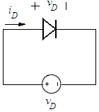
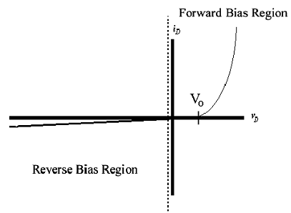

a)

b)

figure_1 a) pn junction diode with applied voltage v_{D}
b) i-v characteristics of pn junction diode
The mathematical model for i-v characteristics of pn junction diode:

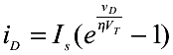

- I_{s} is called the reverse saturation current and its value is constant for a specific diode. Usually this a very small value of current since virtually no current flows in the reverse direction.

- n is another constant whose value ranges from 1 to 2 depending on the material of the semiconductor diode.

- V_{T} is the thermal equivalent voltage. It is equal to kT/q where k is the Boltzman’s constant (1.38E-23 J/K), T is the temperature in Kelvins and q is the basic electronic charge (1.6E-19 C). The value of V_{T} at the room temperature is usually taken as 26mV.
- v_{D} is the applied voltage between the terminals of the diode.

- i_{D} is the diode current.

There are two operation regions for diode which are forward and reverse bias. The zero bias condition, with v_{D} = 0V, represents the boundary between the forward and reverse bias regions.
For v_{D}<0, diode is operating under reverse bias. Only a very small reverse leakage current flows through the diode. This current is small enough that we usually think of the diode as being in the non-conducting or off state when it is reverse biased. The mathematical model for i-v characteristics of pn junction diode for reverse bias condition reduces to

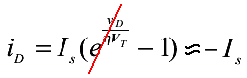

For v_{D}>0, the diode is operating under forward bias, and a large current can be present in the diode. The mathematical model for i-v characteristics of pn junction diode for forward bias condition reduces to

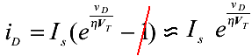

Diode Equivalent Models

Diodes can be modeled as follows;

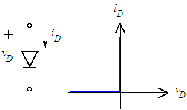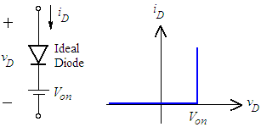

figure_2 i-v characteristics of ideal diode figure_3 i-v characteristics of constant
voltage drop model of diode

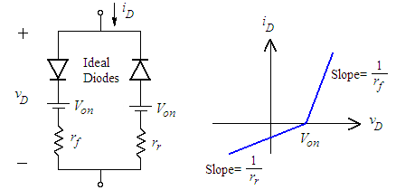
figure_4 i-v characteristics of
piecewise linear model of diode

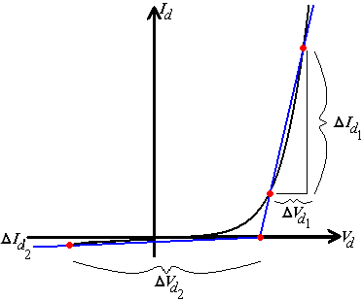

r_{f} = average resistance of the diode
when the conduction is establish
(bulk resistance)
r_{r} = average resistance of the diode
when the non-conduction is establish

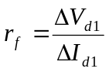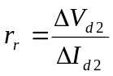

Figure_5 Defining the piecewise linear equivalent circuit using straight-line segments to approximate the characteristic curve

Preliminary Work:

- Review sections 3.2, 3.3, 3.4 from the text book.

- a. The reverse saturation current I_{s} of a pn junction diode is given to be 10⁻¹⁵ A at room temperature and use n = 1. Calculate and plot i-v characteristics of diode by using mathematical model of diode. (Calculate i_{D} for v_{D} = -0.4, -0.2, 0, 0.1, 0.2, 0.3, 0.4, 0.5, 0.6, 0.65, 0.7, 0.75, 0.8, 0.85 volts ).

b. Simulate the circuit in Fig.6a amplifier using PSPICE. Generate a graph of diode voltage versus diode current(i-v characteristics of diode), where V_{in} ranges between -10V and 3V, R = 220Ω and use D1N4148. (Use DC Sweep Analysis for this purpose. )

- Determine the piecewise linear model parameters for this diode, r_{f}, r_{r}, V₀, using the i-v plot which you find at 2.a.

- a. For the circuit in Fig.6b, draw the input and output waveforms (explain briefly how you obtain), assuming constant voltage drop model of diode, v_{in}(t)=10sin(200πt) and R_{L}=1k. What is the circuit used for?

  - Simulate the circuit using PSPICE using 20V peak-to-peak at a frequency of 100 Hz sinusoidal signal and obtain the input(v_{in}) and output(v_{out}) voltage waveforms. Check your drawing with the simulation.

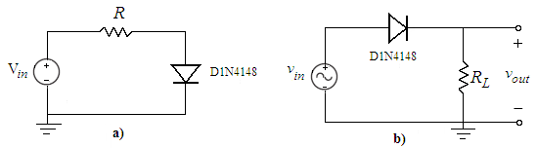
figure_6

- Read the experimental work.

Experimental Work:

- A quick way of determining whether a diode is defective or not, is to use an DMM. Every DMM has diode check function. An internal voltage source of DMM provides current for voltage reading. To select the diode check function, push the button on function scale of DMM.

When the diode is connected in Fig.7a, so that it is forward biased, forward current flow is established and a good diode will produce a voltage(forward voltage drop) reading on the display which is between 0.500 to 0.900 for silicon diode.

When the diode connected in Fig.7b, so that it is reversed biased. If the diode under the test is good, “000.0” will be flickered.

Check whether the diode is good or defective and record the values displayed.

 | Forward Biased | Reverse Biased
V_{diode}

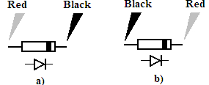
figure_7

- Setup the circuit in Fig.6a with R=220Ω, to obtain the forward i–v characteristics of diode. Increase the voltage on the power supply until the voltage across the diode indicates .35 volts. Record the voltage across the diode and diode current. Continue increasing the voltage across the diode in .05 volt increments(by increasing supply voltage) and measure and record the current for the values shown in following table.

Diode Volts | Diode Volts (measured) | Current
.35
.40
.45
.50
.55
.60
.65
.70
.75
.80
.85
.90
- Consider the circuit in Fig.6a, change series resistor to 1ΜΩ to obtain the reverse i–v characteristics of diode. At very low current, it is often better to measure the voltage across a known resistor than to attempt a direct current measurement. Measure and record the voltage across the resistor and calculate diode current and voltage obtained for the source voltage values shown in following table. Note all values are negative.

Source Voltage | Silicon Diode 1N4148
Source Voltage | V_{resistor}(measured) | V_{diode}(calculated) | I_{diode}(calculated)
0
-1
-2
-3
-4
-5
-10
-15
-20
-25

- Plot the i-v characteristics of diode in millimetric paper. Clearly indicate the regions. You are free to use Excel.

- Setup the circuit in Fig.6b. Set the input voltage signal to a sinusoid with 100 Hz frequency and 5V peak-to-peak amplitude with R_{L}=1k. Observe the input and output voltage waveforms on the oscilloscope and plot them. Explain briefly the differences between v_{in} and v_{out}.

v_{in&} v_{out}

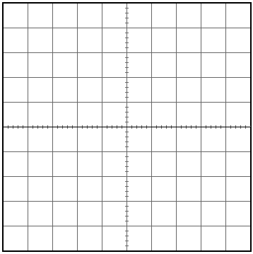

Lab Instruments:  Breadboard  Oscilloscope  Signal Generator  Multimeter  DC Power Supply | Components:  1 220Ω  1 1N4148  1 1MΩ  1 1kΩ

...............................………………………………………………………………..

Experiment Results

Part1 | V_{diode} = (forward)  V_{diode} = (reversed)

Diode Volts | Diode Volts (measured) | Current
.35
.40
.45
.50
.55
.60
.65
.70
.75
.80
.85
.90
Source Voltage | Silicon Diode 1N4148
Source Voltage | V_{resistor} (measured) | V_{diode} (calculated) | I_{diode} (calculated)
0
-1
-2
-3
-4
-5
-10
-15
-20
-25

Student Name :

Number :

Signature…………….………….

