EEM 214 Elektronik
LAB 3
Önçalışma

- Erdem Budak
20193330
EEM

1) Find the mode of the transistors (active , cut off, saturation)? If they are in active mode find the Q-poins of the transistors? (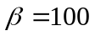 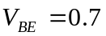)

a)

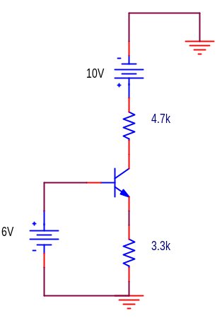
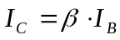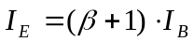

From Base – Emiter loop:

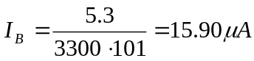

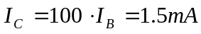

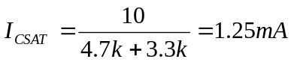

Since 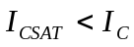 the transistor is saturating.

b)
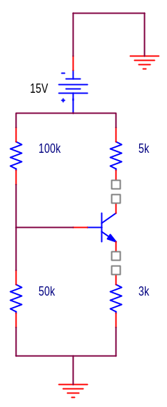

We can solve the problem using Exact method. We first convert the circuit to its equvalant and simplfy the circuit.

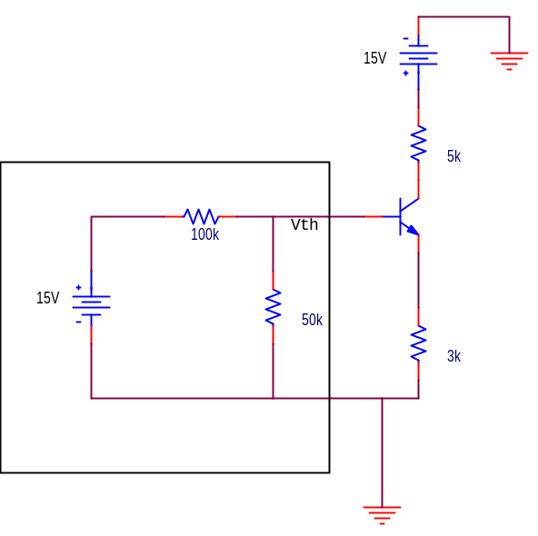
We can now find the Thevenin equvalant circuit.

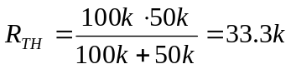

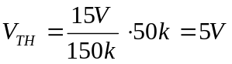

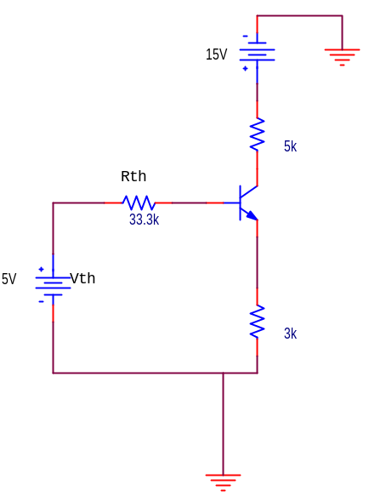

From Base – Emiter loop:

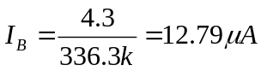

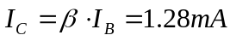

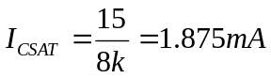

Since 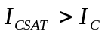 the transistor is active.

