ELEKTRIK VE ELEKTRONIK BÖLÜMÜ

EEM 214 ELEKTRONİK-1

DENEY 3

RAPOR

Part 1: Determation of the Transistor’s type, Terminals, and Material

 | Meterleads connected to BJT |  | Diode check reading  (Or highest resistance range)
Step | Positive | Negative | Diode check reading  (Or highest resistance range)
c | 1 | 2
d | 2 | 1
e | 1 | 3
f | 3 | 1
g | 2 | 3
h | 3 | 2
Table 8.1

Part 1 (i) | Base terminal
Part 1 (j) | Transistor type
Part 1 (k) | Collector terminal
Part 1 (k) | Emitter terminal
Part 1 (l) | Transistor material
Table 8.2

Part 2: The Collector characteristics
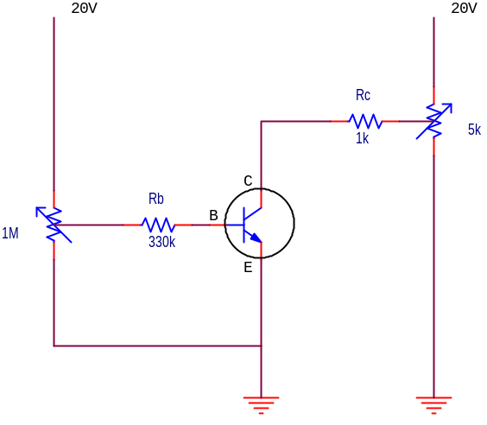
Figure 8-2 Circuit to determine characteristics of a BJT

V_{RB}  (V)  (meas) | I_{B}  (μA)  (calc) | V_{CE}  (V)  (meas) | V_{RC}  (V)  (meas) | I_{C}  (mA)  (cal) | V_{BE}  (V)  (meas) | I_{E}  (mA)  (calc) | α  (calc) | β  (calc)
3.3 | 10 | 2
3.3 | 10 | 4
3.3 | 10 | 6
3.3 | 10 | 8
3.3 | 10 | 10
3.3 | 10 | 12
3.3 | 10 | 14
3.3 | 10 | 16
6.6 | 20 | 2
6.6 | 20 | 4
6.6 | 20 | 6
6.6 | 20 | 8
6.6 | 20 | 10
6.6 | 20 | 12
6.6 | 20 | 14
9.9 | 30 | 2
9.9 | 30 | 4
9.9 | 30 | 6
9.9 | 30 | 8
9.9 | 30 | 10
13.2 | 40 | 2
13.2 | 40 | 4
13.2 | 40 | 6
13.2 | 40 | 8
16.5 | 50 | 2
16.5 | 50 | 4
16.5 | 50 | 6
Table 8.3 Data for Construction of Transistor Collector Curve
and Calculations of Transistor Parameters

Exercises

1-) (calculated) β(average) =
2-) (calculated) V_{BE} (average) =

