ELECTRICAL&ELECTRONICS ENGINEERING DEPARTMENT

EEM 214 ELECTRONICS

EXPERIMENT- 4

JFET Bias Circuits

Objective
To analyze the fixed and voltage-divider bias JFET networks.

Preliminary Work

1- Find R2 to set V_{DQ} = 6 V. (I_{DSS} = 4.5 mA , V_{P} = -6 V )

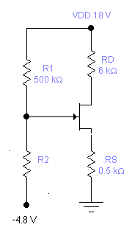

2- Find V_{DQ,} V_{CQ} and the mode of the transistors ? ( I_{DSS} = 12 mA , V_{P} = -6 V, V_{BE} = 0.6V, β= 180 )

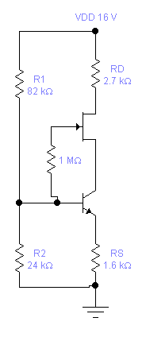

Experimental Work

Part-1 Fixed-Bias Network

For the fixed-bias configuration, V_{GS} will be set by an independent dc supply.

- Costruct the network of Figure-1.Insert the measured value of R_{D}.

- Set V_{GS} to zero volts and measure the voltage V_{RD} . Calculate I_{D} from I_{D} = V_{RD} / R_{D} using the measured value of R_{D} .Since V_{GS} = 0 V the resulting drain current is the saturation value I_{DSS} .Record the value.

- Make V_{GS} more and more negative until V_{RD} =1 mV (and I_{D} =1μA). Since I_{D} is very small (I_{D} = 0 A), the resulting value of V_{GS} is the pinch of voltage V_{P} .Record the value.

- Using the values above for I_{DSS} and V_{P} , sketch the transfer curve ( I_{D} vs V_{GS} ).

- If V_{GS} = -1 V, determine I_{DQ} from the curve that you sketched. Show all work in your sketch.

(calculated) I_{DQ} = -------

- Set V_{GS} = -1 V in the network and measure V_{RD} . Calculate I_{DQ} using the measured
value of R_{D} and insert below.This is the measured value of I_{D} .

(measured) V_{RD} = -----------
(from measured) I_{DQ} = ---------

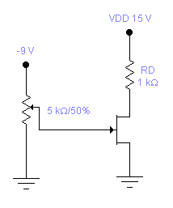

Figure-1

g- Compare the measured and calculated values of I_{DQ} .

Part-2 Voltage-Divider Bias Network

In the voltage-divider-bias configuration V_{GS} is determined by a voltage-divider-bias voltage and voltage drop across the source resistance. That is, for the network of Figure-2,

V_{G} = R₂ . V_{DD} / (R₁ + R₂ )

and

V_{GS} = V_{G} - I_{D} . R_{S}

- Construct the network of Figure-2.Insert the measured resistor values.

- Using the I_{DSS} and V_{P} determined in Part-1, draw the voltage-divider-bias line in your sketch and find the network Q point. Label the resulting straight line as the voltage-divider line.
To draw the bias line determine two points and then connect the two points with a straight line.

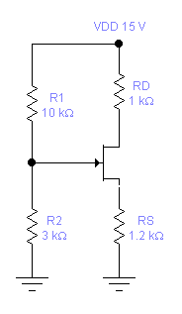

Figure-2

- Calculate the Q- points of the network ( I_{DQ} , V_{GSQ} )
- Calculate the theoretical values of V_{D}, V_{S} and V_{DS} and record the values.
- Measure the voltages V_{GSQ} , V_{D}, V_{S} and V_{DS} and record the values.
- Calculate the percent difference between the calculated and the measured values using the equation below.

% difference= 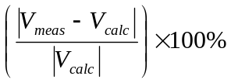

- Calculate I_{DQ} from the measured voltages of step e and compare to the value determined in step c.
I_{DQ} can be found using

I_{DQ} = ( V_{DD} - V_{D} ) / R_{D}

and the measured values of V_{D} and R_{D} . Record the value and calculate the % difference.

