ELECTRICAL&ELECTRONICS ENGINEERING DEPARTMENT

EEM 214 ELECTRONICS

EXPERIMENT- 4

JFET Bias Circuits

RAPOR

Hazırlayan: A. Erdem Budak
20193330
EEM

Objective
To analyze the fixed and voltage-divider bias JFET networks.

Part-1 Fixed-Bias Network

For the fixed-bias configuration, V_{GS} will be set by an independent dc supply.

- Costruct the network of Figure-1.Insert the measured value of R_{D}.

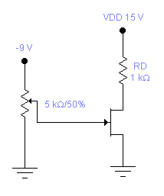
Figure-1
- Set V_{GS} to zero volts and measure the voltage V_{RD} . Calculate I_{D} from I_{D} = V_{RD} / R_{D} using the measured value of R_{D} .Since V_{GS} = 0 V the resulting drain current is the saturation value I_{DSS} .Record the value.

V_{RD} = 14.48 V
I_{D} = V_{RD} / R_{D} = I_{DSS} = 14.48 mA

- Make V_{GS} more and more negative until V_{RD} =1 mV (and I_{D} =1μA). Since I_{D} is very small (I_{D} = 0 A), the resulting value of V_{GS} is the pinch of voltage V_{P} .Record the value.

V_{P} = -3.6 V
- Using the values above for I_{DSS} and V_{P} , sketch the transfer curve ( I_{D} vs V_{GS} ).

V_{P} = -3.6 V , I_{DSS} = 14.48 mA

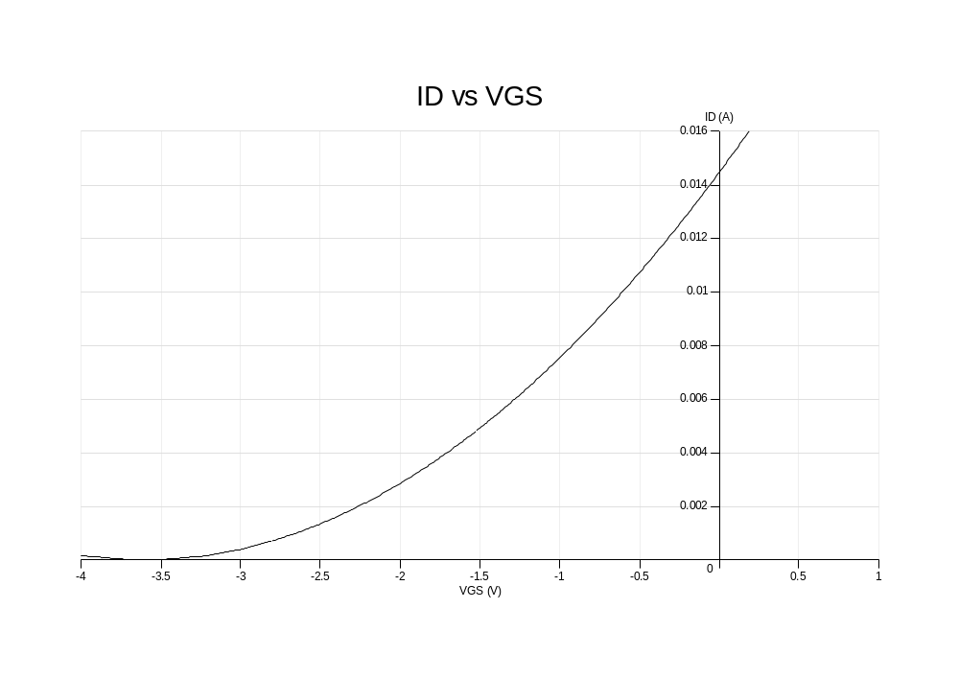
- If V_{GS} = -1 V, determine I_{DQ} from the curve that you sketched. Show all work in your sketch.
(calculated) I_{DQ} = 10.40 mA

- Set V_{GS} = -1 V in the network and measure V_{RD} . Calculate I_{DQ} using the measured
value of R_{D} and insert below.This is the measured value of I_{D} .
(measured) V_{RD} = 13.40 V
(from measured) I_{DQ} = 13.40mA

- Compare the measured and calculated values of I_{DQ} .

(from measured) I_{DQ} = 13.40mA - (calculated) I_{DQ} = 10.40 mA
Part-2 Voltage-Divider Bias Network

In the voltage-divider-bias configuration V_{GS} is determined by a voltage-divider-bias voltage and voltage drop across the source resistance. That is, for the network of Figure-2,

V_{G} = R₂ . V_{DD} / (R₁ + R₂ )

and

V_{GS} = V_{G} - I_{D} . R_{S}

- Construct the network of Figure-2.Insert the measured resistor values.

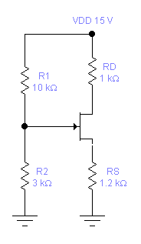

- Using the I_{DSS} and V_{P} determined in Part-1, draw the voltage-divider-bias line in your sketch and find the network Q point. Label the resulting straight line as the voltage-divider line.
To draw the bias line determine two points and then connect the two points with a straight line.
- Calculate the Q- points of the network ( I_{DQ} , V_{GSQ} )

V_{G} = 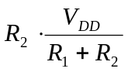 = 3.46V
V_{G} = 3.46V (calc)

V_{GS} = V_{G} - I_{D} . R_{S}
= 3.46 – 1200 . I_{D}
= 3.46 – 1200 . 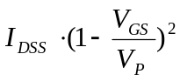
= 3.46 – 1200 . 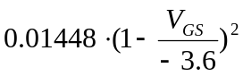
V_{GS} = -1.648 V (calc)

I_{DQ} =
I_{DQ} = 4.25 mA (calc)

- Calculate the theoretical values of V_{D}, V_{S} and V_{DS} and record the values.

V_{D} = 15 - I_{DQ}*1000 = 10.75 V (calc)
V_{S} = I_{DQ} * 1200 = 5.1 V (calc)
V_{DS} = V_{D} - V_{S} = 5.65 V (calc)

- Measure the voltages V_{GSQ} , V_{D}, V_{S} and V_{DS} and record the values.

V_{GSQ} = -1.736 (meas)
V_{D} = 10.685 (meas)
V_{S} = 5.321 (meas)
V_{DS} = 5.364 (meas)

- Calculate the percent difference between the calculated and the measured values using the equation below.

% difference= 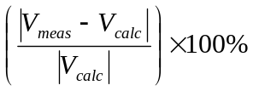

 | calculated | measured | %difference
V_{GSQ} | -1.648 | -1.736 | %5.34
V_{D} | 10.75 | 10.685 | %0.60
V_{S} | 5.1 | 5.321 | %4.33
V_{DS} | 5.65 | 5.364 | %5.06

- Calculate I_{DQ} from the measured voltages of step e and compare to the value determined in step c.
I_{DQ} can be found using

I_{DQ} = ( V_{DD} - V_{D} ) / R_{D}

I_{DQ} = (15-10.685)/1000 = 4.315 mA

and the measured values of V_{D} and R_{D} . Record the value and calculate the % difference.

%difference = 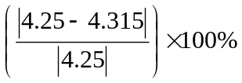= %1.52

