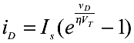
2)

We calculated voltage values by using this formula:

VD = -0.4 → ID = A
VD = -0.2 → ID = 4.56 . 10^-19 A
VD = 0 → ID = 10^-15 A
VD = 0.1 → ID = 4.68 . 10^-14 A
VD = 0.2 → ID = 2.19 . 10^-12 A
VD = 0.3 → ID = 1.02 . 10^-10 A
VD = 0.4 → ID = 4.80 . 10^-9 A
VD = 0.5 → ID = 2.24 . 10^-7 A
VD = 0.6 → ID = 1.05 . 10^-5 A
VD = 0.65 → ID = 7.20 . 10^-5 A
VD = 0.7 → ID = 4.92 . 10^-4 A
VD = 0.75 → ID = 3.37 . 10^-3 A
VD = 0.8 → ID = 0.023 A
VD = 0.85 → ID = 0.1577 A

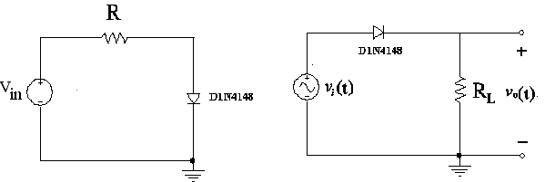

The PSPICE output of the circuit is shown in figure 1.

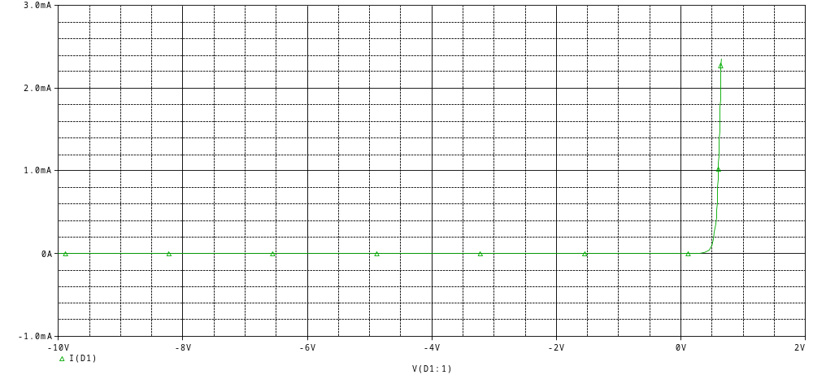

Figure 1

3) 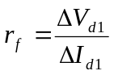 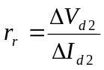

We will find rf and rr.

∆Vd1 = 0.8-0.85 = 0.1 → rf = 0.1 / -0.134 = 0.746 ohm (–) Because of the
∆Id1 = 0.023- 0.157 = -0.134 → current’s direction.

∆Vd1 = 0- (-0.4) = 0.4
∆Id1 = (10^-15 )- (2.08 . 10^-22 ) = 9.99 . 10 ^-16
rr = 0.4 / 9.99 . 10 ^-16 = 4.0 . 10 ^14

4)

The PSPICE output of the circuit is shown in figure 2.

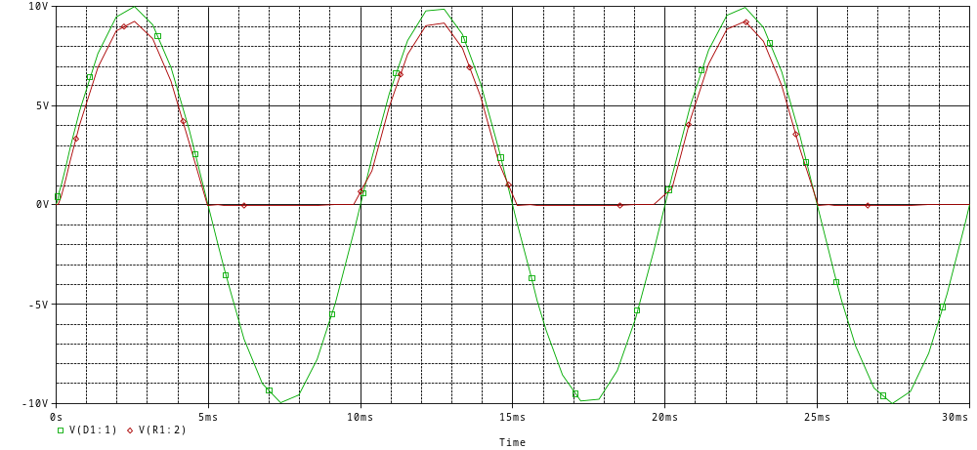
Figure 2



BAŞKENT UNIVERSITY
ELECTRIC & ELECTRONICS ENGINEERING

EEM 214 ~ ELECTRONICS–I
LABORATORY
PRELIMINARY WORK

Experiment Name : Diode Characteristics
Experiment Number : 2

Student Name : Buğra BAYRAM
Student Number :20193272
Section Number : | Experiment Day:

