- We connected one of the DMM as Ohmmeter and the other DMM as Voltmeter that shown in figure 7.Then reset the ohmmeter to the 2k renge and voltmeter 2v range, measure the voltage across the diode and the resistance.

Forward Biased |  | Reverse Biased
V_{diode} | Resistance | V_{diode} | Resistance
619mV | 6443Ω | 3.30 V | -

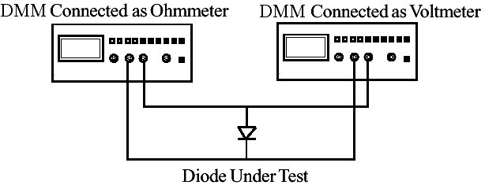

figure_7

- Values of the circuit in 6 a with R=220 Ω are shown in table 2:

Diode Volts | Current in mA 1N4148
.35 | 3,50 microA
.40 | 8,34 microA
.45 | 19,23 microA
.50 | 41,63 microA
.55 | 72,15 microA
.60 | 153,34 microA
.65 | 1.1334 mA
.70 | 4,942 mA
.75 | 11,43 mA
.80 | 24,38 mA
.85 | 48,93 mA
.90 | 95,29 mA
Table 2

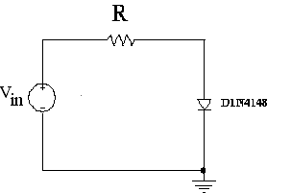

figure_6-a

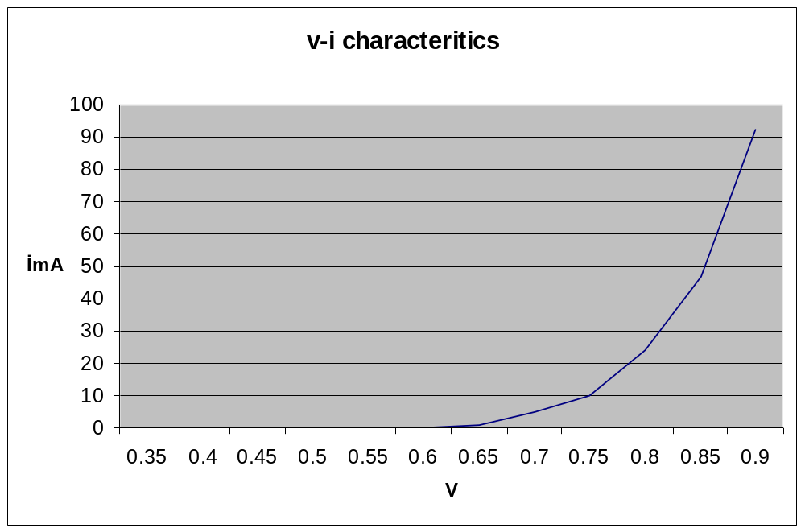

3)

Table 3
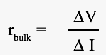
Silicon Diode 1N4148
I_{f} | V_{f} | r_{f}
40mA | 0.869V V | 7 Ω
50mA | 0.905V | 7 Ω

Calculation of the ΔV and ΔI then rbulk :

ΔV = 0.905 – 0.869 = 0.036V
ΔI = 50 – 40 = 10 mA
Rbulk = 0.036 / 10mA = 3,6 Ω

- Values of the circuit in 6 a with R=1 M Ω are shown in table 4:

Source Voltage | Silicon Diode 1N4148
Source Voltage | V_{resistor}(measured) | I_{diode}(calculated)
0 | 1.40mV | 1.40 mA
-1 | 1.93 mV | 1.93 mA
-2 | 2.24 mV | 2.24 mA
-3 | 2.52 mV | 2.52 mA
-4 | 2.55 mV | 2.55 mA
-5 | 2.64 mV | 2.64 mA
-10 | 3.16 mV | 3.16 mA
-15 | 3.63 mV | 3.63 mA
-20 | 3.77 mV | 3.77 mA
-25 | 3.89 mV | 3.89 mA
Table 4

5)
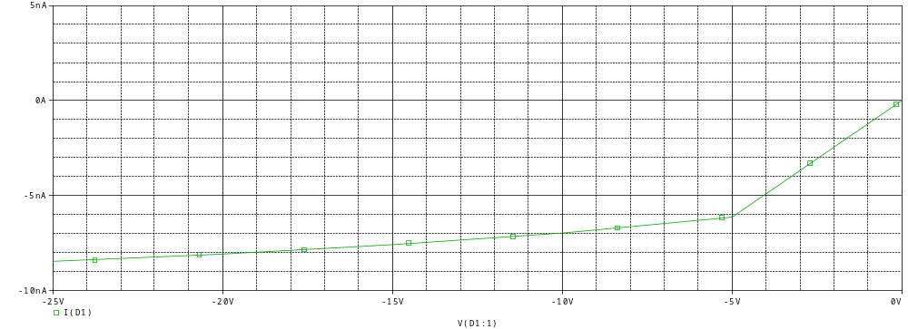
İ-V characteristics



BAŞKENT UNIVERSITY
ELECTRIC & ELECTRONICS ENGINEERING

EEM 214 ~ ELECTRONICS–I
LABORATORY
REPORT

Experiment Name : Diode Characteristics
Experiment Number : 2

Student Name : Buğra BAYRAM
Student Number :20193272
Section Number : | Experiment Day:

