Başkent University

Department of Electrical and Electronics Engineering

EEM 214 Electronics I

Experiment 3

Zener Diode Characteristics & Zener Diode Voltage Regulator

Aim:

The aim of this experiment is investigate the i-v characteristics of zener diodes and application of zener diode for voltage regulation.

Theory:

A zener diode is a special type of diode where the diode has been optimized for operation in the reverse or avalanche region which is shown in Fig.2. This is completely the opposite of normal diodes or rectifiers where every effort is made to keep the diode from breaking down in the reverse direction. The break-down voltage can be well controlled and yields a device which exhibits a constant breakdown voltage over a wide range of currents. In the forward direction, the zener diode acts as a normal forward biased diode.
Consider the i-v characteristics in the breakdown region ; it is observed that current greater than the knee current I_{ZK}, the i-v characteristic is almost a straight line. The zener voltage(voltage across the zener ) is usually specified at test current I_{ZT}. Thus for example, 6.8 V zener diode will exhibit a 6.8 V drop at a specified test current of, say, 10mA. As the current through the zener deviates from I_{ZT}, the voltage across it will change, though slightly. Fig.2 shows that corresponding to current change ∆I the zener voltage changes by ∆V, which is related to ∆I by ∆V=r_{z} ∆I where r_{z} is the inverse of the slope of the almost linear curve at point Q. Resistance r_{z} is the incremental resistance of the zener diode at operating point Q. It is also known as the dynamic resistance of the zener, and its value is specified on device data sheet. Typically, r_{z} is in the range of a few ohms to a few tens of ohms. Obviously, the lower the value of r_{z} is, the more constant the zener voltage remains as its current varies and thus the more ideal its performance becomes. In this regard, it is observed from Fig.2 that while r_{z} remains low and almost constant over a wide range of current, its value increases considerably operating the zener in this low-current region.
Zener diodes are fabricated with voltages V_{Z} in the range of a few volts to a few hundred volts. In addition to specifying V_{Z}, r_{z}, and I_{ZK}, maximum power that the device can safely dissipate is also specified.

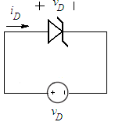
figure_1 Zener diode with applied voltage v_{D}
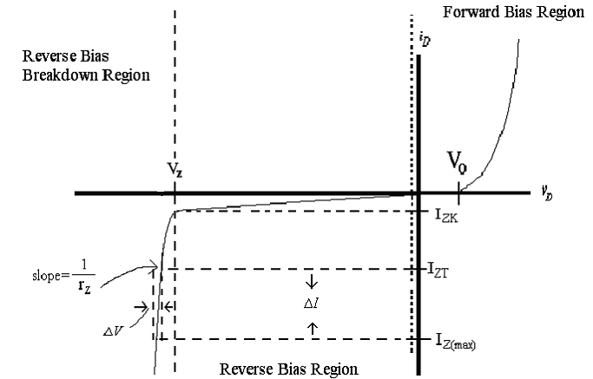

figure_2 i-v characteristics of zener diode

Zener Diode Equivalent Models

Zener diodes can be modeled as follows;

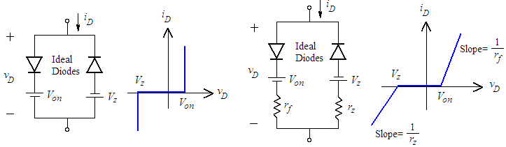
figure_3 i-v characteristics of constant
voltage drop model of zener diode
figure_4 i-v characteristics of piecewise linear model of zener diode

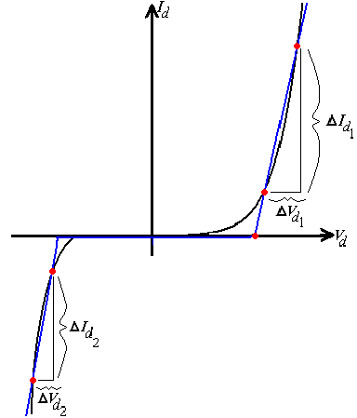
r_{f} = average resistance of the diode when the conduction is established
r_{z} = zener resistance

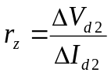
Figure_5 Defining the piecewise linear equivalent circuit using straight-line segments to approximate the characteristic curve

Zener Diode Voltage Regulator

In Fig.6, an often used Zener diode voltage regulator is shown. The function of a voltage regulator is to provide a constant low ripple output voltage under varying load current conditions. While very high quality voltage regulators are available in integrated circuits, at times it may be sufficient and convenient to use a simple Zener diode regulator. Since the Zener diode will conduct in the reverse direction for any V_{out} greater than V_{Z} , V_{out} can never exceed V_{Z}. As the load current changes, the Zener diode will conduct sufficient current to maintain a voltage drop of V_{S} – V_{out} across the series dropping resistor R_{S}. The selected Zener diode must have a reverse breakdown voltage equal to the desired output voltage and be capable of dissipating the power that results when R_{L} is very large. This type of regulator is generally not good for output voltages less than 5 volts or so because low voltage diodes with a sharp knee at reverse breakdown are not available. The difference between V_{S} and V_{out} should be selected as small as possible but must be large enough to prevent the voltage drop across R_{S} from exceeding V_{S} – V_{out}, when I_{L} is maximum. It is clear that a smaller value for R_{S} translate to a smaller value for V_{S} – V_{out}; however, a smaller value for R_{S} will result in a greater diode current when R_{L} is large and this will increase the power dissipation requirement of the diode.

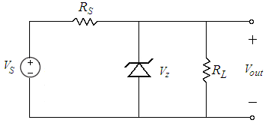
Figure_6

Two parameters can be used to measure how well the regulator is performing its function: line regulation and the load regulation. The line regulation is defined as the change in V_{out}(output voltage) corresponding to a 1-V change in V_{S} (input voltage),

and is usually expressed in mV/V. The load regulation is defined as the change in V_{out} corresponding to a 1 mA change in I_{L}(Load Current).

Preliminary Work:

- Review sections 3.6 and 3.12 from the text book.
.

- Construct the circuit in Fig.7 using PSPICE. Generate a graph of diode current versus diode voltage(i-v characteristics of zener diode), where V_{in} ranges between -20V and 10V with R=1k and 1N750 zener diode. (Simulate using DC Sweep Analysis for this purpose and don’t forget to change the axis variable.)

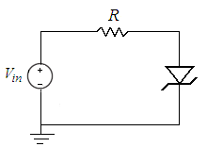
Figure_7

- Briefly describe the difference between a Zener diode and a standard diode.

- Consider the circuit in Fig.6, zener diode is specified to has 6.8V voltage drop at I_{ZT} = 5mA, r_{z} = 20Ω, and I_{ZK} = 0.2mA. The supply voltage V_{S} is nominally 10V but can vary ±1V.

a) Find V_{Z}.

b) Find V_{out} with no load and with V_{S} =10V, R_{S} = 0.5kΩ.

c) Find the change in V_{out} resulting from the ±1V change in V_{S} .

d) Find the change in V_{out} resulting from connecting a load resistance R_{L}=2kΩ

e) Find the value of V_{out} when R_{L}=0.5kΩ

f) What is the minimum value of R_{L} for which diode still operates in breakdown region?

- Read the experimental work.

Experimental Work:

Part I Zener Diode Test

A zener diode can be checked for functionality using a DMM. This is because the voltage supplied by the DMM is less than 3 volts and (provided that the zener voltage is greater than 3 volts) the zener acts as a normal diode in the forward direction. In the reverse direction, the zener does not reach the avalanche point and looks high resistance. To select the diode check function, push the button on function scale of DMM.

- When zener the diode is connected in Fig.8a, so that it is forward biased, forward current flow is established and a good zener diode will produce a voltage(forward voltage drop) reading on the display which is between 0.500 to 0.900 for zener diode(silicon diode).

When the zener diode connected in Fig.8b, so that it is reversed biased. If the zener diode under the test is good, “000.0” will be flickered.

Check whether the diode is good or defective and record the values displayed.

 | Forward Biased | Reverse Biased
V_{diode}

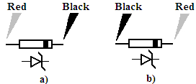
Figure_8

Part II Forward & Reverse Characteristics of Zener Diode

- Setup the circuit in Fig.7 with R = 330Ω and BZX55C(6.2V) zener diode, to obtain the forward i–v characteristics of diode. Increase the voltage on power supply until the voltage across the diode indicates .35 volts. Record voltage across the diode and diode current. Continue increasing the voltage across the diode(by increasing supply voltage) and measure and record the current for the voltage values shown in following table.

Diode Volts | Diode Volts  (mesured) | Current in mA BZX55C (measured)
.35
.45
.55
.60
.65
.70
.75
.80
- Consider the circuit that you construct at previous step. Reverse the zener diode and measure the voltages and currents obtained for the voltage values shown in following table.

V_{applied} in Volts | V_{zener} in Volts  (measured) | I_{zener} in mA  (measured)
3.5
4
4.5
5
5.5
6
6.5
7
7.5
8
9
10
11
12
13
14
15

- Plot the i-v characteristics of zener diode in millimetric paper. Clearly indicate the regions. You are free to use Excel.

Part III Zener Regulator

- Construct the circuit below, with the Zener diode BZX55C (6.2 V) and R_{S} = 390Ω.
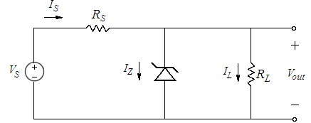
Figure_9

- Measure and record V_{out} after it has stabilized for V_{S} = 12 V_{DC} then repeat for V_{S} = 8 V_{DC}.
a) with R_{L} = 820Ω b) with R_{L} = 330Ω

- a) Repeat steps 1 and 2 with R_{S} = 620Ω.
b) Repeat steps 1 and 2 with R_{S} = 100Ω.

 | V_{out}
 | V_{S} = 12 |  | V_{S} = 8
 | R_{L} = 820 Ω | R_{L} = 330 Ω | R_{L} = 820 Ω | R_{L} = 330 Ω
R_{S} = 620 Ω
R_{S} = 390 Ω
R_{S} = 100 Ω

- For each value of V_{S}, calculate I_{L} and I_{Z} for each of the 12 combinations of resistors (R_{S} and R_{L}).

- For each of the values of R_{S}, calculate the line regulation for R_{L} = 330Ω and then for R_{L} = 820Ω.

- For each of the values of R_{S}, calculate the load regulation for V_{S} = 12 V_{DC} and then for V_{S} = 8 V_{DC}.
Remember you will have the maximum load current flowing through the minimum resistance and the minimum current through the maximum resistance.

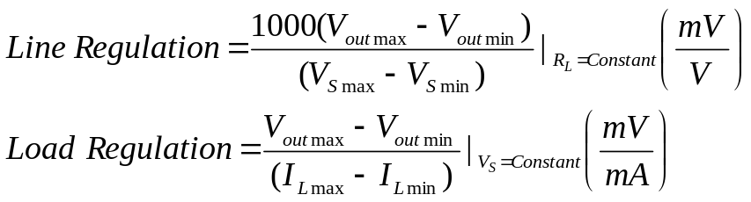

- Check the results for cases where the zener diode drops out of regulation. That is I_{Z} goes to zero or close to zero so the diode is no longer on the steep part of the reverse breakdown curve. In this case the output voltage depends on the value of V_{S}, R_{S}, and R_{L} and not on V_{Z}. Comment on the results.

- Calculate P_{Z} and P_{Rs} for each of the 12 sets of data. Compare the results to the maximum power rating of the components.

- What voltage do you expect would be across the Zener diode if it was accidentally reversed in the voltage regulator circuit?

- Which value of R_{S} gives the best overall regulation operation? Explain why the regulation is worse at the other values of R_{S}.

Lab Instruments:  Breadboard  Multimeter  DC Power Supply | Components:  1 BZX55C 6.2 V  1 100Ω  1 390Ω 1 620Ω  1 330 Ω 1 820Ω

...............................………………………………………………………………......................................................

Experiment Results
Diode Volts | Diode Volts  (mesured) | Current in mA BZX55C (measured)
.35
.45
.55
.60
.65
.70
.75
.80
V_{applied} in Volts | V_{zener} in Volts  (measured) | I_{zener} in mA  (measured)
3.5
4
4.5
5
5.5
6
6.5
7
7.5
8
9
10
11
12
13
14
15

 | V_{out}
 | V_{S} = 12 |  | V_{S} = 8
 | R_{L} = 820 Ω | R_{L} = 330 Ω | R_{L} = 820 Ω | R_{L} = 330 Ω
R_{S} = 620 Ω
R_{S} = 390 Ω
R_{S} = 100 Ω

Student Name :

Number :

Signature…………….………….

