Başkent University
Department of Electrical and Electronics Engineering
EEM 214 Electronics I Experiment 5

Zener Diode Characteristics & Zener Diode Voltage Regulator

Aim:

The aim of this experiment is investigate the i-v characteristics of zener diodes and application of zener diode for voltage regulation.

Theory:

A zener diode is a special type of diode where the diode has been optimized for operation in the reverse or avalanche region which is shown in Fig.2. This is completely the opposite of normal diodes or rectifiers where every effort is made to keep the diode from breaking down in the reverse direction. The break-down voltage can be well controlled and yields a device which exhibits a constant breakdown voltage over a wide range of currents. In the forward direction, the zener diode acts as a normal forward biased diode.
Consider the i-v characteristics in the breakdown region ; it is observed that current greater than the knee current IZK, the i-v characteristic is almost a straight line. The zener voltage(voltage across the zener ) is usually specified at test current IZT. Thus for example,
6.8 V zener diode will exhibit a 6.8 V drop at a specified test current of, say, 10mA. As the current through the zener deviates from IZT, the voltage across it will change, though slightly. Fig.2 shows that corresponding to current change ∆I the zener voltage changes by
∆V, which is related to ∆I by ∆V=rz ∆I where rz is the inverse of the slope of the almost linear curve at point Q. Resistance rz is the incremental resistance of the zener diode at operating point Q. It is also known as the dynamic resistance of the zener, and its value is specified on device data sheet. Typically, rz is in the range of a few ohms to a few tens of ohms. Obviously, the lower the value of rz is, the more constant the zener voltage remains as its current varies and thus the more ideal its performance becomes. In this regard, it is observed from Fig.2 that while rz remains low and almost constant over a wide range of current, its value increases considerably operating the zener in this low-current region.
Zener diodes are fabricated with voltages VZ in the range of a few volts to a few hundred volts. In addition to specifying VZ, rz, and IZK, maximum power that the device can safely dissipate is also specified.

figure_1 Zener diode with applied voltage vD
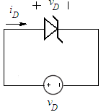

1
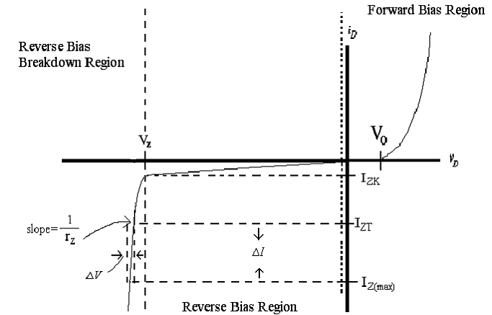

figure_2 i-v characteristics of zener diode

Zener Diode Equivalent Models

Zener diodes can be modeled as follows;

figure_3 i-v characteristics of constant voltage drop model of zener diode

figure_4 i-v characteristics of piecewise linear model of zener diode

rf = average resistance of the diode when the conduction is established
rz = zener resistance

r = ΔVd 2
z
f
ΔI d 2
r = ΔVd 1
ΔI d 1

Figure_5 Defining the piecewise linear equivalent circuit using straight-line segments to approximate the characteristic curve

2

Zener Diode Voltage Regulator

In Fig.6, an often used Zener diode voltage regulator is shown. The function of a voltage regulator is to provide a constant low ripple output voltage under varying load current conditions. While very high quality voltage regulators are available in integrated circuits, at times it may be sufficient and convenient to use a simple Zener diode regulator. Since the Zener diode will conduct in the reverse direction for any Vout greater than VZ , Vout can never exceed VZ. As the load current changes, the Zener diode will conduct sufficient current to maintain a voltage drop of VS – Vout across the series dropping resistor RS. The selected Zener diode must have a reverse breakdown voltage equal to the desired output voltage and be capable of dissipating the power that results when RL is very large. This type of regulator is generally not good for output voltages less than 5 volts or so because low voltage diodes with a sharp knee at reverse breakdown are not available. The difference between VS and Vout should be selected as small as possible but must be large enough to prevent the voltage drop across RS from exceeding VS – Vout, when IL is maximum. It is clear that a smaller value for RS translate to a smaller value for VS – Vout; however, a smaller value for RS will result in a greater diode current when RL is large and this will increase the power dissipation requirement of the diode.

Figure_6
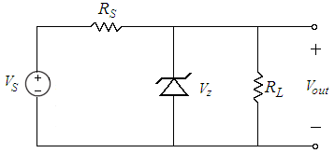

Two parameters can be used to measure how well the regulator is performing its function: line regulation and the load regulation. The line regulation is defined as the change in Vout(output voltage) corresponding to a 1-V change in VS (input voltage),

ΔV Line regulation = out
ΔVS

and is usually expressed in mV/V. The load regulation is defined as the change in Vout
corresponding to a 1 mA change in IL(Load Current).

Load
ΔV
regulation = out
ΔI L

3

Preliminary Work:

1) Review sections 3.6 and 3.12 from the text book.
.

2) Construct the circuit in Fig.7 using PSPICE. Generate a graph of diode current versus diode voltage(i-v characteristics of zener diode), where Vin ranges between -20V and
10V with R=1k and 1N750 zener diode. (Simulate using DC Sweep Analysis for this
purpose and don’t forget to change the axis variable.)

Figure_7
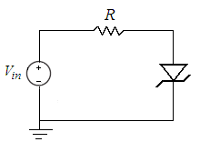

3) Briefly describe the difference between a Zener diode and a standard diode.

4) Consider the circuit in Fig.6, zener diode is specified to has 6.8V voltage drop at IZT = 5mA, rz = 20Ω, and IZK = 0.2mA. The supply voltage VS is nominally 10V but can vary ±1V.

a) Find VZ.

b) Find Vout with no load and with VS =10V, RS = 0.5kΩ.

c) Find the change in Vout resulting from the ±1V change in VS .

d) Find the change in Vout resulting from connecting a load resistance RL=2kΩ

e) Find the value of Vout when RL=0.5kΩ

f) What is the minimum value of RL for which diode still operates in breakdown region?

5) Read the experimental work.

4
Experimental Work: Part I Zener Diode Test
A zener diode can be checked for functionality using a DMM. This is because the voltage supplied by the DMM is less than 3 volts and (provided that the zener voltage is greater than 3 volts) the zener acts as a normal diode in the forward direction. In the reverse direction, the zener does not reach the avalanche point and looks high resistance. To select the diode check function, push the button on function scale of DMM.

1) When zener the diode is connected in Fig.8a, so that it is forward biased, forward current flow is established and a good zener diode will produce a voltage(forward voltage drop) reading on the display which is between 0.500 to 0.900 for zener diode(silicon diode).

When the zener diode connected in Fig.8b, so that it is reversed biased. If the zener diode under the test is good, “000.0” will be flickered.

Check whether the diode is good or defective and record the values displayed.

 | Forward Biased | Reverse Biased
Vdiode

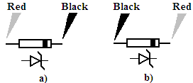
Figure_8

Part II Forward & Reverse Characteristics of Zener Diode

1) Setup the circuit in Fig.7 with R = 330Ω and BZX55C(6.2V) zener diode, to obtain the forward i–v characteristics of diode. Increase the voltage on power supply until the voltage across the diode indicates .35 volts. Record voltage across the diode and diode current. Continue increasing the voltage across the diode(by increasing supply voltage) and measure and record the current for the voltage values shown in following table.

Diode Volts | Diode Volts  (mesured) | Current in mA BZX55C (measured)
.35
.45
.55
.60
.65
.70
.75
.80

5
2) Consider the circuit that you construct at previous step. Reverse the zener diode and measure the voltages and currents obtained for the voltage values shown in following table.

Vapplied in Volts | Vzener in Volts  (measured) | Izener in mA (measured)
3.5
4
4.5
5
5.5
6
6.5
7
7.5
8
9
10
11
12
13
14
15

3) Plot the i-v characteristics of zener diode in millimetric paper. Clearly indicate the regions. You are free to use Excel.

Part III Zener Regulator

1) Construct the circuit below, with the Zener diode BZX55C (6.2 V) and RS = 390Ω.

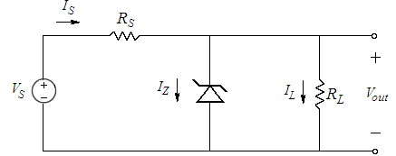
Figure_9

2) Measure and record Vout after it has stabilized for VS = 12 VDC then repeat for VS = 8
VDC.
a) with RL = 820Ω b) with RL = 330Ω

6

3) a) Repeat steps 1 and 2 with RS = 620Ω.
b) Repeat steps 1 and 2 with RS = 100Ω.

 | Vout
 | VS = 12 |  | VS = 8
 | RL = 820 Ω | RL = 330 Ω | RL = 820 Ω | RL = 330 Ω
RS = 620 Ω
RS = 390 Ω
RS = 100 Ω

4) For each value of VS, calculate IL and IZ for each of the 12 combinations of resistors
(RS and RL).

5) For each of the values of RS, calculate the line regulation for RL = 330Ω and then for
RL = 820Ω.

6) For each of the values of RS, calculate the load regulation for VS = 12 VDC and then for
VS = 8 VDC.
Remember you will have the maximum load current flowing through the minimum
resistance and the minimum current through the maximum resistance.

1000(Voutmax − Voutmin )
⎛ mV ⎞

Line Regulation =

(VS

max

− VS

min )
| R =Co n stant⎜ ⎟
L ⎝ V ⎠

Voutmax − Voutmin
⎛ mV ⎞

Load Regulation =
| V =Co n stant⎜ ⎟

(I L max − I L min )
S
⎝ mA ⎠

7) Check the results for cases where the zener diode drops out of regulation. That is IZ goes to zero or close to zero so the diode is no longer on the steep part of the reverse breakdown curve. In this case the output voltage depends on the value of VS, RS, and RL and not on VZ. Comment on the results.

8) Calculate PZ and PRs for each of the 12 sets of data. Compare the results to the maximum power rating of the components.

9) What voltage do you expect would be across the Zener diode if it was accidentally reversed in the voltage regulator circuit?

10) Which value of RS gives the best overall regulation operation? Explain why the regulation is worse at the other values of RS.

7

Lab Instruments:
Breadboard
Multimeter
DC Power Supply
Components:
1 BZX55C 6.2 V
1 100Ω
1 390Ω 1 620Ω
1 330 Ω 1 820Ω

...............................………………………………………………………………......................................................
Vapplied in Volts | Vzener in Volts  (measured) | Izener in mA (measured)
3.5
4
4.5
5
5.5
6
6.5
7
7.5
8
9
10
11
12
13
14
15

Experiment Results

Diode Volts | Diode Volts  (mesured) | Current in mA BZX55C (measured)
.35
.45
.55
.60
.65
.70
.75
.80

 | Vout
 | VS = 12 |  | VS = 8
 | RL = 820 Ω | RL = 330 Ω | RL = 820 Ω | RL = 330 Ω
RS = 620 Ω
RS = 390 Ω
RS = 100 Ω

Student Name : Number :
Signature…………….………….

8

