2)
a)

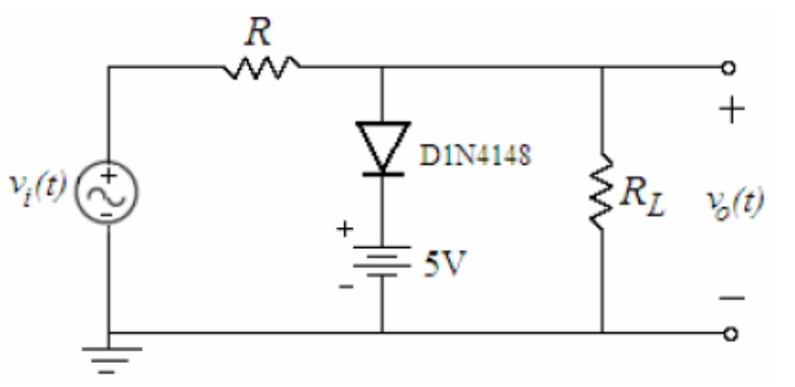

We can easily see that v_{O}(t) will be clipped at (5V + V_{diode} ) = 5 + 0.7 = 5.7 Volts. D1 will be
off for v_{i}(t) < V_{DC} + V_{diode}, so v_{O}(t) will ve equal to v_{i}(t) for v_{i}(t) < V_{DC} + V_{diode}.

If we change the DC voltage to another value, this time v_{O}(t) will be clipped at (V_{DC} + V_{diode} ).

If we rotate the DC voltage, v_{O}(t) will be clipped at ( -V_{DC} + V_{diode} ) but this time D1 will be off for v_{i}(t) < -V_{DC} + V_{diode} , so v_{O}(t) will ve equal to v_{i}(t) for v_{i}(t) < - V_{DC} + V_{diode}. But for v_{i}(t) > -V_{DC} + V_{diode}, D1 will be on and v_{O}(t) will ve equal to -V_{DC} + V_{diode}.

The minimum values are not the same since for v_{i}(t) < V_{DC} + V_{diode}, D1 is off, so v_{O}(t) will ve equal to v_{i}(t)x ( R_{L} / R_{L} + R) = v_{i}(t)x(47/48)
( The self-plotted graphs are attached to the end of the document )
( PSPICE generated graph )

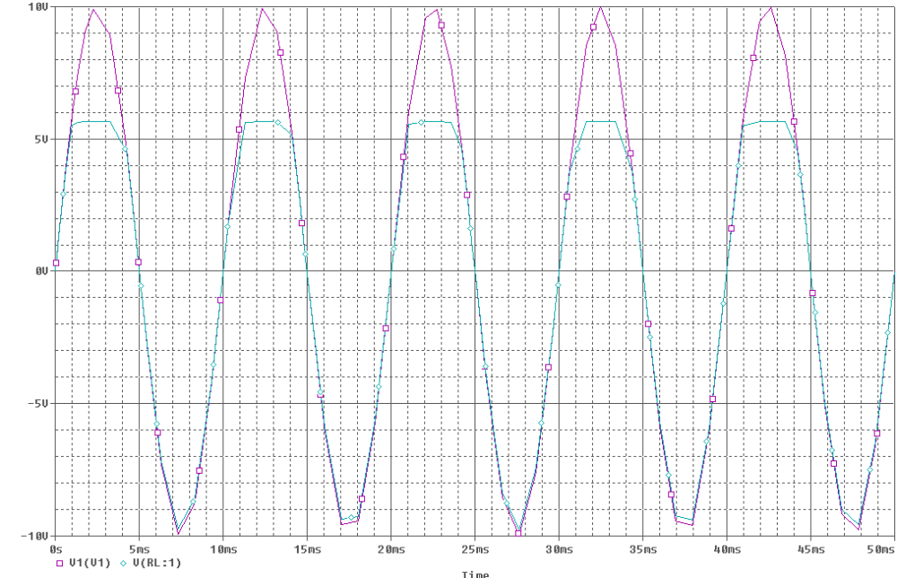
b)
This time the cricuit becomes:
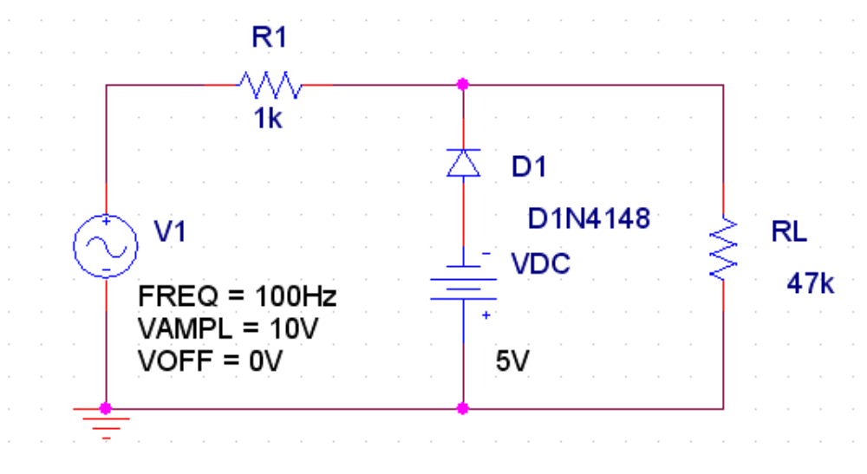

D1 is off for v_{i}(t) > - ( V_{DC} + V_{diode} ) so that v_{O}(t) will ve equal to v_{i}(t)x(47/48) for
v_{i}(t) > - ( V_{DC} + V_{diode} ). But for v_{i}(t) < - ( V_{DC} + V_{diode} ), D1 will be on and
v_{O}(t) will ve equal to - ( V_{DC} + V_{diode} ).

For this circiut, V_{DC} = 5V, so v_{O}(t) will ve equal to v_{i}(t)x(47/48) for v_{i}(t) > - 5.7 and v_{O}(t) will ve equal to -5.7 for v_{i}(t) < - 5.7

( The self-plotted graphs are attached to the end of the document )
( PSPICE generated graph )

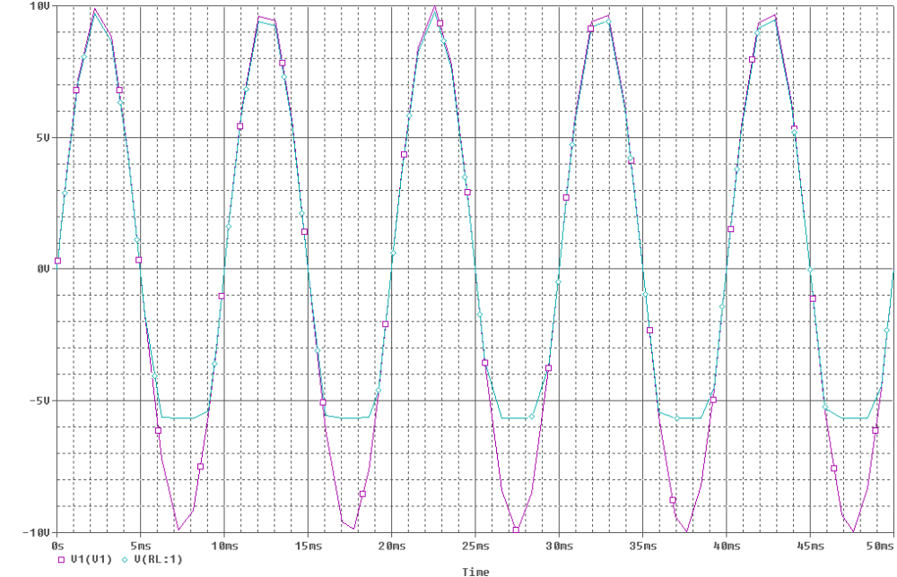
3)
a)
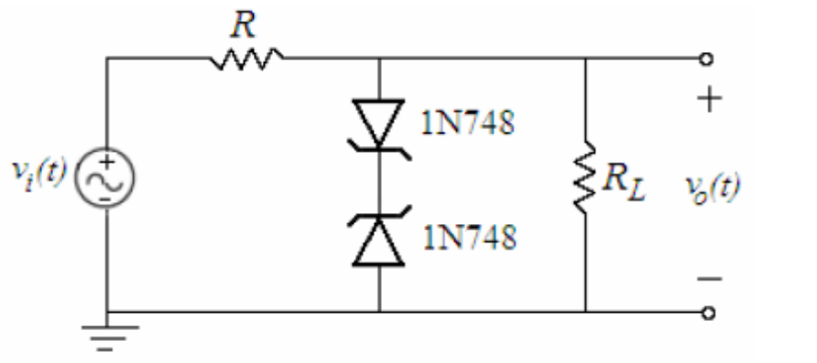
We can see from the maintained pdf file that 1N748 Zener diode has a zener voltage of :
V_{Z} = 3.9 V

Let’s analyze this circuit as well. For v_{i}(t) > 0 , D1 will act like a normal diode while D2 will regulate the voltage and won’t let it’s terminals to exceed 3.9 Volts. The total voltage is V_{Z} + V_{diode} = 3.9 + 0.7 = 4.6 Volts. So for v_{i}(t) > 4.6 Volts , v_{O}(t) will ve equal to 4.6.

For v_{i}(t) < 0 , D2 will act like a normal diode while D1 will regulate the voltage and won’t let it’s terminals to exceed 3.9 Volts. The total voltage is -V_{Z} - V_{diode} = -3.9 - 0.7 = -4.6 Volts. So for v_{i}(t) < - 4.6 Volts , v_{O}(t) will ve equal to - 4.6.

For 4.6 > v_{i}(t) > -4.6 , v_{O}(t) will ve equal to v_{i}(t)x(47/48)
( The self-plotted graphs are attached to the end of the document )

( PSPICE generated graphs )
v_{i}(t) and v_{O}(t) :
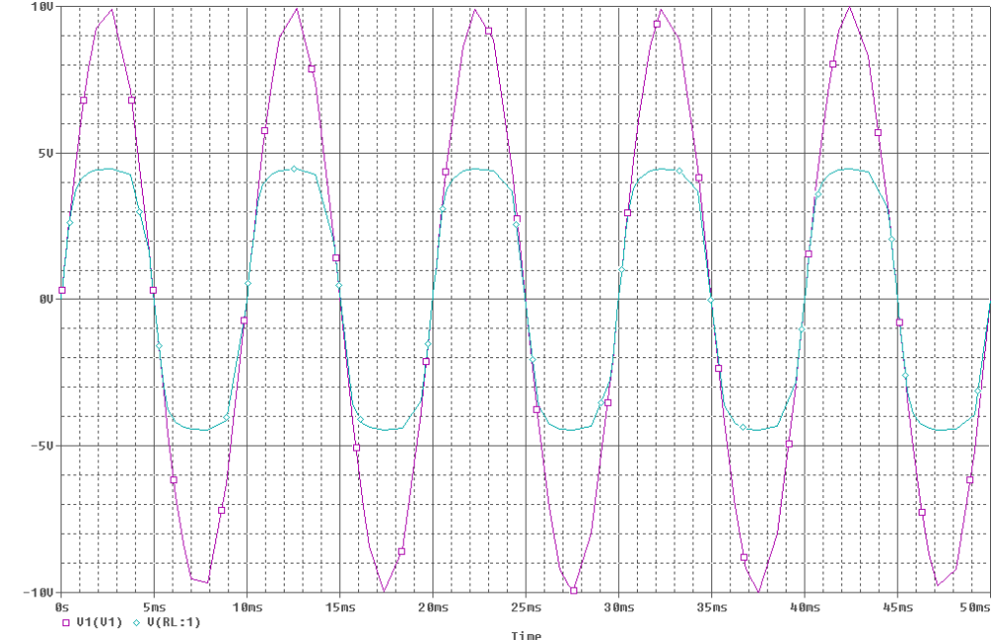
V_{D1} and V_{D2}
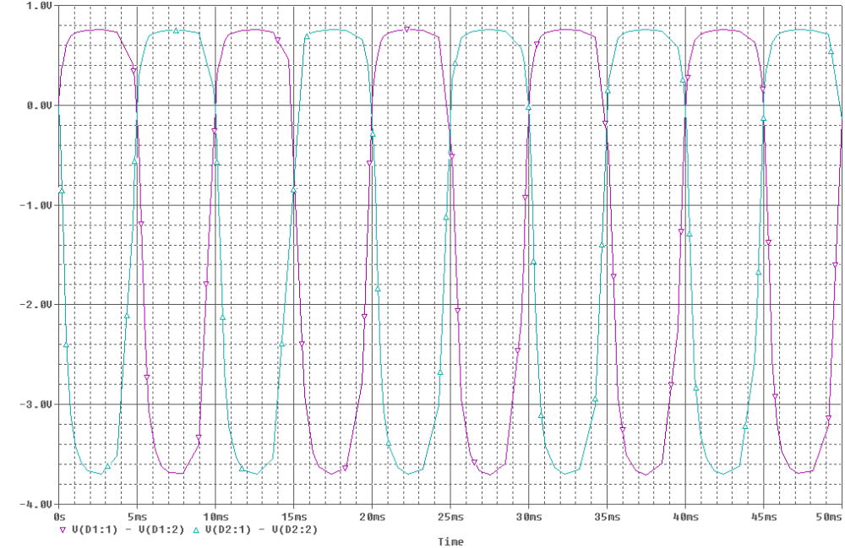

b)

The circuit becomes:
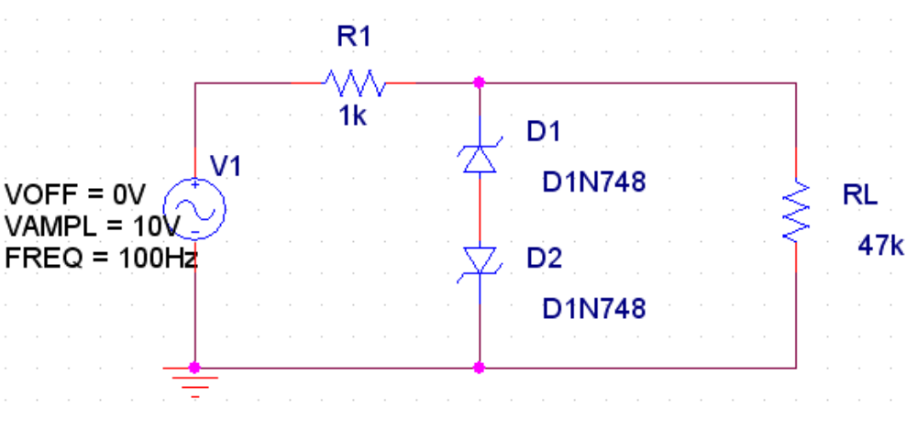
The output voltage doesn’t change since in this circuit, D1 does D2’s job and vice versa with respect to the circuit in 3-a). But D1’s and D2’s voltages are changed, their voltages are inverted w.r.t. the t-axis.

( PSPICE generated graphs )
v_{i}(t) and v_{O}(t) :
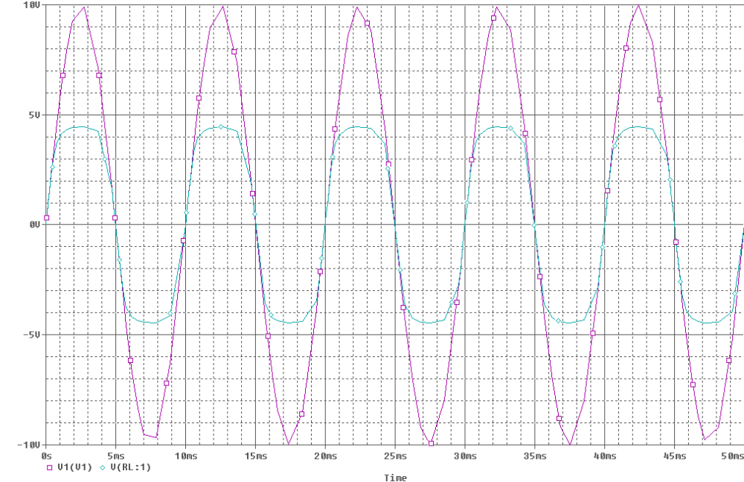

V_{D1} and V_{D2}

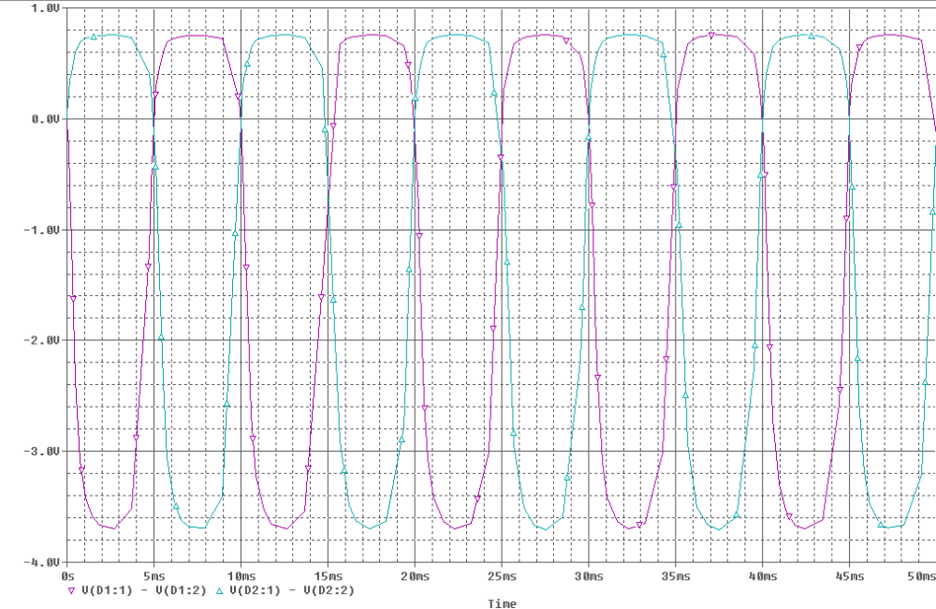

4)

Design Problem: v_{i}(t) and v_{O}(t) :

We can see that v_{O}(t) is clipped at 3.7 Volts and -2.7 Volts. We can use a simple two-diode circuit for this example. Since the diode’s voltages are equal to (V_{D1} = V_{D2} = 0.7 Volts ), we need to DC voltages, one is 3 Volts and the other is 2 Volts.

This circuit is what we need here:
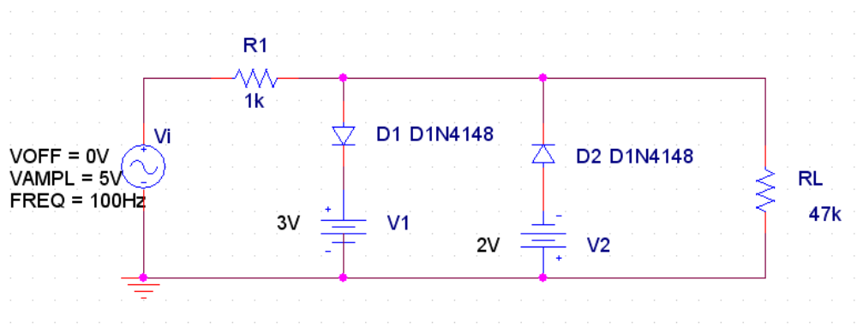
PSPICE simulation graph gives what we are looking for, circuit is correct:

v_{O}(t)

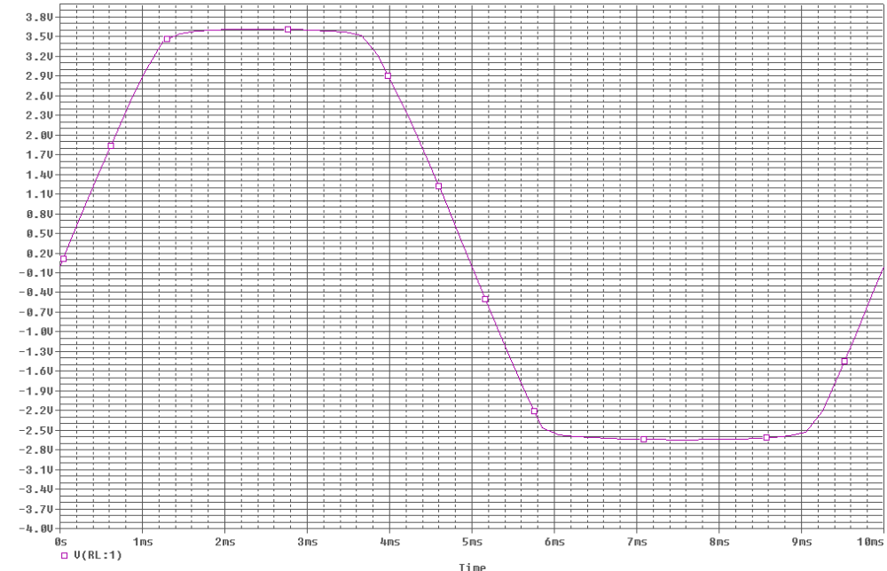

5)

a)
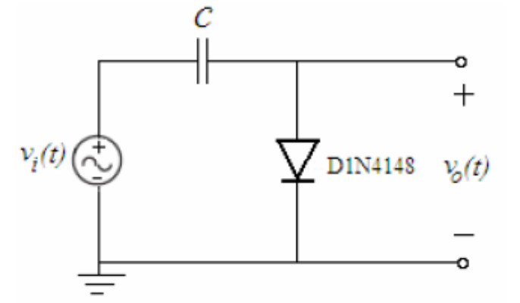
If we analyze the circuit, we will see that for the first quarter ( 0 – 2.5 ms ) , v_{i}(t) is increasing and C is charging with the value Vc = Vp. So at the first quarter, v_{O}(t) = V_{diode} = 0.7 Volts.

Since there are no resistive elements on this circuit, C will not discharge it’s load. So after the first quarter v_{O}(t) is equal to -Vc + v_{i}(t) + V_{diode}.

Since the output voltage is oscillating around -Vp + V_{diode} = -10 + 0.7 = -9.3 Volts, this average value is the DC value of the output:

∫_{T} ( -10 + v_{i}(t) + V_{diode}) dt = -10 + V_{diode}

( The self-plotted graphs are attached to the end of the document )
( PSPICE generated graphs )
v_{i}(t) and v_{O}(t) :
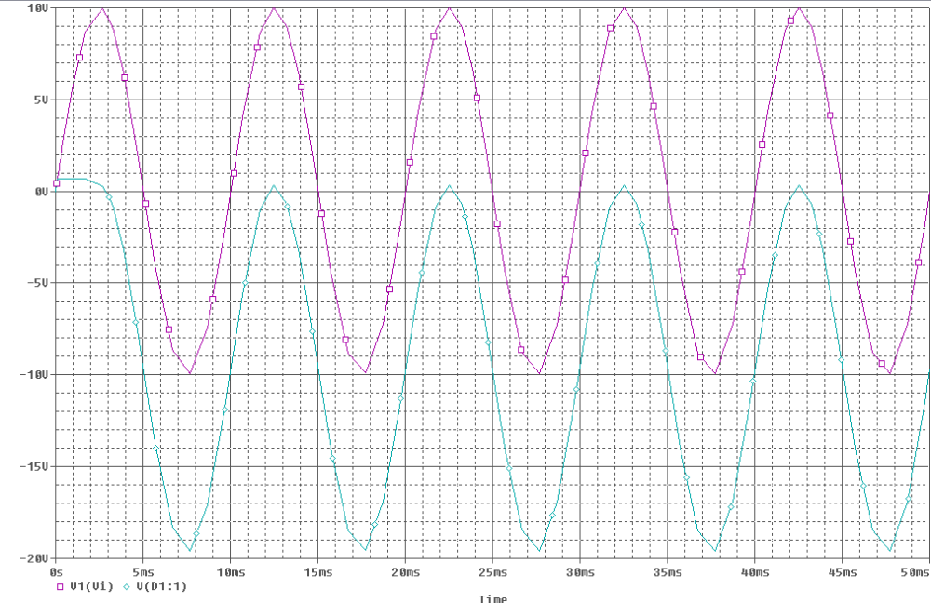

DC ( Average ) value of v_{O}(t):
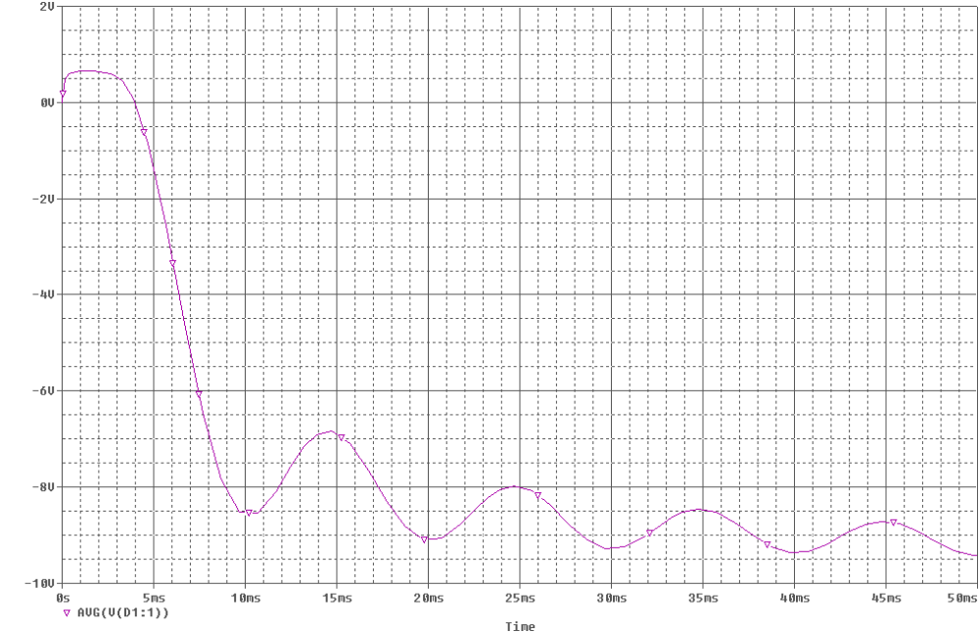

b)

Circuit is:

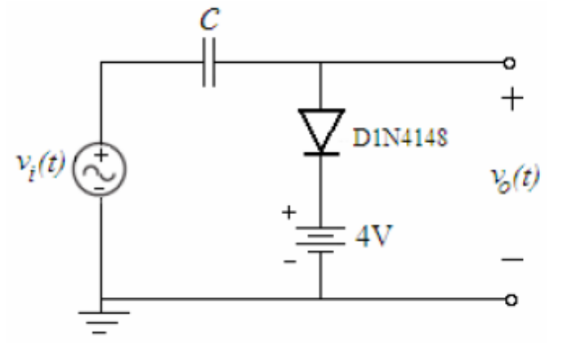

We can see that D1 is off for v_{i}(t) < 4 + V_{diode} ⬄ v_{i}(t) < 4.7 Volts . For v_{i}(t) > 4.7 Volts, D1 is on and the maximum voltage between capacitor’s terminals happens at v_{i}(t) = 10 Volts, so capacitor is loaded with V_{C} = 10 – 4 – 0.7 Volts = 5.3 Volts.

So for v_{i}(t) < 4.7 Volts, v_{O}(t) is equal to 4.7 Volts. For v_{i}(t) > 4.7 Volts, D1 is on and v_{O}(t) becomes - Vc + v_{i}(t) Volts.

( The self-plotted graphs are attached to the end of the document )
( PSPICE generated graphs )

v_{i}(t) and v_{O}(t) :

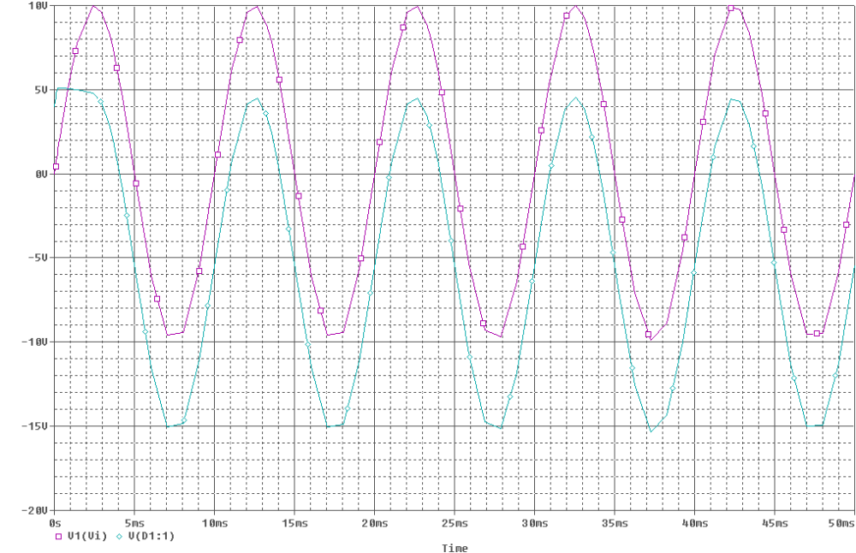

c)

The circuit becomes:

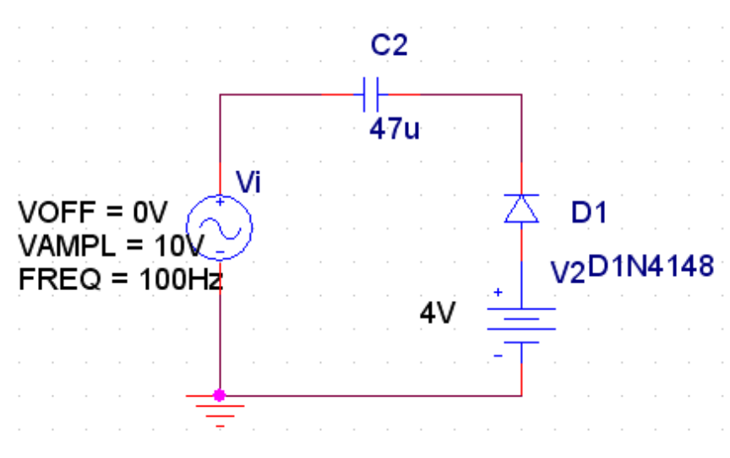

We can see that D1 is off for v_{i}(t) > -4 + V_{diode} ⬄ v_{i}(t) > -3.3 Volts . Capacitor charges with
- 4 Volts.

For v_{i}(t) < -4 + V_{diode} , D1 is on and Capacitor charges with –Vp-3.3 Volts = -13.3 Volts and remains charged with that value. So after capacitor is charged with -13.3 Volts , v_{O}(t) is equal to - Vc + v_{i}(t) Volts.

( The self-plotted graphs are attached to the end of the document )
( PSPICE generated graphs )

v_{i}(t) and v_{O}(t) :

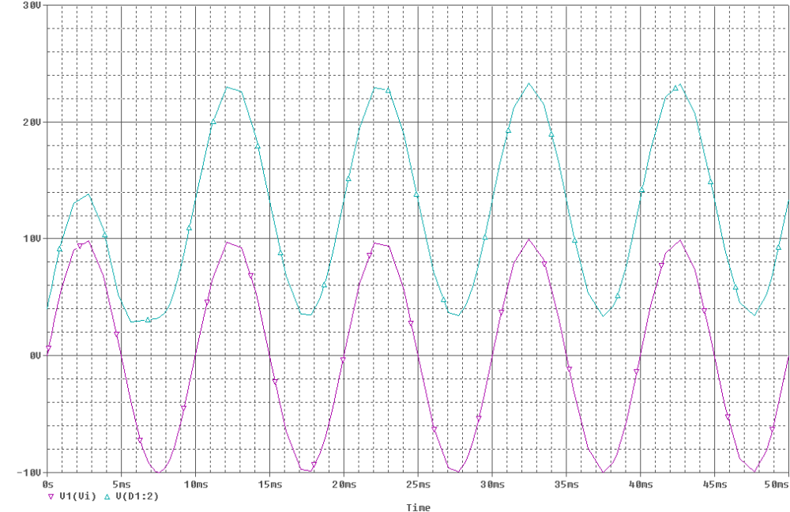

6)

We know from the datasheet that V_{Z} for 1N748 is 3.9 Volts. Here, v_{i}(t) oscillates between 10 + Vp and 10 – Vp that is between 12 and 8 volts.Since zener diode will always act like a regulator , by kvl, v_{O}(t) will be:

v_{O}(t) = 10 – v_{S}(t) – V_{Z}

( The self-plotted graphs are attached to the end of the document )
( PSPICE generated graphs )

v_{i}(t) and v_{O}(t) :
