Başkent University
Department of Electrical and Electronics Engineering
EEM 214 Electronics I

Experiment 6

Small-Signal Analysis of Diode Circuits

Aim:

The aim of this experiment is to investigate the small-signal AC model of diode and usage of that model in a circuit.

Theory:

For a forward biased diode, the small-signal resistance is given by

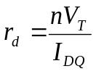

where V_{T} is the thermal voltage, n is the ideality factor, and I_{DQ} is the quiescent(DC) diode current.

The i-v characteristics of pn junction diode is

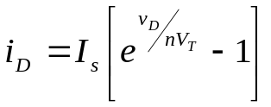

where the ideality factor n is a number between 1 and 2. By definition, the small-signal resistance is the inverse of the slope of this i-v curve evaluated at the Q-point. In other words,

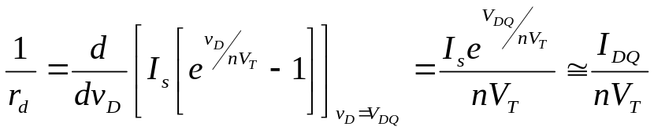

since 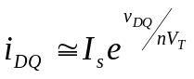 for a forward biased diode.
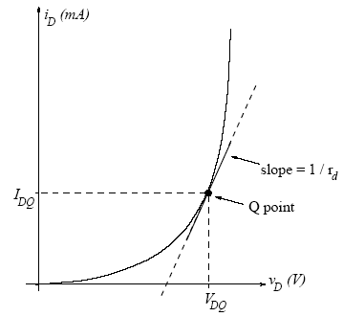

The diode small-signal AC model is a linear approximation to the exponential diode i-v curve around a DC operating point in the forward-bias region. Consider a diode in a circuit. The presence of the diode with its nonlinear i-v relationship poses a problem in analyzing the circuit. In general, the diode voltage and current may have both DC and AC components. The small-signal AC model may be used if

- the diode is biased to a DC Q-point in the forward-bias region and

- the AC component of the diode voltage is small relative to nV_{T}

The DC diode current and voltage (the Q-point) may be found using either a numerical method to solve the exponential i-v relationship or a simple piecewise linear model. Once the Q-point is found, AC variations around that Q-point can be considered to be approximately linear, provided they are small in amplitude. The AC diode current can then be considered to be linearly related to the AC diode voltage, and hence the diode can be modeled as a resistor with a resistance that is equal to the inverse of the slope of the i-v curve at the Q-point. The small-signal AC model begins to break down if the AC voltage across the diode exceeds nV_{T}. In this case distortions due to the diode nonlinearity become noticeable in the circuit.

Preliminary Work

1) Review Section 13.4 from the textbook.

2)
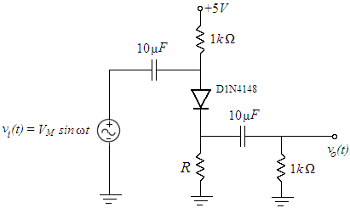

For two different values of R, namely 3.9kΩ and 56kΩ, perform the following steps. These R values will bias the diode at two different Q-points in the forward-bias region. The small-signal resistance r_{d} will therefore be different for different values of R.
Assume that the coupling capacitors are short circuit at the frequency of operation. Also assume that the input voltage signal v_{i} is small enough so that v_{d} <<nV_{T} . The ideality factor of 1N4148 diodes is 2.

a. Find the quiescent diode current I_{DQ} using a piecewise linear model with V_{on}=0.6V and the forward resistance r=20Ω.

b. Determine the small-signal resistance r_{d} and draw the small-signal AC model for the circuit.

c. Find the output voltage as a function of the input voltage and determine the small-signal voltage gain A_{v}= v_{o}/v_{i}

d. Approximately determine the largest input voltage amplitude for which the small-signal approximation can be expected to work. To do this, you may calculate the largest value that V_{M} can take for v_{d} ≈nV_{T} to be satisfied.

3) Design problem:

Determine the value of R that will yield a small-signal voltage gain, A_{v}=0.70±0.03 to have 0.67<A_{v} < 0.73. In addition, the DC diode current should be less than 3 mA. Use standard resistor values only. After finishing your design, simulate your circuit using PSPICE: The diode is listed in PSPICE library as D1N4148. Use VSIN as the AC voltage source. First calculate all the DC voltages and currents, and compare the Q-point with your design value. Then use Time Domain Analysis to calculate the small-signal voltage gain using V_{M}=20mV and f=2kHz. Increase V_{M} up to 500 mV and repeat. Comment on your simulation results.

4) Read the experimental work
Experimental work

- Construct the circuit given in the preliminary work section using R=3.9kΩ. (Note that the capacitors that you use here are electrolytic capacitors. Make sure to connect the positive terminal of the capacitor towards the DC power supply.) Set the signal generator frequency to 2 kHz (sinusoidal output) and the amplitude to 100mV peak-to-peak(V_{M}=50mV). With relatively small voltages like these, make sure to use normal triggering and adjust the trigger level on the oscilloscope carefully.

  - Turn off the signal generator. Measure the DC voltage drop (with a multimeter) across the 1kΩ resistor that is connected to the DC supply. From your measurement, determine the quiescent diode current I_{DQ} and make sure that the diode is biased properly. Measure the DC voltage drop across the diode (V_{DQ})as well.

 | Part1 | Part2 | Part3
DC voltage drop across the 1kΩ
V_{DQ}

  - Turn on the signal generator. Obtain and record the input and output voltage waveforms on the oscilloscope on two separate channels. Measure the small-signal voltage gain A_{v}. Compare this with the value calculated in your preliminary work.

PART1 v_{in} v_{out}


PART2 v_{in} v_{out}
PART3 v_{in} v_{out}

  - Increase the signal generator amplitude V_{M} until you begin to see distortion at the output (output no longer sinusoidal). Note the V_{M} when this occurs.

 | Part1 | Part2 | Part3
V_{M}

  - Set the signal generator back to amplitude to 100mV peak-to-peak(V_{M}=50mV). Put the oscilloscope into XY-mode to observe and record the input-output graph of this circuit. Increase the input voltage to make sure that you see where the linear approximation breaks down. (It helps to define the origin of this graph by reducing the input voltage to zero first, and then move the resulting bright dot to the center of the screen.)

PART1 v_{out} vs v_{in} PART2 v_{out} vs v_{in} PART3 v_{out} vs v_{in}


- Repeat the part1 for R=56k. Compare your results and observations with the R=3.9k case.

- Repeat the part1 for the R value that you calculated in your design(V_{M}=20mV). Does your circuit meet the design requirement that A_{v}=0.70±0.03 If not, try to figure out the problem, and redesign and/or reconstruct your circuit.
Increase the signal generator amplitude to 1V peak-to-peak (V_{M}=500mV) and obtain input and the output waveform. Compare the output waveform with your PSPICE simulation results.

v_{in} v_{out}

Lab Instruments:  Breadboard  Oscilloscope  Signal Generator  Multimeter  DC Power Supply | Components:  1 1N4148  1 56kΩ.  1 3.9kΩ  2 1kΩ. | 2 10μF

...............................………………………………………………………………..

Experiment Results

 | Part1 | Part2 | Part3
V_{M}

 | Part1 | Part2 | Part3
DC voltage drop across the 1kΩ
V_{DQ}

Student Name :

Number :

Signature…………….………….

