BAŞKENT UNIVERSITY

EEM 214 LABORATORY WORK

EXPERIMENT 7

COMPARING DIFFERENT BIAS CONFIGURATIONS

OBJECTIVES

- To compare different bias configurations
- To determine the stability factors of BJT circuits

1. THEORY & PRELIMINARY PART

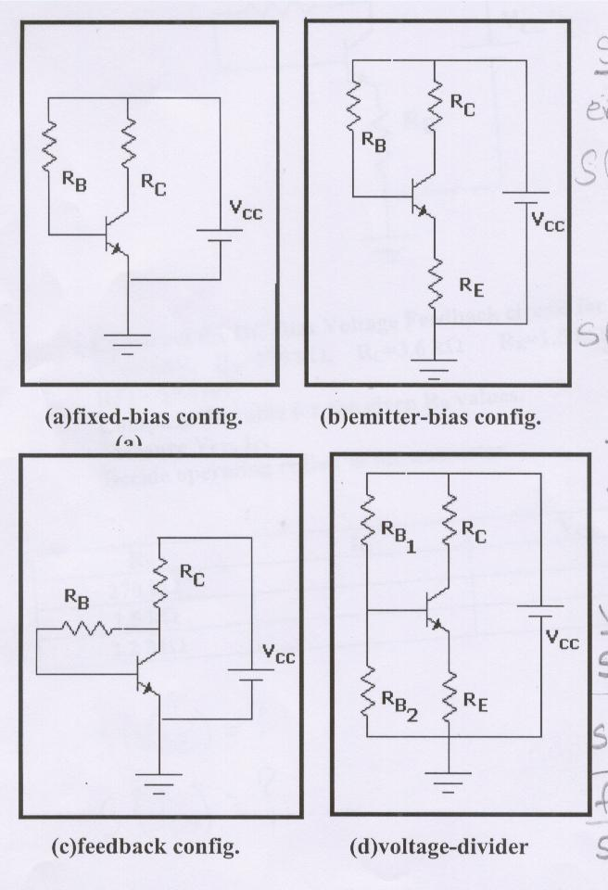

In figures, different types of bias configurations are given. The values are:

V_{CC} = 30V β = 100

R_{B} = 470kΩ R_{C} = 4.7kΩ R_{E1} = 1.2kΩ R_{B2} = 5.6kΩ

Find I_{B} (Base current) and V_{CE}(collector-emitter voltage) of all configurations.

Calculate stability factors S(I_{CO}), S(V_{BE}) of all configurations then decide which configuration is more stable (robust). Explain why?
In your calculations, you can use below formulas:

Stability Factors:

Emitter – bias configuration:

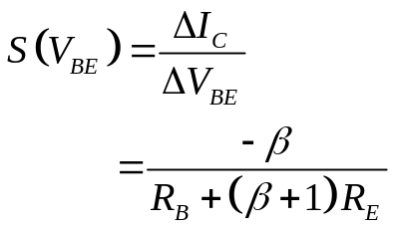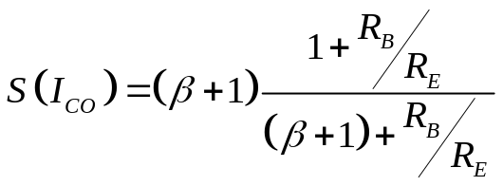

Fixed – bias configuration:

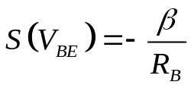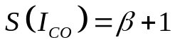

Voltage Divider:

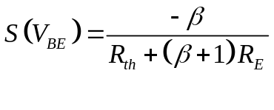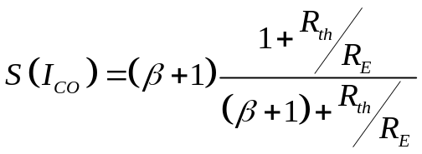

Feedback Configuration:

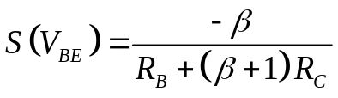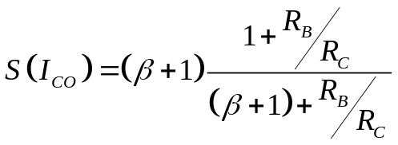

2. EXPERIMENT PART

- Construct the DC Bias Voltage Feedback circuit for the given elements:

- V_{CC} = 16 V, R_{B} = 270 kΩ, R_{C} = 3.6 kΩ R_{E} = 1.5 kΩ
BJT = 2N3107

- Measure V_{CE}, I_{C} values.

- Complete the table-1 for the given R_{B} values.

- Decide operating region of the transistor.

- Calculate the Stability Factors for the values given in report

R_{B}
R_{C}
R_{E}
V_{CC}
2N3107

3. RESULTS AND CONCLUSION

- Which circuitry is more stable.
- Examine the stabilization factors and give some comments on results

Name :
Surname :
Id Number :
Lab Section :
4. REPORT

hFE =

R_{B} | I_{C} | V_{CE} | Operating Region
270 kΩ
1.5 kΩ
2.2 kΩ
Table – 1

R_{B} = 270 kΩ

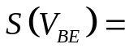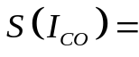

R_{B} = 1.5 kΩ

R_{B} = 2.2 kΩ

